Final Implementation Evidence
Predictive Pre-Congestion Aware QoS Optimization for Video Streaming using SDN and Lightweight AI
CS23502 Networks and Data Communication | MIT-Chennai
Sana Tasneem Azimudin (2024503007), Priyadharshini M (2024503501), Sharmu R (2024503055), Monisha G (2024503043)

1. Overview
This document records the evidence for the implemented system: a Ryu OpenFlow 1.3 controller on a four-switch Mininet topology that predicts congestion a short time ahead from a sliding window of recent link metrics, and reroutes traffic from the normal path (s1, s2, s4) to an alternate path (s1, s3, s4) only when the model's confidence is at or above a threshold (0.90 in these runs).
Scope note. The link metrics (bandwidth, packet loss, delay, jitter) used for training and for the live controller are produced by a simulated telemetry generator that drifts gradually and includes congestion episodes. They are not measured from the Mininet switches. The forecasting, OpenFlow rerouting and flow-table changes shown below are real; the telemetry that drives them is simulated.

2. Data Collection
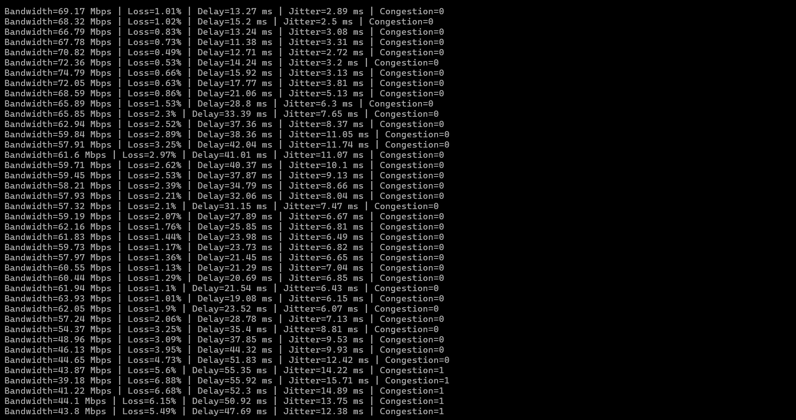
Figure 1. Trending telemetry produced by data_collector.py
Each line is one 2-second sample. Bandwidth falls while loss, delay and jitter rise gradually, then recover. A sample is labelled Congestion=1 when loss exceeds 5%, delay exceeds 60 ms or jitter exceeds 15 ms. The collector produced 574 samples. Gradual drift (rather than independent random values) is what gives a sliding-window model a trend to learn from.

3. Forecasting Dataset and Model Training
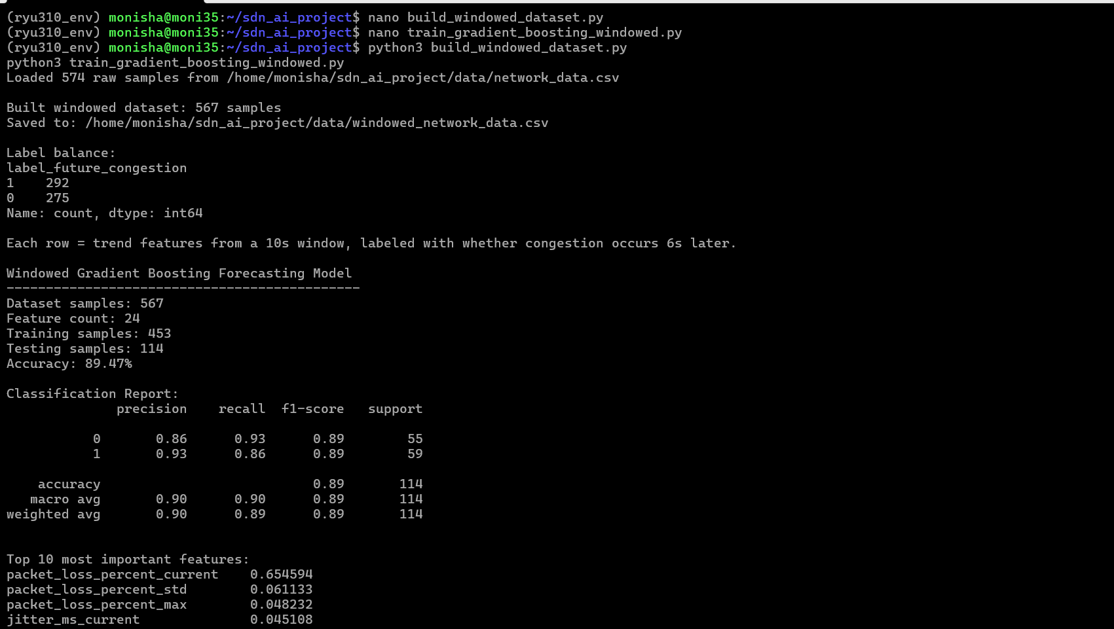
Figure 2. Windowed dataset build and Gradient Boosting training
build_windowed_dataset.py turned 574 samples into 567 windowed rows. Each row summarises the last 5 samples (10 s) as 24 features (current, mean, standard deviation, min, max and slope for each of the four metrics) and is labelled with whether congestion occurs 3 samples (6 s) later. Labels are balanced (292 congested, 275 normal). With a random 80/20 split (453 train, 114 test) the model reached 89.47% accuracy, with precision and recall between 0.86 and 0.93 for both classes.
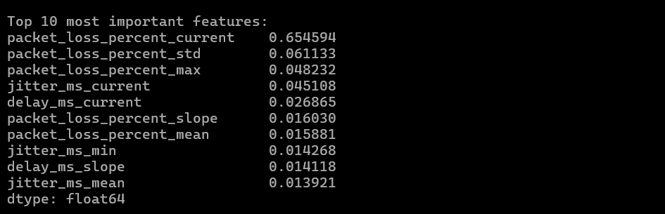
Figure 3. Top 10 feature importances
Current packet loss carries most of the weight (0.655). Window-based features also contribute, including packet-loss standard deviation (0.061) and maximum (0.048), packet-loss slope (0.016) and delay slope (0.014). The model therefore uses history from the window and not only the latest reading, although the latest packet-loss value dominates.

4. Testbed Connectivity
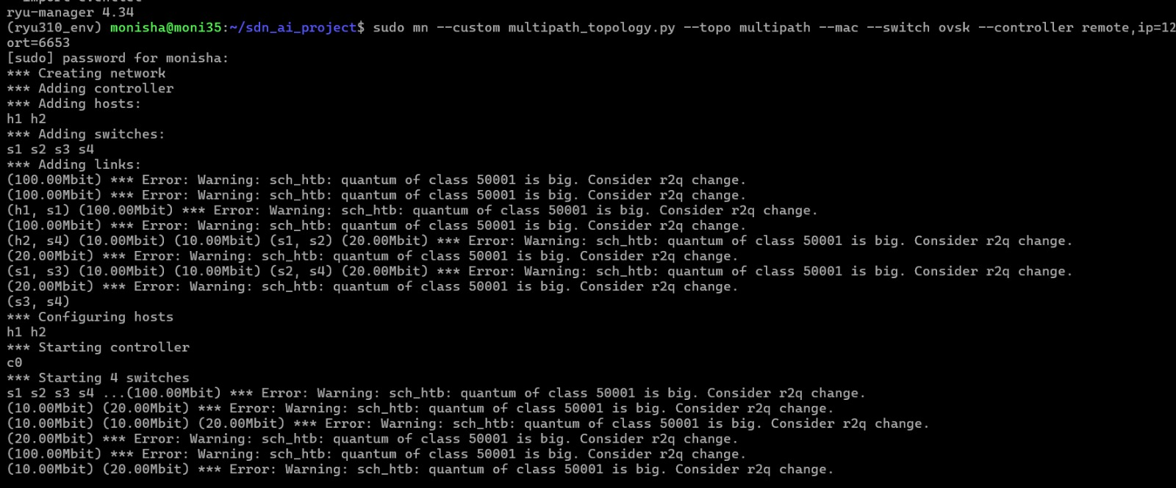
Figure 4. Mininet creating the four-switch topology
Mininet adds hosts h1 and h2, switches s1 to s4 and the links between them, then starts the remote controller c0 and the four Open vSwitch switches. The links are bandwidth-limited (10, 20 and 100 Mbit values appear), and the ryu-manager 4.34 line is visible above. The sch_htb 'quantum is big' lines are standard Linux traffic-control warnings from the bandwidth-limited links and do not affect operation.
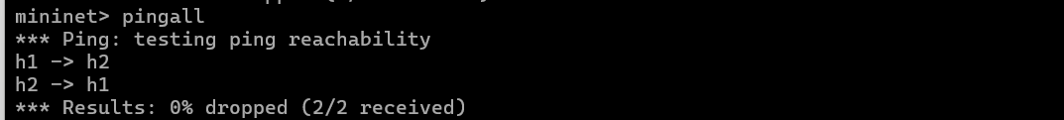
Figure 5. Mininet pingall after the controller installed the initial path
Both hosts reach each other with 0% packets dropped (2/2 received). This was run after the controller reported that all four switches were connected and the normal path was installed.

5. Live Forecasting and Confidence-Threshold Switching
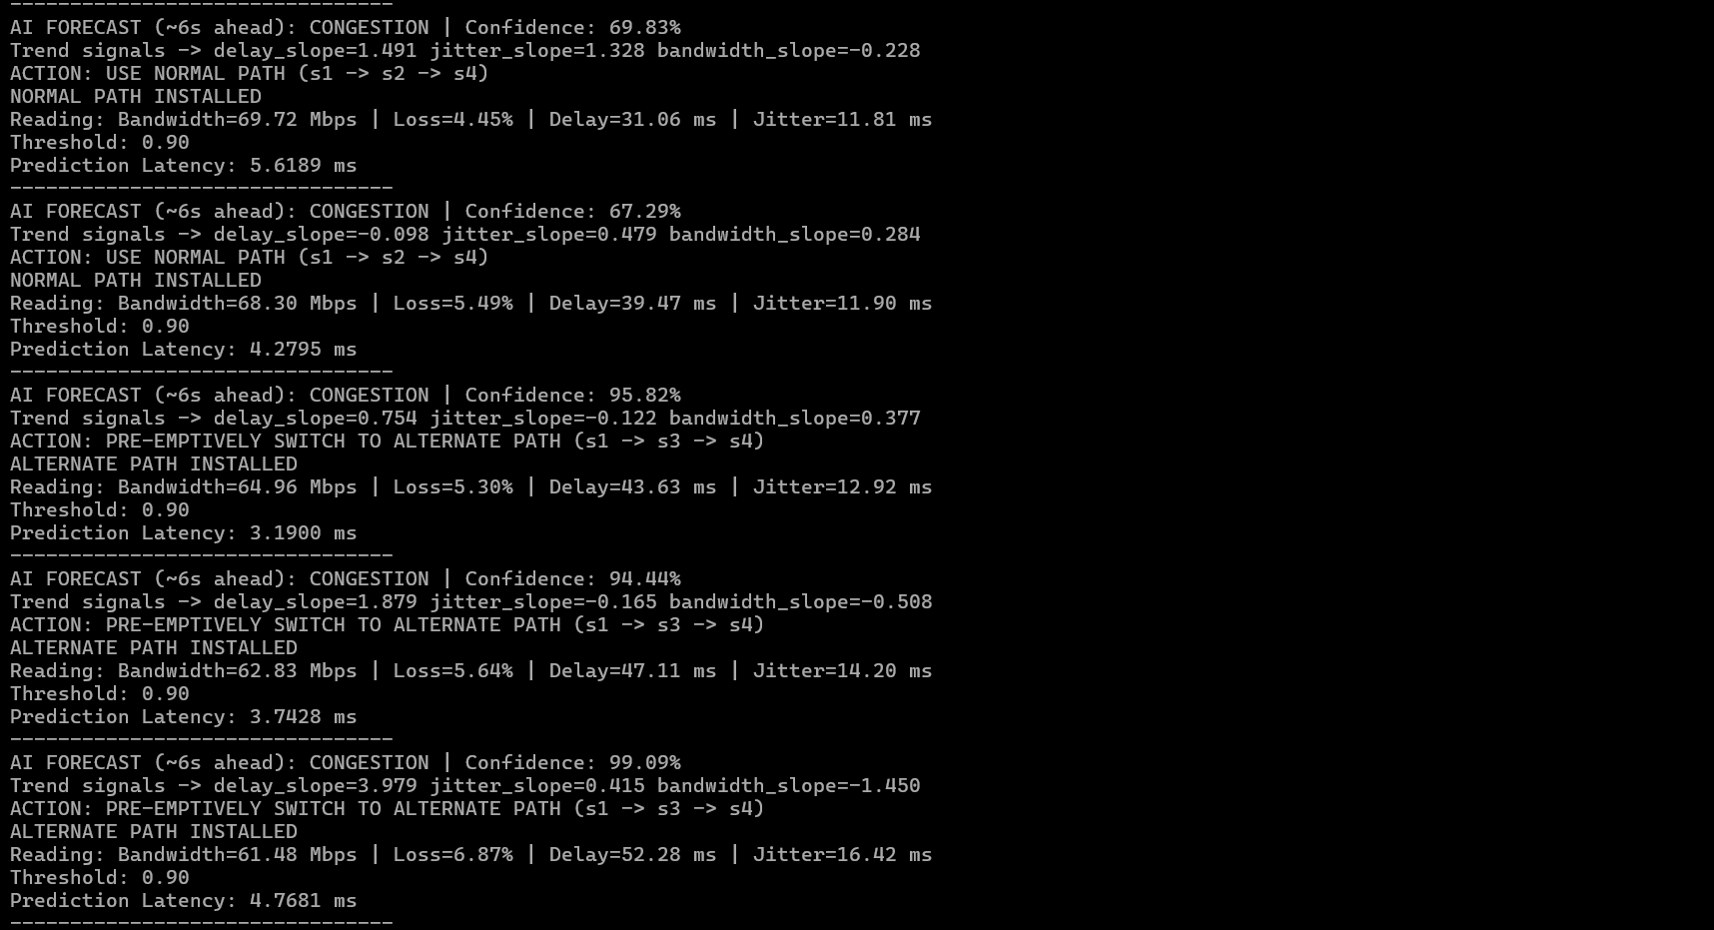
Figure 6. Controller log showing forecasts gated by the 0.90 confidence threshold
The first two forecasts predict CONGESTION at 69.83% and 67.29% confidence. Both are below the 0.90 threshold, so the controller keeps the normal path. The next three forecasts predict CONGESTION at 95.82%, 94.44% and 99.09%. These are at or above the threshold, so the controller logs "PRE-EMPTIVELY SWITCH TO ALTERNATE PATH" and installs the alternate path. Each cycle also prints the trend signals (delay, jitter and bandwidth slopes) and the model prediction latency, which was between about 3 and 6 ms.

6. OpenFlow Verification
Figure 7. Flow table of s1 before the switch (normal path)
ovs-ofctl dump-flows s1 shows traffic entering s1-eth1 leaving through s1-eth2, and the reverse. This is the normal path toward s2.
Figure 8. Flow table of s1 after the switch (alternate path)
After the controller logged ALTERNATE PATH INSTALLED, the same command shows s1-eth1 leaving through s1-eth3, and the reverse. The output port changed from eth2 to eth3, which shows the controller's decision rewrote the switch's OpenFlow rules.

7. Static versus AI-Enabled Comparison
The same traffic commands were run once under each controller: a 60 s iperf3 TCP stream from h1 to h2, then 30 pings. The static controller installs the normal path once and never changes it. The AI controller is multipath_ai_controller_windowed.py.

7.1 Static (no-AI) baseline
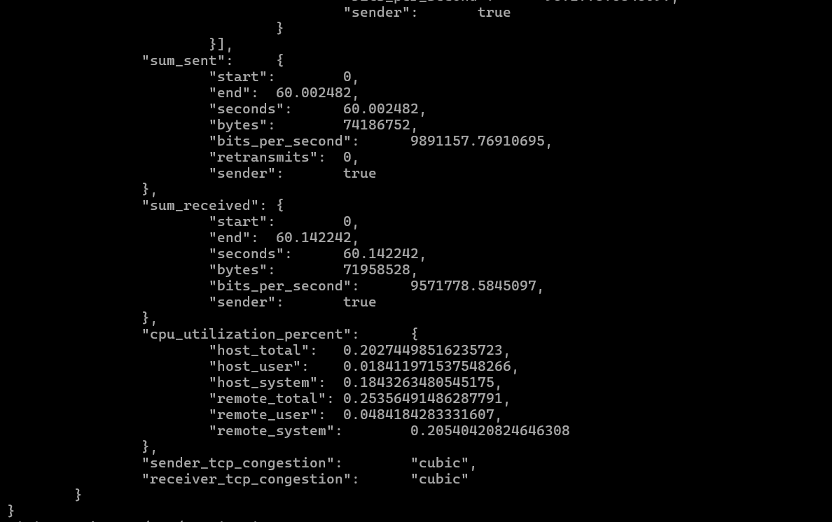
Figure 9. Static baseline: iperf3 summary
Sender 9.89 Mbps, receiver 9.57 Mbps, 0 TCP retransmits over 60 s.
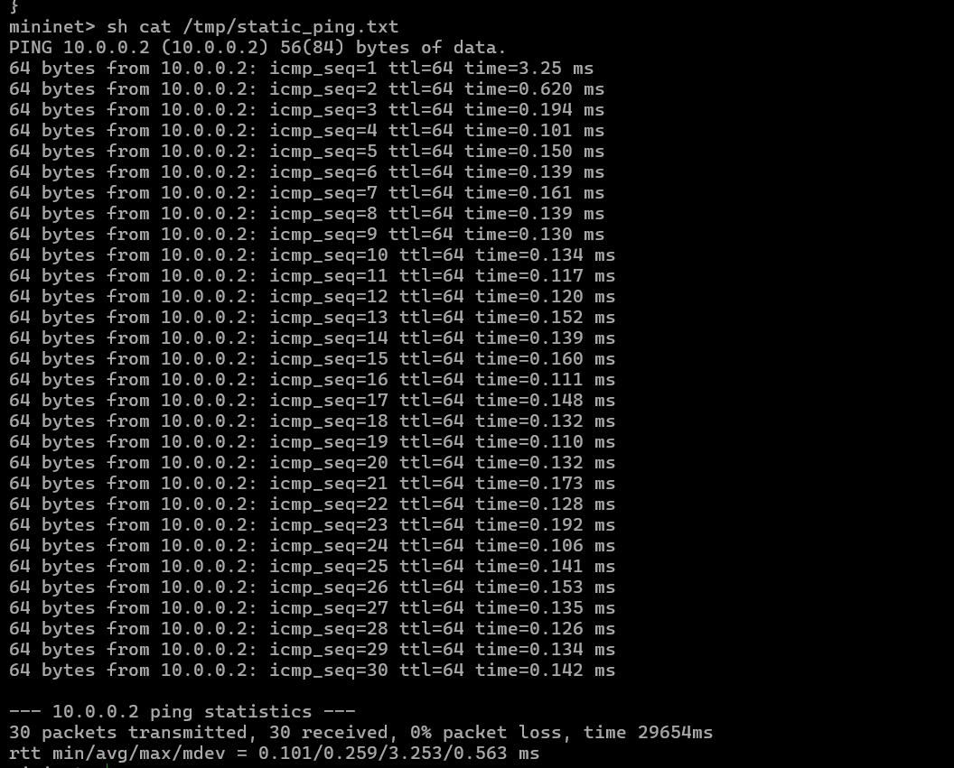
Figure 10. Static baseline: ping statistics
30 of 30 packets received, 0% loss. Round-trip time min/avg/max/mdev = 0.101 / 0.259 / 3.253 / 0.563 ms.

7.2 AI-enabled run
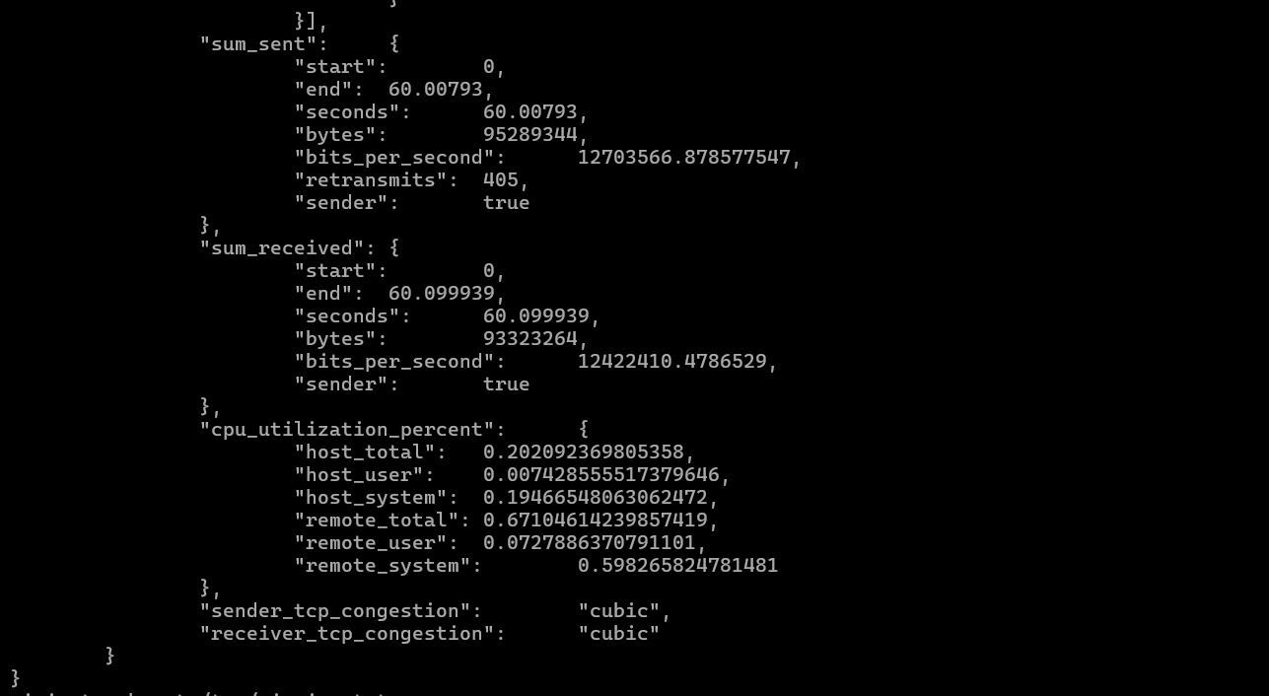
Figure 11. AI-enabled: iperf3 summary
Sender 12.70 Mbps, receiver 12.42 Mbps, 405 TCP retransmits over 60 s.
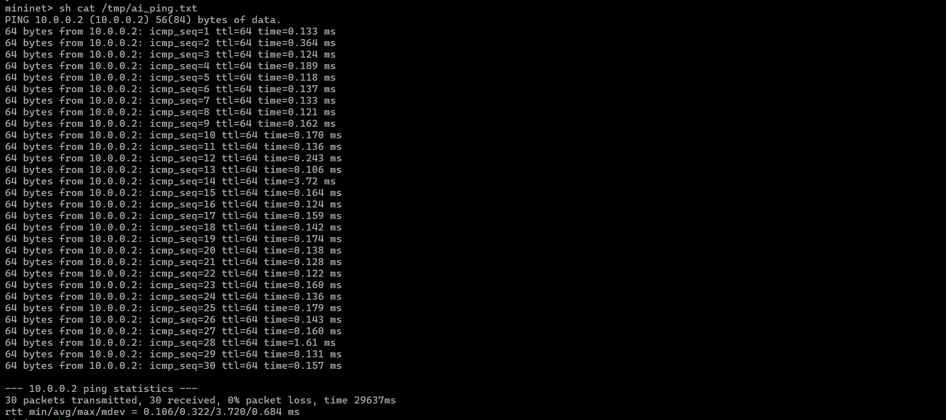
Figure 12. AI-enabled: ping statistics
30 of 30 packets received, 0% loss. Round-trip time min/avg/max/mdev = 0.106 / 0.322 / 3.720 / 0.684 ms.

7.3 Side-by-side numbers
Metric | Static (no AI) | AI-enabled | Note
iperf3 throughput, sender | 9.89 Mbps | 12.70 Mbps | +28.4% in this run
iperf3 throughput, receiver | 9.57 Mbps | 12.42 Mbps | +29.8% in this run
TCP retransmits | 0 | 405 | Bursts at roughly 13 s, 17 s, 35 s, 39-42 s, 51-53 s
Ping loss | 0% | 0% | Same
Ping RTT avg | 0.259 ms | 0.322 ms | Ping ran after iperf3 finished, so this is an idle path
Ping RTT max | 3.253 ms | 3.720 ms | Single outliers in both runs

7.4 How to read these numbers
- One 60 s run per configuration. The difference in throughput is an observation from a single run, not a statistically established gain.
- The AI controller's congestion forecasts come from the simulated telemetry generator inside the controller, not from measurements of the iperf3 flow. The throughput difference therefore cannot be credited to the model predicting this traffic's congestion.
- The AI controller deletes and reinstalls its flow rules every 2 s cycle, while the static controller installs them once. The retransmit bursts are consistent with brief loss while rules are rewritten, including path switches; the exact cause was not isolated.
- In the AI run, iperf3's reported RTT falls during the same intervals in which the congestion window (snd_cwnd) shrinks after retransmits. That pattern is also what TCP queue behaviour after loss looks like, so it does not by itself show that the alternate path is faster.
- The ping averages (0.259 ms vs 0.322 ms) differ by 0.06 ms and were measured on an idle network. Treat them as equal.

8. Summary of What Is Demonstrated
- Sliding-window forecasting model: 24 trend features, 6 s horizon, 89.47% accuracy on a held-out split of simulated telemetry.
- Live integration: the trained model runs inside the Ryu controller and makes a decision every 2 s.
- Confidence threshold: forecasts below 0.90 are ignored, forecasts at or above 0.90 trigger the reroute.
- OpenFlow effect: the flow table on s1 changes from output port eth2 to eth3 when the reroute fires.
- Preliminary comparison against a static controller, with the limits listed in section 7.4.

9. Planned Improvements
- Feed the model real measurements: poll OpenFlow port statistics from the switches and derive bandwidth and loss from them, instead of the simulated generator.
- Repeat each configuration several times and report mean and standard deviation.
- Install flow rules only when the chosen path changes, to avoid rewriting identical rules every cycle.
- Compare under additional traffic loads (light, moderate, bursty).

10. Screenshot Files in the GitHub Repository
All screenshots are in docs/screenshots/ with the names below.
Figure | File name | Shows
1 | 01-data-collection-trending-telemetry.png | Simulated trending telemetry
2 | 02-windowed-dataset-and-model-training.png | Dataset build, training, 89.47% accuracy
3 | 03-feature-importance-top10.png | Top 10 feature importances
4 | 04-mininet-topology-startup.png | Topology creation, controller start
5 | 05-mininet-pingall-connectivity.png | Connectivity check, 0% dropped
6 | 06-live-forecast-confidence-threshold-switching.png | Forecasts, threshold 0.90, reroute
7 | 07-flow-table-before-normal-path.png | s1 flows, eth1 to eth2
8 | 08-flow-table-after-alternate-path.png | s1 flows, eth1 to eth3
9 | 09-static-baseline-iperf3-summary.png | Static: 9.89 Mbps, 0 retransmits
10 | 10-static-baseline-ping.png | Static: avg RTT 0.259 ms
11 | 11-ai-enabled-iperf3-summary.png | AI: 12.70 Mbps, 405 retransmits
12 | 12-ai-enabled-ping.png | AI: avg RTT 0.322 ms

