**Testing_D4_SeleniumWebDriver**

**1).**

**CODE:**

**package com.selenium.softwaretesting.test1;**

**import org.openqa.selenium.By;**

**import org.openqa.selenium.JavascriptExecutor;**

**import org.openqa.selenium.WebDriver;**

**import org.openqa.selenium.WebElement;**

**import org.openqa.selenium.chrome.ChromeDriver;**

**import org.openqa.selenium.chrome.ChromeOptions;**

**import io.github.bonigarcia.wdm.WebDriverManager;**

**public class Day4q2 {**

**public static void main(String[] args) throws InterruptedException {**

**// TODO Auto-generated method stub**

**WebDriverManager.chromedriver().setup();**

**ChromeOptions co=new ChromeOptions();**

**co.addArguments("--remote-allow-origins=*");**

**WebDriver driver=new ChromeDriver(co);**

**driver.get("https://demo.opencart.com/index.php?route=account/register&language=en-gb");**

**driver.manage().window().maximize();**

**Thread.sleep(3000);**

**JavascriptExecutor js = (JavascriptExecutor) driver;**

**js.executeScript("window.scrollBy(0,1000)","");**

**WebElement fn= driver.findElement(By.xpath("//*[@id=\"input-firstname\"]"));**

**fn.sendKeys("Arun");**

**WebElement ln= driver.findElement(By.xpath("//*[@id=\"input-lastname\"]"));**

**ln.sendKeys("Kumar");**

**WebElement em= driver.findElement(By.xpath("//*[@id=\"input-email\"]"));**

**em.sendKeys("Kumar@gmail.com");**

**WebElement pwd= driver.findElement(By.xpath("//*[@id=\"input-password\"]"));**

**pwd.sendKeys("Kumar@1");**

**SNAPSHOT:**

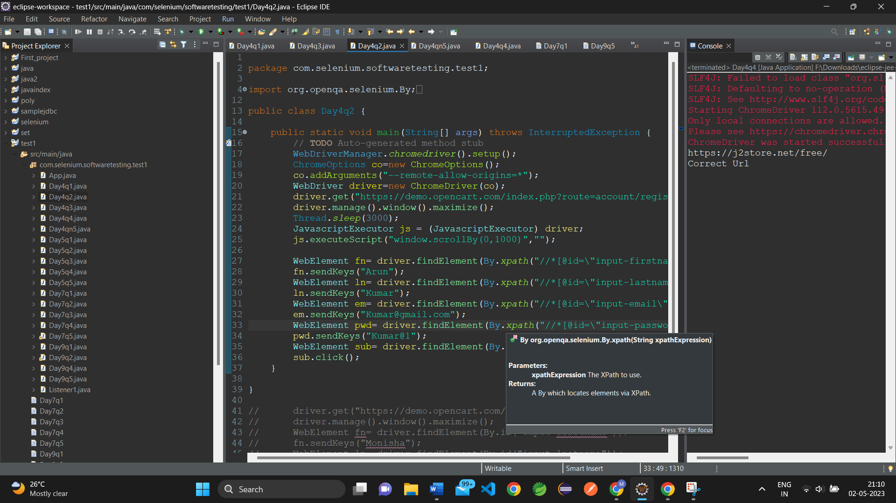

**OUTPUT:**

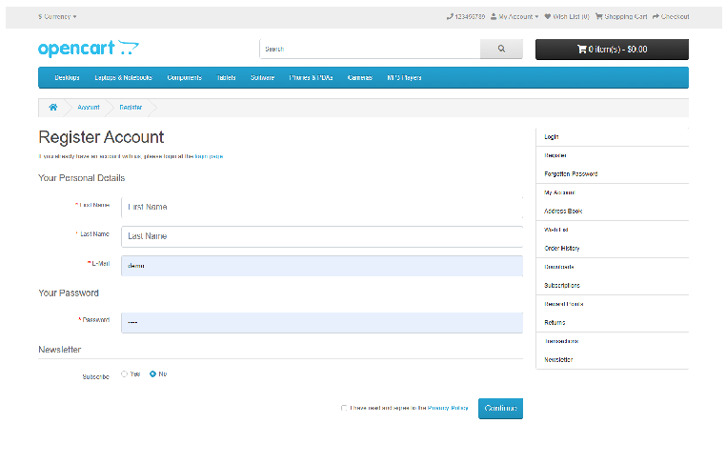

**2).**

**CODE:**

package com.selenium.softwaretesting.test1;

import org.openqa.selenium.By;

import org.openqa.selenium.Keys;

import org.openqa.selenium.WebDriver;

import org.openqa.selenium.chrome.ChromeDriver;

import org.openqa.selenium.chrome.ChromeOptions;

import io.github.bonigarcia.wdm.WebDriverManager;

public class Day4q1 {

public static void main(String[] args) {

// TODO Auto-generated method stub

WebDriverManager.chromedriver().setup();

ChromeOptions co=new ChromeOptions();

co.addArguments("--remote-allow-origins=*");

WebDriver driver=new ChromeDriver(co);

driver.get("https://google.com");

driver.manage().window().maximize();

driver.findElement(By.name("q")).sendKeys("Hello");

driver.findElement(By.name("q")).sendKeys(Keys.ENTER);

//driver.findElement(By.className("gNO89b")).submit();

driver.quit();

}

}

**SNAPSHOT:**

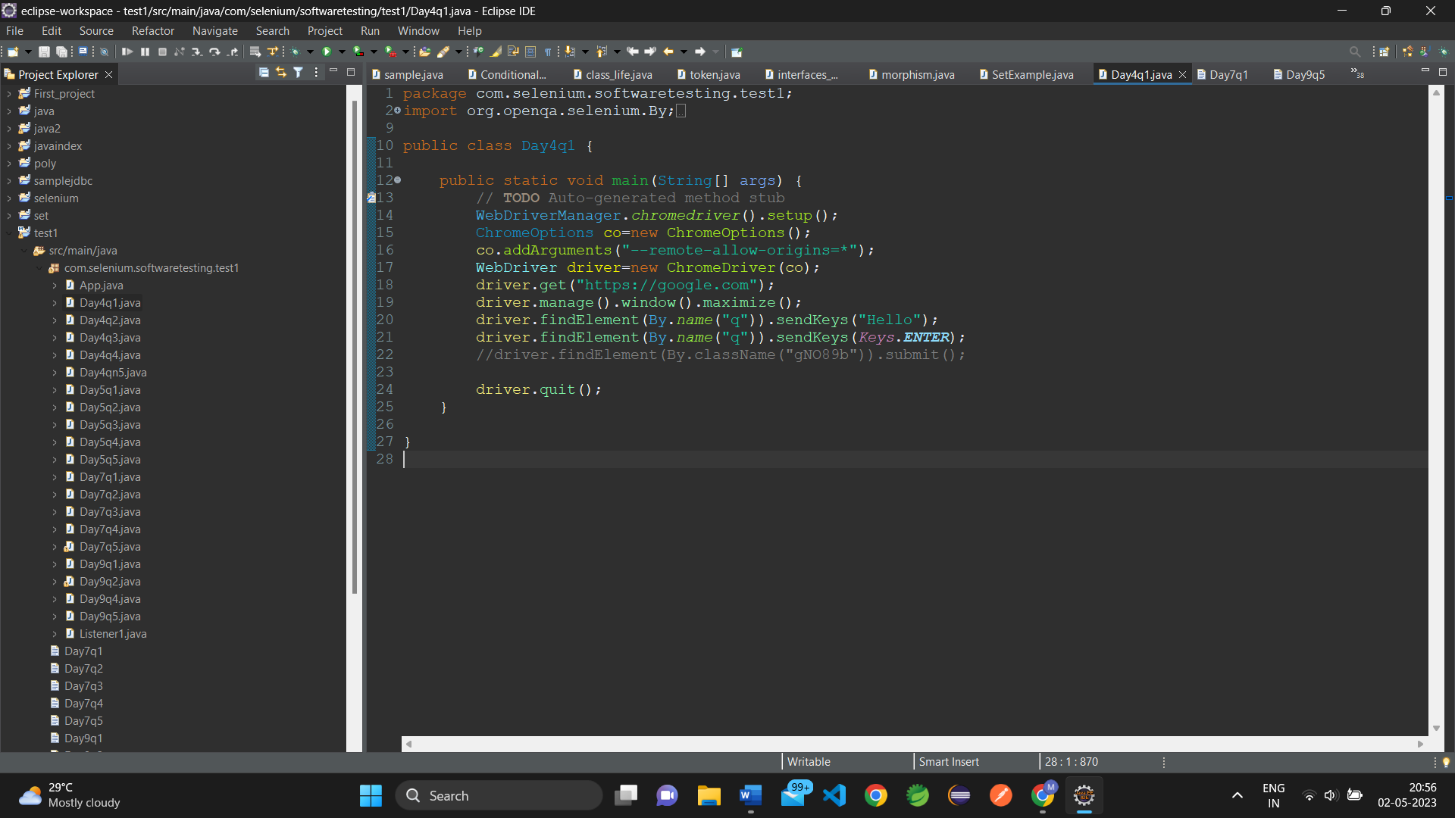

**OUTPUT:**

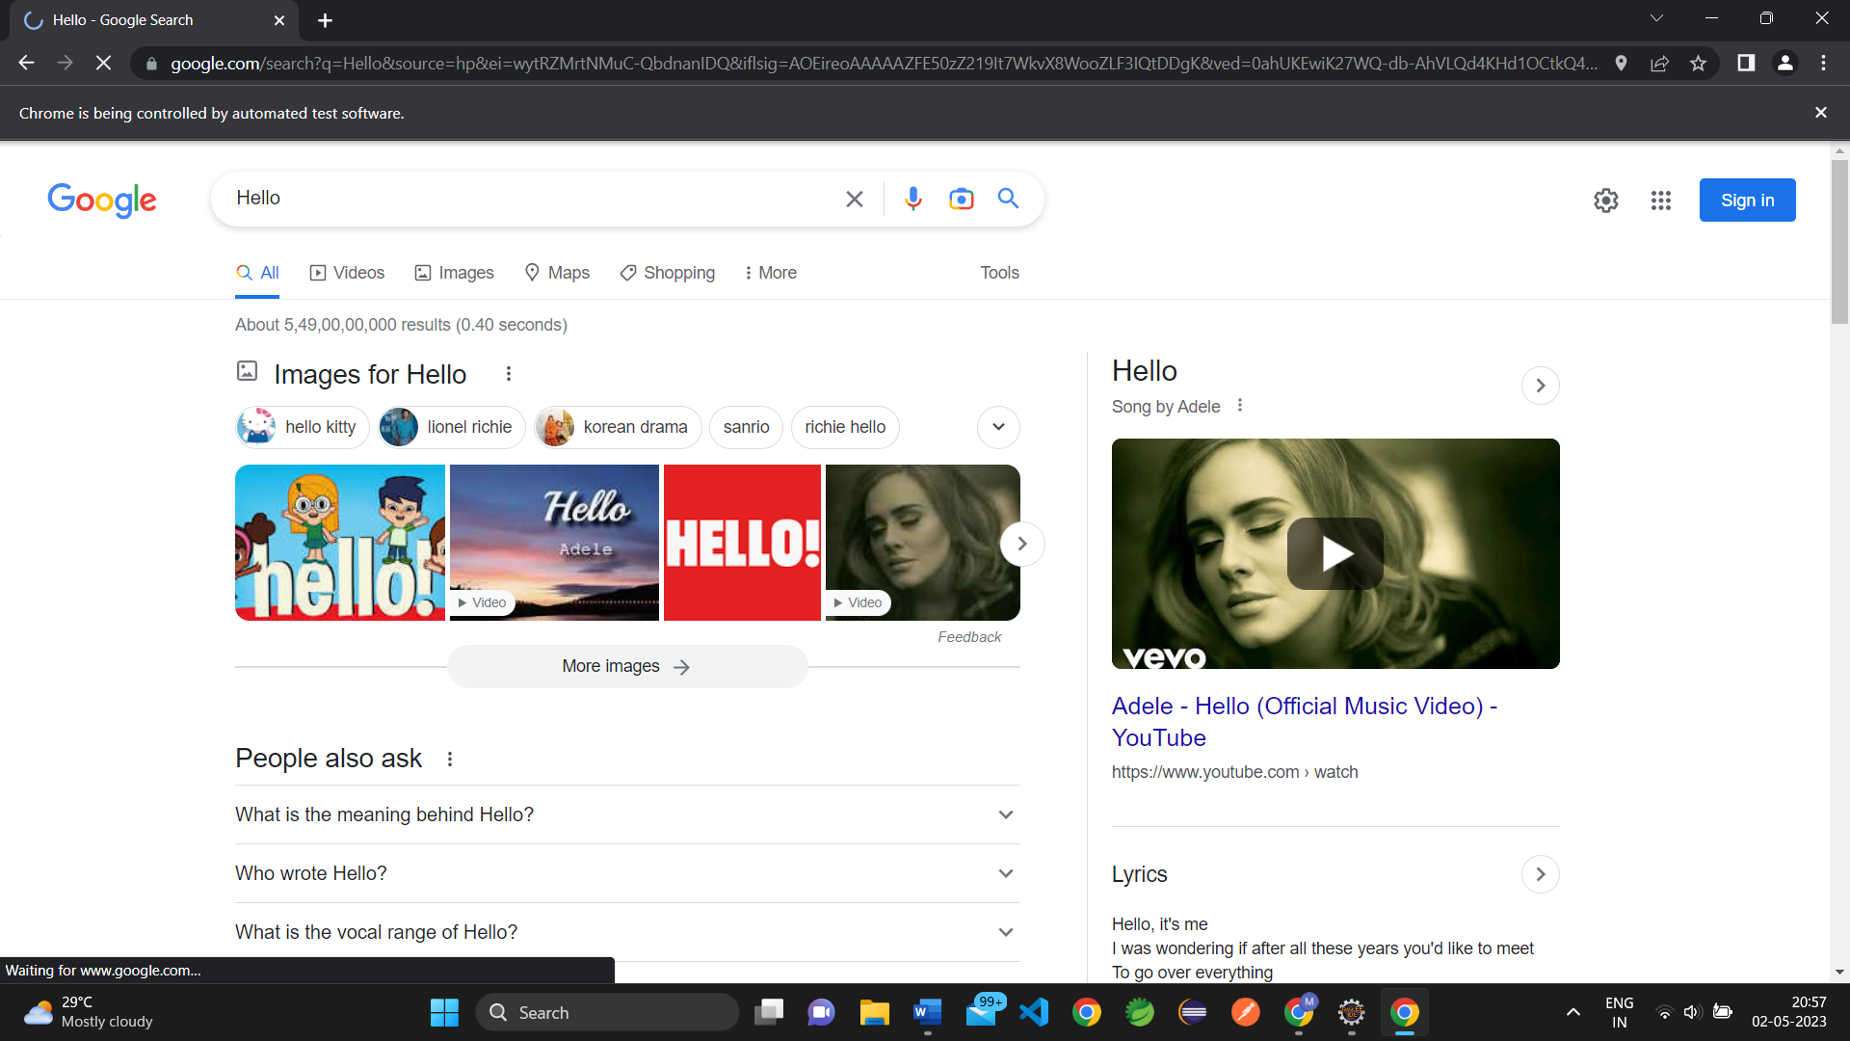

**3).**

**CODE:**

**package com.selenium.softwaretesting.test1;**

**import org.openqa.selenium.By;**

**import org.openqa.selenium.JavascriptExecutor;**

**import org.openqa.selenium.WebDriver;**

**import org.openqa.selenium.WebElement;**

**import org.openqa.selenium.chrome.ChromeDriver;**

**import org.openqa.selenium.chrome.ChromeOptions;**

**import io.github.bonigarcia.wdm.WebDriverManager;**

**public class Day4q2 {**

**public static void main(String[] args) throws InterruptedException {**

**// TODO Auto-generated method stub**

**WebDriverManager.chromedriver().setup();**

**ChromeOptions co=new ChromeOptions();**

**co.addArguments("--remote-allow-origins=*");**

**WebDriver driver=new ChromeDriver(co);**

**driver.get("https://demo.opencart.com/index.php?route=account/register&language=en-gb");**

**driver.manage().window().maximize();**

**Thread.sleep(3000);**

**JavascriptExecutor js = (JavascriptExecutor) driver;**

**js.executeScript("window.scrollBy(0,1000)","");**

**WebElement fn= driver.findElement(By.xpath("//*[@id=\"input-firstname\"]"));**

**fn.sendKeys("Arun");**

**WebElement ln= driver.findElement(By.xpath("//*[@id=\"input-lastname\"]"));**

**ln.sendKeys("Kumar");**

**WebElement em= driver.findElement(By.xpath("//*[@id=\"input-email\"]"));**

**em.sendKeys("Kumar@gmail.com");**

**WebElement pwd= driver.findElement(By.xpath("//*[@id=\"input-password\"]"));**

**pwd.sendKeys("Kumar@1");**

**WebElement sub= driver.findElement(By.xpath("//*[@id=\"input-newsletter-yes\"]"));**

**sub.click();**

**}**

**}**

**SNAPSHOT:**

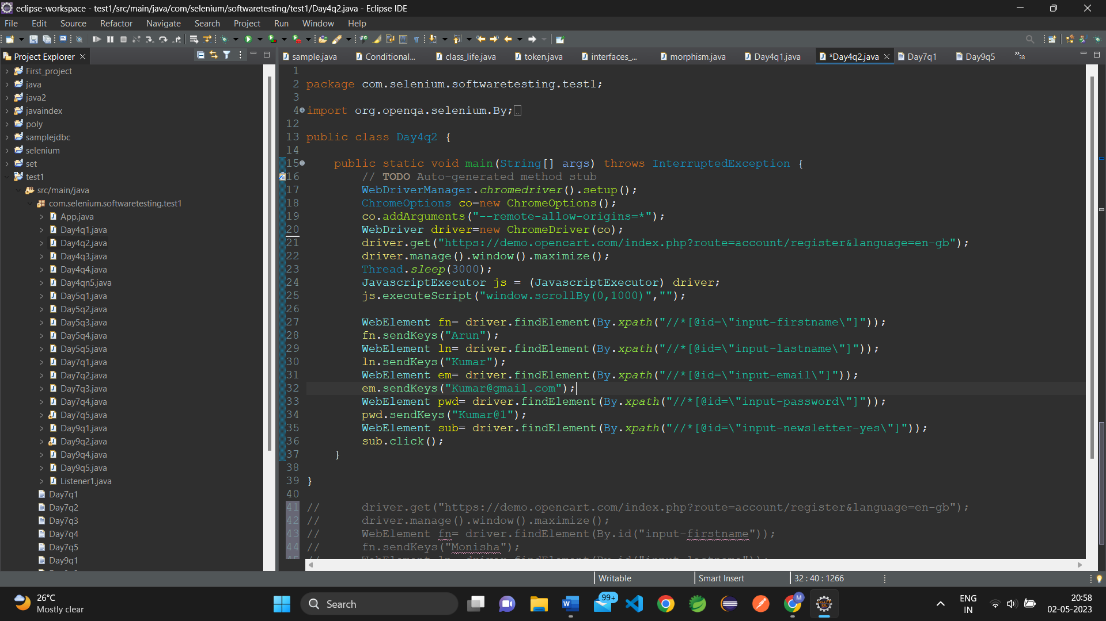

**OUTPUT:**

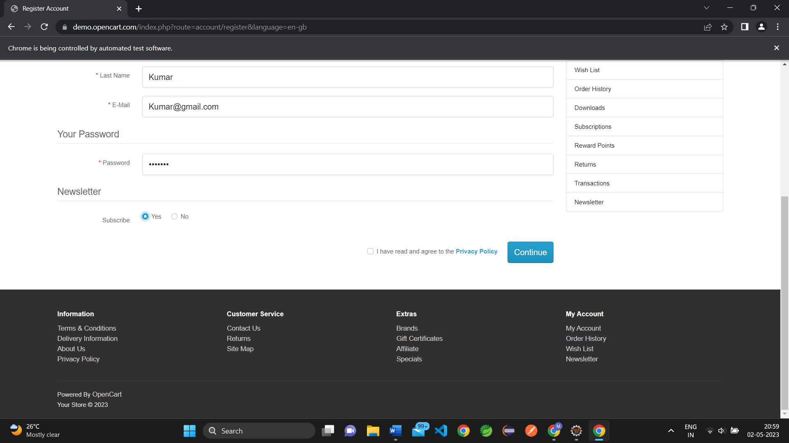

**4).**

**CODE:**

**package com.selenium.softwaretesting.test1;**

**import org.openqa.selenium.By;**

**import org.openqa.selenium.JavascriptExecutor;**

**import org.openqa.selenium.WebDriver;**

**import org.openqa.selenium.chrome.ChromeDriver;**

**import org.openqa.selenium.chrome.ChromeOptions;**

**import io.github.bonigarcia.wdm.WebDriverManager;**

**public class Day4q3 {**

**public static void main(String[] args) throws InterruptedException {**

**// TODO Auto-generated method stub**

**WebDriverManager.chromedriver().setup();**

**ChromeOptions co=new ChromeOptions();**

**co.addArguments("--remote-allow-origins=*");**

**WebDriver driver=new ChromeDriver(co);**

**//open an url**

**driver.get("https://j2store.net/free/");**

**driver.manage().window().maximize();**

**Thread.sleep(3000);**

**JavascriptExecutor js = (JavascriptExecutor) driver;**

**js.executeScript("window.scrollBy(0,1000)","");**

**driver.findElement(By.linkText("Clothing (5)")).click();**

**driver.navigate().back();**

**Thread.sleep(3000);**

**driver.navigate().forward();**

**Thread.sleep(3000);**

**driver.navigate().refresh();**

**driver.quit();**

**}**

**}**

**SNAPSHOT:**

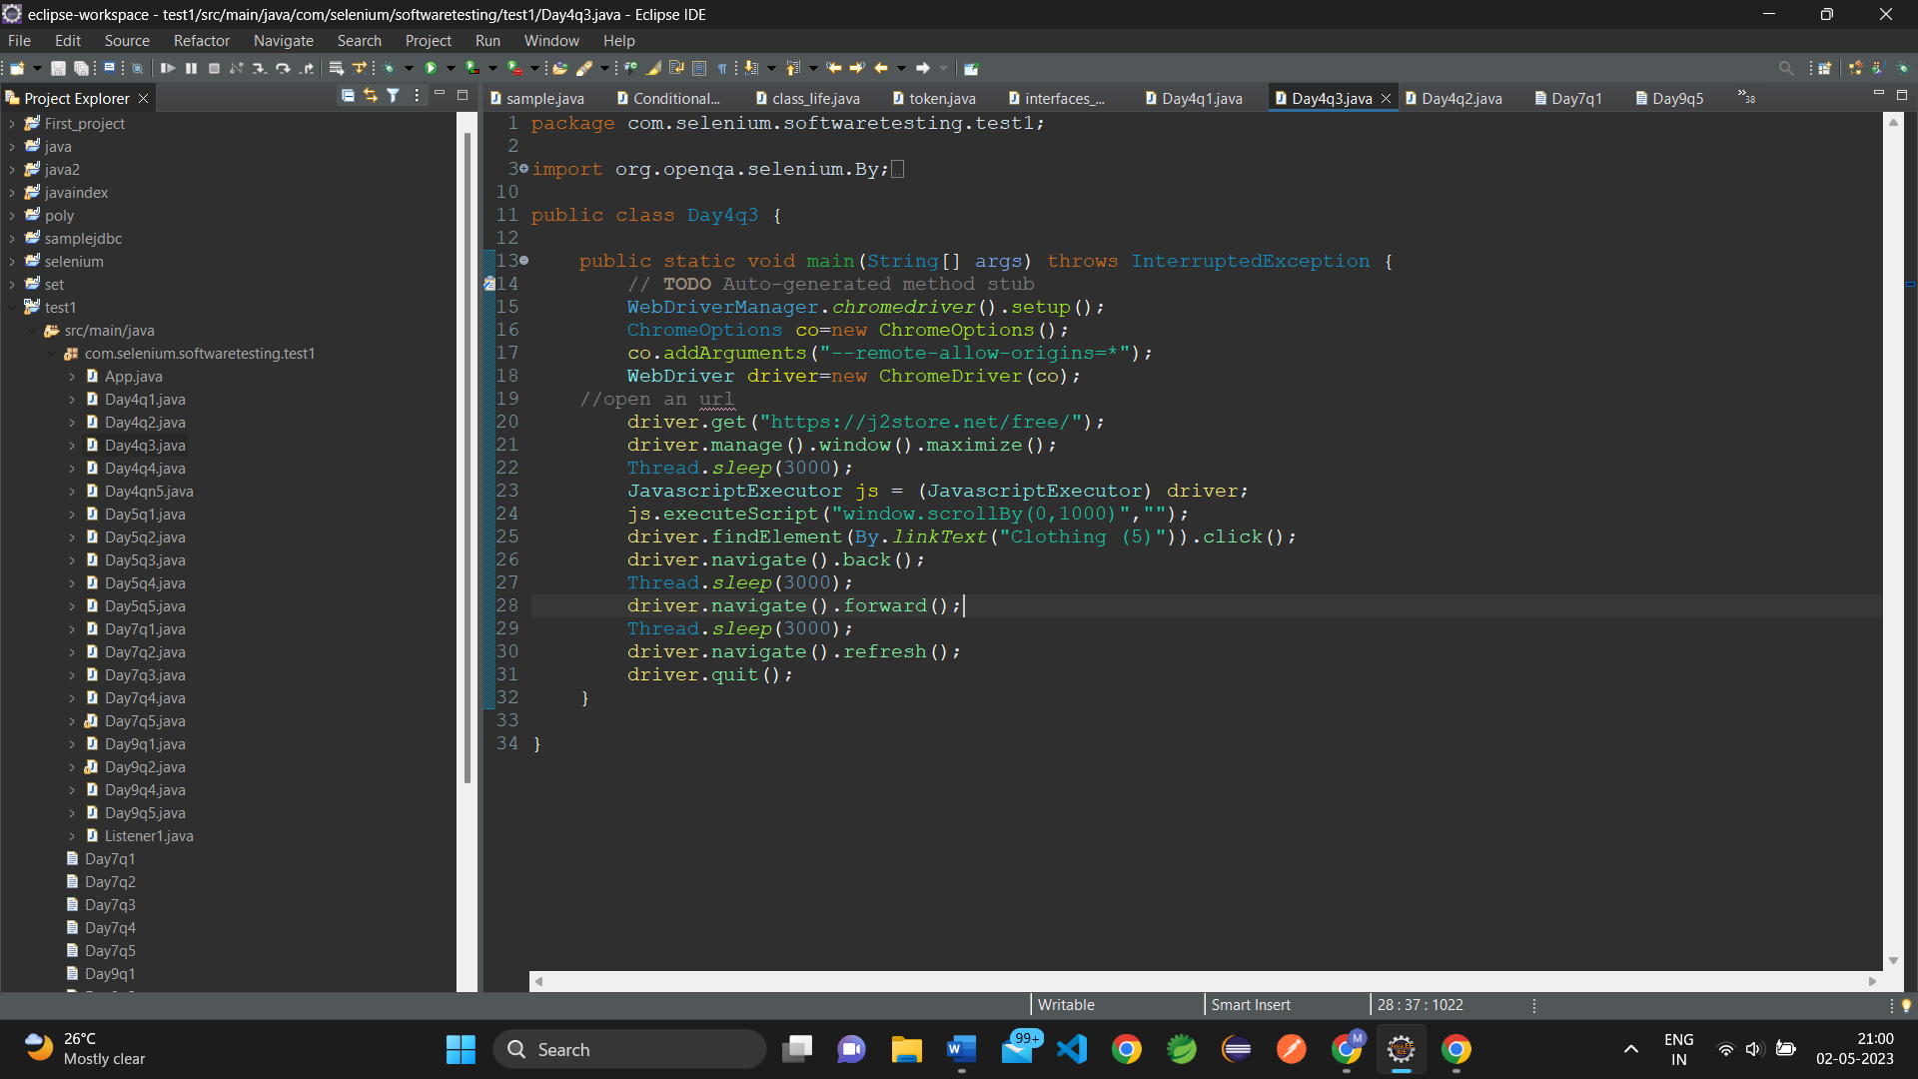

**OUTPUT:**

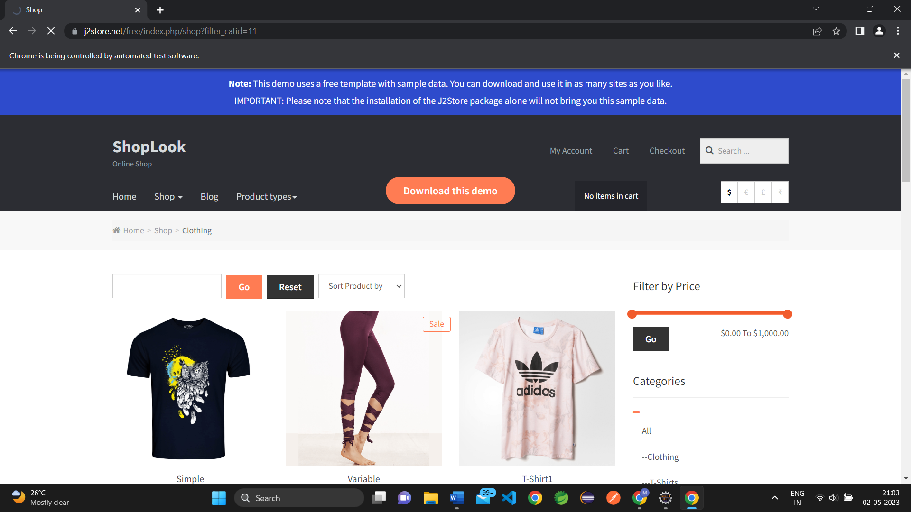

**5.1).**

**CODE:**

**package com.selenium.softwaretesting.test1;**

**import org.openqa.selenium.JavascriptExecutor;**

**import org.openqa.selenium.WebDriver;**

**import org.openqa.selenium.chrome.ChromeDriver;**

**import org.openqa.selenium.chrome.ChromeOptions;**

**import io.github.bonigarcia.wdm.WebDriverManager;**

**public class Day4q4 {**

**public static void main(String[] args) throws Exception {**

**// TODO Auto-generated method stub**

**// Driver setup**

**WebDriverManager.chromedriver().setup();**

**ChromeOptions co=new ChromeOptions();**

**co.addArguments("--remote-allow-origins=*");**

**WebDriver driver=new ChromeDriver(co);**

**// WebDriverManager.edgedriver().setup();**

**// WebDriver driver=new EdgeDriver();**

**driver.get("https://j2store.net/free/");**

**driver.manage().window().maximize();**

**Thread.sleep(3000);**

**JavascriptExecutor js = (JavascriptExecutor) driver;**

**js.executeScript("window.scrollBy(0,1000)","");**

**String t1=driver.getCurrentUrl();**

**String t2="https://j2store.net/free/";**

**System.out.println(t1);**

**if(t1.equals(t2))**

**{ System.out.println("Correct Url");**

**}**

**else**

**{ System.out.println("Wrong Url");**

**}**

**}**

**}**

**SNAPSHOT:**

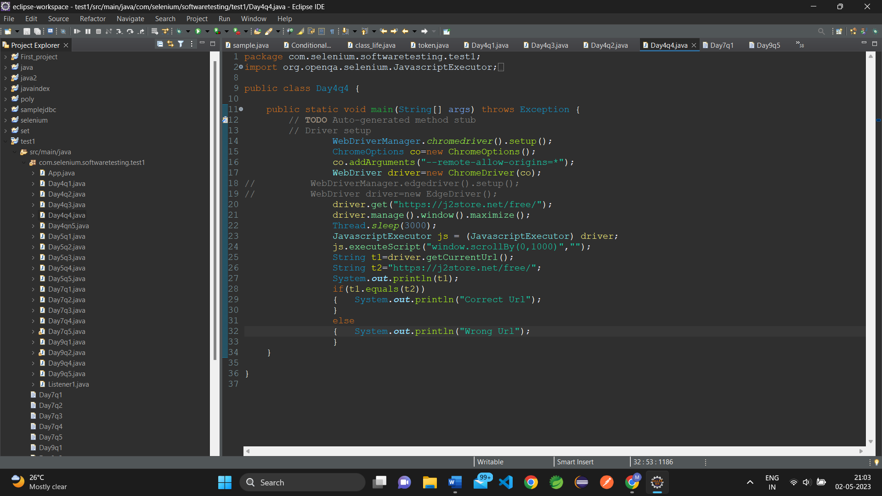

**OUTPUT:**

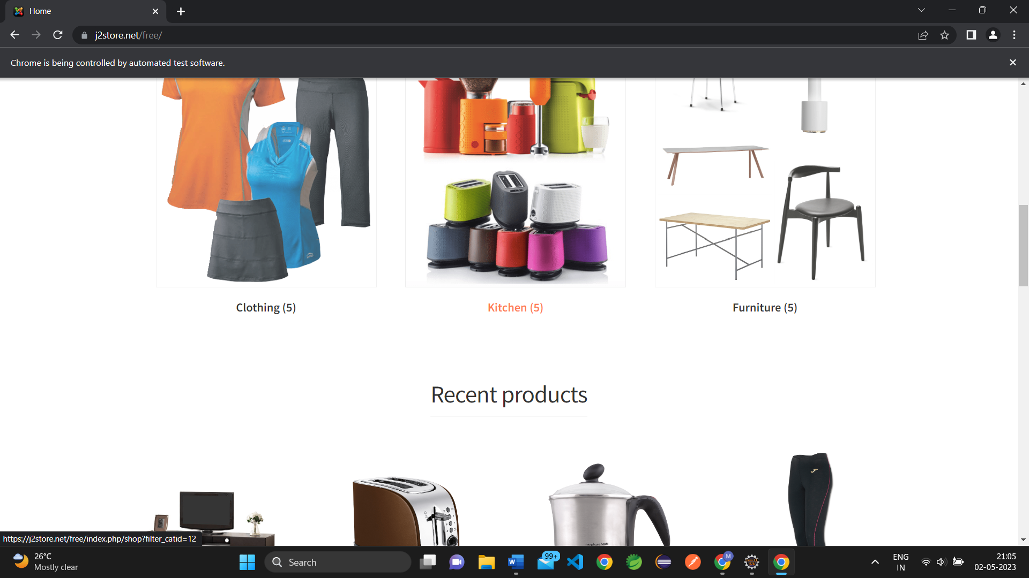

**5.2)**

**CODE:**

**package com.selenium.softwaretesting.test1;**

**import java.util.List;**

**import org.openqa.selenium.By;**

**import org.openqa.selenium.JavascriptExecutor;**

**import org.openqa.selenium.WebDriver;**

**import org.openqa.selenium.WebElement;**

**import org.openqa.selenium.chrome.ChromeDriver;**

**import org.openqa.selenium.chrome.ChromeOptions;**

**import io.github.bonigarcia.wdm.WebDriverManager;**

**public class Day4qn5 {**

**public static void main(String[] args) throws Exception {**

**// TODO Auto-generated method stub**

**// Driver setup**

**WebDriverManager.chromedriver().setup();**

**ChromeOptions co=new ChromeOptions();**

**co.addArguments("--remote-allow-origins=*");**

**WebDriver driver=new ChromeDriver(co);**

**//open an url**

**driver.get("https://j2store.net/free/");**

**driver.manage().window().maximize();**

**Thread.sleep(3000);**

**JavascriptExecutor js = (JavascriptExecutor) driver;**

**js.executeScript("window.scrollBy(0,1000)","");**

**driver.findElement(By.linkText("Clothing (5)")).click();**

**List<WebElement> l1=driver.findElements(By.xpath("//h2[@class='product-title']"));**

**for(WebElement link:l1)**

**{**

**System.out.println(link.getText());**

**}**

**}**

**}**

**SNAPSHOT:**

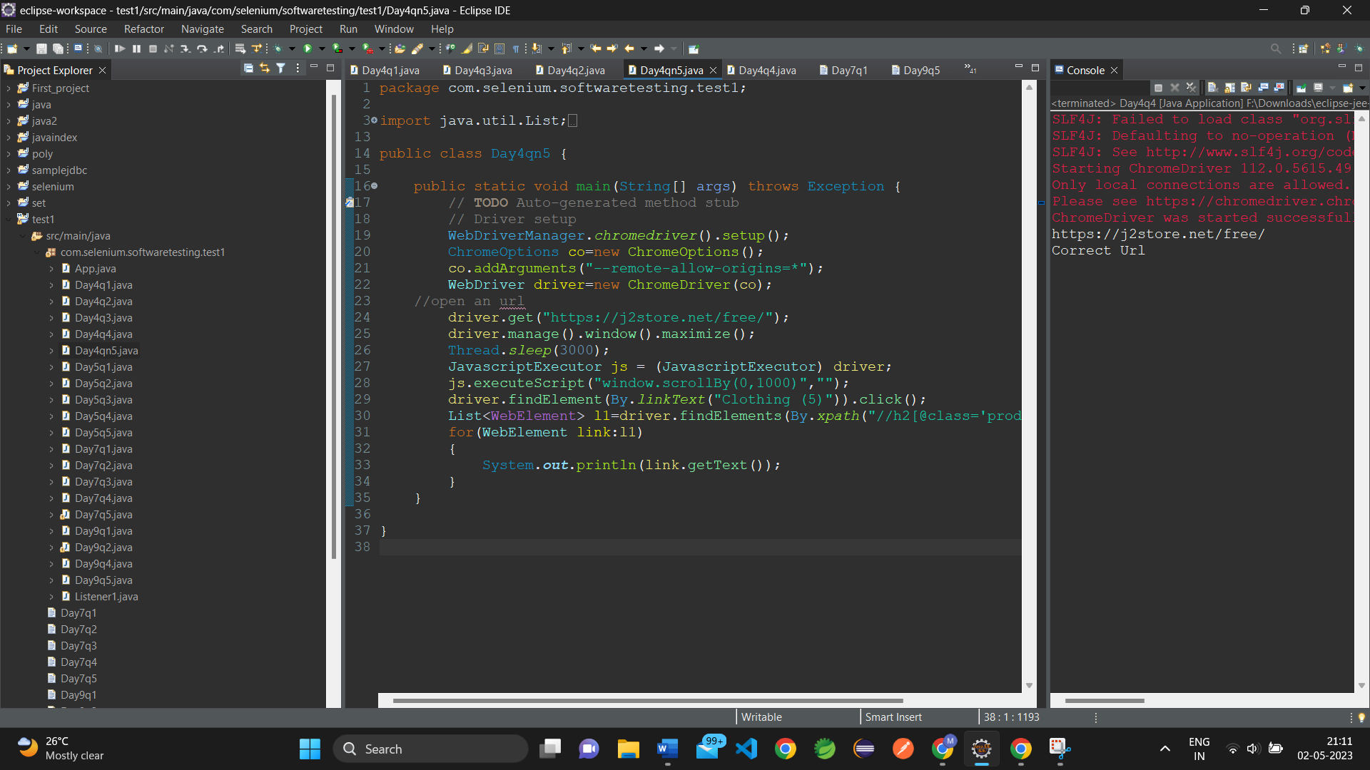

**OUTPUT:**