**Testing_D5_SeleniumWebHandlers**

**1).**

**CODE:**

package com.selenium.softwaretesting.test1;

import org.openqa.selenium.By;

import org.openqa.selenium.WebDriver;

import org.openqa.selenium.WebElement;

import org.openqa.selenium.chrome.ChromeDriver;

import org.openqa.selenium.chrome.ChromeOptions;

import org.openqa.selenium.interactions.Actions;

import io.github.bonigarcia.wdm.WebDriverManager;

public class Day5q1 {

public static void main(String[] args) throws InterruptedException {

WebDriverManager.chromedriver().setup();

//System.setProperty("webdriver.chrome.driver","C:\\drivers\\chromedriver.exe");

ChromeOptions co=new ChromeOptions();

co.addArguments("--remote-allow-origins=*");

WebDriver driver=new ChromeDriver(co);

driver.get("https://demoqa.com/droppable/");

Actions a=new Actions(driver);

WebElement source_ele=driver.findElement(By.id("draggable"));

WebElement dest_ele=driver.findElement(By.id("droppable"));

a.clickAndHold(source_ele).release(dest_ele).build().perform();

// a.dragAndDrop(source_ele, dest_ele).build().perform();

}

}

SNAPSHOT:  
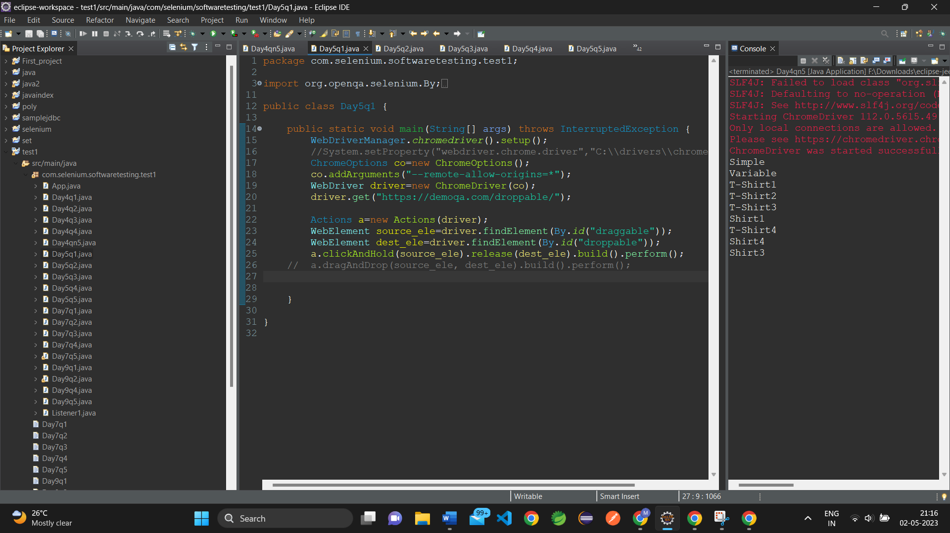

OUTPUT:

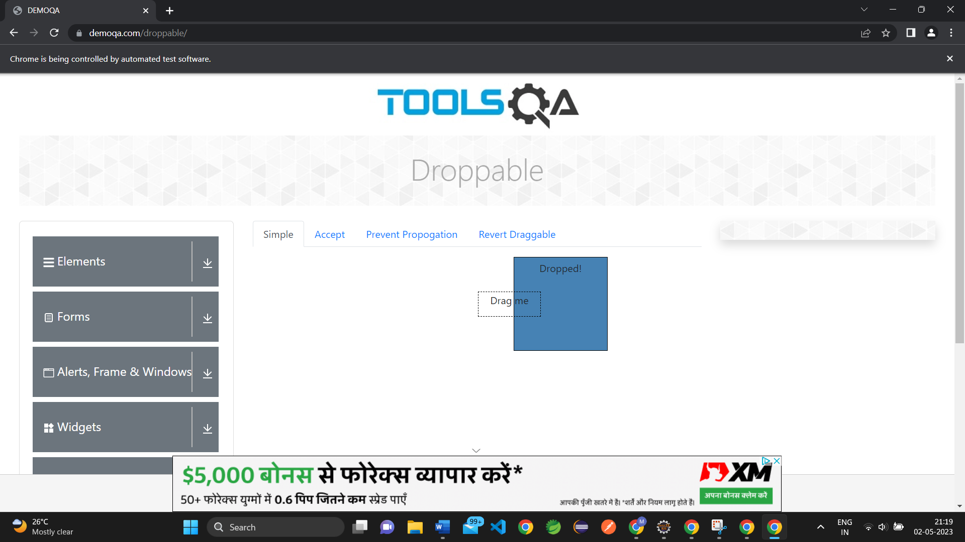

**2).CODE:**

**package com.selenium.softwaretesting.test1;**

**import org.openqa.selenium.By;**

**import org.openqa.selenium.JavascriptExecutor;**

**import org.openqa.selenium.WebDriver;**

**import org.openqa.selenium.WebElement;**

**import org.openqa.selenium.chrome.ChromeDriver;**

**import org.openqa.selenium.chrome.ChromeOptions;**

**import org.openqa.selenium.interactions.Actions;**

**import io.github.bonigarcia.wdm.WebDriverManager;**

**public class Day5q2 {**

**public static void main(String[] args) throws InterruptedException {**

**// TODO Auto-generated method stub**

**WebDriverManager.chromedriver().setup();**

**ChromeOptions co=new ChromeOptions();**

**co.addArguments("--remote-allow-origins=*");**

**WebDriver driver=new ChromeDriver(co);**

**//open an url**

**driver.get("https://jqueryui.com/droppable/");**

**//maximise**

**driver.manage().window().maximize();**

**Thread.sleep(3000);**

**JavascriptExecutor js = (JavascriptExecutor) driver;**

**js.executeScript("window.scrollBy(0 ,1000)","");**

**//switch to frame**

**driver.switchTo().frame(0);**

**//class and obj**

**Actions a=new Actions(driver);**

**WebElement drag=driver.findElement(By.id("draggable"));**

**WebElement drop=driver.findElement(By.id("droppable"));**

**a.clickAndHold(drag).release(drop).build().perform();**

**}**

**}**

**SNAPSHOT:**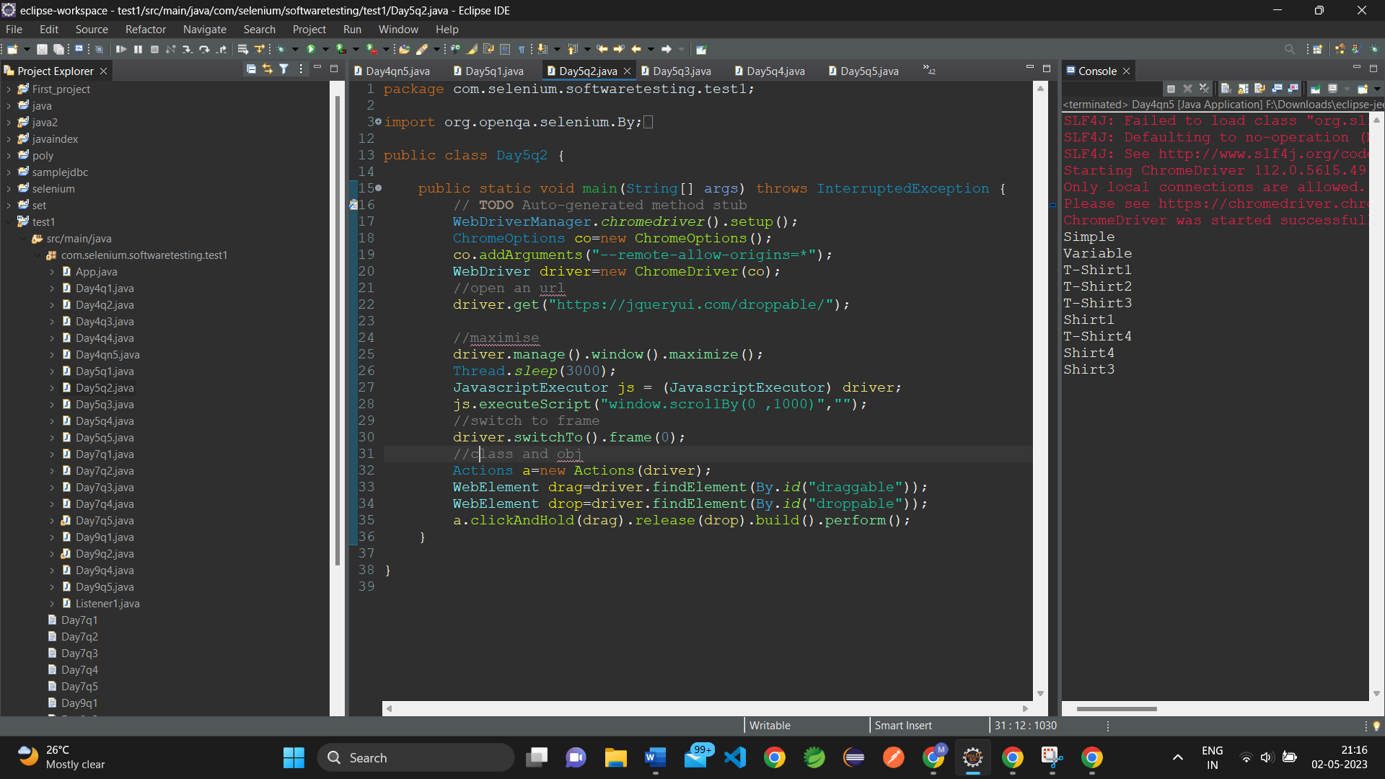

**OUTPUT:**

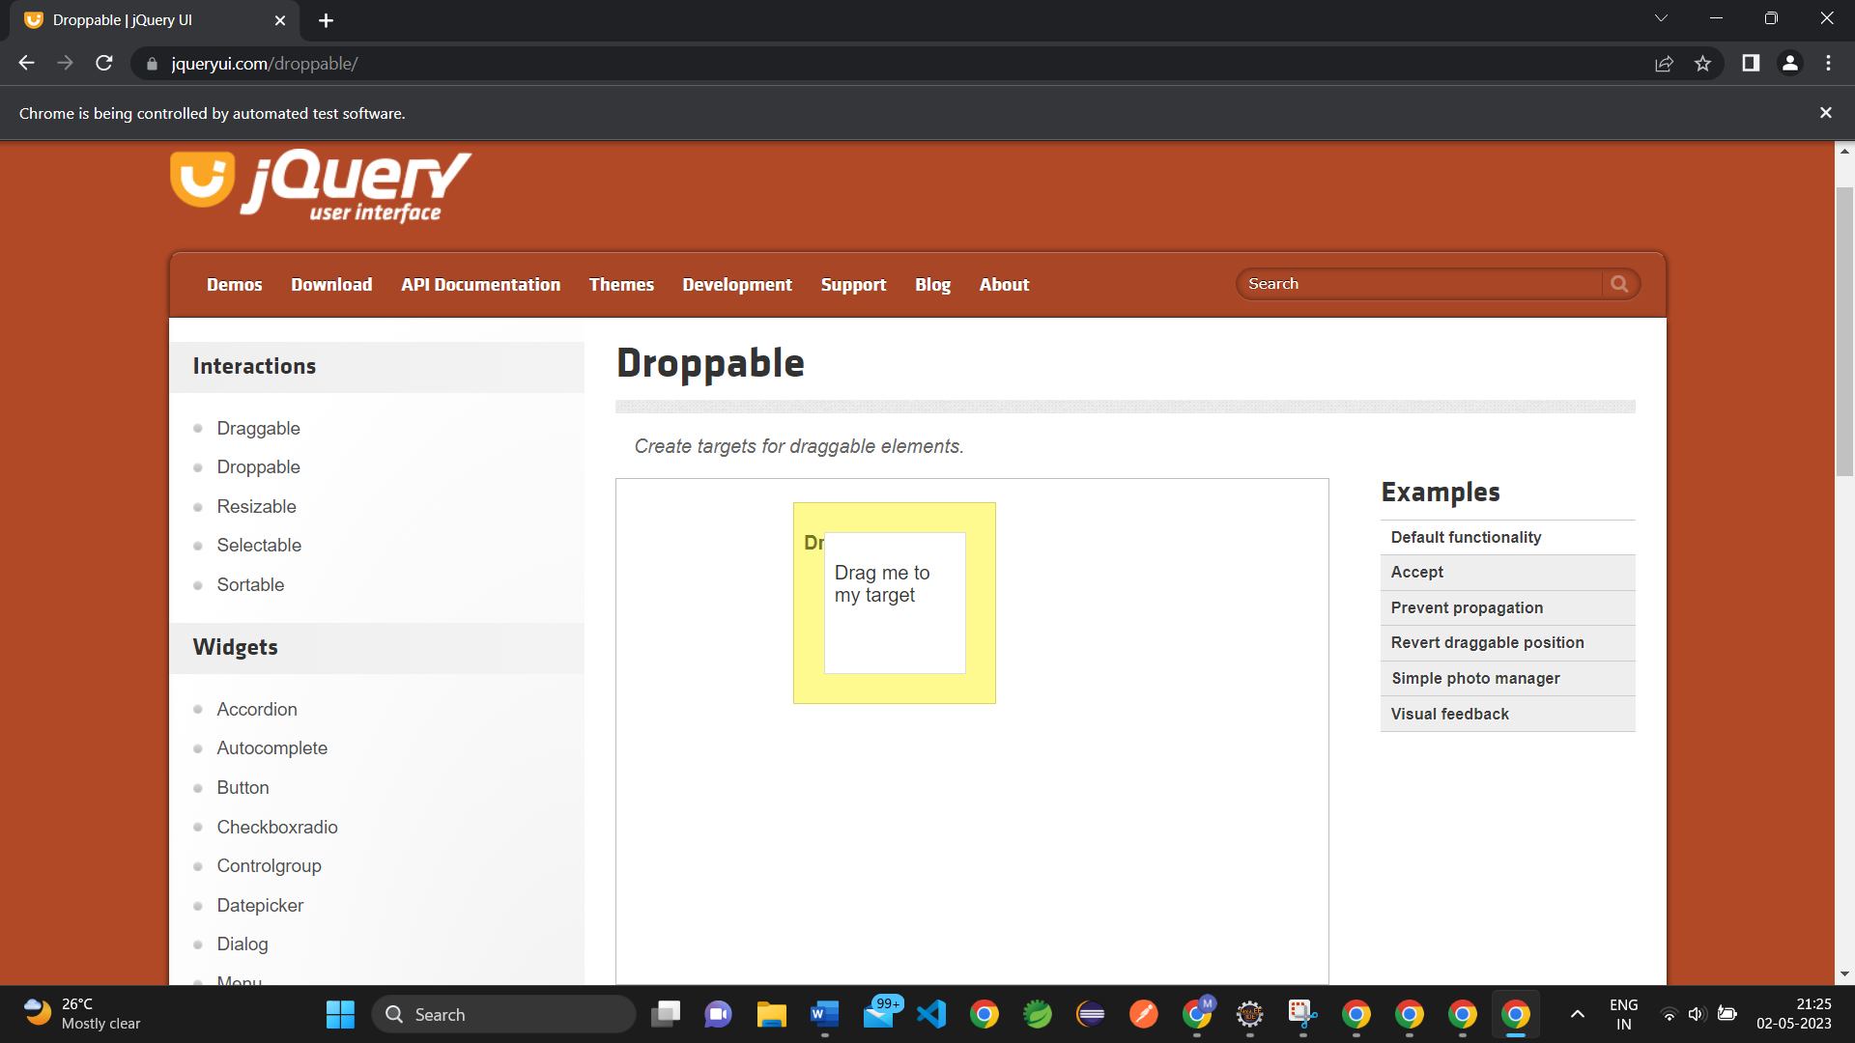

**3).CODE:**

**package com.selenium.softwaretesting.test1;**

**import org.openqa.selenium.Alert;**

**import org.openqa.selenium.By;**

**import org.openqa.selenium.WebDriver;**

**import org.openqa.selenium.WebElement;**

**import org.openqa.selenium.chrome.ChromeDriver;**

**import org.openqa.selenium.chrome.ChromeOptions;**

**import io.github.bonigarcia.wdm.WebDriverManager;**

**public class Day5q3 {**

**public static void main(String[] args) throws Exception {**

**// TODO Auto-generated method stub**

**WebDriverManager.chromedriver().setup();**

**ChromeOptions co=new ChromeOptions();**

**co.addArguments("--remote-allow-origins=*");**

**WebDriver driver=new ChromeDriver(co);**

**driver.get("https://demo.guru99.com/test/delete_customer.php");**

**WebElement txt_box= driver.findElement(By.name("cusid"));**

**WebElement submit_btn=driver.findElement(By.name("submit"));**

**txt_box.sendKeys("401");**

**submit_btn.click();**

**Thread.sleep(3000);**

**Alert alert1=driver.switchTo().alert();**

**alert1.dismiss();**

**Thread.sleep(3000);**

**txt_box.clear();**

**txt_box.sendKeys("402");**

**submit_btn.click();**

**Thread.sleep(3000);**

**Alert alert2=driver.switchTo().alert();**

**alert2.accept();**

**Thread.sleep(3000);**

**Alert alert3=driver.switchTo().alert();**

**String txt=alert3.getText();**

**alert3.accept();**

**Thread.sleep(3000);**

**System.out.println(txt);**

**}**

**}**

**SNAPSHOT:**

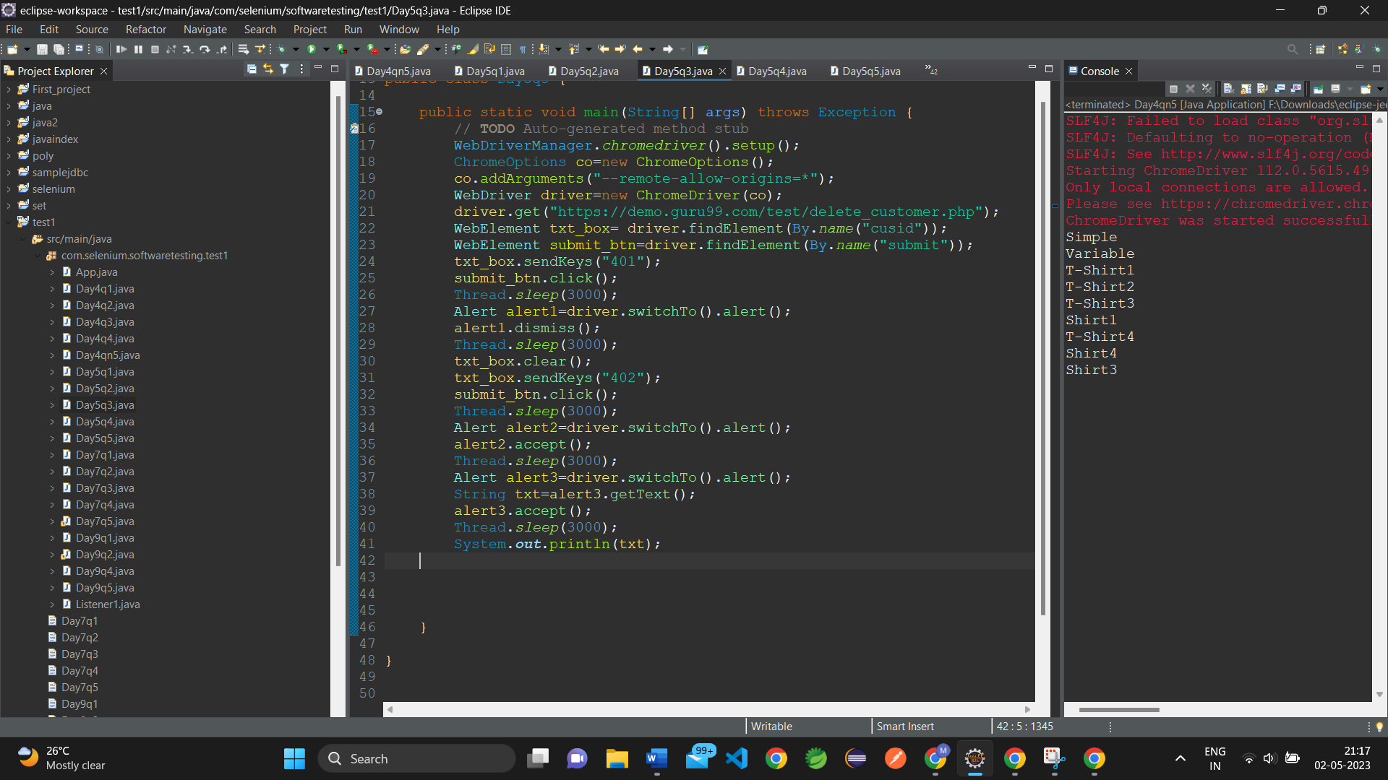

**OUTPUT:**

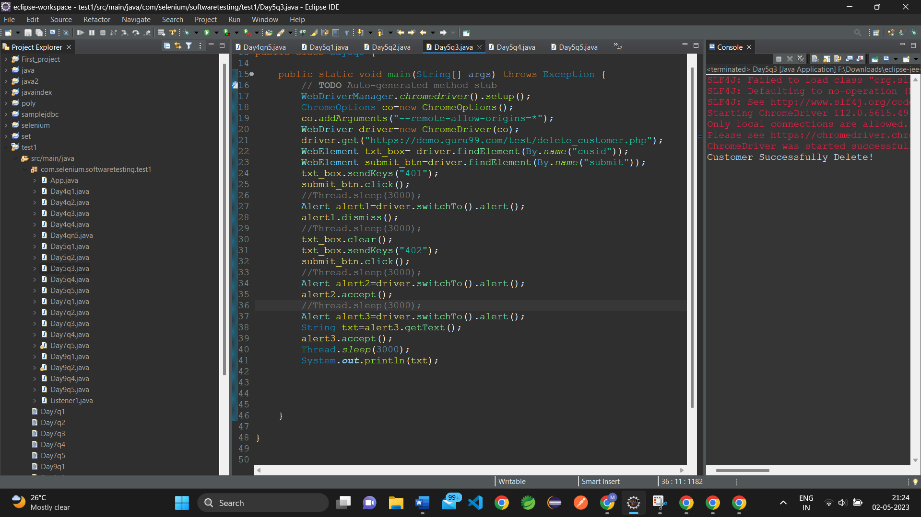

**4).CODE:  
package com.selenium.softwaretesting.test1;**

**import org.openqa.selenium.By;**

**import org.openqa.selenium.JavascriptExecutor;**

**import org.openqa.selenium.WebDriver;**

**import org.openqa.selenium.WebElement;**

**import org.openqa.selenium.chrome.ChromeDriver;**

**import org.openqa.selenium.chrome.ChromeOptions;**

**import io.github.bonigarcia.wdm.WebDriverManager;**

**public class Day5q4 {**

**public static void main(String[] args) throws InterruptedException {**

**// TODO Auto-generated method stub**

**WebDriverManager.chromedriver().setup();**

**ChromeOptions co=new ChromeOptions();**

**co.addArguments("--remote-allow-origins=*");**

**WebDriver driver=new ChromeDriver(co);**

**driver.get("https://www.abhibus.com/bus-ticket-booking");**

**WebElement src=driver.findElement(By.id("source"));**

**src.sendKeys("Coimbatore");**

**WebElement dst=driver.findElement(By.id("destination"));**

**dst.sendKeys("Chennai");**

**WebElement datepick=driver.findElement(By.xpath("//*[@id=\"datepicker1\"]"));**

**JavascriptExecutor js=(JavascriptExecutor) driver;**

**js.executeScript("arguments[0].setAttribute('value', '04/10/2023')",datepick);**

**Thread.sleep(3000);**

**driver.quit();**

**}**

**}**

**SNAPSHOT:**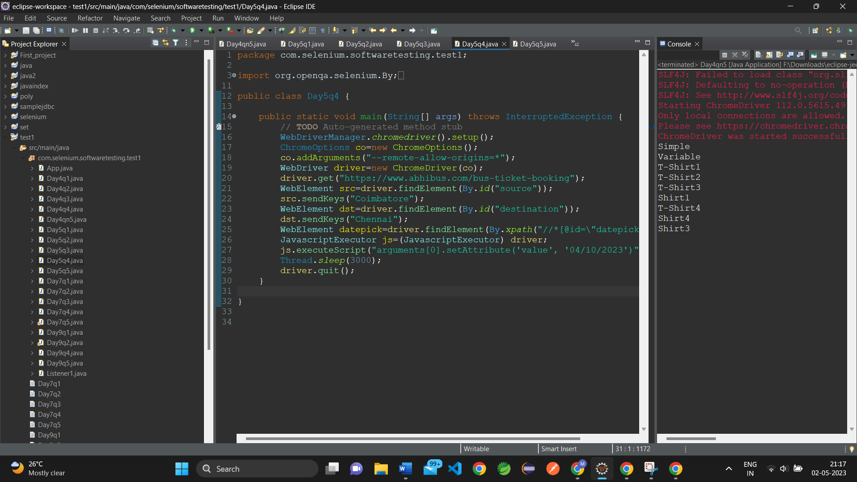

**OUTPUT:**

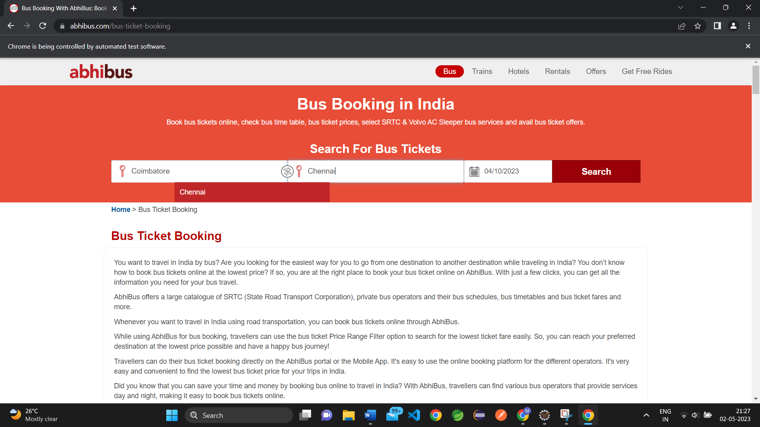

**5).CODE:**

**package com.selenium.softwaretesting.test1;**

**import java.util.Set;**

**import org.openqa.selenium.By;**

**import org.openqa.selenium.Keys;**

**import org.openqa.selenium.WebDriver;**

**import org.openqa.selenium.WindowType;**

**import org.openqa.selenium.chrome.ChromeDriver;**

**import org.openqa.selenium.chrome.ChromeOptions;**

**import io.github.bonigarcia.wdm.WebDriverManager;**

**public class Day5q5 {**

**public static void main(String[] args) throws Exception {**

**// TODO Auto-generated method stub**

**WebDriverManager.chromedriver().setup();**

**ChromeOptions co=new ChromeOptions();**

**co.addArguments("--remote-allow-origins=*");**

**WebDriver driver=new ChromeDriver(co);**

**driver.get("https://google.com");**

**driver.findElement(By.name("q")).sendKeys("Apple");**

**driver.findElement(By.name("q")).sendKeys(Keys.ENTER);**

**Thread.sleep(3000);**

**String t1=driver.getTitle();**

**String i1=driver.getWindowHandle();**

**System.out.println(t1);**

**System.out.println(i1);**

**//2nd tab**

**driver.switchTo().newWindow(WindowType.TAB);**

**driver.get("https://google.com");**

**driver.findElement(By.name("q")).sendKeys("Selenium");**

**driver.findElement(By.name("q")).sendKeys(Keys.ENTER);**

**Thread.sleep(3000);**

**String t2=driver.getTitle();**

**String i2=driver.getWindowHandle();**

**System.out.println(t2);**

**System.out.println(i2);**

**//3rd tab**

**driver.switchTo().newWindow(WindowType.TAB);**

**driver.get("https://google.com");**

**driver.findElement(By.name("q")).sendKeys("Cucumber");**

**driver.findElement(By.name("q")).sendKeys(Keys.ENTER);**

**Thread.sleep(3000);**

**String t3=driver.getTitle();**

**String i3=driver.getWindowHandle();**

**System.out.println(t3);**

**System.out.println(i3);**

**Set<String>s=driver.getWindowHandles();**

**System.out.println("Number of Tabs opened: "+s.size());**

**}**

**}**

**SNAPSHOT:**

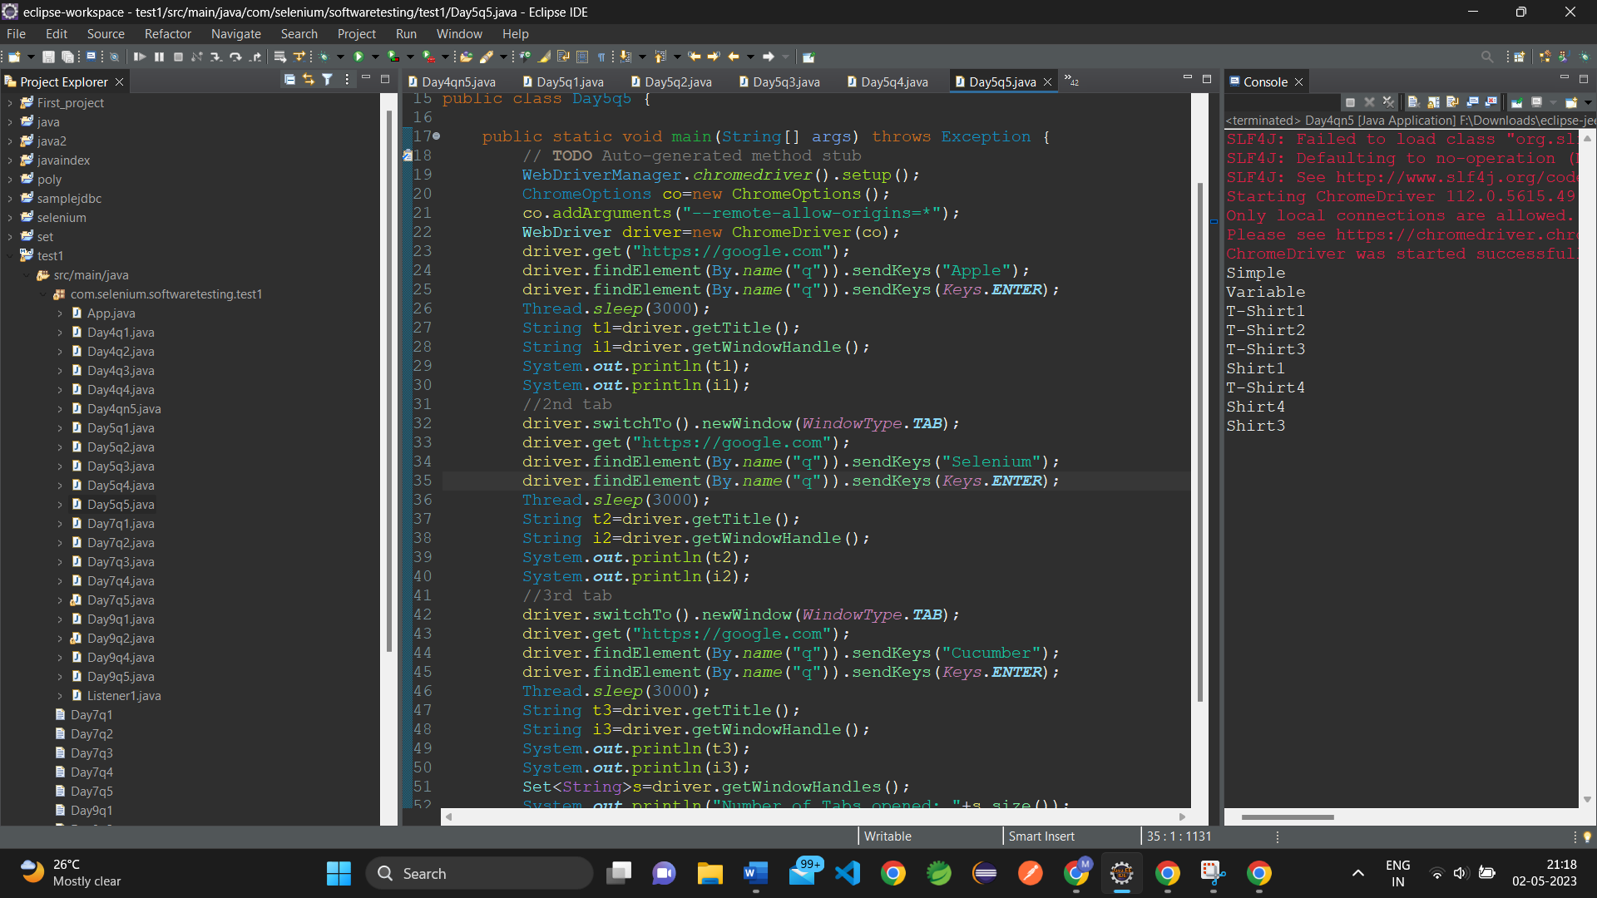

**OUTPUT:**