DATABASE MANAGEMENT SYSTEMS LAB
EXPERIMENT 2 – DDL COMMANDS WITH CONSTRAINTS
NAME:MONISHA D
REG.NO:192311412

AIM
To add and verify PRIMARY KEY, FOREIGN KEY, UNIQUE and CHECK constraints using DDL commands in a Boutique database.
DATABASE
boutique
NOTE
This experiment is written as a self-contained Boutique example. The tables are created first and the constraints are added using ALTER TABLE, matching the DDL-with-constraints approach in the lab manual.
1. CREATE CATEGORY TABLE
SQL Query:
CREATE TABLE categories (
category_id VARCHAR(5),
category_name VARCHAR(30)
);
Output / Verification:
DESC categories;
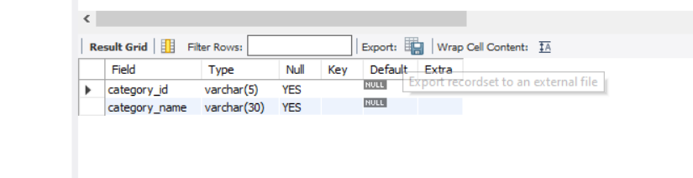

2. CREATE EMPLOYEE TABLE
SQL Query:
CREATE TABLE employees (
employee_id VARCHAR(5),
employee_name VARCHAR(30),
gender CHAR(1)
);
Output / Verification:
DESC employees;
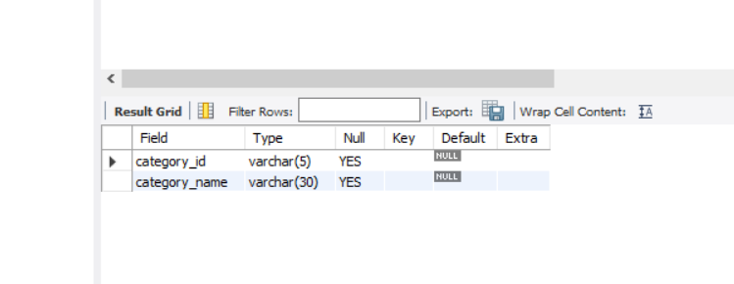
3. CREATE PRODUCT TABLE
SQL Query:
CREATE TABLE products2 (
product_id VARCHAR(5),
product_name VARCHAR(50),
category_id VARCHAR(5),
employee_id VARCHAR(5),
price DECIMAL(10,2),
stock INT
);
Output / Verification:
DESC products2;
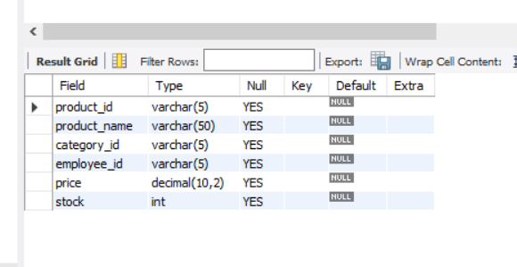

4. PRIMARY KEY – CATEGORY
SQL Query:
ALTER TABLE categories
ADD PRIMARY KEY (category_id);
Output / Verification:
SHOW CREATE TABLE categories;
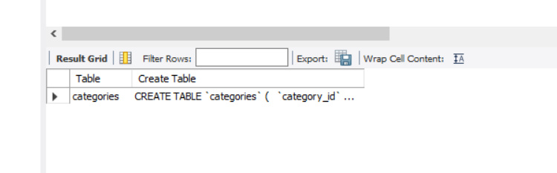

5. FOREIGN KEY – PRODUCT CATEGORY
SQL Query:
ALTER TABLE products2
ADD CONSTRAINT fk_product_category
FOREIGN KEY (category_id)
REFERENCES categories(category_id);
Output / Verification:
SHOW CREATE TABLE products2;
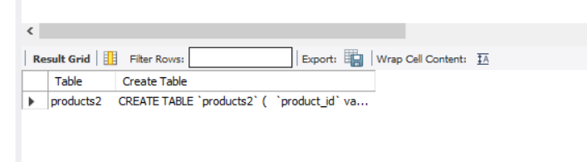

6. UNIQUE KEY – PRODUCT NAME
SQL Query:
ALTER TABLE products2
ADD CONSTRAINT uq_product_name UNIQUE (product_name);
Output / Verification:
SHOW CREATE TABLE products2;
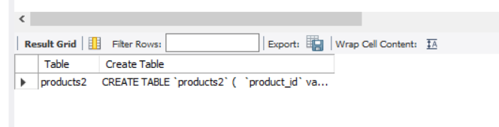
7. CHECK – EMPLOYEE GENDER
SQL Query:
ALTER TABLE employees
ADD CONSTRAINT chk_employee_gender
CHECK (gender IN ('M','F'));
Output / Verification:
SHOW CREATE TABLE employees;
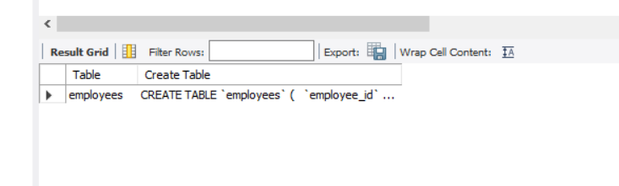

RESULT
Thus, PRIMARY KEY, FOREIGN KEY, UNIQUE and CHECK constraints were successfully added and verified using DDL commands in the Boutique database.

