DATABASE MANAGEMENT SYSTEMS LAB
EXPERIMENT 3 – DML COMMANDS – INSERT, SELECT
NAME:MONISHA D
REG.NO:192311412

AIM
To perform Data Manipulation Language (DML) commands such as INSERT and SELECT in the Boutique database.
1. INSERT COMMAND
Insert records into the five Boutique tables.
Table 1:
INSERT INTO categories (category_id, category_name)
VALUES
('C01', 'Sarees'),
('C02', 'Dresses'),
('C03', 'Kurtis'),
('C04', 'Tops'),
('C05', 'Lehenga');
Table 2:
INSERT INTO employees (employee_id, employee_name, gender)
VALUES
('E01', 'Anitha', 'F'),
('E02', 'Karthik', 'M'),
('E03', 'Priya', 'F'),
('E04', 'Rahul', 'M'),
('E05', 'Divya', 'F');
Table 3:
INSERT INTO products2
(product_id, product_name, category_id, employee_id, price, stock)
VALUES
('P01', 'Silk Saree', 'C01', 'E01', 4500.00, 10),
('P02', 'Party Dress', 'C02', 'E02', 2800.00, 8),
('P03', 'Cotton Kurti', 'C03', 'E03', 1200.00, 15),
('P04', 'Casual Top', 'C04', 'E04', 900.00, 20),
('P05', 'Bridal Lehenga', 'C05', 'E05', 8500.00, 5);
Table 4:
INSERT INTO customers
(customer_id, customer_name, gender, mobile_no, city)
VALUES
(101, 'Monisha', 'F', '9876543210', 'Chennai'),
(102, 'Harini', 'F', '9876543211', 'Madurai'),
(103, 'Arun', 'M', '9876543212', 'Salem'),
(104, 'Keerthi', 'F', '9876543213', 'Chennai'),
(105, 'Vijay', 'M', '9876543214', 'Coimbatore');
2. SELECT COMMAND
View all records from the five Boutique tables.
SELECT * FROM categories;
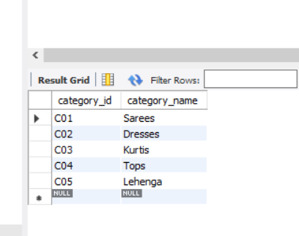
SELECT * FROM employees;
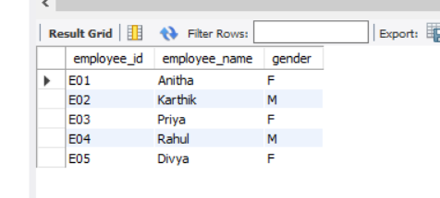
SELECT * FROM products2;
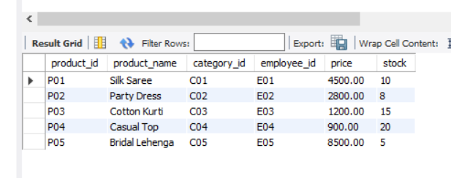
SELECT * FROM customers;
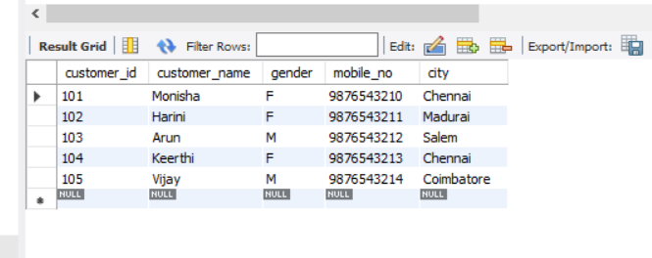

RESULT
Thus, the DML commands INSERT and SELECT were successfully performed in the Boutique database.

