DATABASE MANAGEMENT SYSTEMS LAB
EXPERIMENT 1 – DDL COMMANDS
NAME:MONISHA D
REG.NO:192311412

AIM
To perform Data Definition Language (DDL) commands such as CREATE, ALTER, RENAME, TRUNCATE and DROP using a Boutique database.
DATABASE
boutique
1. CREATE DATABASE
SQL Query:
CREATE DATABASE boutique;
USE boutique;
Output / Verification:

2. CREATE TABLE
SQL Query:
CREATE TABLE products (
product_id INT,
product_name VARCHAR(50),
category VARCHAR(30),
size VARCHAR(10),
color VARCHAR(20),
price DECIMAL(10,2),
stock INT
);
Output / Verification:
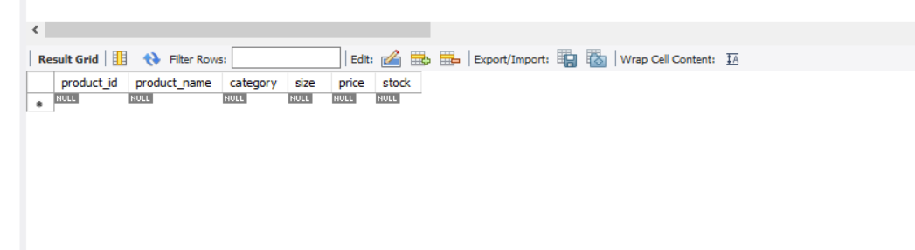

3. ALTER – ADD COLUMN
SQL Query:
ALTER TABLE products
ADD brand VARCHAR(30);
Output / Verification:
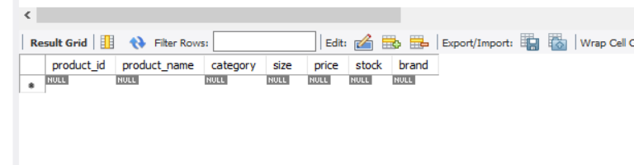
4. ALTER – MODIFY COLUMN
SQL Query:
ALTER TABLE products
MODIFY product_name VARCHAR(100);
Output / Verification:

5. ALTER – DROP COLUMN
SQL Query:
ALTER TABLE products
DROP COLUMN brand;
Output / Verification:
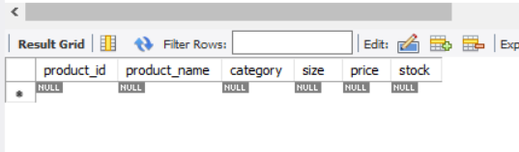
6. RENAME TABLE
SQL Query:
RENAME TABLE products TO boutique_products;
Output / Verification:
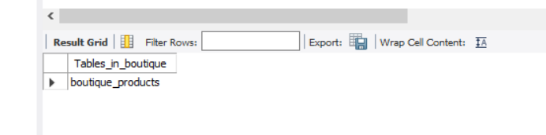

7. TRUNCATE TABLE
SQL Query:
TRUNCATE TABLE boutique_products;
Output / Verification:
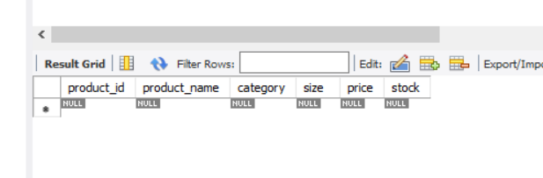

8. DROP TABLE
SQL Query:
DROP TABLE boutique_products;
Output / Verification:
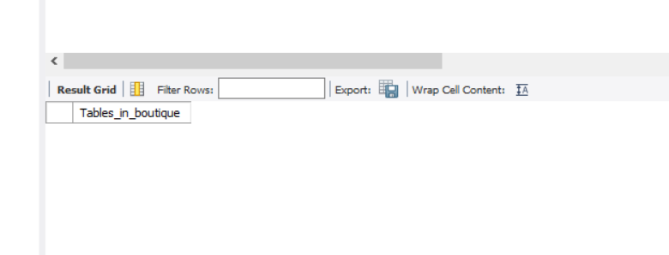
RESULT
Thus, the DDL commands CREATE, ALTER, RENAME, TRUNCATE and DROP were successfully performed on the Boutique database.

