DATABASE MANAGEMENT SYSTEMS LAB
EXPERIMENT 4 – DML COMMANDS WITH CONSTRAINTS
NAME:MONISHA D
REG N0:192311412

AIM
To perform DML commands UPDATE and DELETE in the Boutique database.
1. UPDATE
Update the price of the product whose product ID is 'P03'.
UPDATE products2
SET price = 1500.00
WHERE product_id = 'P03';
Output:
SELECT * FROM products2
WHERE product_id = 'P03';
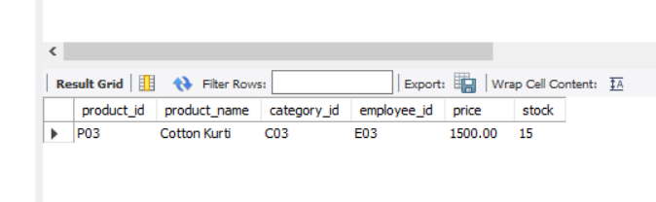
2. DELETE
Delete the customer record whose customer ID is 105.
DELETE FROM customers
WHERE customer_id = 105;
Output:
SELECT * FROM customers;
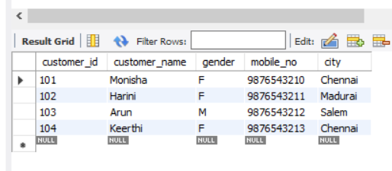
RESULT
Thus, the UPDATE and DELETE commands were successfully performed in the Boutique database.

