DATABASE MANAGEMENT SYSTEMS LAB
EXPERIMENT 5 – SELECT WITH VARIOUS CLAUSES
NAME:MONISHA D
REG N0:192311412

AIM
To retrieve records from the Boutique database using the SELECT statement with WHERE and pattern matching clauses.
1. WHERE CLAUSE
Display products whose price is greater than 2000.
SELECT * FROM products2
WHERE price > 2000;
OUTPUT:
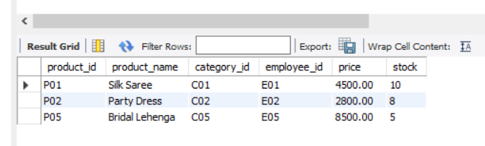
2. WHERE CLAUSE WITH EQUALITY
Display the product whose product ID is P03.
SELECT * FROM products2
WHERE product_id = 'P03';
OUTPUT:
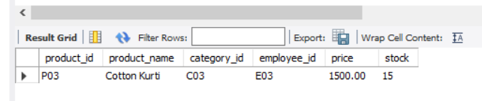
3. PATTERN MATCHING – STARTS WITH
Display products whose name starts with the letter C.
SELECT * FROM products2
WHERE product_name LIKE 'C%';
OUTPUT:
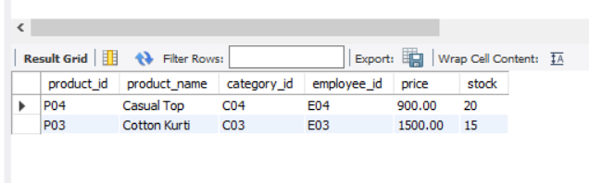
4. PATTERN MATCHING – ENDS WITH
Display products whose name ends with the letter e.
SELECT * FROM products2
WHERE product_name LIKE '%e';
OUTPUT:
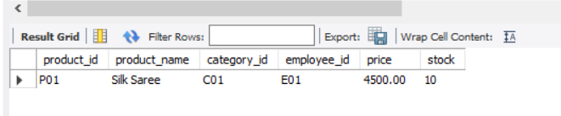
5. PATTERN MATCHING – CONTAINS
Display products whose name contains the letter a.
SELECT * FROM products2
WHERE product_name LIKE '%a%';
OUTPUT:
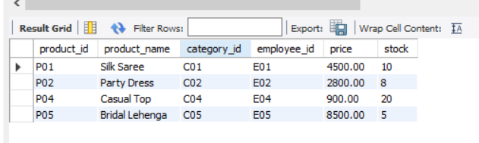
6. PATTERN MATCHING – SINGLE CHARACTER
Display products whose second character is S.
SELECT * FROM products2
WHERE product_name LIKE '_S%';
OUTPUT:
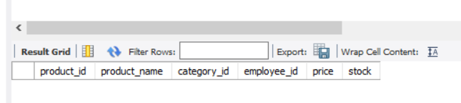
RESULT
Thus, SELECT queries using the WHERE clause and pattern matching with LIKE were successfully executed in the Boutique database.

