DATABASE MANAGEMENT SYSTEMS LAB
EXPERIMENT 6 – SELECT WITH VARIOUS CLAUSES
NAME:MONISHA D
REG N0:192311412

AIM
To retrieve records from the Boutique database using SELECT with BETWEEN, IN, and aggregate functions.
1. BETWEEN
Display products whose price is between ₹1000 and ₹5000.
SELECT * FROM products2
WHERE price BETWEEN 1000 AND 5000;
OUTPUT:
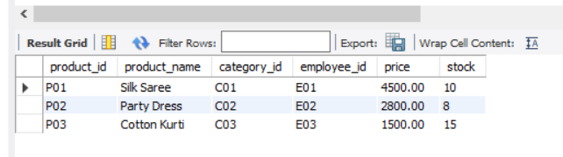
2. IN
Display products belonging to categories C01, C03, or C05.
SELECT * FROM products2
WHERE category_id IN ('C01', 'C03', 'C05');
OUTPUT:
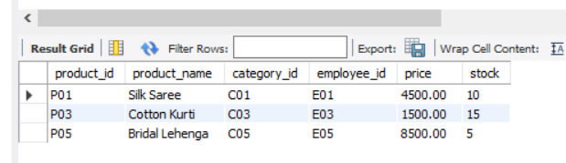
3. AGGREGATE FUNCTIONS
COUNT – Count the total number of products:
SELECT COUNT(*) AS total_products FROM products2;
OUTPUT:
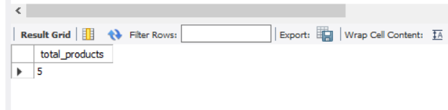
SUM – Find the total stock:
SELECT SUM(stock) AS total_stock FROM products2;
OUTPUT:
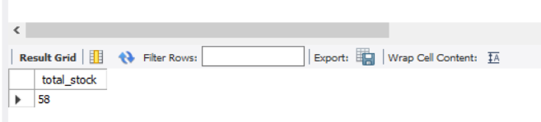
AVG – Find the average product price:
SELECT AVG(price) AS average_price FROM products2;
OUTPUT:
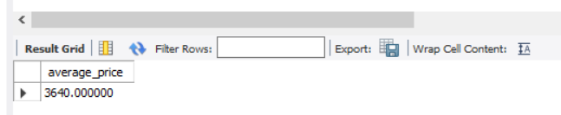
MAX – Find the highest product price:
SELECT MAX(price) AS highest_price FROM products2;
OUTPUT:
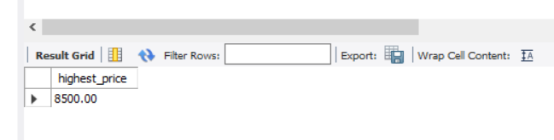
MIN – Find the lowest product price:
SELECT MIN(price) AS lowest_price FROM products2;
OUTPUT:
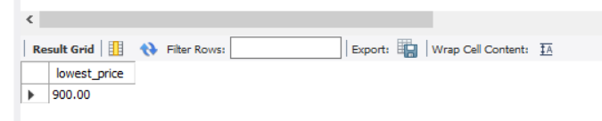
RESULT
Thus, SELECT queries using BETWEEN, IN, and aggregate functions were successfully executed in the Boutique database.

