DATABASE MANAGEMENT SYSTEMS LAB
EXPERIMENT 7 – SELECT WITH VARIOUS CLAUSES
NAME: MONISHA D
REG N0:192311412

AIM
To retrieve and organize records from the Boutique database using GROUP BY, HAVING and ORDER BY clauses.
1. GROUP BY
Find the number of products available in each category.
SELECT category_id, COUNT(*) AS total_products
FROM products2
GROUP BY category_id;
OUTPUT:

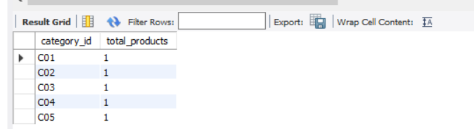
2. HAVING
Display categories having more than one product.
SELECT category_id, COUNT(*) AS total_products
FROM products2
GROUP BY category_id
HAVING COUNT(*) > 1;
OUTPUT:
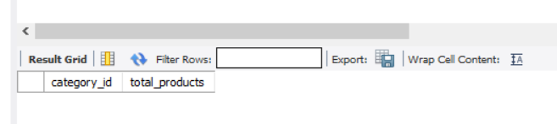

3. ORDER BY
Display products from highest price to lowest price.
SELECT * FROM products2
ORDER BY price DESC;
OUTPUT:
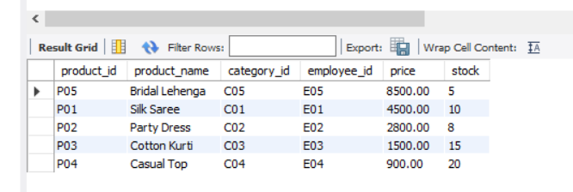
Display products from lowest price to highest price.
SELECT * FROM products2
ORDER BY price ASC;
OUTPUT:
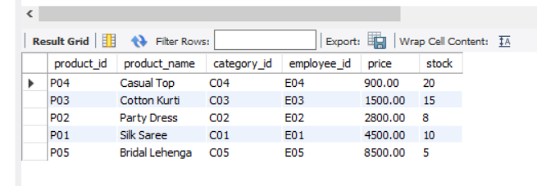
RESULT
Thus, SELECT queries using GROUP BY, HAVING and ORDER BY clauses were successfully executed in the Boutique database.

