DATABASE MANAGEMENT SYSTEMS LAB
EXPERIMENT 8 – SUBQUERY & CORRELATED QUERY
NAME: MONISHA D
REG N0:192311412

AIM
To retrieve records from the Boutique database using subquery and correlated query.
1. SUBQUERY
Display the products whose price is greater than the average price of all products.
SELECT *
FROM products2
WHERE price > (
SELECT AVG(price)
FROM products2
);
OUTPUT:
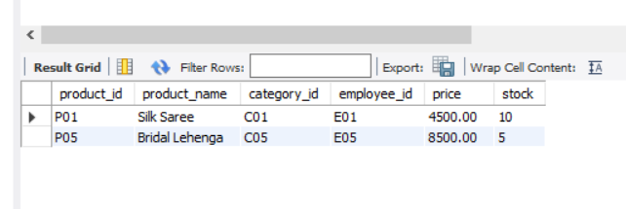
2. CORRELATED QUERY
Display products whose price is greater than the average price of products in the same category.
SELECT p1.*
FROM products2 p1
WHERE p1.price > (
SELECT AVG(p2.price)
FROM products2 p2
WHERE p2.category_id = p1.category_id
);
OUTPUT:
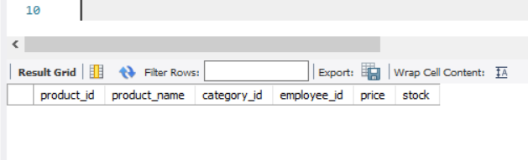

RESULT
Thus, the subquery and correlated query were successfully executed in the Boutique database.

