DATABASE MANAGEMENT SYSTEMS LAB
EXPERIMENT 15 – DCL COMMANDS: GRANT, REVOKE
AIM
To implement Data Control Language (DCL) commands such as GRANT and REVOKE to control user access to the Boutique database.
PROCEDURE
- Open MySQL and connect using an account with user and privilege administration permissions.
- Create a sample database user.
- Grant SELECT and INSERT privileges on the Boutique database to the user.
- Verify the granted privileges using SHOW GRANTS.
- Revoke the INSERT privilege from the user.
- Verify the privileges again using SHOW GRANTS.
1. GRANT
Create a user and grant SELECT and INSERT privileges on the Boutique database.
CREATE USER 'boutique_user'@'localhost'
IDENTIFIED BY 'Boutique@123';
GRANT SELECT, INSERT
ON boutique.*
TO 'boutique_user'@'localhost';
OUTPUT
SHOW GRANTS FOR 'boutique_user'@'localhost';
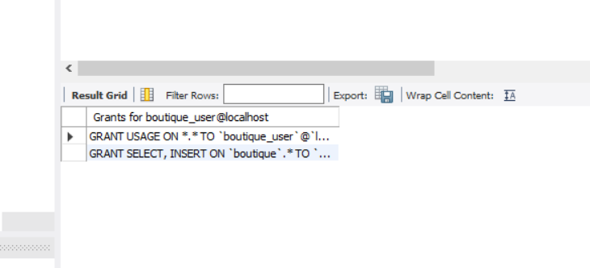
The user is granted SELECT and INSERT privileges on boutique.*.
2. REVOKE
Revoke the INSERT privilege from the Boutique database user.
REVOKE INSERT
ON boutique.*
FROM 'boutique_user'@'localhost';
OUTPUT
SHOW GRANTS FOR 'boutique_user'@'localhost';
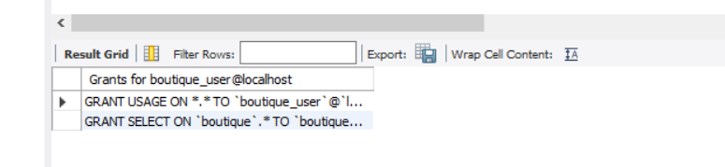
The INSERT privilege is removed, while the SELECT privilege remains.
RESULT
Thus, the DCL commands GRANT and REVOKE were successfully implemented to control user privileges on the Boutique database.

