EXPERIMENT 12 – SIMPLE PROGRAMMING USING REPEAT, WHILE

NAME/REGNO:MONISHA D/19231142

AIM
To implement simple programming logic using REPEAT and WHILE loops in MySQL.

PROCEDURE
- Open MySQL and select the boutique database.
- Create a stored procedure using the REPEAT loop.
- Execute the procedure and observe the output.
- Create another stored procedure using the WHILE loop.
- Execute the procedure and verify the output.

QUERY

1. REPEAT LOOP
Generate numbers from 1 to 5 using the REPEAT statement.
DELIMITER //

CREATE PROCEDURE repeat_example()
BEGIN
DECLARE i INT DEFAULT 1;

REPEAT
SELECT i AS Number;
SET i = i + 1;
UNTIL i > 5
END REPEAT;
END //

DELIMITER ;
Execute:
CALL repeat_example();

OUTPUT

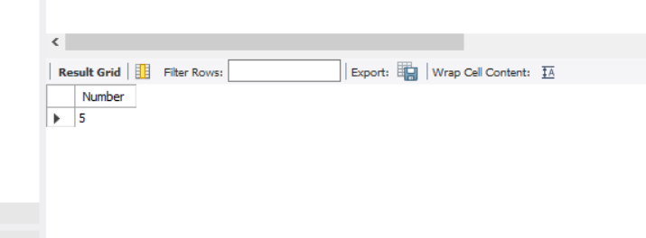2. WHILE LOOP
Generate numbers from 1 to 5 using the WHILE statement.
DELIMITER //

CREATE PROCEDURE while_example()
BEGIN
DECLARE i INT DEFAULT 1;

WHILE i <= 5 DO
SELECT i AS Number;
SET i = i + 1;
END WHILE;
END //

DELIMITER ;
Execute:
CALL while_example();

OUTPUT

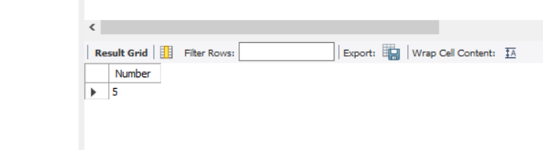

RESULT
Thus, simple programming using REPEAT and WHILE loops was successfully implemented and executed in MySQL.

