EXPERIMENT 13 – SIMPLE PROGRAMMING USING CASE AND LOOP

NAME/REGNO:MONISHA D/192311412

AIM
To implement simple programming logic using CASE and LOOP statements in MySQL.

PROCEDURE
- Open MySQL and select the boutique database.
- Create a stored procedure using the CASE statement.
- Execute the procedure and observe the output.
- Create a stored procedure using the LOOP statement.
- Execute the procedure and verify the output.

QUERY

1. CASE STATEMENT
Display a message based on the product stock.
DELIMITER //

CREATE PROCEDURE case_example()
BEGIN
DECLARE stock_value INT DEFAULT 15;

CASE
WHEN stock_value = 0 THEN
SELECT 'Out of Stock' AS Stock_Status;
WHEN stock_value < 10 THEN
SELECT 'Low Stock' AS Stock_Status;
ELSE
SELECT 'Available' AS Stock_Status;
END CASE;
END //

DELIMITER ;
Execute:
CALL case_example();

OUTPUT
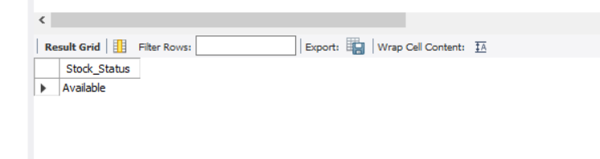

2. LOOP STATEMENT
Generate numbers from 1 to 5 using the LOOP statement.
DELIMITER //

CREATE PROCEDURE loop_example()
BEGIN
DECLARE i INT DEFAULT 1;

number_loop: LOOP
SELECT i AS Number;
SET i = i + 1;

IF i > 5 THEN
LEAVE number_loop;
END IF;
END LOOP;
END //

DELIMITER ;
Execute:
CALL loop_example();

OUTPUT

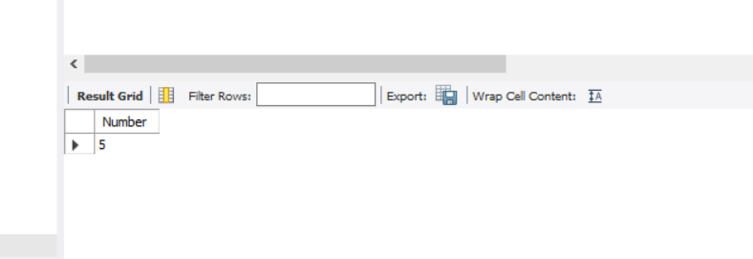RESULT
Thus, simple programming using CASE and LOOP statements was successfully implemented and executed in MySQL.

