EXPERIMENT 14 – TCL COMMANDS

NAME/REGNO:MONISHA D/192311412

AIM
To perform Transaction Control Language (TCL) commands such as COMMIT, SAVEPOINT, and ROLLBACK in the Boutique database.

PROCEDURE
- Open MySQL and select the boutique database.
- Start a transaction using START TRANSACTION.
- Perform an INSERT or UPDATE operation.
- Create a SAVEPOINT within the transaction.
- Use ROLLBACK to undo changes made after the savepoint.
- Use COMMIT to permanently save the required changes.
- Display the records to verify the transaction.

QUERY

1. COMMIT
Insert a new product and permanently save the transaction.
USE boutique;

START TRANSACTION;

INSERT INTO products2
(product_id, product_name, category_id, employee_id, price, stock)
VALUES
('P06', 'Designer Saree', 'C01', 'E01', 5500.00, 7);

COMMIT;

OUTPUT
SELECT * FROM products2
WHERE product_id = 'P06';
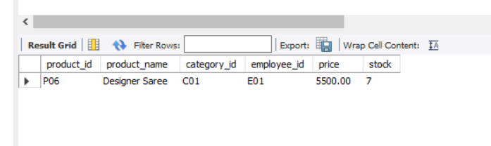

2. SAVEPOINT
Update the stock and create a savepoint.
START TRANSACTION;

UPDATE products2
SET stock = 12
WHERE product_id = 'P06';

SAVEPOINT stock_update;

3. ROLLBACK
Rollback to the savepoint after another change.
UPDATE products2
SET price = 6000.00
WHERE product_id = 'P06';

ROLLBACK TO stock_update;

COMMIT;

OUTPUT
SELECT * FROM products2
WHERE product_id = 'P06';
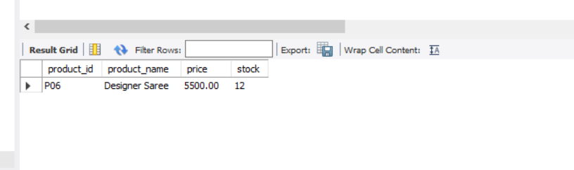
Here, the price change to 6000 was rolled back, while the stock change to 12 was retained and committed.

RESULT
Thus, the TCL commands COMMIT, SAVEPOINT, and ROLLBACK were successfully executed in the Boutique database.

