EXPERIMENT 11 – DATABASE WITH AUTO_INCREMENT SEQUENCES

NAME/REGNO:MONISHA D/192311412
AIM
To create and manage a database table using the AUTO_INCREMENT attribute, which automatically generates a unique, sequential value for a column (typically the primary key) each time a new record is inserted, without the value being explicitly specified.
PROCEDURE
1. Open the MySQL command-line client / workbench and log in.
2. Create a new database using the CREATE DATABASE statement.
3. Select the database for use with the USE statement.
4. Create a table and declare the required column as INT AUTO_INCREMENT PRIMARY KEY.
5. Insert new records into the table without giving a value for the auto-increment column.
6. Retrieve the table contents using SELECT and verify that the column values were generated automatically in sequence.
7. Insert further records and confirm that the sequence continues to increment.
8. Use ALTER TABLE ... AUTO_INCREMENT = n to reset or change the starting value of the sequence, if required.
9. Insert a record after the reset and verify the new starting value.
10. Close the session.
QUERY

1. Create Table with AUTO_INCREMENT
USE boutique;

CREATE TABLE boutique_customers (
customer_id INT AUTO_INCREMENT PRIMARY KEY,
customer_name VARCHAR(50),
city VARCHAR(30)
);

2. Insert Records
INSERT INTO boutique_customers (customer_name, city)
VALUES
('Monisha', 'Chennai'),
('Harini', 'Madurai'),
('Arun', 'Salem'),
('Keerthi', 'Chennai'),
('Vijay', 'Coimbatore');

3. Display Records
SELECT * FROM boutique_customers;

OUTPUT
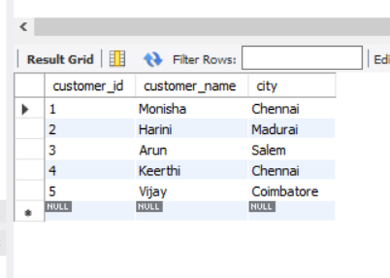

RESULT
Thus, a database table was successfully created using the AUTO_INCREMENT attribute, and unique sequential values were automatically generated for the primary key column on each insertion. The AUTO_INCREMENT sequence was also verified after modifying its starting value using the ALTER TABLE statement, and the program was executed and verified successfully.

