DATABASE MANAGEMENT SYSTEMS LAB
EXPERIMENT 16 – HIGH LEVEL PROGRAMMING EXTENSIONS – PROCEDURES
AIM
To create and execute a stored procedure for performing operations on the Boutique database.
PROCEDURE
- Open MySQL and select the boutique database.
- Create a stored procedure using the CREATE PROCEDURE statement.
- Define the required SQL statements inside the procedure.
- Execute the stored procedure using the CALL statement.
- Observe and verify the output.
QUERY
1. CREATE PROCEDURE
Create a procedure to display all products whose price is greater than ₹2000.
USE boutique;
DELIMITER //
CREATE PROCEDURE expensive_products()
BEGIN
SELECT product_id, product_name, price, stock
FROM products2
WHERE price > 2000;
END //
DELIMITER ;
2. EXECUTE PROCEDURE
CALL expensive_products();
OUTPUT

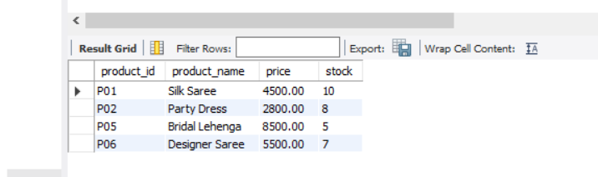

RESULT
Thus, the stored procedure was successfully created and executed to retrieve products with a price greater than ₹2000 from the Boutique database.

