EXPERIMENT 17 – HIGH LEVEL PROGRAMMING EXTENSIONS – FUNCTIONS

AIM
To create and execute a user-defined function for performing an operation on the Boutique database.

PROCEDURE
- Open MySQL and select the boutique database.
- Create a user-defined function using the CREATE FUNCTION statement.
- Define the required calculation inside the function.
- Call the function using a SELECT statement.
- Observe and verify the output.

QUERY

1. CREATE FUNCTION
Create a function to calculate the discounted price of a Boutique product.
USE boutique;

DELIMITER //

CREATE FUNCTION get_discounted_price(
original_price DECIMAL(10,2),
discount_percent DECIMAL(5,2)
)
RETURNS DECIMAL(10,2)
DETERMINISTIC
BEGIN
RETURN original_price -
(original_price * discount_percent / 100);
END //

DELIMITER ;

2. EXECUTE FUNCTION
Calculate the discounted price with a 10% discount.
SELECT product_name,
price,
get_discounted_price(price, 10) AS discounted_price
FROM products2;

OUTPUT

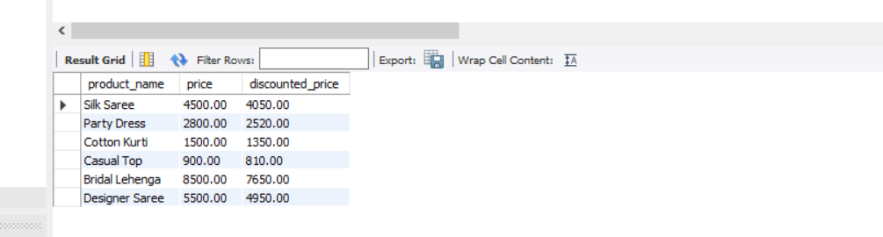

RESULT
Thus, the user-defined function was successfully created and executed to calculate the discounted price of Boutique products.

