EXPERIMENT 18

HIGH LEVEL LANGUAGE EXTENSION WITH CURSORS

AIM
To create and execute a cursor in MySQL to process Boutique product records one by one.

PROCEDURE
- Open MySQL and select the boutique database.
- Create a stored procedure containing a cursor.
- Declare the cursor to retrieve product details from the products2 table.
- Open the cursor and fetch the records one by one.
- Display the fetched product details.
- Close the cursor and verify the output.

QUERY
USE boutique;

DELIMITER //

CREATE PROCEDURE boutique_cursor()
BEGIN
DECLARE done INT DEFAULT 0;
DECLARE p_name VARCHAR(50);
DECLARE p_price DECIMAL(10,2);

DECLARE product_cursor CURSOR FOR
SELECT product_name, price
FROM products2;

DECLARE CONTINUE HANDLER FOR NOT FOUND SET done = 1;

OPEN product_cursor;

read_loop: LOOP
FETCH product_cursor INTO p_name, p_price;

IF done = 1 THEN
LEAVE read_loop;
END IF;

SELECT p_name AS Product_Name, p_price AS Price;
END LOOP;

CLOSE product_cursor;
END //

DELIMITER ;

EXECUTE
CALL boutique_cursor();

OUTPUT
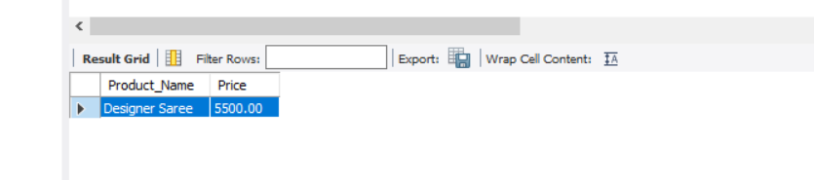

RESULT
Thus, the cursor was successfully created and executed to retrieve Boutique product records one by one.

