EXPERIMENT 19

TRIGGER

AIM
To create and execute a trigger in MySQL to automatically perform an operation when a record is inserted into the Boutique database.

PROCEDURE
- Open MySQL and select the boutique database.
- Create a log table to store newly inserted product information.
- Create a trigger using the CREATE TRIGGER statement.
- Insert a new product into the products2 table.
- The trigger automatically inserts the product details into the log table.
- Display the log table to verify the result.

QUERY

1. Create Log Table
USE boutique;

CREATE TABLE product_log (
log_id INT AUTO_INCREMENT PRIMARY KEY,
product_id VARCHAR(5),
product_name VARCHAR(50),
action VARCHAR(20)
);

2. Create Trigger
DELIMITER //

CREATE TRIGGER after_product_insert
AFTER INSERT ON products2
FOR EACH ROW
BEGIN
INSERT INTO product_log(product_id, product_name, action)
VALUES (NEW.product_id, NEW.product_name, 'INSERTED');
END //

DELIMITER ;

3. Insert a New Product
INSERT INTO products2
(product_id, product_name, category_id, employee_id, price, stock)
VALUES
('P07', 'Embroidered Kurti', 'C03', 'E03', 2200.00, 10);

4. Display Log
SELECT * FROM product_log;

OUTPUT

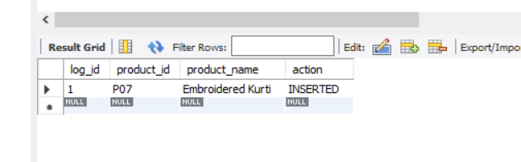

RESULT
Thus, the trigger was successfully created and executed. The trigger automatically recorded the newly inserted product in the product_log table.

