EXPERIMENT 20

MYSQL STRING FUNCTIONS – REPLACE, REPEAT, REVERSE, RIGHT, LEFT, RPAD, LPAD

AIM
To perform various MySQL string functions such as REPLACE, REPEAT, REVERSE, RIGHT, LEFT, RPAD, and LPAD on Boutique data.

PROCEDURE
- Open MySQL and select the boutique database.
- Use the products2 table for string operations.
- Execute the REPLACE, REPEAT, REVERSE, RIGHT, LEFT, RPAD, and LPAD functions.
- Observe the output of each function.
- Verify the results.

QUERY

1. REPLACE
SELECT REPLACE(product_name, 'Saree', 'Dress') AS Result
FROM products2
WHERE product_id = 'P01';
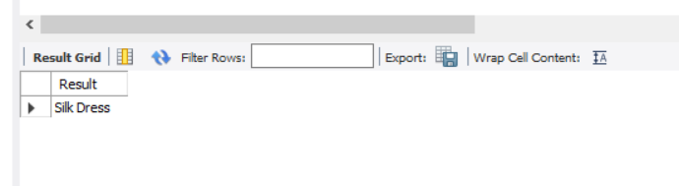

2. REPEAT
SELECT REPEAT(product_name, 2) AS Result
FROM products2
WHERE product_id = 'P04';
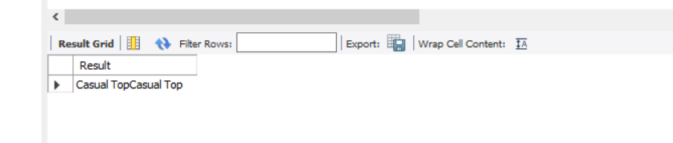

3. REVERSE
SELECT REVERSE(product_name) AS Result
FROM products2
WHERE product_id = 'P01';
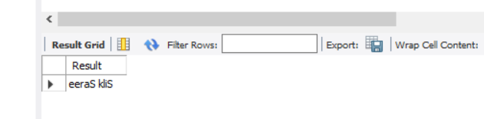

4. RIGHT
SELECT RIGHT(product_name, 4) AS Result
FROM products2
WHERE product_id = 'P01';

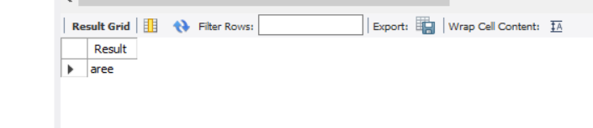

5. LEFT
SELECT LEFT(product_name, 4) AS Result
FROM products2
WHERE product_id = 'P01';
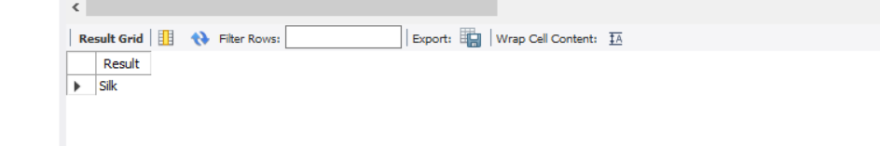

6. RPAD
SELECT RPAD(product_name, 15, '*') AS Result
FROM products2
WHERE product_id = 'P01';
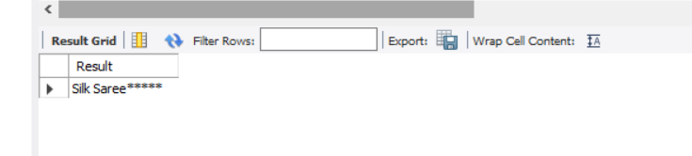

7. LPAD
SELECT LPAD(product_name, 15, '*') AS Result
FROM products2
WHERE product_id = 'P01';

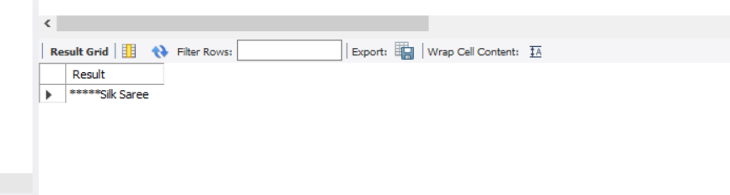

RESULT
Thus, the MySQL string functions REPLACE, REPEAT, REVERSE, RIGHT, LEFT, RPAD, and LPAD were successfully executed and the required results were obtained.

