EXPERIMENT 21

MYSQL STRING FUNCTIONS – SPACE, SUBSTR, UPPER, LOWER, TRIM, LENGTH

AIM
To perform MySQL string functions such as SPACE, SUBSTR, UPPER, LOWER, TRIM, and LENGTH on Boutique data.

PROCEDURE
- Open MySQL and select the boutique database.
- Use the products2 table for string operations.
- Execute the required string functions.
- Observe the output obtained from each function.
- Verify the results.

QUERY
1. SPACE
SELECT CONCAT(product_name, SPACE(3), 'Boutique') AS Result
FROM products2
WHERE product_id = 'P01';
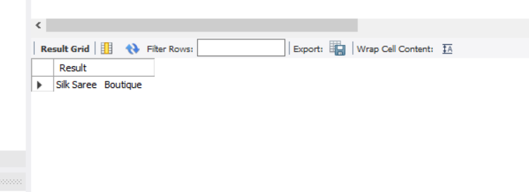
2. SUBSTR
SELECT SUBSTR(product_name, 1, 4) AS Result
FROM products2
WHERE product_id = 'P01';
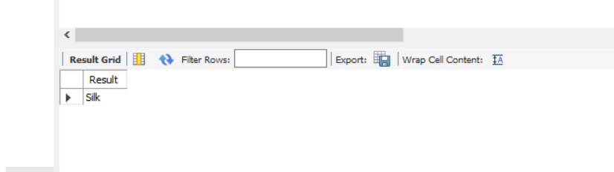
3. UPPER
SELECT UPPER(product_name) AS Result
FROM products2
WHERE product_id = 'P01';
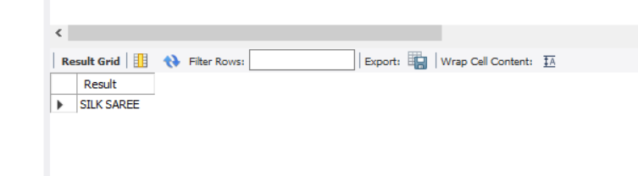
4. LOWER
SELECT LOWER(product_name) AS Result
FROM products2
WHERE product_id = 'P01';
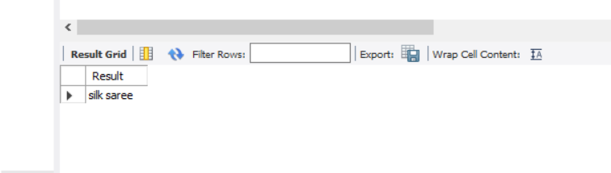
5. TRIM
SELECT TRIM(' Boutique ') AS Result;
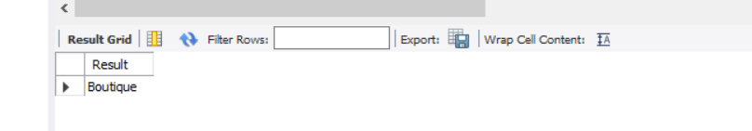
6. LENGTH
SELECT LENGTH(product_name) AS Result
FROM products2
WHERE product_id = 'P01';

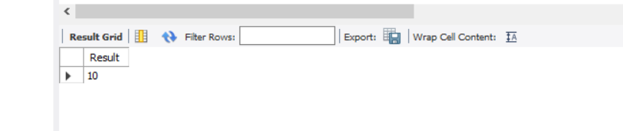

RESULT
Thus, the MySQL string functions SPACE, SUBSTR, UPPER, LOWER, TRIM, and LENGTH were successfully executed.

