EXPERIMENT 23

TRAIN TICKET RESERVATION SYSTEM TO RECEIVE TICKETS THROUGH SOCIAL NETWORK

AIM
To design and implement a simple Train Ticket Reservation System that allows users to enter passenger and journey details and receive ticket information through a social network/contact channel.

PROCEDURE
- Create a database for storing train ticket details.
- Create a reservation form to accept passenger information.
- Enter passenger name, train number, source, destination and journey date.
- Store the reservation details in MySQL.
- Generate a ticket confirmation.
- Provide the ticket details that can be shared through a social network.

QUERY

Create Table
CREATE TABLE train_reservation (
ticket_id INT AUTO_INCREMENT PRIMARY KEY,
passenger_name VARCHAR(50),
train_no VARCHAR(10),
source VARCHAR(30),
destination VARCHAR(30),
journey_date DATE,
seat_no VARCHAR(10)
);

Insert Ticket
INSERT INTO train_reservation
(passenger_name, train_no, source, destination, journey_date, seat_no)
VALUES
('Monisha', '12601', 'Chennai', 'Bangalore', '2026-09-10', 'S1-25');

Display Ticket
SELECT * FROM train_reservation
WHERE ticket_id = 1;

OUTPUT

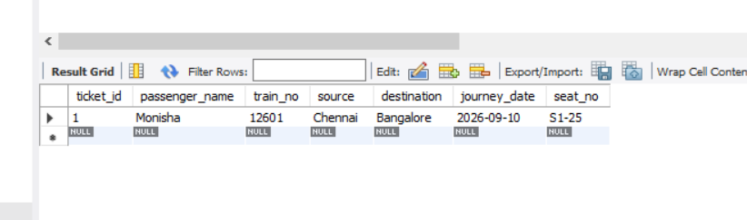

RESULT
Thus, a simple Train Ticket Reservation System was successfully designed to store reservation details and generate ticket information suitable for sharing through a social network.

