EXPERIMENT 24

COLLEGE ADMISSION FORM

AIM
To design and implement a College Admission Form to collect and store student admission details in a MySQL database.

PROCEDURE
- Create a database for college admission.
- Create a table to store student details.
- Design an admission form using HTML.
- Enter student details such as name, gender, course, email and phone number.
- Store the submitted details in the MySQL database.
- Retrieve and display the admission details.

QUERY

Create Table
CREATE TABLE college_admission (
application_id INT AUTO_INCREMENT PRIMARY KEY,
student_name VARCHAR(50),
gender VARCHAR(10),
course VARCHAR(50),
email VARCHAR(50),
phone VARCHAR(15)
);

Insert Admission Details
INSERT INTO college_admission
(student_name, gender, course, email, phone)
VALUES
('Monisha D', 'Female', 'Computer Science Engineering',
'monisha@example.com', '9876543210');

Display Details
SELECT * FROM college_admission;

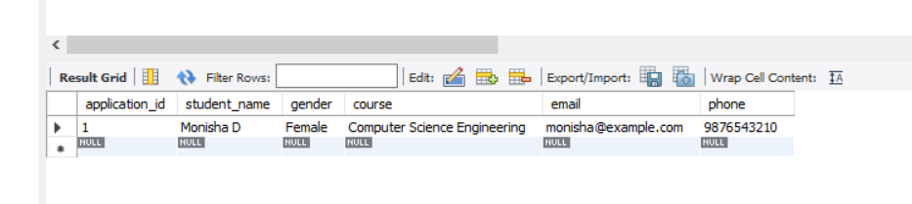

RESULT
Thus, the College Admission Form was successfully designed and the student admission details were stored and retrieved from the MySQL database.

