EXPERIMENT 25

QR ENABLED AUTOMATIC BUS TICKET BOOKING SYSTEM

AIM
To design and implement a QR Enabled Automatic Bus Ticket Booking System for storing passenger details, generating a ticket and providing a QR code for the booked ticket.

PROCEDURE
- Create a database for bus ticket booking.
- Create a table to store passenger and ticket details.
- Enter passenger name, bus number, source, destination and journey date.
- Generate a unique ticket ID automatically.
- Store the booking details in MySQL.
- Generate a QR code containing the ticket information.
- Scan the QR code to verify the ticket details.

QUERY

Create Table
CREATE TABLE bus_booking (
ticket_id INT AUTO_INCREMENT PRIMARY KEY,
passenger_name VARCHAR(50),
bus_no VARCHAR(10),
source VARCHAR(30),
destination VARCHAR(30),
journey_date DATE,
seat_no VARCHAR(10)
);

Insert Booking
INSERT INTO bus_booking
(passenger_name, bus_no, source, destination, journey_date, seat_no)
VALUES
('Monisha', 'BUS101', 'Chennai', 'Pondicherry',
'2026-09-15', 'A12');

Display Ticket
SELECT * FROM bus_booking
WHERE ticket_id = 1;

OUTPUT

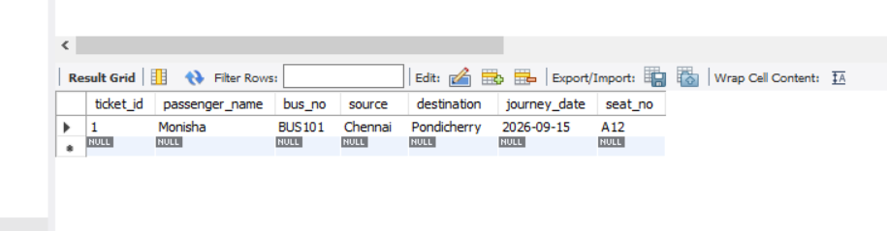

QR CODE DATA
The following information can be encoded into the QR code:
Ticket ID: 1
Passenger: Monisha
Bus No: BUS101
From: Chennai
To: Pondicherry
Date: 15-09-2026
Seat: A12
The QR code can then be scanned to retrieve and verify the ticket information.

RESULT
Thus, the QR Enabled Automatic Bus Ticket Booking System was successfully designed to store booking details, generate an automatic ticket ID and provide ticket information for QR-based verification.

