EXPERIMENT 10 – DATABASE WITH VIEW AND INDEX

AIM
To create and use a VIEW and an INDEX in the Boutique database for simplified data retrieval and efficient searching.

PROCEDURE
- Open MySQL and select the boutique database.
- Create a VIEW using the products2 table.
- Retrieve records from the created VIEW.
- Create an INDEX on the product_name column of the products2 table.
- Display the index details and verify the result.

QUERY

1. CREATE VIEW
Create a view to display product ID, product name, category ID, price and stock.
USE boutique;

CREATE VIEW boutique_product_view AS
SELECT product_id, product_name, category_id, price, stock
FROM products2;

OUTPUT
SELECT * FROM boutique_product_view;

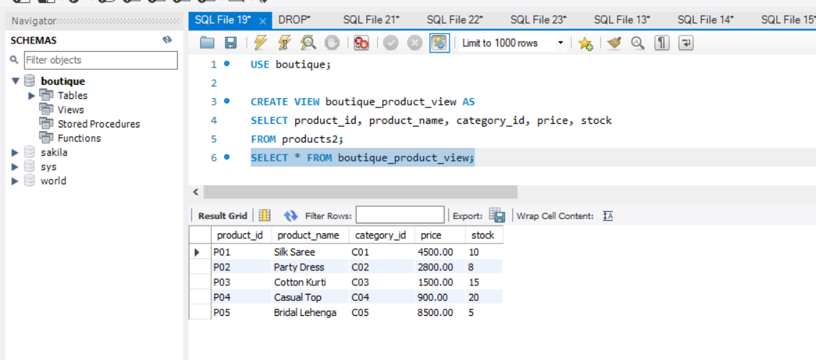

2. CREATE INDEX
Create an index on the product_name column for faster searching.
CREATE INDEX idx_product_name
ON products2(product_name);

OUTPUT
SHOW INDEX FROM products2;
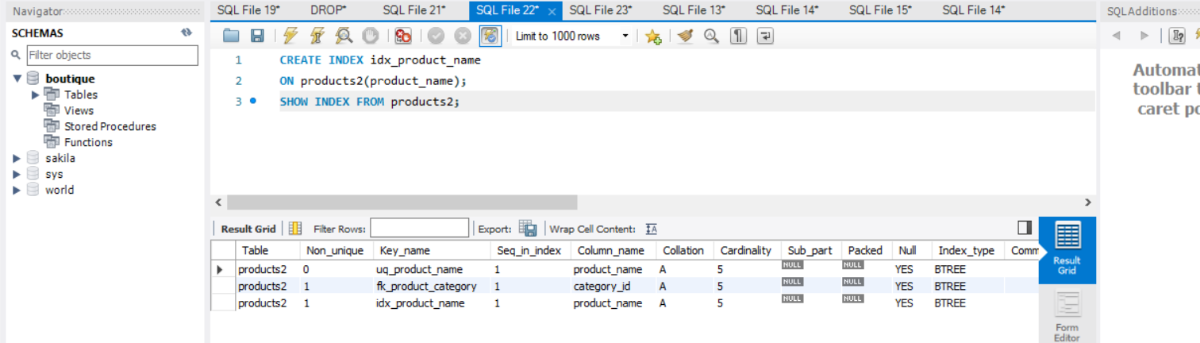

RESULT
Thus, the VIEW and INDEX were successfully created and verified in the Boutique database.

