DATABASE MANAGEMENT SYSTEMS LAB
EXPERIMENT 9 – QUERY WITH JOINS

NAME/REGNO: MONISHA D/192311412
AIM
To perform Equi Join, Inner Join, and Outer Join operations using the Boutique database.
PROCEDURE
1. Open MySQL and select the boutique database.
2. Create the required tables and establish relationships between them.
3. Insert sample records into the Boutique tables.
4. Execute Equi Join, Inner Join, and Outer Join queries.
5. Observe and verify the output obtained from each query.
QUERY AND OUTPUT
1. EQUI JOIN
Query:
SELECT p.product_id, p.product_name, c.category_name
FROM products2 p, categories c
WHERE p.category_id = c.category_id;
Output:
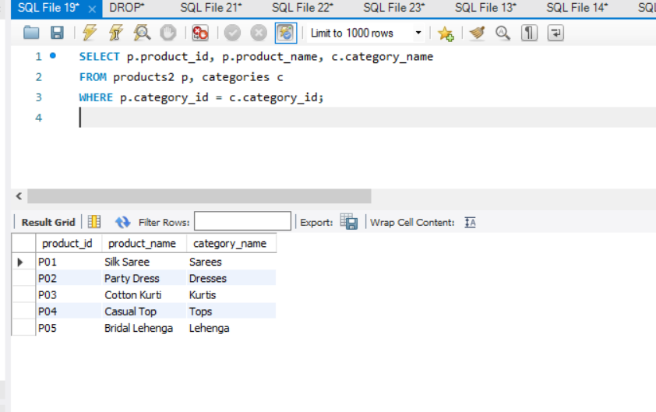
2. INNER JOIN
Query:
SELECT p.product_name, c.category_name, e.employee_name
FROM products2 p
INNER JOIN categories c ON p.category_id = c.category_id
INNER JOIN employees e ON p.employee_id = e.employee_id;
Output:
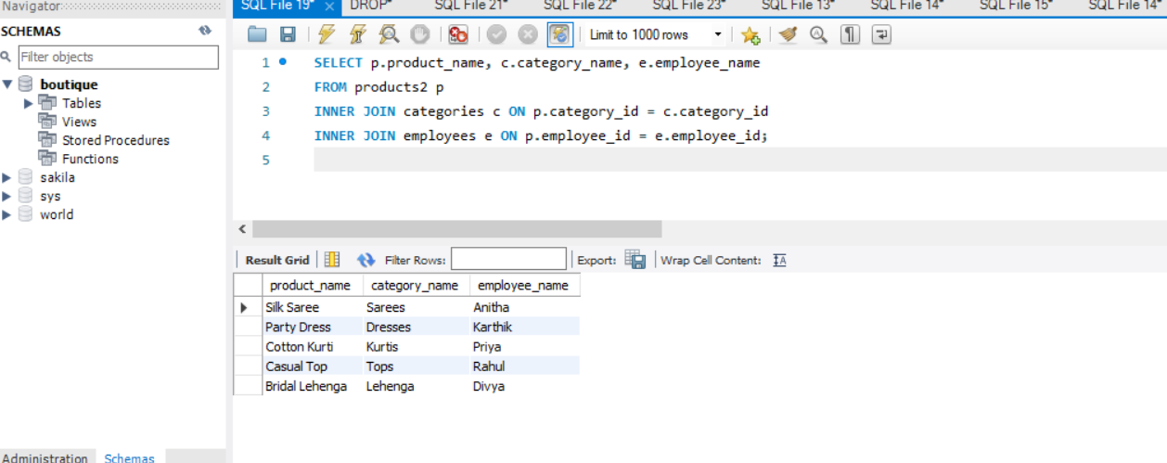
3. LEFT OUTER JOIN
Query:
SELECT c.category_id, c.category_name, p.product_name
FROM categories c
LEFT OUTER JOIN products2 p ON c.category_id = p.category_id;
Output:
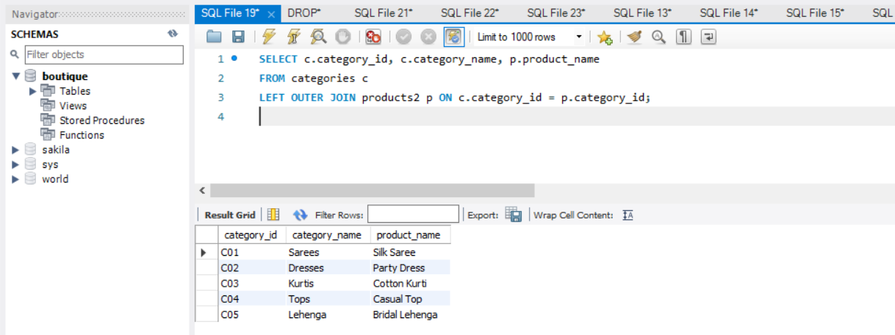
RESULT
Thus, Equi Join, Inner Join, and Left Outer Join queries were successfully executed and the required records were retrieved from the Boutique database.

