Exercise 1: Setting Up JUnit

Calculator.java
package com.example;
public class Calculator {
public int add(int a, int b) {
return a + b;
}
}

CalculatorTest.java
package com.example;
import org.junit.Test;
import static org.junit.Assert.*;
public class CalculatorTest {
@Test
public void testAdd() {
Calculator calc = new Calculator();
System.out.println("Test passed: 2 + 3 = " + calc.add(2, 3));
assertEquals(5, calc.add(2, 3));
}
}

pom.xml
<project xmlns="http://maven.apache.org/POM/4.0.0"
xmlns:xsi="http://www.w3.org/2001/XMLSchema-instance"
xsi:schemaLocation="http://maven.apache.org/POM/4.0.0
http://maven.apache.org/xsd/maven-4.0.0.xsd">
<modelVersion>4.0.0</modelVersion>
<groupId>com.example</groupId>
<artifactId>calculator</artifactId>
<version>1.0-SNAPSHOT</version>
<dependencies>
<dependency>
<groupId>junit</groupId>
<artifactId>junit</artifactId>
<version>4.13.2</version>
<scope>test</scope>
</dependency>
</dependencies>
</project>

OUTPUT:
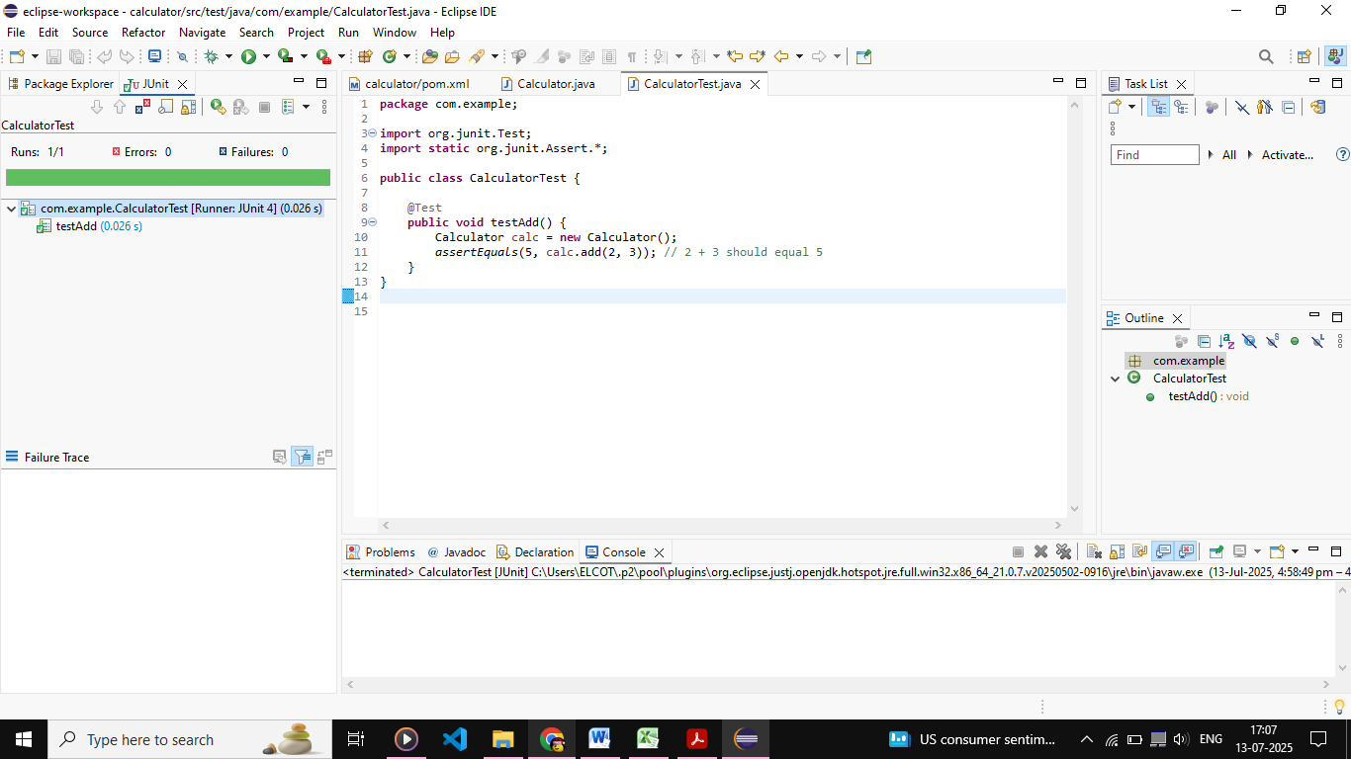

Exercise 3: Assertions in JUnit

AssertionsTest.java
package com.example;
import org.junit.Test;
import static org.junit.Assert.*;
public class AssertionsTest {
@Test
public void testAssertions() {
assertEquals(5, 2 + 3);
assertTrue(5 > 3);
assertFalse(5 < 3);
assertNull(null);
assertNotNull(new Object());
}
}

OUTPUT:
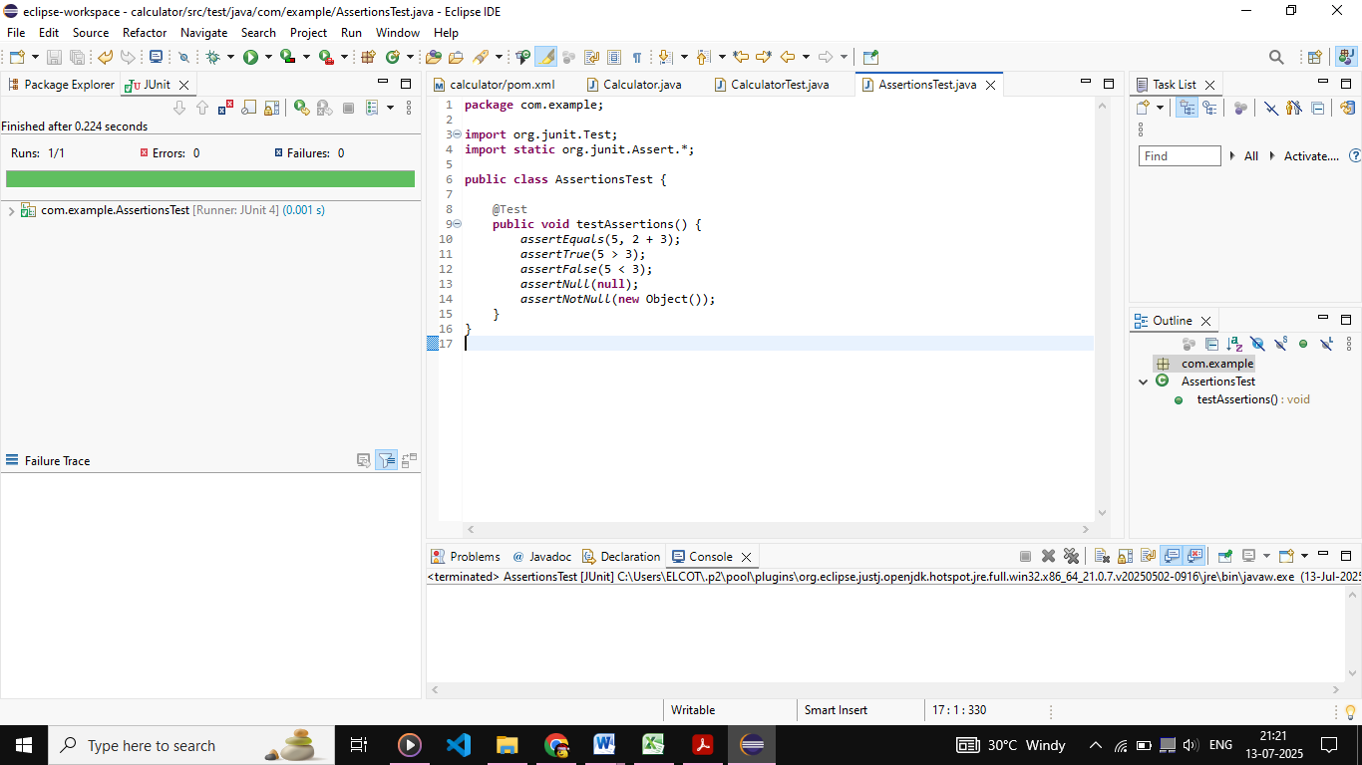
Exercise 4: Arrange-Act-Assert (AAA) Pattern, Test Fixtures, Setup and Teardown Methods in JUnit

Calculator.java
package com.example;
public class Calculator {
public int add(int a, int b) {
return a + b;
}
public int subtract(int a, int b) {
return a - b;
}
}

CalculatorTestAAA.java
package com.example;
import org.junit.After;
import org.junit.Before;
import org.junit.Test;
import static org.junit.Assert.*;
public class CalculatorTestAAA {
private Calculator calculator;
@Before
public void setUp() {
System.out.println("Setting up...");
calculator = new Calculator();
}
@After
public void tearDown() {
System.out.println("Cleaning up...");
calculator = null;
}
@Test
public void testAddition() {
int result = calculator.add(10, 5);
assertEquals(15, result);
}
@Test
public void testSubtraction() {
int result = calculator.subtract(10, 5);
assertEquals(5, result);
}
}

OUTPUT:
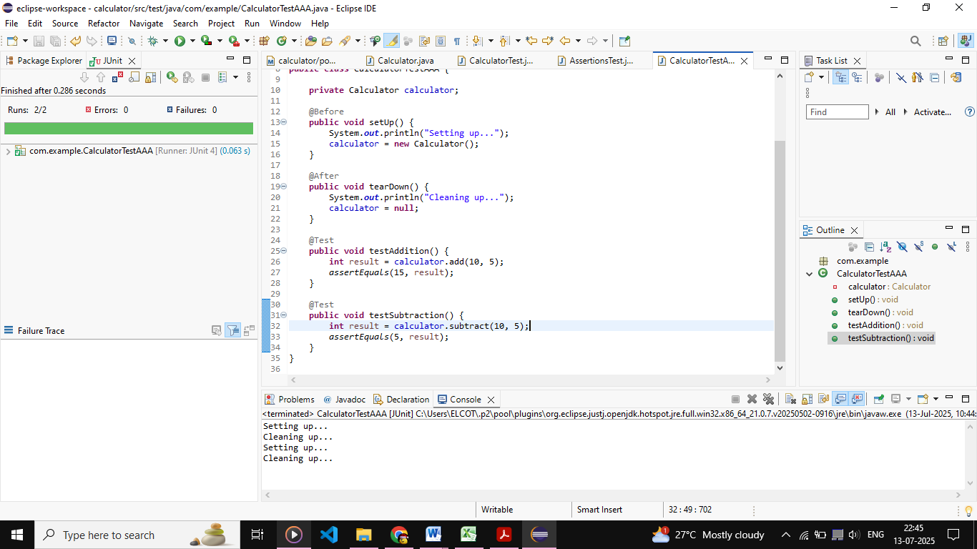

Exercise 1: Mocking and Stubbing

ExternalApi.java
package com.example;
public interface ExternalApi {
String getData();
}

MyService.java
package com.example;
public class MyService {
private ExternalApi api;
public MyService(ExternalApi api) {
this.api = api;
}
public String fetchData() {
return api.getData();
}
}

MyServiceTest.java
package com.example;
import org.junit.jupiter.api.Test;
import static org.junit.jupiter.api.Assertions.*;
import static org.mockito.Mockito.*;
public class MyServiceTest {
@Test
public void testExternalApi() {
ExternalApi mockApi = mock(ExternalApi.class);
when(mockApi.getData()).thenReturn("Mock Data");
MyService service = new MyService(mockApi);
String result = service.fetchData();
assertEquals("Mock Data", result);
}
}

OUTPUT:
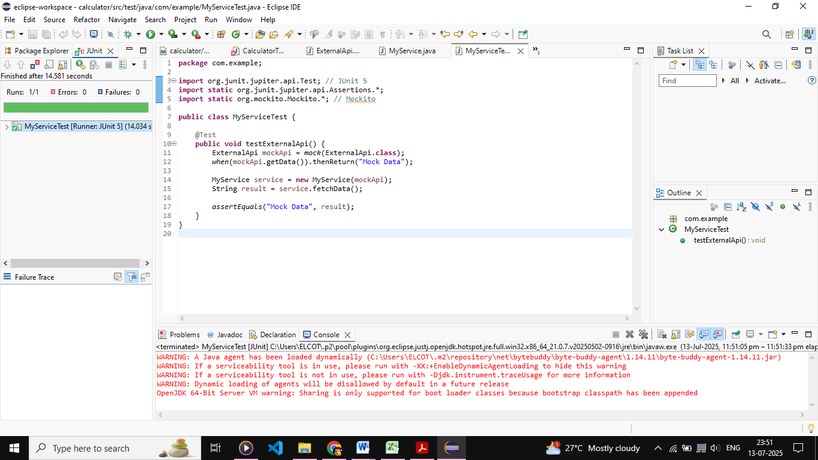

Exercise 2: Verifying Interactions

ExternalApi.java

package com.example;
public interface ExternalApi {
String getData();
}

MyService.java

package com.example;
public class MyService {
private ExternalApi api;
public MyService(ExternalApi api) {
this.api = api;
}
public String fetchData() {
return api.getData();
}
}

MyServiceTest.java

package com.example;
import org.junit.jupiter.api.Test;
import static org.mockito.Mockito.*;
import static org.junit.jupiter.api.Assertions.*;

public class MyServiceTest {

@Test

public void testExternalApi() {
ExternalApi mockApi = mock(ExternalApi.class);
when(mockApi.getData()).thenReturn("Mock Data");
MyService service = new MyService(mockApi);
String result = service.fetchData();
assertEquals("Mock Data", result);
}

@Test

public void testVerifyInteraction() {

ExternalApi mockApi = mock(ExternalApi.class);
MyService service = new MyService(mockApi);
service.fetchData();
verify(mockApi).getData();
}
}

OUTPUT:
