**Exercise 2: E-commerce Platform Search Function**

import java.util.Arrays;

import java.util.Comparator;

class Product {

int productId;

String productName;

String category;

public Product(int productId, String productName, String category) {

this.productId = productId;

this.productName = productName;

this.category = category;

}

public String toString() {

return "Product ID: " + productId + ", Name: " + productName + ", Category: " + category;

}

}

public class Main {

public static Product linearSearch(Product[] products, int targetId) {

for (Product p : products) {

if (p.productId == targetId) {

return p;

}

}

return null;

}

public static Product binarySearch(Product[] products, int targetId) {

int left = 0;

int right = products.length - 1;

while (left <= right) {

int mid = left + (right - left) / 2;

if (products[mid].productId == targetId) {

return products[mid];

} else if (products[mid].productId < targetId) {

left = mid + 1;

} else {

right = mid - 1;

}

}

return null;

}

public static void main(String[] args) {

Product[] products = {

new Product(101, "Laptop", "Electronics"),

new Product(105, "Shampoo", "Personal Care"),

new Product(102, "Mobile Phone", "Electronics"),

new Product(103, "Table", "Furniture"),

new Product(104, "Shoes", "Fashion")

};

Arrays.sort(products, Comparator.comparingInt(p -> p.productId));

Product result1 = linearSearch(products, 103);

System.out.println("Linear Search Result: " + (result1 != null ? result1 : "Product not found"));

Product result2 = binarySearch(products, 103);

System.out.println("Binary Search Result: " + (result2 != null ? result2 : "Product not found"));

}

}

**Output:**

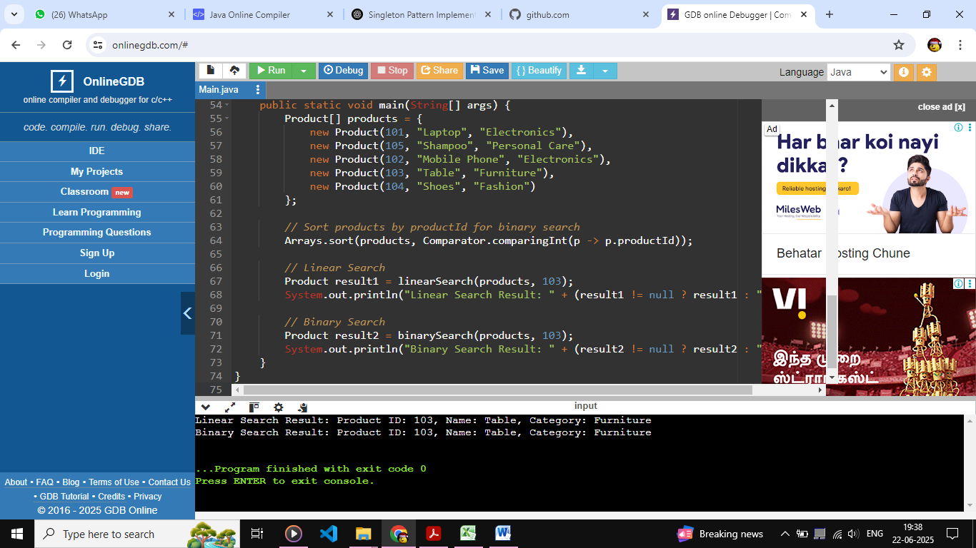

**Exercise 7: Financial Forecasting**

public class Main {

public static double futureValue(double presentValue, double rate, int years) {

if (years == 0) {

return presentValue;

}

return futureValue(presentValue * (1 + rate), rate, years - 1);

}

public static void main(String[] args) {

double presentValue = 10000;

double rate = 0.08;

int years = 5;

double future = futureValue(presentValue, rate, years);

System.out.printf("Future Value after %d years: ₹%.2f%n", years, future);

}

}

**Output:**

