AEM Task – 1

Step 1: Set Up AEM Locally

1. Download AEM Jar file from the drive link
2. 2. Extract the file into a folder

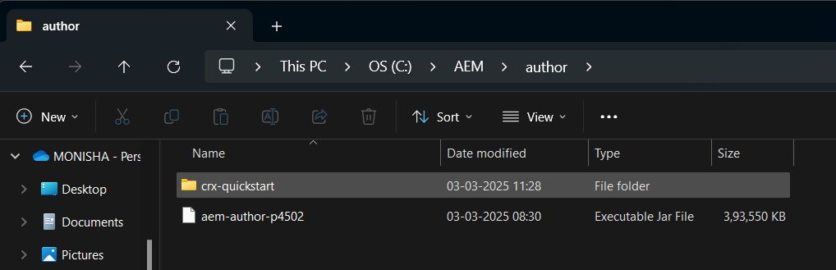

Step 2: Start AEM Author Instance

1. Start the AEM setup in command prompt, by run the cmd as shown below.

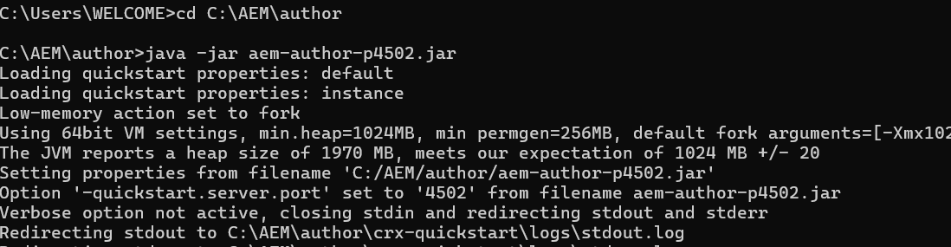

1. Go to browser and search http://localhost:4502 , to get AEM login screen

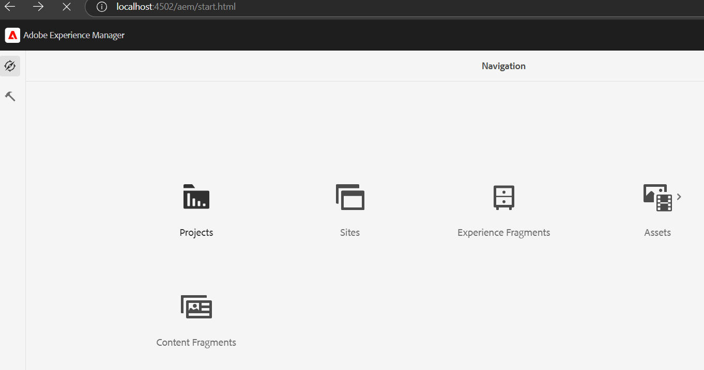

Step 3: Create AEM Project Structure

1. Download Maven
2. 2. Extract the Maven file into Folder

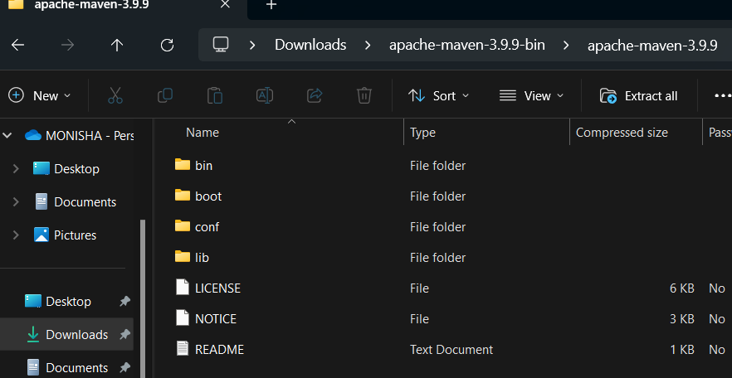

1. Generate AEM Project Using Maven by running the command in cmd by giving run as administrator
2. Step 4: Open the AEM Project 1. Folder structure of the generated AEM project in File Explorer.

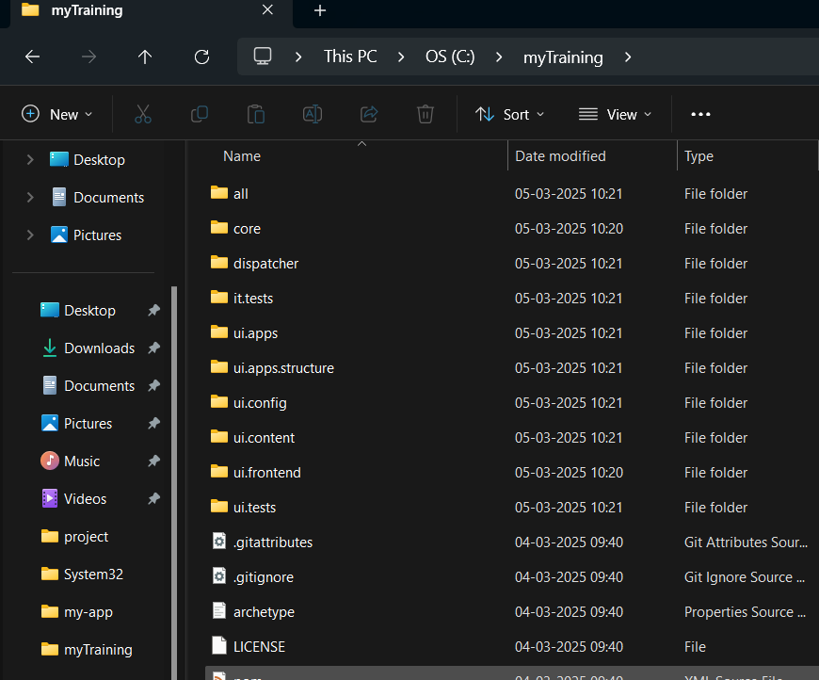

1. AEM project opened in Visual Studio Code

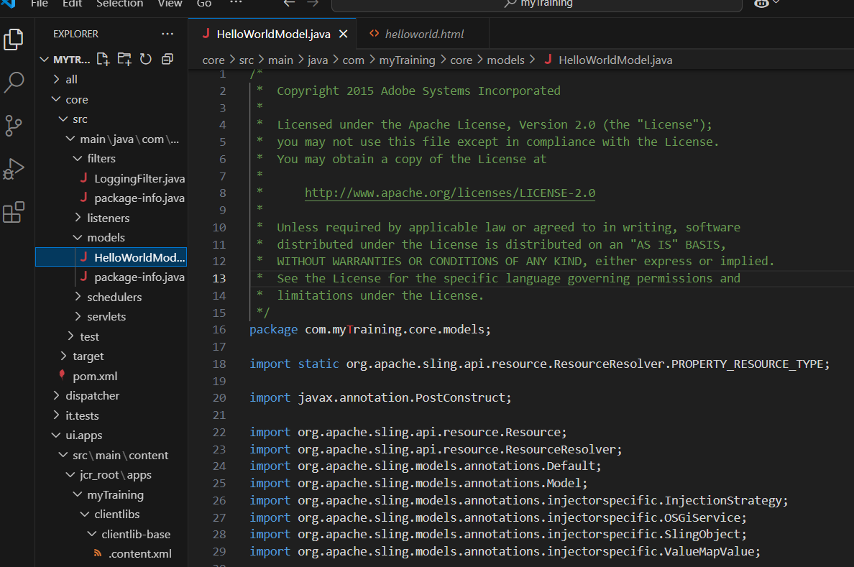

Step 5: Build and Deploy the Project

Verify the file in the <http://localhost:4502/sites.html/content>