**Project Name:** Online Education Platform  
**Version:** 1.0  
**Date:** [23-02-2025]  
**Author:** [Monisha R]

**1. Introduction**

This project is an **online education platform** that allows users to browse courses, view instructor details, and enroll in courses. The platform features a user-friendly interface and interactive elements for enhanced learning experiences.

**2. Features**

* 📚 Course browsing and filtering
* 👨‍🏫 Instructor details with profiles
* 📜 Enrollment system with validation
* 📱 Fully responsive design
* 🎨 UI/UX with hover effects and animations

**3. Technologies Used**

* **Frontend**: HTML, CSS, JavaScript
* **Styling**: CSS Grid, Flexbox, Animations
* **Data Storage**: JSON (for course and instructor data)

**4. Website Screenshots**

**Homepage**

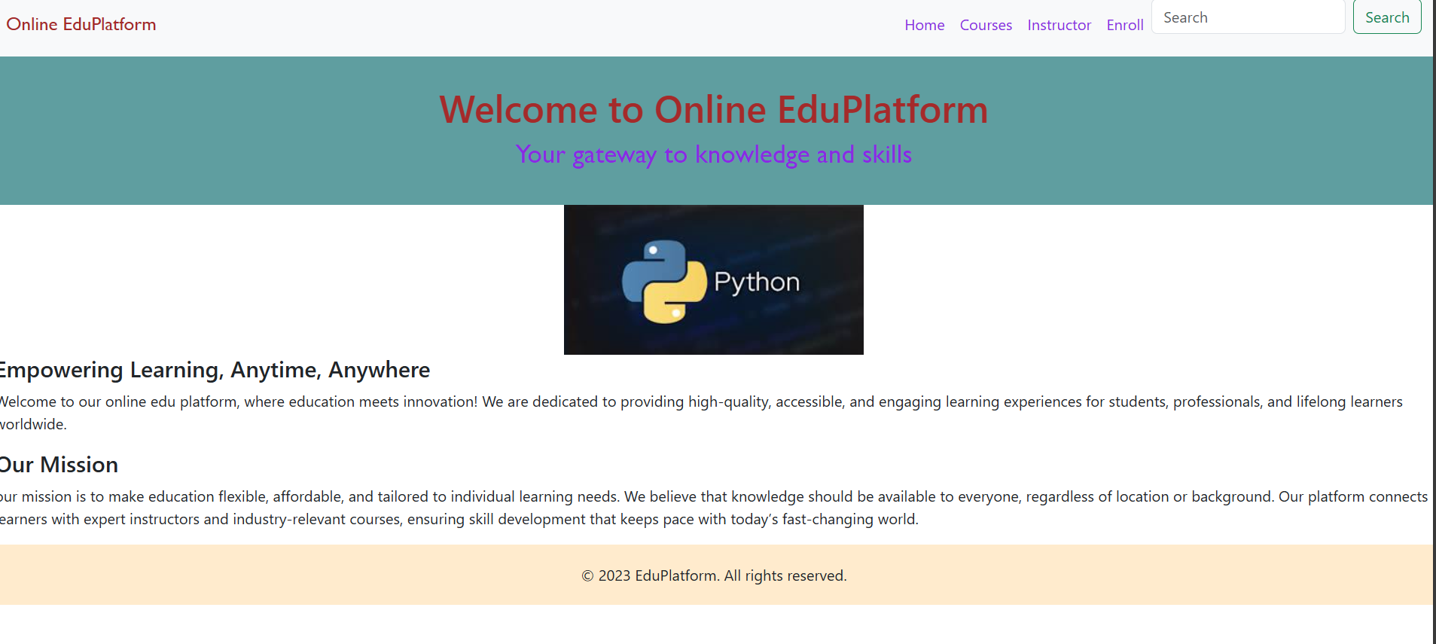**Courses Page**

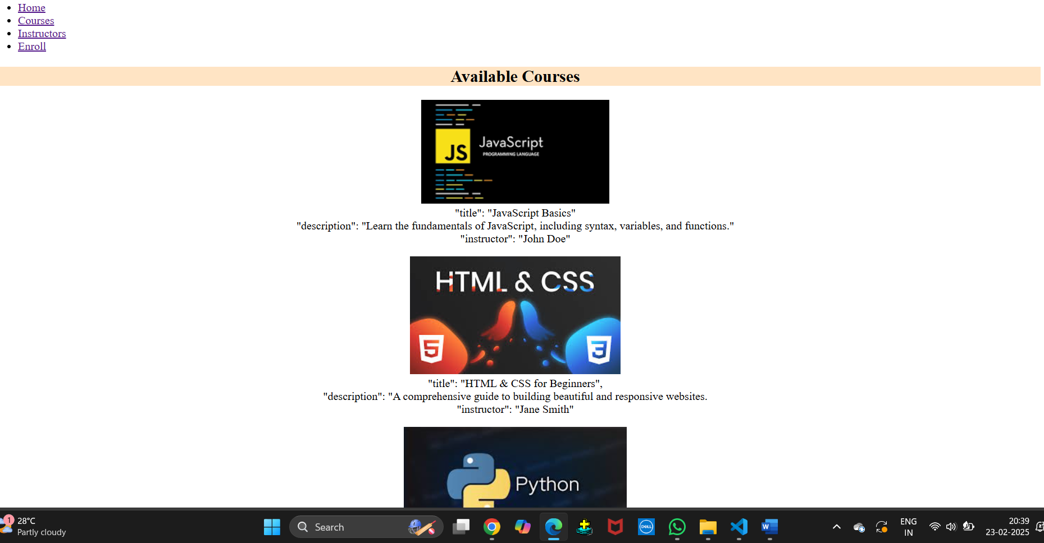

**Instructor Page**

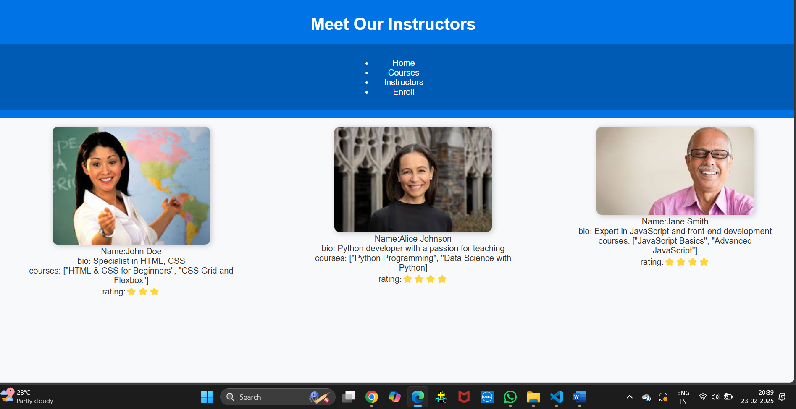

**Enrollment Page**

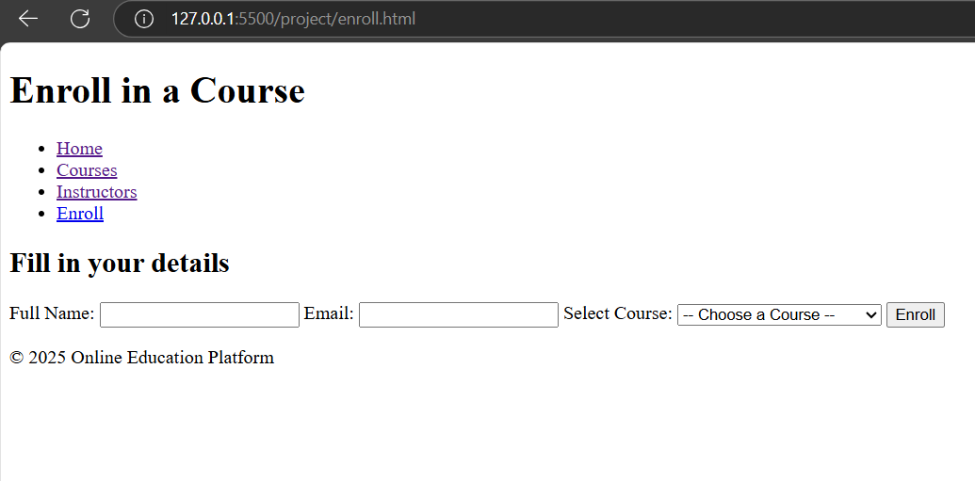

**Enrollment Form Validation**

* Ensures all fields are filled before submission
* Validates email format and phone number length
* Displays error messages for invalid inputs  
  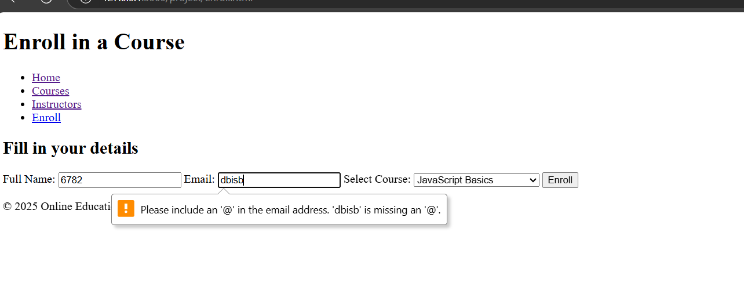

**6. Installation & Setup**

1. Download the project files from the repository.
2. Open index.html in a browser.
3. Ensure all assets (images, styles.css, script.js) are in the correct directories.
4. Test the website’s responsiveness on different devices.

**7. Conclusion**

This project demonstrates a functional and interactive **online education platform** with structured course browsing, instructor details, and an enrollment system. The implementation of **form validation** ensures data integrity and user-friendly interactions.

**Note:** Ensure that screenshots of all the pages created, along with the validation performed, are included in the final submission.