Project Title: Movie Theatre Management System

Case Study
In a movie theatre there are many halls to display many movies. A movies theatre is identified by theatre address, theatre name and unique theatre number. Theatre address is composed of street number, building number and floor number. Every hall contains a unique hall number, hall name and hall_ class. Every hall display with display type and specific screen time. Movies have attributes named movie name, movie category, movie year, movie language, movie ratting, movie duration and unique movie code. In the movie theatre management system an audience can buy many tickets but one ticket can be bought by exactly one audience. System stores audience name, audience email and audience phone number and unique audience id for audience details. While buying tickets system stores payment type and booking time. A ticket is identified by unique ticket number, date, show time, ticket price and seat number. Audience may watch movies in the specified date and time of the tickets.

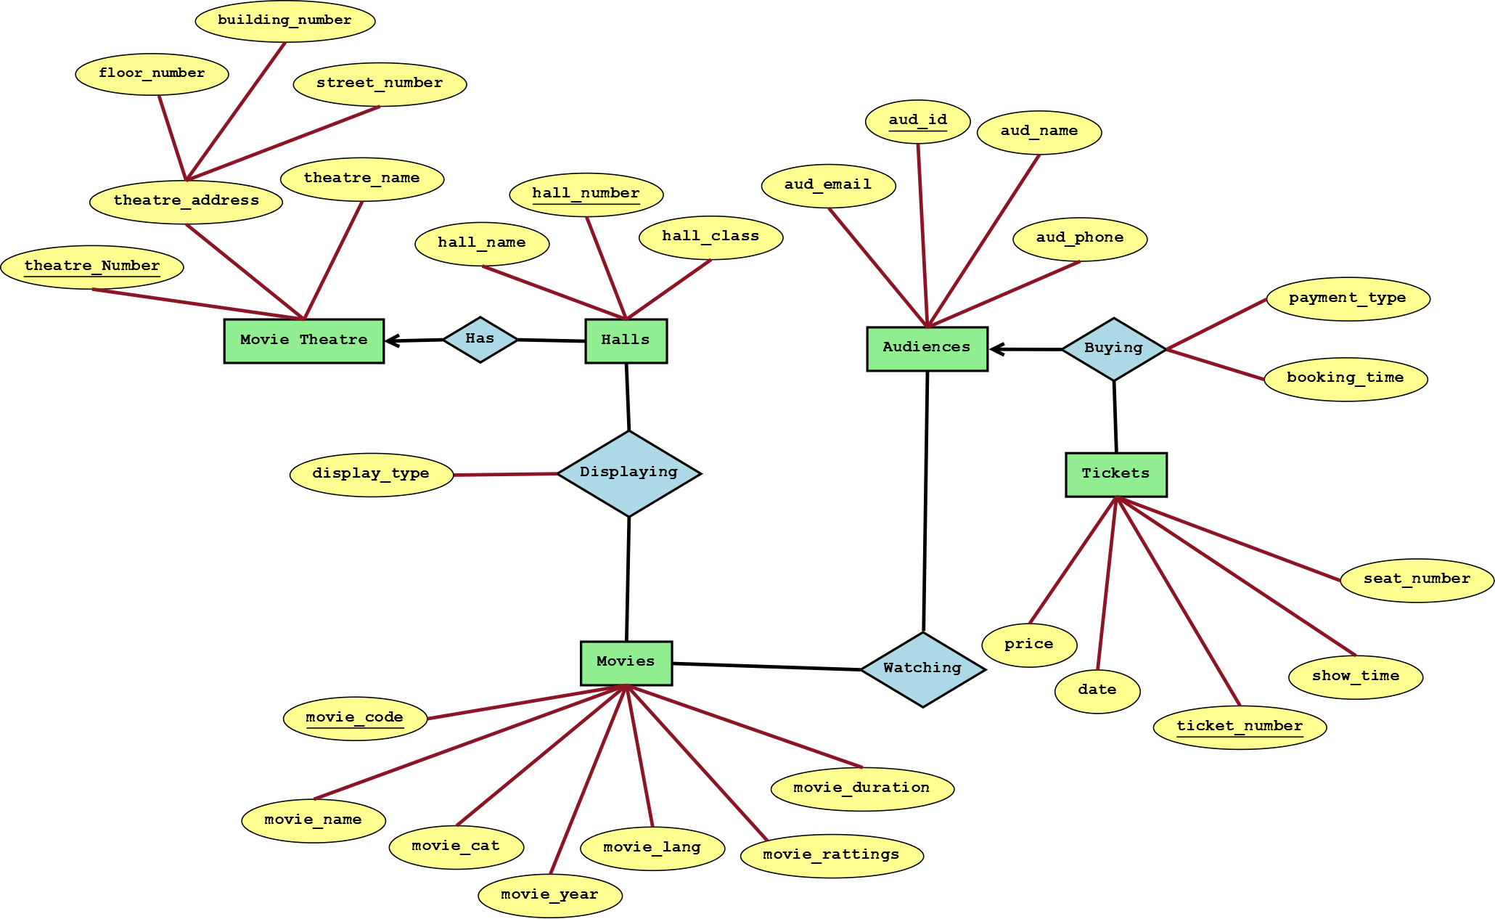
ER Diagram

NORMALIZATION

Has:
UNF:1st: theatre_number, floor_number, building _number, street_number, theatre_name, hall_name, hall_number, hall_class.
1NF:1st: theatre_number, hall_number, floor_number, building_number, street_number, theatre_name, hall_name, hall_class.
2NF: 1st: hall_number, hall_name, hall_class, theatre_number.
2nd: theatre_number, floor_number, building_number, street_number, theatre_name.
3NF: 1st: hall_number, hall_name, theatre_number.
2nd: hall_name, hall_class.
3rd: theatre_number, theatre_name , floor_number, building_number, street_number.

BUYING :
UNF: 1st: aud_id, aud_name, aud_phone, aud_email, ticket_number, price, date, show_time, seat_number, payment_type, booking_time.
1NF: 1st: aud_id, aud_name, aud_phone, aud_email, ticket number, price, show_time, date, seat_number, payment_type, booking_time.
2NF: 1st: aud_id, aud_name, aud_phone, aud_email.
2nd: ticket_number, price, date, show time, seat number.
3rd: serial_no,aud_id, ticket_number, payment type, booking time.
3NF: 1st: aud_id, aud_name, aud_phone, aud_email.
2nd: ticket_number, price, show_time, date, seat_number.
3rd: serial_no, aud_id, ticket_number, payment_type, booking_time.

WATCHING
UNF: 1st: aud_id, aud_name, aud_phone,aud_email, movie_code, movie_name, movie_cat, movie_year, movie _lang, movie_rattings, movie_duration.
1NF: 1st: aud_id, aud_name, aud_phone,aud_email, movie_code, movie_name, movie_cat, movie_year, movie_lang, movie_rattings, movie_duration.
2NF: 1st: aud_id ,aud_name, aud_phone,aud_email
2nd: movie code, movie_name, movie_cat, movie_year, movie_lang, movie _rattings, movie_duration.
3rd:serial_no,aud_id, movie_code.
3NF: 1st: aud_Id, aud_name, aud_phone,aud_email
2nd: movie_code, movie_name, movie_category, movie_year, movie_lang, movie_rattings, movie_duration.
3rd: Serial_no, audience_id, movie_code.

DISPLAYING
UNF: 1st: hall number, hall name, hall_class, movie code, movie_name, movie_cat, movie_year, movie_lang, movie_ratings, movie_duration, display_type.
1NF: 1st: hall number, hall name, hall_class, movie code, movie_name, movie_cat, movie_year, movie_lang, movie_ratings, movie_duration, display_type.
2NF: 1st: hall_number, hall name, hall class.
2nd: movie code, movie_name, movie_cat, movie_year, movie_lang, movie_ratings, movie_duration.
3rd: serial_no,hall_number, movie_code, display_type.
3NF: 1st: hall number, hall_name .
2nd: hall name, hall_class.
3rd: movie code, movie_name, movi_ cat, movie_year, movie_lang, movie_ratings, movie_duration.
4th: Serial no, hall_number, movie_code, display_type.

FINAL TABLE:
- Hall_info: hall number , hall_name, theater_number.
- Hall_class: hall name, hall_class.
- Theatre : theatre_number, theatre_name, floor_number, building_number, street_number.
- Audience: aud_id , aud_name, aud_phone, aud_email.
- Booking_details: serial no , Aud_id , ticket_number, payment_type, booking_time.
- Ticket: ticket number , price, show_time, seat_number.
- Movie: movie code , movie_name, movie_cat, movie year, movie_lang, movie_rattings, movie_duration.
- Movie_for_aud : serial no ,Audience_id , movie_code.
- Display: serial no ,Hall_number, movie_code, display_type.

Table Creation and Data Insertion

Hall_info:
Table Creation:
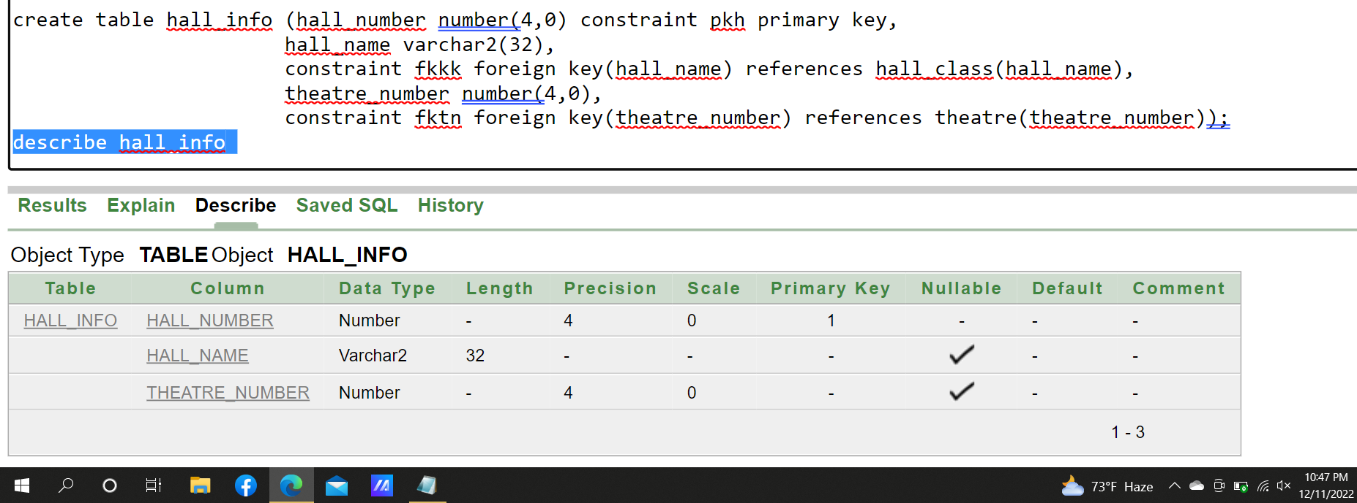

Data Insertion:
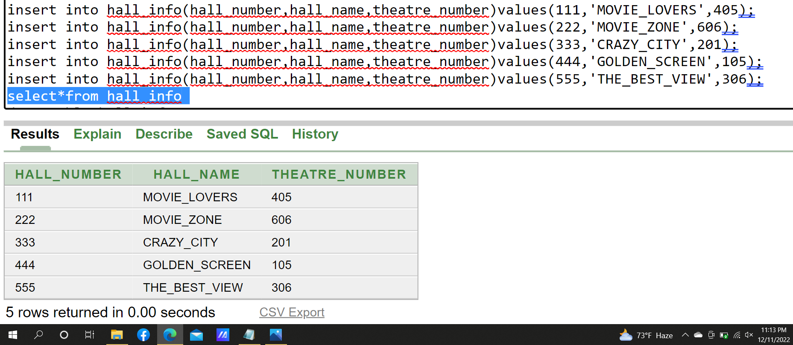

Hall Class:
Table Creation:
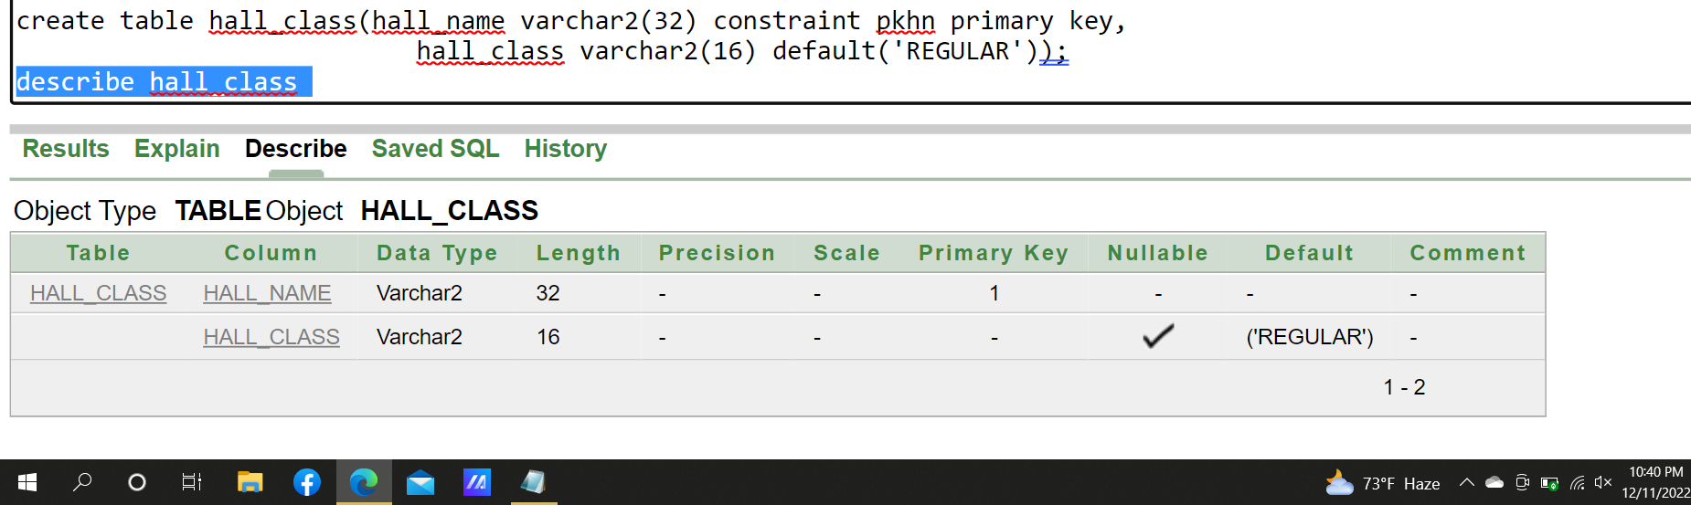

Data Insertion:
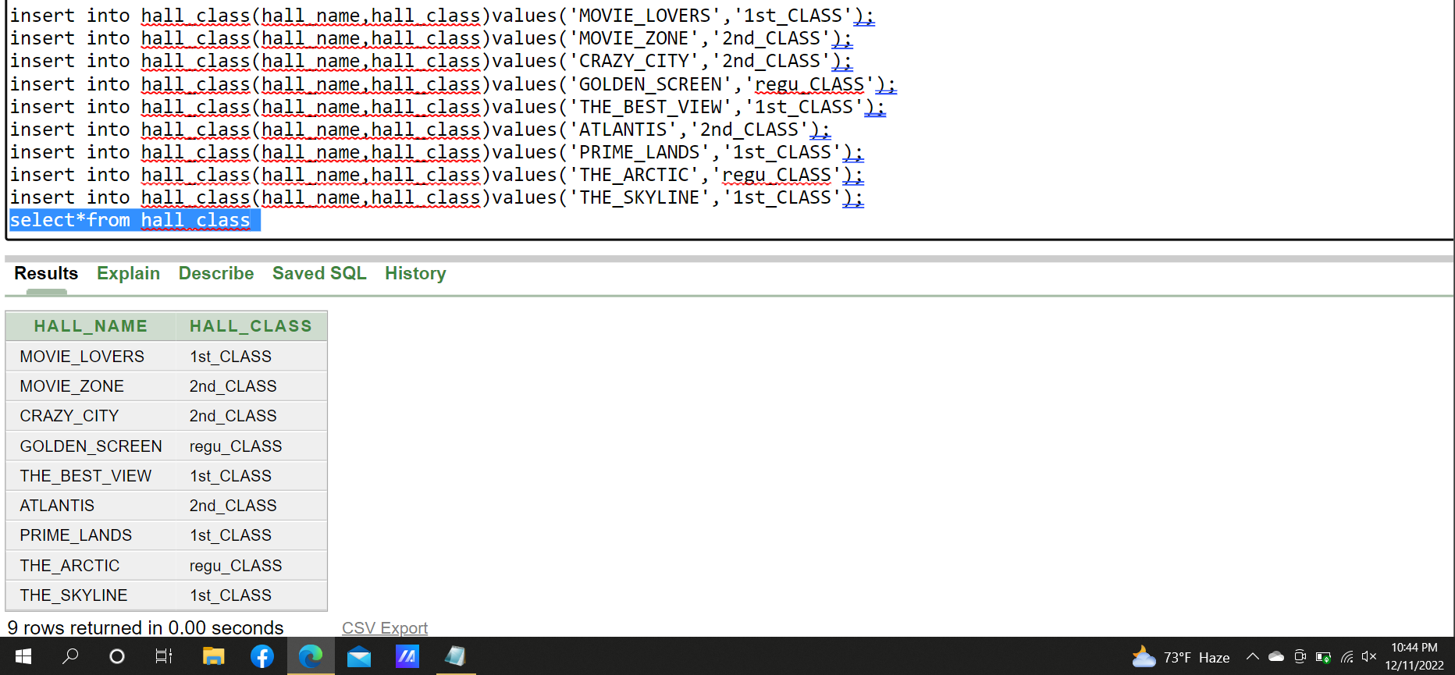

Theatre:
Table Creation:
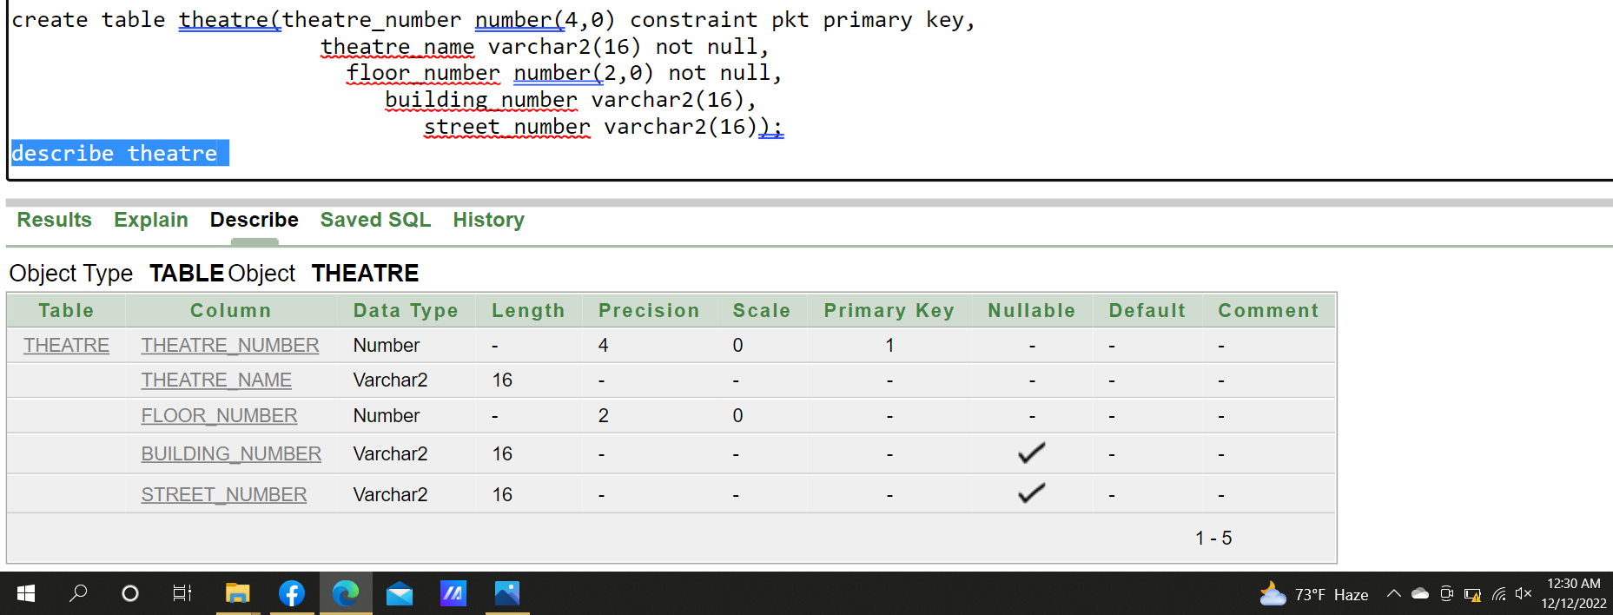

Data Insertion:
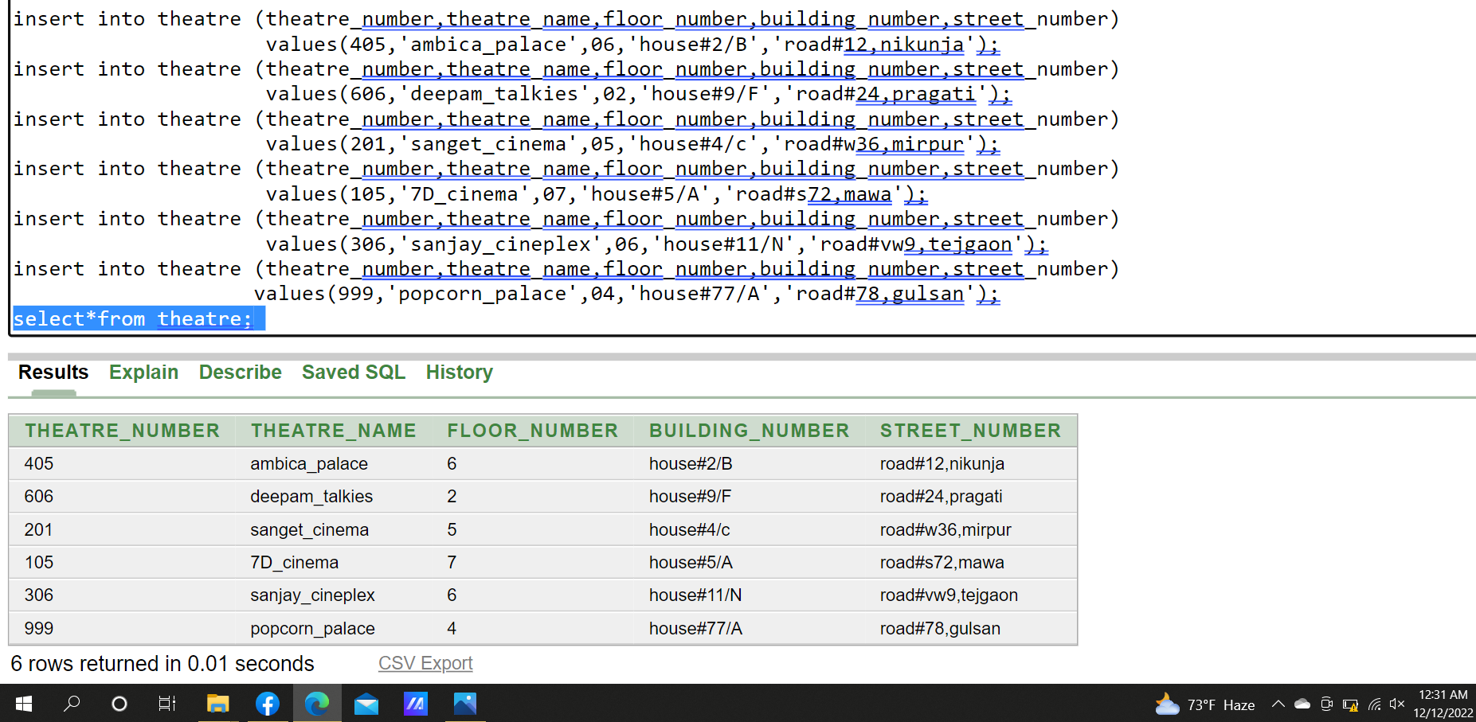

Audience:
Table Craetion:
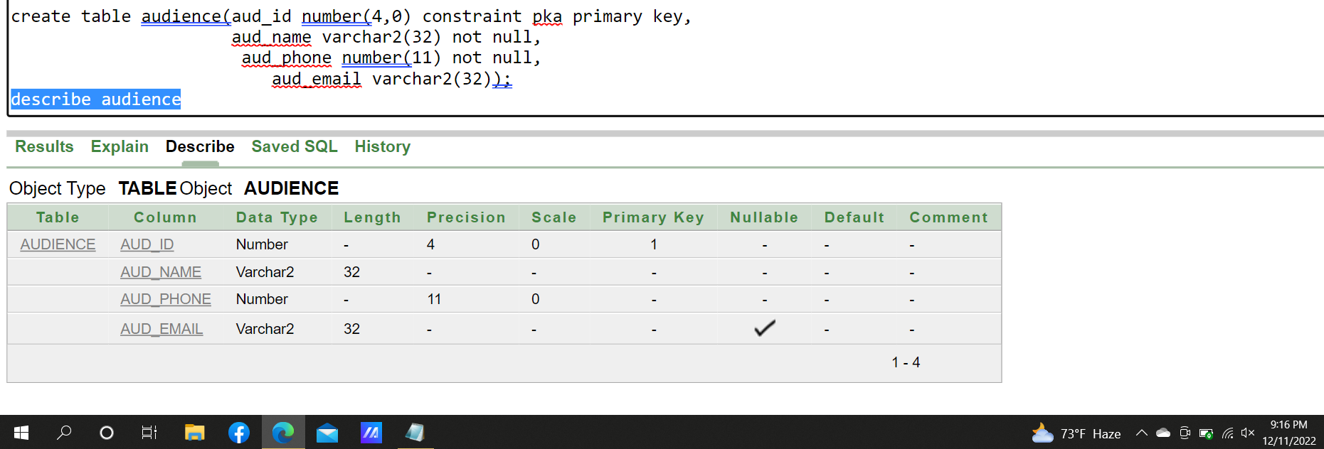

Data Insertion:
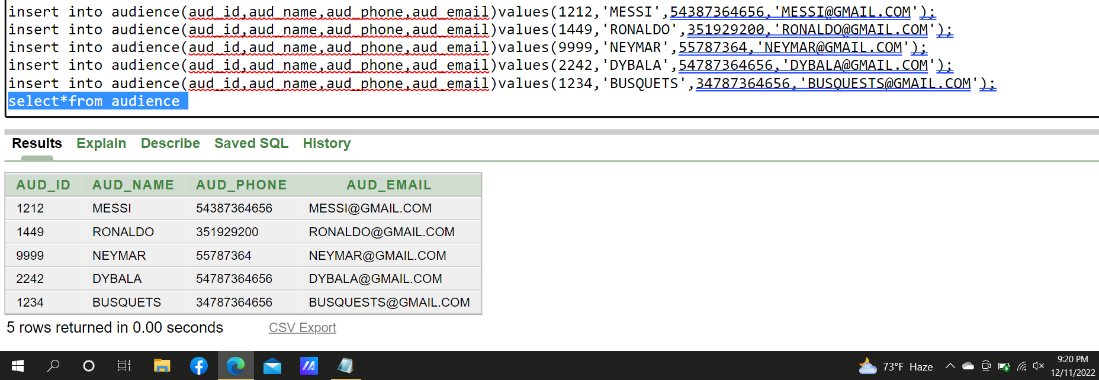

Booking_details:
Table Creation:
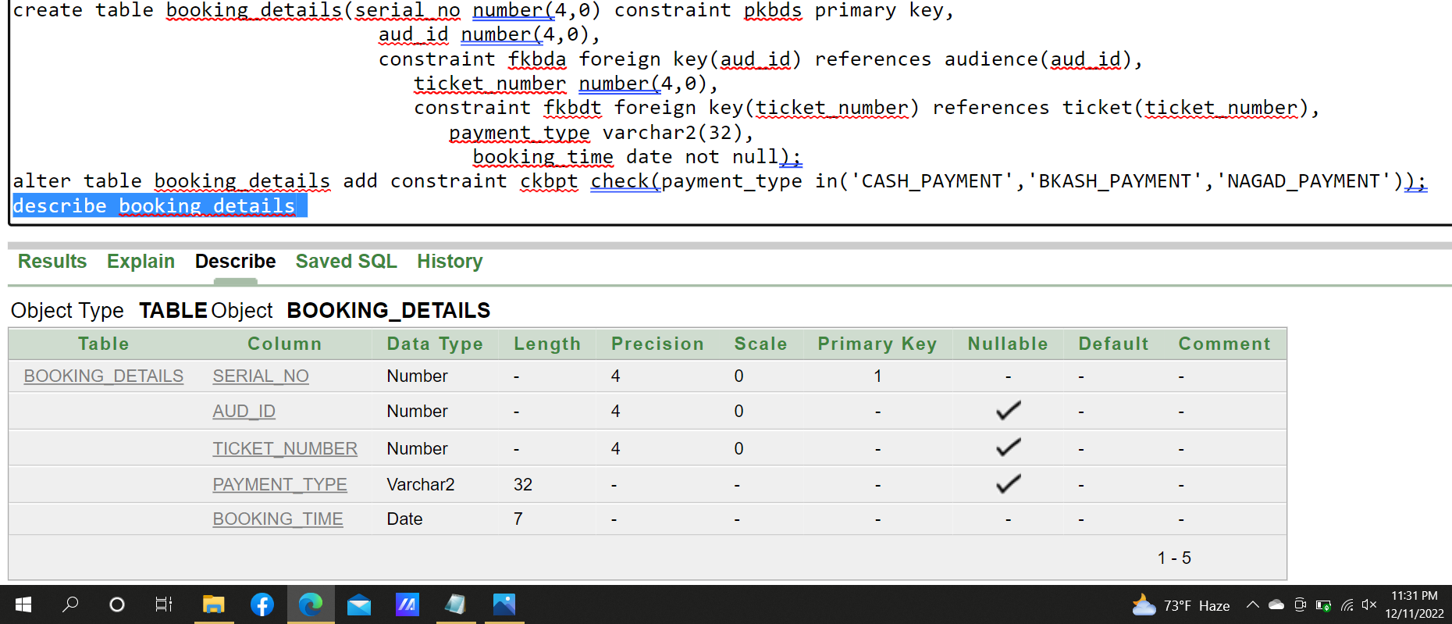

Data Insertion:
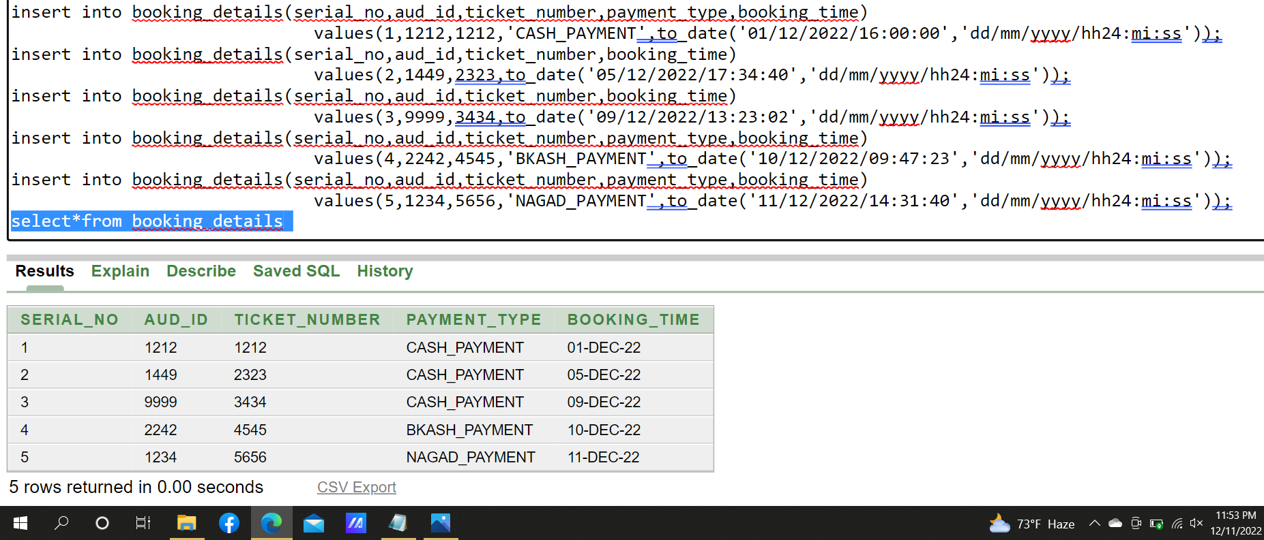

Ticket:
Table Craetion:
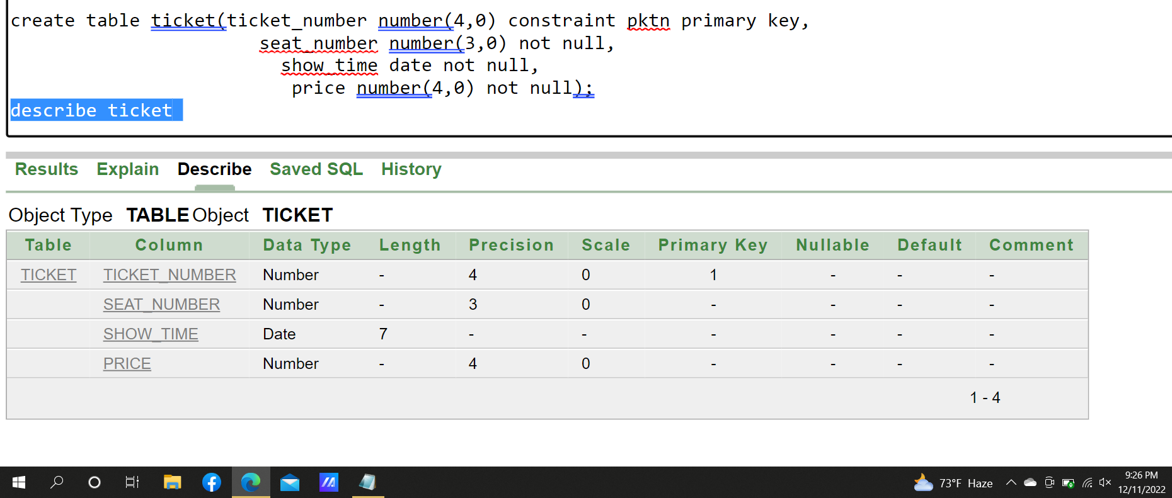

Data Insertion:
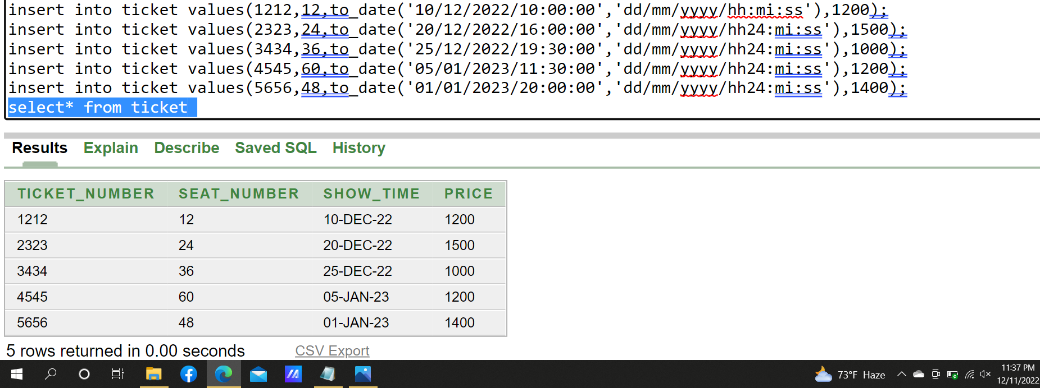

Movie:
Table Craetion :
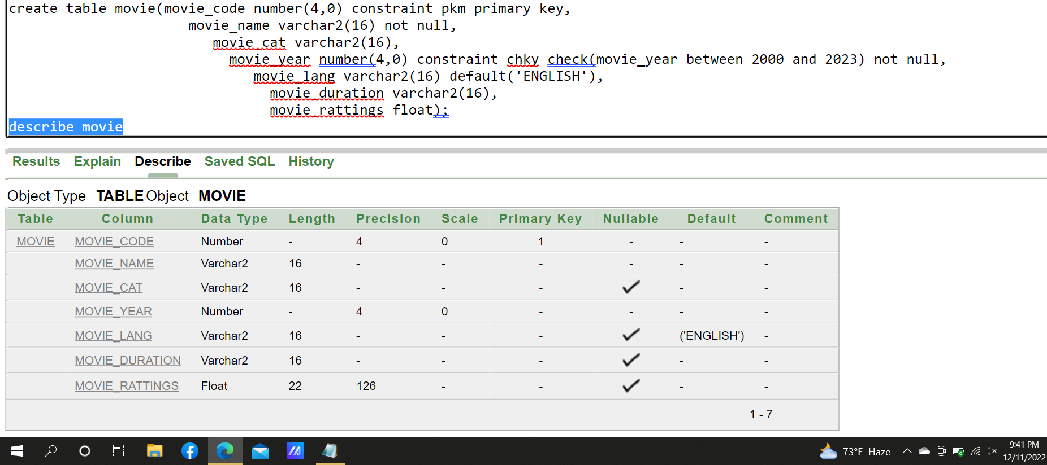

Data insertion:
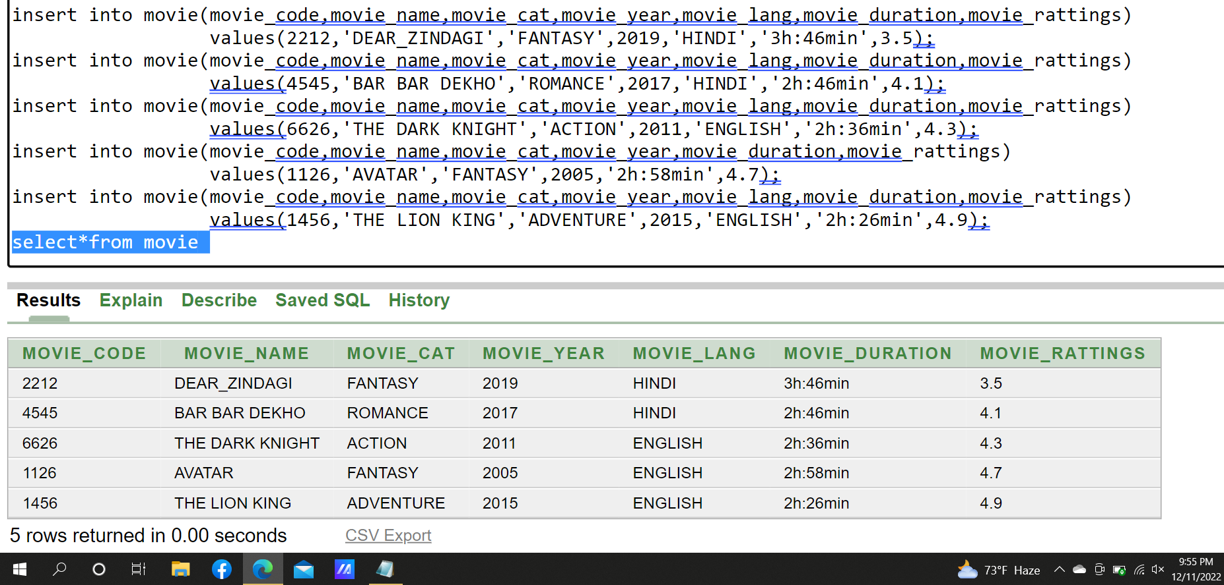
Movie_for_aud:
Table_creation:
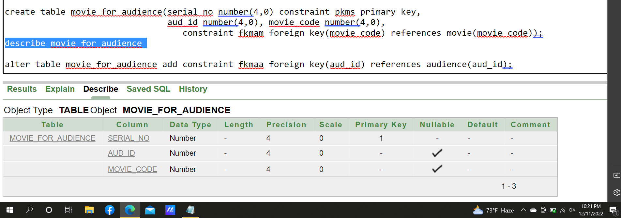

Data Insertion:
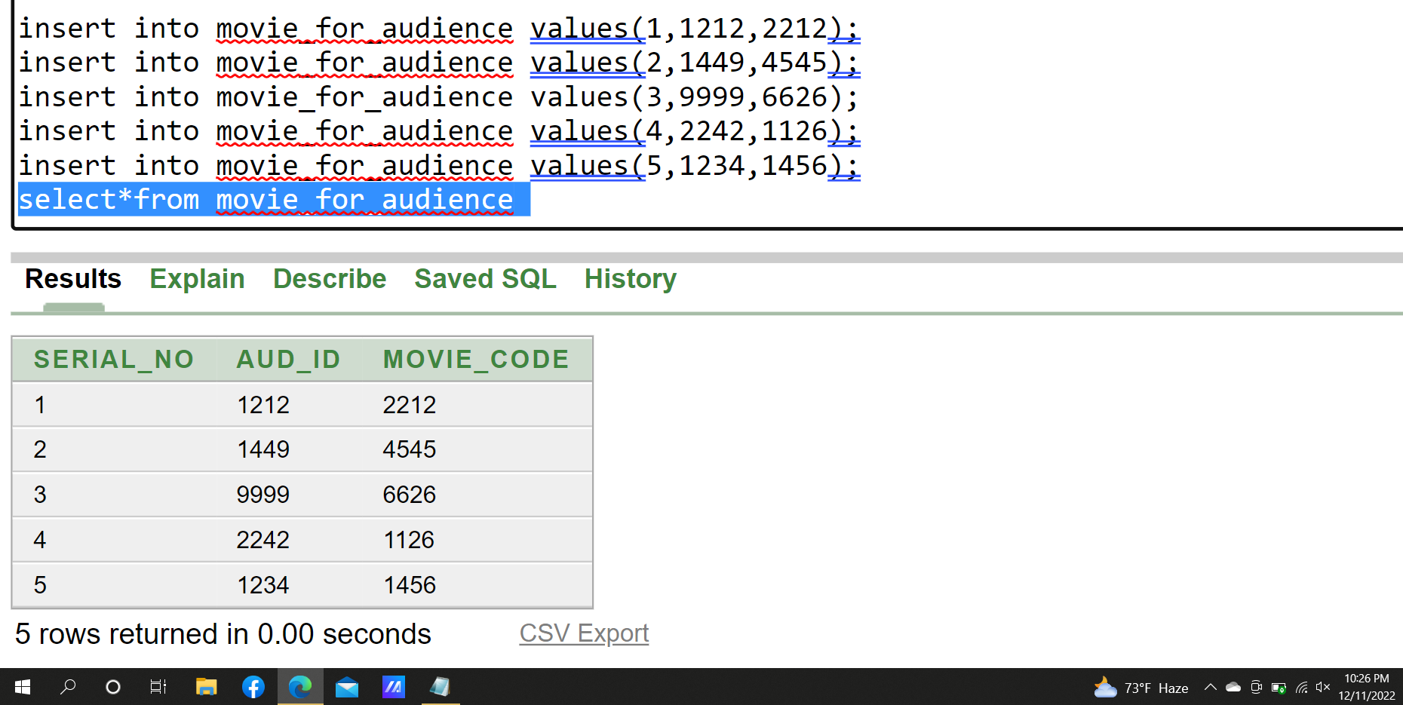
Display:
Table Creation:
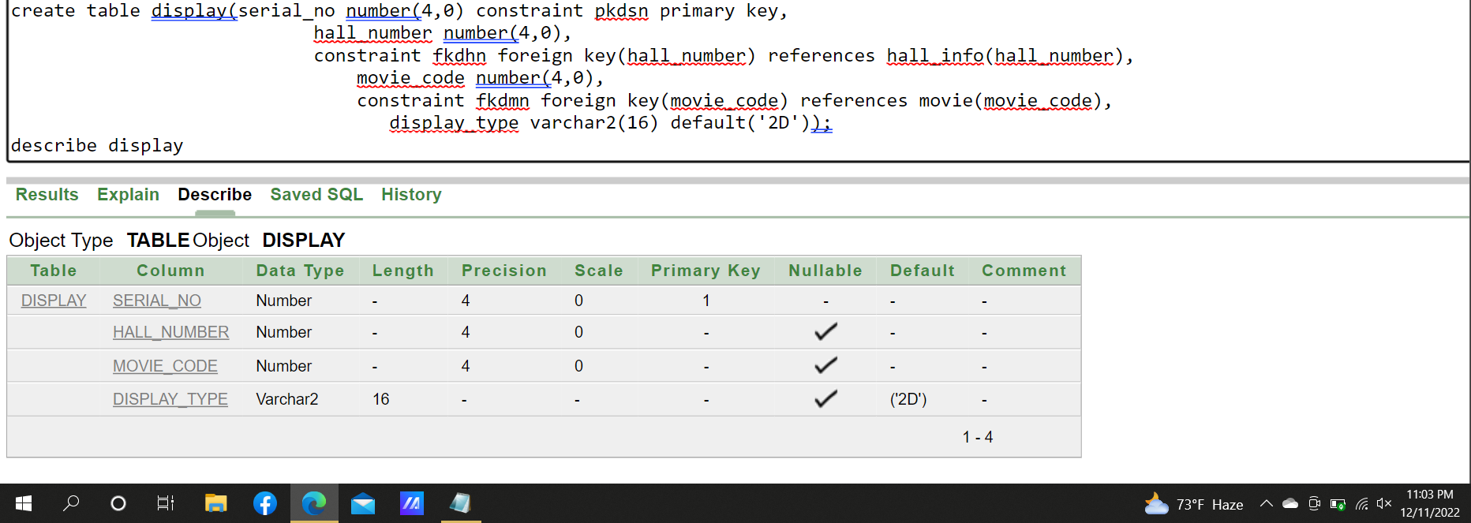

Data Insertion:
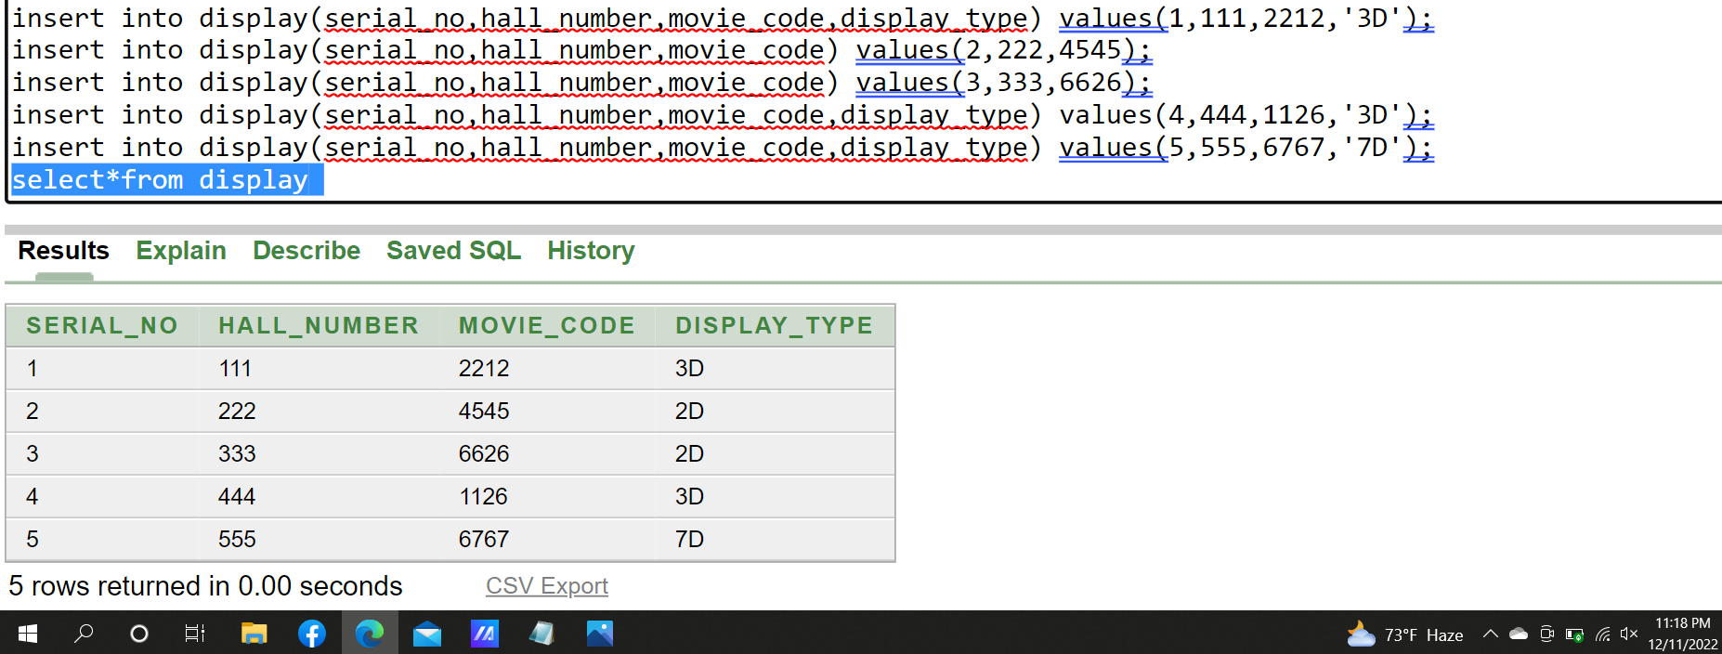

Joining
Equijoin

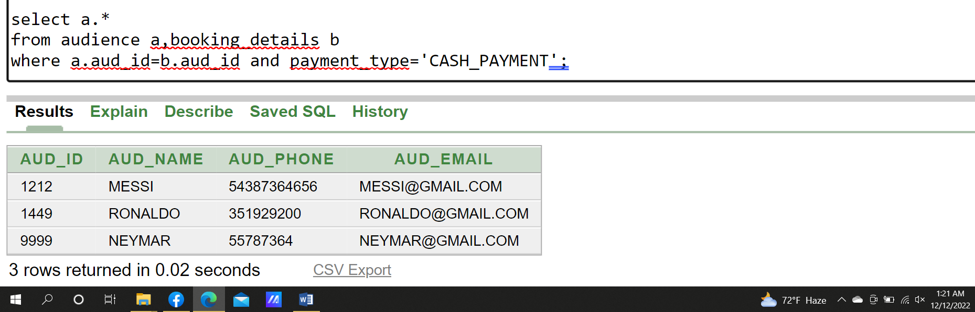
1.Display all the audience who booked tickets on cash.

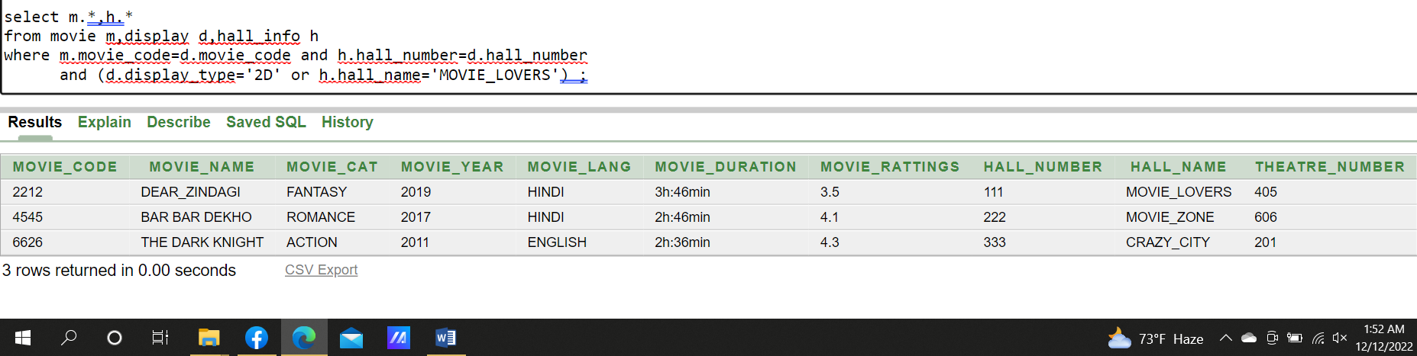
2.Display all the movie details and hall information which are shown on 2D display or shown at hall name “MOVIE_ LOVER”.

Outer join

1.Display all the hall names along with the theatre details if any theatre doesn’t have any hall mark the theatre as 'Under construction'.
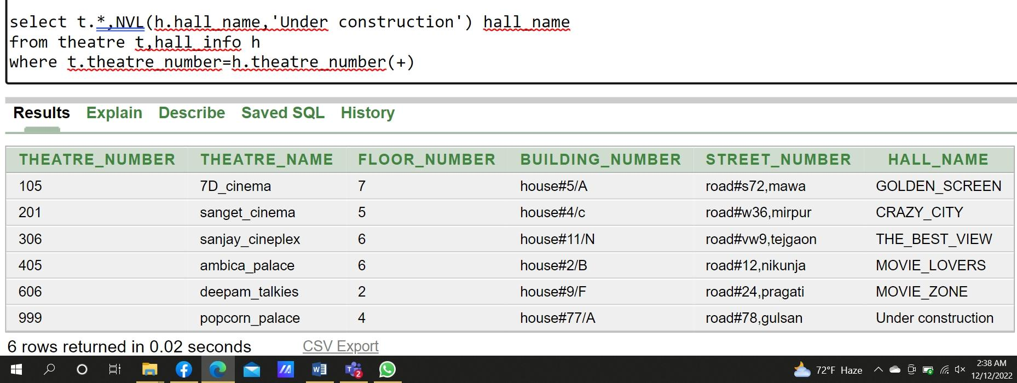

2.Display all the hall names and theatre information along with movie names if any movie does not shown yet mark it on the hall name as 'Not Shown'.
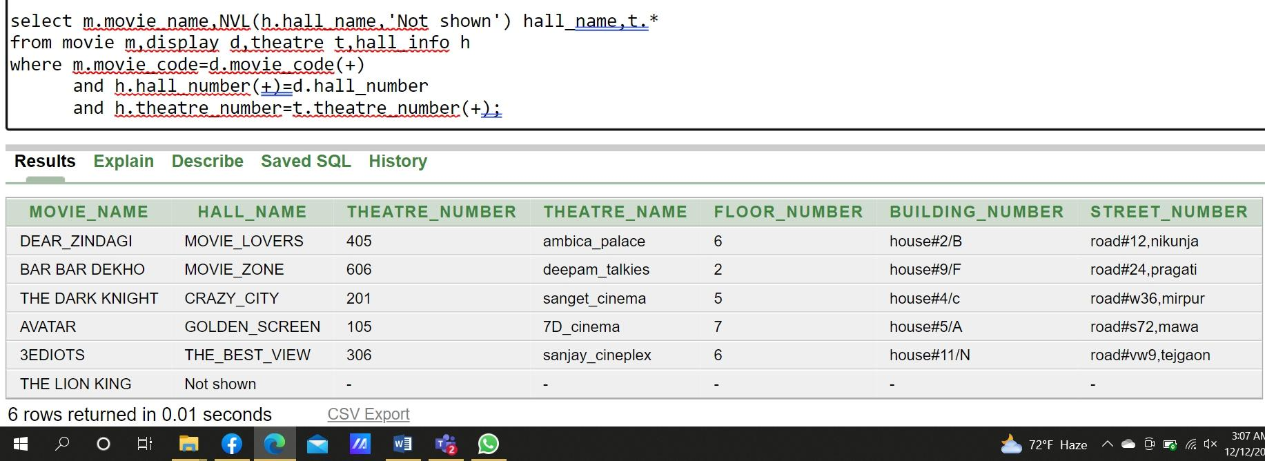

Sub-Query

- Display all the movie details whose movie years are grater than movie 3EDIOTS and ratting grater than movie 'DEAR_ ZINDAGI'.

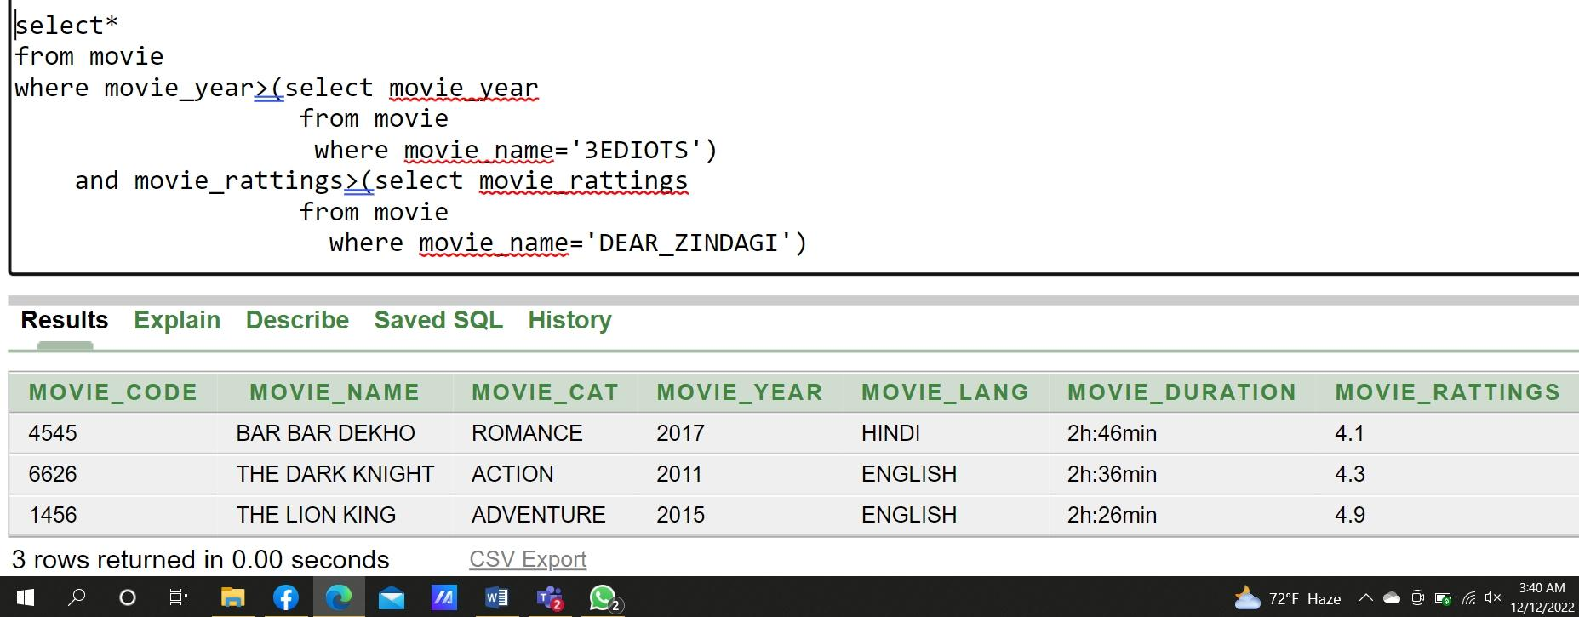

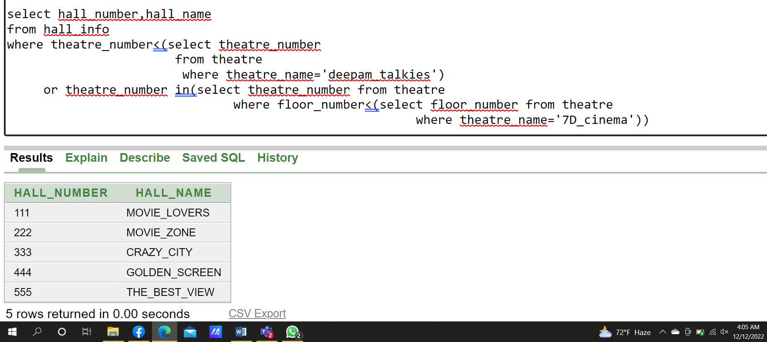
- Display hall numbers and hall names whose theatre number is lower than theatre ‘deepam_ talkies’ or located in the lower floor than theatre '7D_ cinema'.

- Display ticket number along with the price where the tickets cost more than the average price.

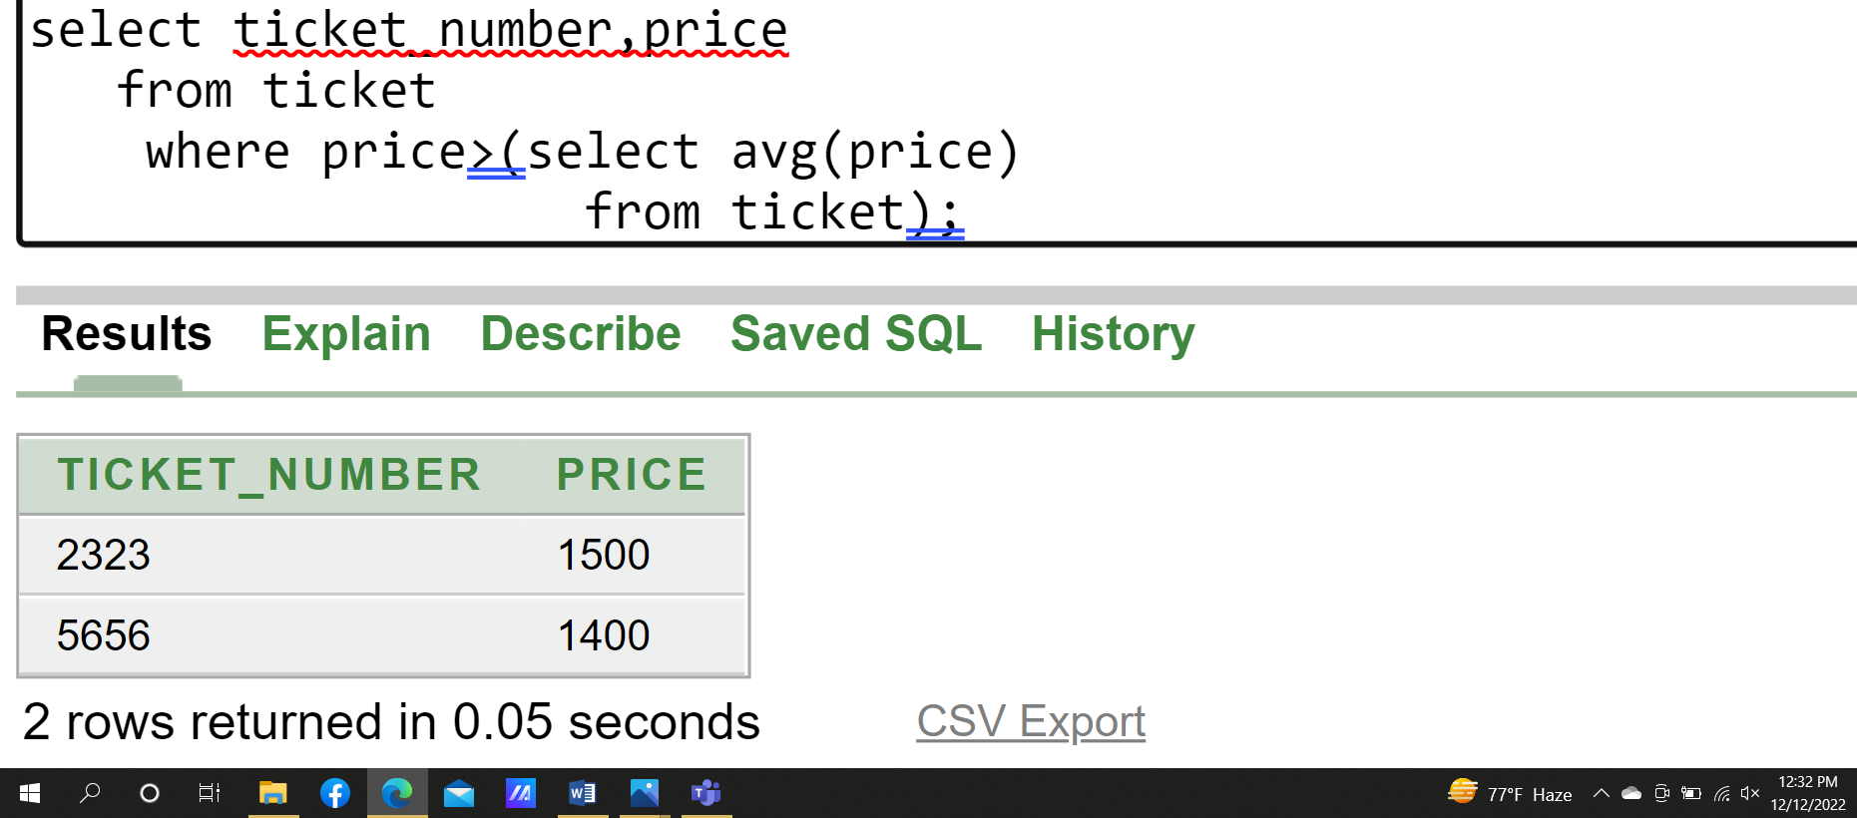

- Display all the audience details who watched the movie ‘AVATAR’ or ‘BAR BAR DEKHO’.

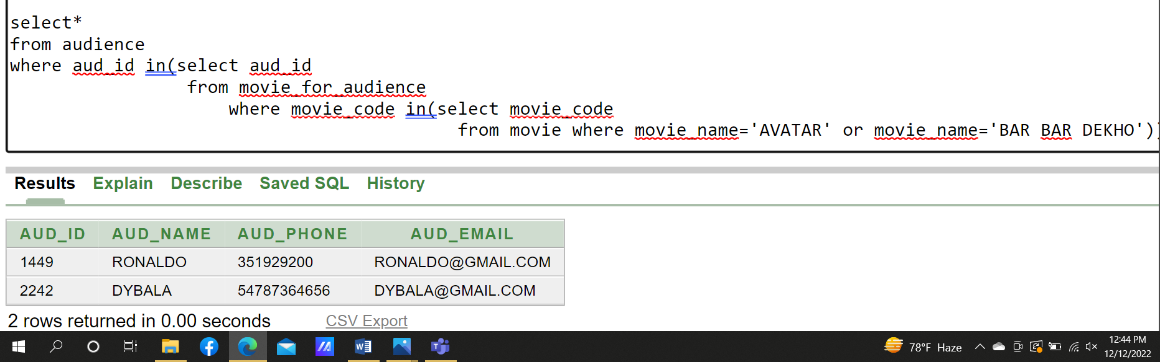

View

- Simple View: Create a view named movie_details from table movie containing movie names, movie year, and movie category where movie code is grater than 1456.

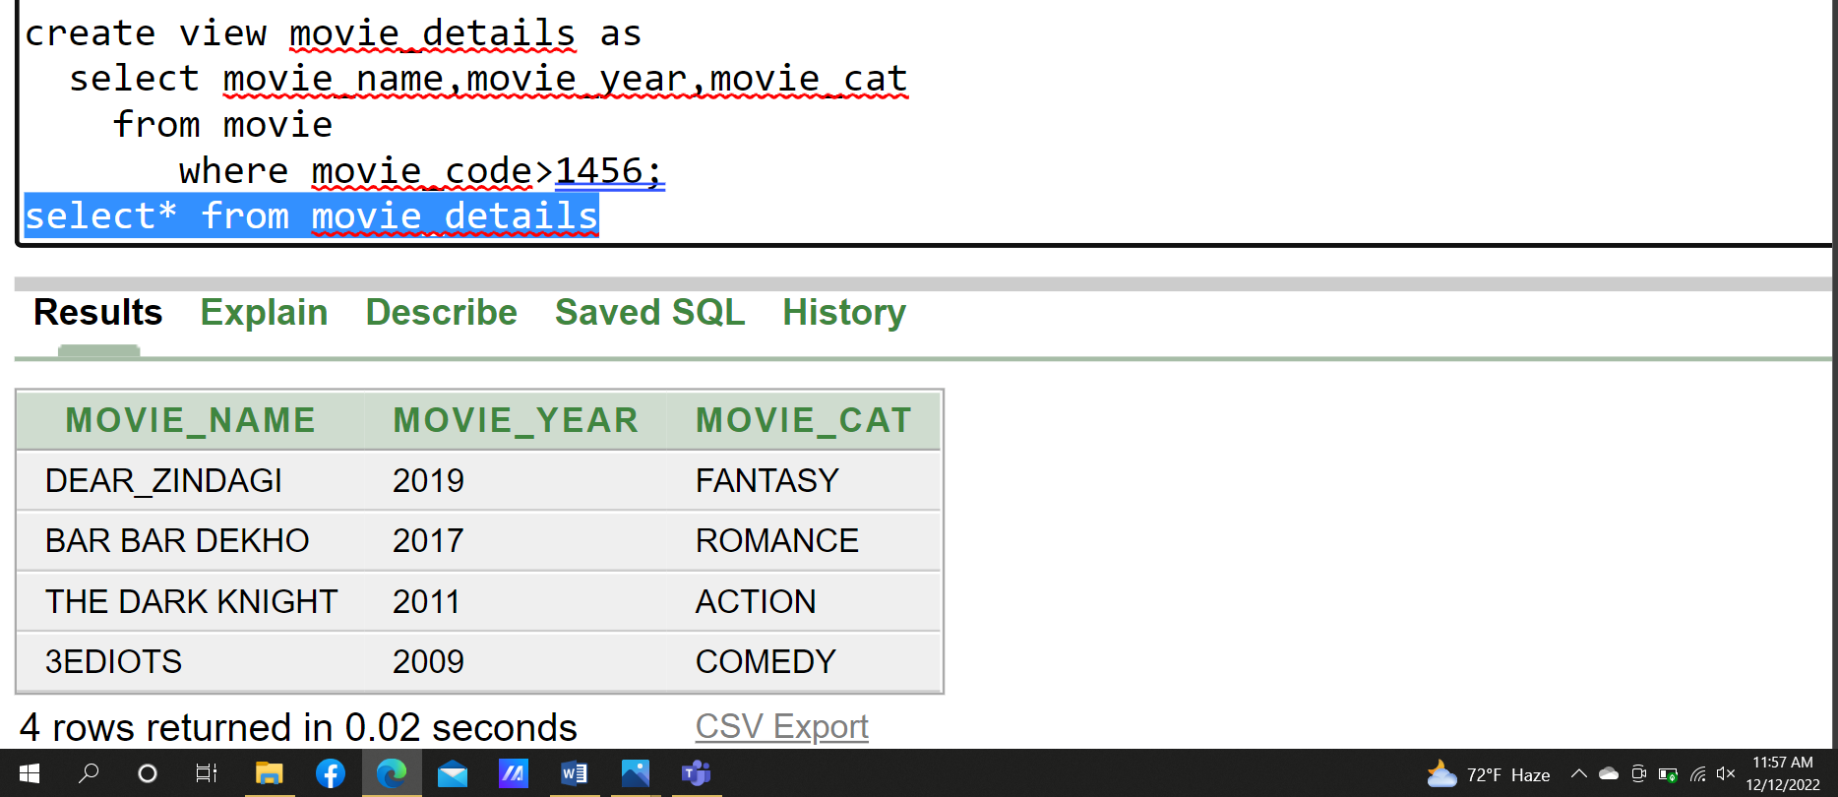

- Complex View: Create a view named v_theatre that contains the hall numbers, hall names, and theatre numbers for all halls where theatre number is grater than 201. Do not allow any hall to be changed to the another theatre though the view.

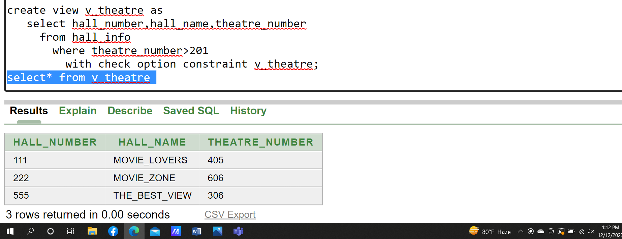

Adding constraint:

Adding check constraint on table theatre :

