# Hands-on 1: Create a Spring Web Project using Maven

package com.cognizant.springlearn; import org.slf4j.Logger;

import org.slf4j.LoggerFactory;

import org.springframework.boot.SpringApplication; import

org.springframework.boot.autoconfigure.SpringBootApplication; @SpringBootApplication

public class SpringLearnApplication {

private static final Logger LOGGER = LoggerFactory.getLogger(SpringLearnApplication.class);

public static void main(String[] args) { LOGGER.info("START");

SpringApplication.run(SpringLearnApplication.class, args); LOGGER.info("END");

}

}

**OUTPUT:**

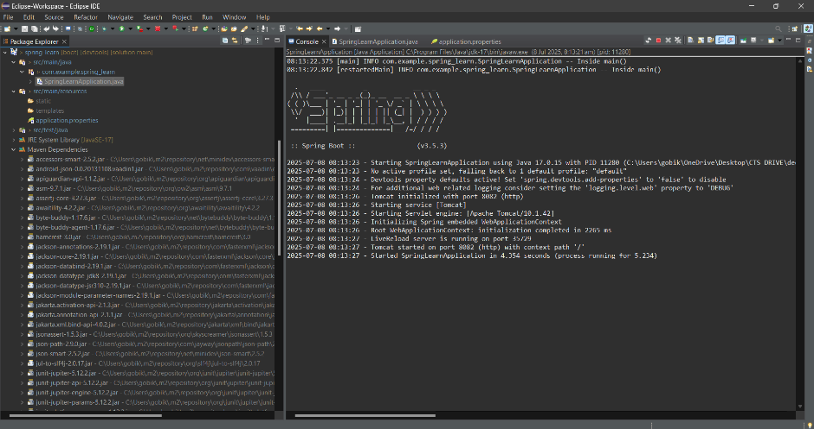

# Hands-on 2: Load SimpleDateFormat from Spring XML Config:

<?xml version="1.0" encoding="UTF-8"?>

<beans xmlns[="http://www.springframework.org/schema/beans](http://www.springframework.org/schema/beans)" xmlns:x[si="http://www.w3.org/2001/XMLSchema-instance"](http://www.w3.org/2001/XMLSchema-instance)

xsi:schemaLocation[="http://www.springframework.org/schema/beans](http://www.springframework.org/schema/beans) http[s://www.springframework.org/schema/beans/spring-beans.xsd](http://www.springframework.org/schema/beans/spring-beans.xsd)">

<bean id="dateFormat" class="java.text.SimpleDateFormat">

<constructor-arg value="dd/MM/yyyy" />

</bean>

</beans>

# Update SpringLearnApplication.java

import org.springframework.context.ApplicationContext; import

org.springframework.context.support.ClassPathXmlApplicationConte xt;

import java.text.SimpleDateFormat; import java.util.Date;

public class SpringLearnApplication {

private static final Logger LOGGER = LoggerFactory.getLogger(SpringLearnApplication.class);

public static void main(String[] args) { LOGGER.info("START");

SpringApplication.run(SpringLearnApplication.class, args); displayDate();

LOGGER.info("END");

}

public static void displayDate() { ApplicationContext context = new

ClassPathXmlApplicationContext("date-format.xml");

SimpleDateFormat format = context.getBean("dateFormat", SimpleDateFormat.class);

try {

Date date = format.parse("31/12/2018"); System.out.println(date);

} catch (Exception e) {

e.printStackTrace();

}

}

}

**OUTPUT:**

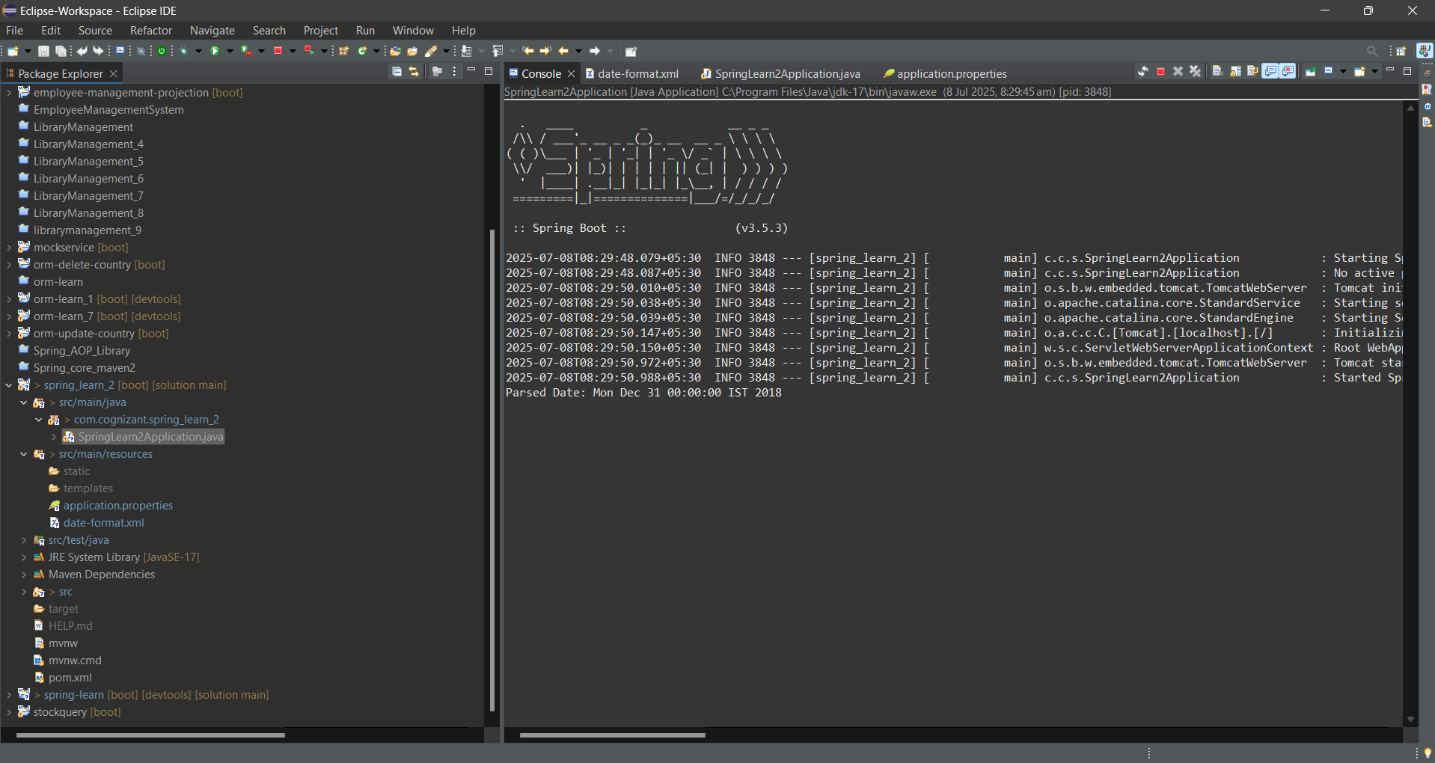

# Hands-on: Create a Basic REST API with Spring Boot:

package com.cognizant.springlearn.controller; import org.slf4j.Logger;

import org.slf4j.LoggerFactory;

import org.springframework.web.bind.annotation.GetMapping; import org.springframework.web.bind.annotation.RestController; @RestController

public class HelloController {

private static final Logger LOGGER = LoggerFactory.getLogger(HelloController.class);

@GetMapping("/hello") public String sayHello() {

LOGGER.info("START");

String message = "Hello World!!"; LOGGER.info("END");

return message;

}

}

Sample Output:

123 INFO 12345 --- [nio-8083-exec-1]

c.c.s.controller.HelloController : START

1. INFO 12345 --- [nio-8083-exec-1]

c.c.s.controller.HelloController : END

# Country API (Load from XML Bean):

<beans xmlns[="http://www.springframework.org/schema/beans](http://www.springframework.org/schema/beans)" xmlns:x[si="http://www.w3.org/2001/XMLSchema-instance"](http://www.w3.org/2001/XMLSchema-instance)

xsi:schemaLocation[="http://www.springframework.org/schema/beans](http://www.springframework.org/schema/beans)

http[s://www.springframework.org/schema/beans/spring-](http://www.springframework.org/schema/beans/spring-) beans.xsd">

<bean id="country" class="com.cognizant.springlearn.model.Country">

<property name="code" value="IN"/>

<property name="name" value="India"/>

</bean>

</beans>

# Country.java:

package com.cognizant.springlearn.model; public class Country {

private String code; private String name;

// Getters and Setters

public String getCode() { return code; }

public void setCode(String code) { this.code = code; } public String getName() { return name; }

public void setName(String name) { this.name = name; }

}

**CountryController.java**

package com.cognizant.springlearn.controller; import com.cognizant.springlearn.model.Country; import org.slf4j.Logger;

import org.slf4j.LoggerFactory;

import org.springframework.context.ApplicationContext; import

org.springframework.context.support.ClassPathXmlApplicationConte xt;

import org.springframework.web.bind.annotation.RequestMapping; import org.springframework.web.bind.annotation.RestController; @RestController

public class CountryController {

private static final Logger LOGGER = LoggerFactory.getLogger(CountryController.class);

@RequestMapping("/country") public Country getCountryIndia() {

LOGGER.info("START");

ApplicationContext context = new ClassPathXmlApplicationContext("country.xml");

Country country = context.getBean("country", Country.class); LOGGER.info("END");

return country;

}

}

**Output:**

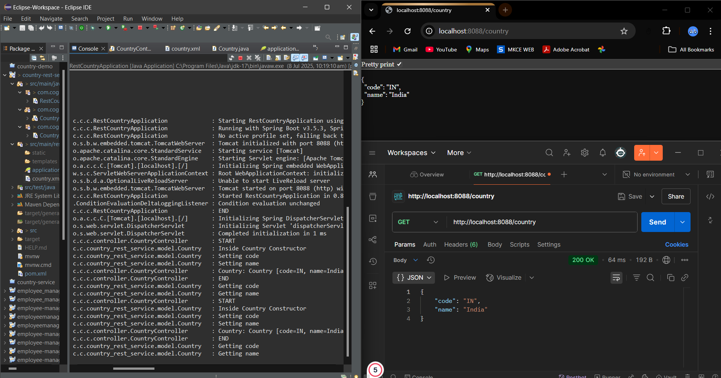

**MockMVC Testing (Basic Example):**

package com.cognizant.springlearn.controller; import org.junit.jupiter.api.Test;

import org.springframework.beans.factory.annotation.Autowired;

import org.springframework.boot.test.autoconfigure.web.servlet.AutoConfig ureMockMvc;

import org.springframework.boot.test.context.SpringBootTest;

import org.springframework.test.web.servlet.MockMvc; import static

org.springframework.test.web.servlet.request.MockMvcRequestBuild ers.get;

import static org.springframework.test.web.servlet.result.MockMvcResultMatchers

.*; @SpringBootTest

@AutoConfigureMockMvc public class HelloControllerTest {

@Autowired

private MockMvc mockMvc; @Test

public void testSayHello() throws Exception { mockMvc.perform(get("/hello"))

.andExpect(status().isOk())

.andExpect(content().string("Hello World!!"));

}

}

Sample Output:

1. INFO 12345 --- [ main] c.c.s.controller.HelloController : START
2. INFO 12345 --- [ main] c.c.s.controller.HelloController : END

. HelloControllerTest > testSayHello() PASSED

# REST - Get country based on country code:

**country.xml** (in src/main/resources):

<?xml version="1.0" encoding="UTF-8"?>

<beans xmlns[="http://www.springframework.org/schema/beans](http://www.springframework.org/schema/beans)" xmlns:x[si="http://www.w3.org/2001/XMLSchema-instance"](http://www.w3.org/2001/XMLSchema-instance)

xsi:schemaLocation[="http://www.springframework.org/schema/beans](http://www.springframework.org/schema/beans) http[s://www.springframework.org/schema/beans/spring-beans.xsd](http://www.springframework.org/schema/beans/spring-beans.xsd)">

<bean id="countryList" class="java.util.ArrayList">

<constructor-arg>

<list>

<bean class="com.cognizant.springlearn.model.Country">

<property name="code" value="IN" />

<property name="name" value="India" />

</bean>

<bean class="com.cognizant.springlearn.model.Country">

<property name="code" value="US" />

<property name="name" value="United States" />

</bean>

<bean class="com.cognizant.springlearn.model.Country">

<property name="code" value="CN" />

<property name="name" value="China" />

</bean>

</list>

</constructor-arg>

</bean>

</beans>

# Country.java

package com.cognizant.springlearn.model; public class Country {

private String code; private String name;

// Getters and Setters

public String getCode() { return code; }

public void setCode(String code) { this.code = code; } public String getName() { return name; }

public void setName(String name) { this.name = name; }

}

# CountryService.java:

package com.cognizant.springlearn.service; import com.cognizant.springlearn.model.Country;

import org.springframework.context.ApplicationContext;

import org.springframework.context.support.ClassPathXmlApplicati onContext;

import org.springframework.stereotype.Service; import java.util.List;

@Service

public class CountryService {

public Country getCountry(String code) { ApplicationContext context = new

ClassPathXmlApplicationContext("country.xml");

List<Country> countryList = context.getBean("countryList", List.class);

return countryList.stream()

.filter(country -> country.getCode().equalsIgnoreCase(code))

.findFirst()

.orElse(null); // or throw an exception if country not

found

}

}

# CountryController.java:

package com.cognizant.springlearn.controller; import com.cognizant.springlearn.model.Country;

import com.cognizant.springlearn.service.CountryService; import org.slf4j.Logger;

import org.slf4j.LoggerFactory;

import org.springframework.beans.factory.annotation.Autowired;

import org.springframework.web.bind.annotation.*; @RestController

public class CountryController {

private static final Logger LOGGER = LoggerFactory.getLogger(CountryController.class);

@Autowired

private CountryService countryService; @GetMapping("/countries/{code}")

public Country getCountry(@PathVariable String code) { LOGGER.info("START");

Country country = countryService.getCountry(code); LOGGER.info("END");

return country;

}

}

**Output:**



# 3.Static Employee Data Using Spring XML:

<beans xml[ns="http://www.springframework.org/schema/beans"](http://www.springframework.org/schema/beans)

xmlns:xsi="<http://www.w3.org/2001/XMLSchema-> instance"

xsi:schemaLoc[ation="http://www.springframework.org/schem](http://www.springframework.org/schem) a/beans https://[www.springframework.org/schema/beans/spring-](http://www.springframework.org/schema/beans/spring-) beans.xsd">

<bean id="skill1" class="com.cognizant.springlearn.model.Skill">

<property name="id" value="1" />

<property name="name" value="Java" />

</bean>

<bean id="skill2" class="com.cognizant.springlearn.model.Skill">

<property name="id" value="2" />

<property name="name" value="SQL" />

</bean>

<!-- Departments -->

<bean id="dept1" class="com.cognizant.springlearn.model.Department">

<property name="id" value="1" />

<property name="name" value="HR" />

</bean>

<bean id="dept2" class="com.cognizant.springlearn.model.Department">

<property name="id" value="2" />

<property name="name" value="IT" />

</bean>

<!-- Employees -->

<bean id="employeeList" class="java.util.ArrayList">

<constructor-arg>

<list>

<bean class="com.cognizant.springlearn.model.Employee">

<property name="id" value="1" />

<property name="name" value="Alice" />

<property name="salary" value="60000" />

<property name="permanent" value="true" />

<property name="department" ref="dept1" />

<property name="skillList">

<list>

<ref bean="skill1" />

<ref bean="skill2" />

</list>

</property>

</bean>

<!-- Add 3 more Employee beans similarly -->

</list>

</constructor-arg>

</bean>

</beans>

# DAO Layer:

package com.cognizant.springlearn.dao;

import com.cognizant.springlearn.model.Employee;

import org.springframework.context.ApplicationContext;

import org.springframework.context.support.ClassPathXmlApplicati onContext;

import org.springframework.stereotype.Repository; import java.util.List;

@Repository

public class EmployeeDao {

private static List<Employee> EMPLOYEE_LIST; public EmployeeDao() {

ApplicationContext context = new ClassPathXmlApplicationContext("employee.xml");

EMPLOYEE_LIST = context.getBean("employeeList", List.class);

}

public List<Employee> getAllEmployees() { return EMPLOYEE_LIST;

}

}

Sample Output:

123 INFO 12345 --- [nio-8083-exec-1]

c.c.s.controller.EmployeeController : GET /employees called

# Service Layer:

package com.cognizant.springlearn.service;

import com.cognizant.springlearn.dao.EmployeeDao;

import com.cognizant.springlearn.model.Employee;

import org.springframework.beans.factory.annotation.Autowired;

import org.springframework.stereotype.Service;

import org.springframework.transaction.annotation.Transactional;

import java.util.List; @Service

public class EmployeeService { @Autowired

private EmployeeDao employeeDao; @Transactional

public List<Employee> getAllEmployees() { return employeeDao.getAllEmployees();

}

}

**output:**

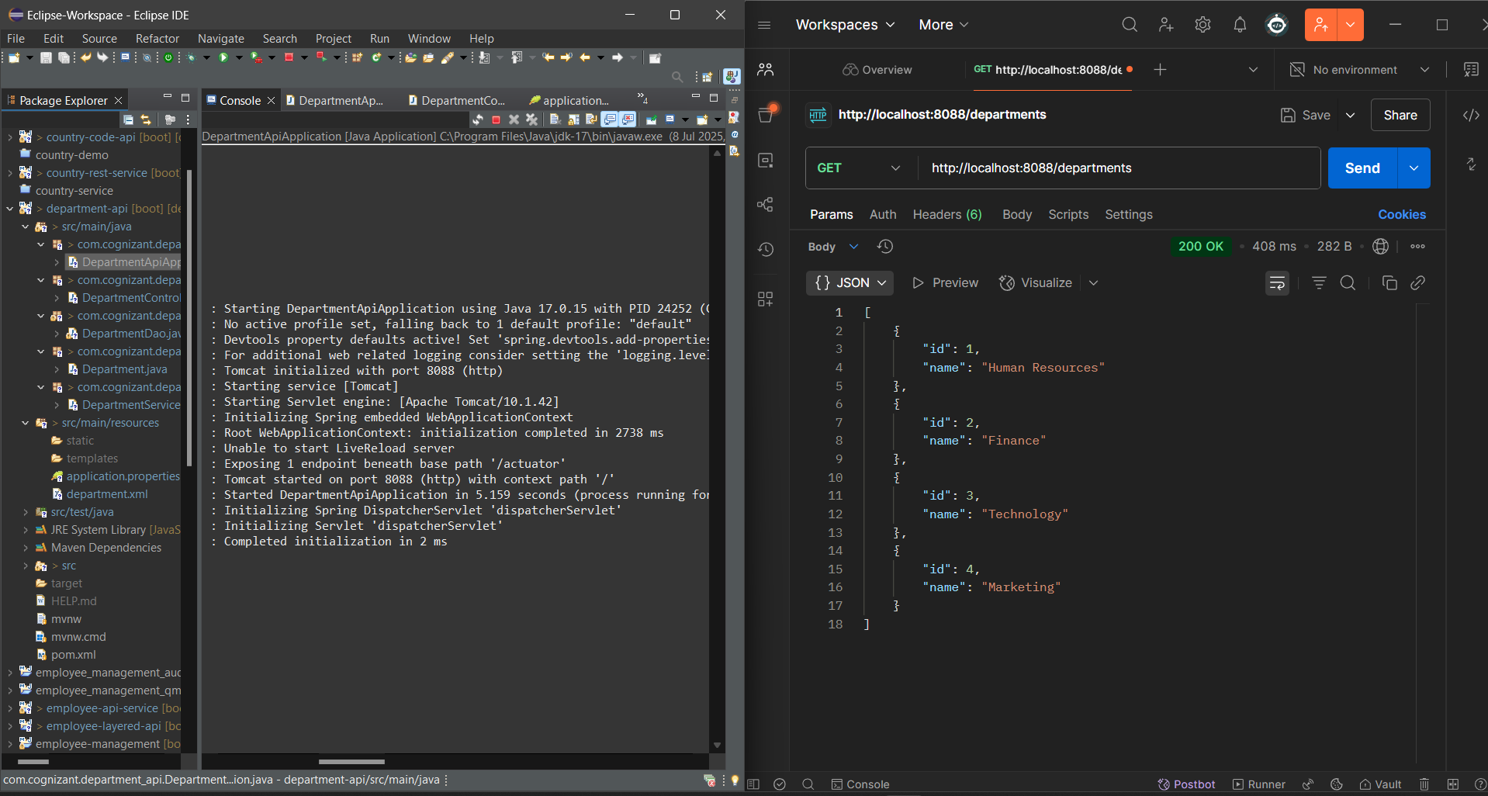

# REST Controller:

package com.cognizant.springlearn.controller; import com.cognizant.springlearn.model.Employee;

import com.cognizant.springlearn.service.EmployeeService;

import org.springframework.beans.factory.annotation.Autowired;

import org.springframework.web.bind.annotation.*; import java.util.List;

@RestController

public class EmployeeController { @Autowired

private EmployeeService employeeService; @GetMapping("/employees")

public List<Employee> getAllEmployees() { return employeeService.getAllEmployees();

}

}

# Department REST Service:

package com.cognizant.springlearn.dao;

import com.cognizant.springlearn.model.Department;

import org.springframework.context.ApplicationContext;

import org.springframework.context.support.ClassPathXmlApplicati onContext;

import org.springframework.stereotype.Repository; import java.util.List;

@Repository

public class DepartmentDao {

private static List<Department> DEPARTMENT_LIST; public DepartmentDao() {

ApplicationContext context = new ClassPathXmlApplicationContext("employee.xml");

DEPARTMENT_LIST =

context.getBean("departmentList", List.class); // Ensure departmentList bean exists

}

public List<Department> getAllDepartments() { return DEPARTMENT_LIST;

}

}

package com.cognizant.springlearn.service;

import com.cognizant.springlearn.dao.DepartmentDao; import com.cognizant.springlearn.model.Department;

import org.springframework.beans.factory.annotation.Autowired;

import org.springframework.stereotype.Service; import java.util.List;

@Service

public class DepartmentService { @Autowired

private DepartmentDao departmentDao

public List<Department> getAllDepartments() { return departmentDao.getAllDepartments();

}

}

package com.cognizant.springlearn.controller;

import com.cognizant.springlearn.model.Department;

import com.cognizant.springlearn.service.DepartmentService;

import org.springframework.beans.factory.annotation.Autowired;

import org.springframework.web.bind.annotation.*; import java.util.List;

@RestController

public class DepartmentController { @Autowired

private DepartmentService departmentService @GetMapping("/departments")

public List<Department> getAllDepartments() { return departmentService.getAllDepartments();

}

}

# output:

getEmployees(): Observable<Employee[]> { return

this.http.get<Employee[][>('http://localhost:8083/employees');](http://localhost:8083/employees%27)%3B)

}

GET <http://localhost:8083/countries/in>

{

"code": "IN",

"name": "India"

}

# 5. Create authentication service that returns JWT:

<dependency>

<groupId>io.jsonwebtoken</groupId>

<artifactId>jjwt</artifactId>

<version>0.9.1</version>

</dependency>

<dependency>

<groupId>org.springframework.boot</groupId>

<artifactId>spring-boot-starter-security</artifactId>

</dependency>

2. Security Configuration (SecurityConfig.java):

package com.cognizant.springlearn.config; import

org.springframework.context.annotation.Configuration;

import org.springframework.security.config.annotation.web.builders. HttpSecurity;

import org.springframework.security.config.annotation.web.configur ation.WebSecurityConfigurerAdapter;

@Configuration

public class SecurityConfig extends WebSecurityConfigurerAdapter {

@Override

protected void configure(HttpSecurity http) throws Exception {

http.csrf().disable()

.authorizeRequests().antMatchers("/authenticate").permitAll()

.anyRequest().authenticated();

}

}

package com.cognizant.springlearn.controller; import com.cognizant.springlearn.util.JwtUtil; import org.springframework.http.HttpHeaders; import org.springframework.http.ResponseEntity; import org.springframework.util.Base64Utils; import org.springframework.web.bind.annotation.*; @RestController

public class AuthenticationController {

@GetMapping("/authenticate") public ResponseEntity<?>

authenticate(@RequestHeader(HttpHeaders.AUTHORIZATI ON) String authHeader) {

")) {

if (authHeader != null && authHeader.startsWith("Basic

String base64Credentials =

authHeader.substring("Basic ".length());

String credentials = new String(Base64Utils.decodeFromString(base64Credentials));

String[] values = credentials.split(":", 2); String username = values[0];

String password = values[1];

if ("user".equals(username) && "pwd".equals(password)) {

String token = JwtUtil.generateToken(username); return ResponseEntity.ok().body("{\"token\":\"" +

token + "\"}");

} else {

return ResponseEntity.status(401).body("Invalid credentials");

}

}

return ResponseEntity.status(400).body("Missing Authorization Header");

}

}

package com.cognizant.springlearn.util; import io.jsonwebtoken.Jwts;

import io.jsonwebtoken.SignatureAlgorithm; import java.util.Date;

public class JwtUtil {

private static final String SECRET_KEY = "your_secret_key";

private static final long EXPIRATION_TIME = 1000 * 60

* 60; // 1 hour

public static String generateToken(String username) { return Jwts.builder()

.setSubject(username)

.setIssuedAt(new Date(System.currentTimeMillis()))

.setExpiration(new Date(System.currentTimeMillis() + EXPIRATION_TIME))

.signWith(SignatureAlgorithm.HS256, SECRET_KEY)

.compact();

}

}

**OUTPUT:**

