**Exercise 1: Control Structures**

**SCENARIO 1**: Loan Interest Discount for Senior Citizens

**CODE:**

BEGIN

  FOR cust IN (SELECT customer_id, age FROM customers) LOOP

    IF cust.age > 60 THEN

      UPDATE loans

      SET interest_rate = interest_rate * 0.99

      WHERE customer_id = cust.customer_id;

    END IF;

  END LOOP;

END;

/

SELECT * FROM loans;

**OUTPUT:**

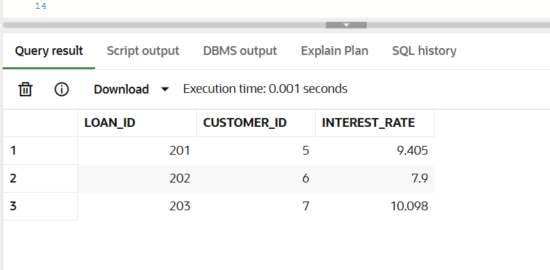

**Scenario 2:** A customer can be promoted to VIP status based on their balance.

**CODE:**

BEGIN

EXECUTE IMMEDIATE 'DROP TABLE customers';

EXCEPTION

WHEN OTHERS THEN

IF SQLCODE != -942 THEN

RAISE;

END IF;

END;

/

CREATE TABLE customers (

customer_id NUMBER PRIMARY KEY,

name VARCHAR2(50),

age NUMBER,

balance NUMBER,

is_vip CHAR(1) DEFAULT 'N'

);

BEGIN

INSERT INTO customers VALUES (1, 'John', 65, 9500, 'N');

INSERT INTO customers VALUES (2, 'Mary', 45, 15000, 'N');

INSERT INTO customers VALUES (3, 'Ravi', 70, 12000, 'N');

INSERT INTO customers VALUES (4, 'Anita', 30, 8000, 'N');

END;

/

BEGIN

FOR cust IN (SELECT customer_id, balance FROM customers) LOOP

IF cust.balance > 10000 THEN

UPDATE customers

SET is_vip = 'Y'

WHERE customer_id = cust.customer_id;

END IF;

END LOOP;

END;

/

SELECT * FROM customers;

**OUTPUT:**

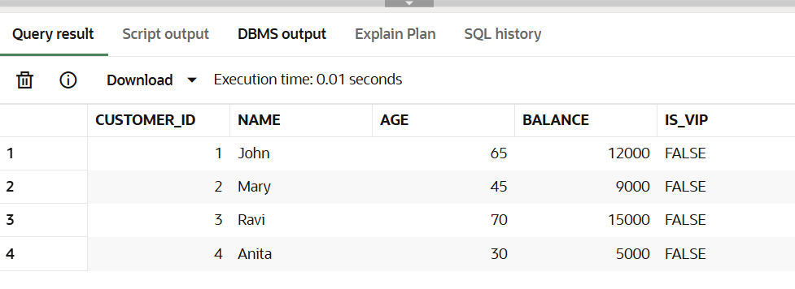

**Scenario 3:** The bank wants to send reminders to customers whose loans are due within the next 30 days.

**CODE:**

BEGIN

FOR rec IN (

SELECT l.loan_id, c.name, l.due_date

FROM loans l

JOIN customers c ON l.customer_id = c.customer_id

WHERE l.due_date BETWEEN SYSDATE AND SYSDATE + 30

) LOOP

DBMS_OUTPUT.PUT_LINE('Reminder: Loan ' || rec.loan_id ||

' for ' || rec.name ||

' is due on ' || TO_CHAR(rec.due_date, 'DD-MON-YY'));

END LOOP;

END;

/

**OUTPUT:**

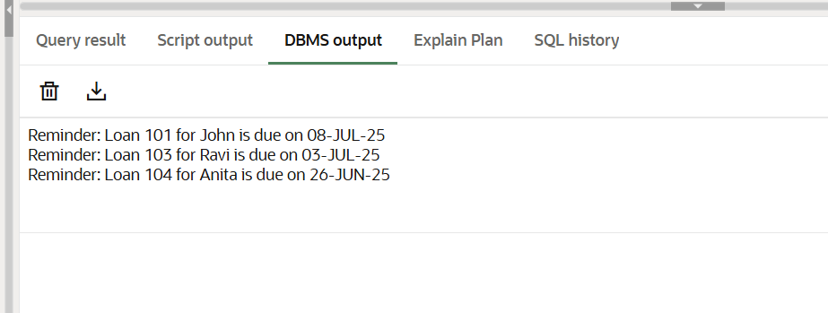

**Exercise 3: Stored Procedures**

**Scenario 1:** The bank needs to process monthly interest for all savings accounts.

**CODE:**

**Step 1**: Create accounts table

CREATE TABLE accounts (

account_id NUMBER PRIMARY KEY,

customer_id NUMBER,

account_type VARCHAR2(20),

balance NUMBER

);

**Step 2:** Insert sample data

BEGIN

INSERT INTO accounts VALUES (101, 1, 'Savings', 10000);

INSERT INTO accounts VALUES (102, 2, 'Current', 8000);

INSERT INTO accounts VALUES (103, 3, 'Savings', 15000);

COMMIT;

END;

**Step 3:** Create stored procedure

CREATE OR REPLACE PROCEDURE ProcessMonthlyInterest AS

BEGIN

UPDATE accounts

SET balance = balance * 1.01

WHERE account_type = 'Savings';

END;

/

**Step 4:** Execute procedure

BEGIN

ProcessMonthlyInterest;

END;

/

**Step 5:** View result

SELECT * FROM accounts;

**OUTPUT:**

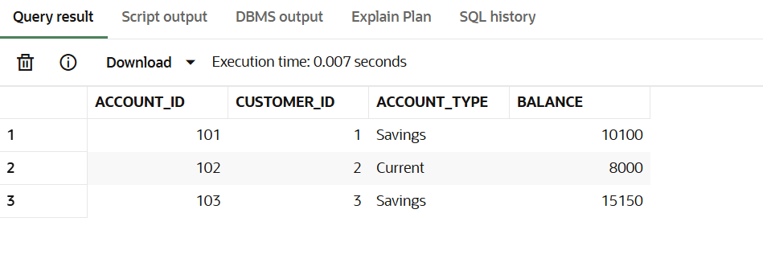

**Scenario 2:** The bank wants to implement a bonus scheme for employees based on their performance.

**CODE:**

**Step 1:** Create employees table

CREATE TABLE employees (

emp_id NUMBER PRIMARY KEY,

name VARCHAR2(50),

department VARCHAR2(50),

salary NUMBER

);

**Step 2:** Insert sample data

BEGIN

INSERT INTO employees VALUES (1, 'Alice', 'HR', 30000);

INSERT INTO employees VALUES (2, 'Bob', 'IT', 40000);

INSERT INTO employees VALUES (3, 'Charlie', 'IT', 45000);

COMMIT;

END;

/

**Step 3:** Create stored procedure

CREATE OR REPLACE PROCEDURE UpdateEmployeeBonus (

dept_name IN VARCHAR2,

bonus_percent IN NUMBER

) AS

BEGIN

UPDATE employees

SET salary = salary + (salary * bonus_percent / 100)

WHERE department = dept_name;

END;

/

**Step 4:** Execute procedure

BEGIN

UpdateEmployeeBonus('IT', 10);

END;

/

**Step 5:** View result

SELECT * FROM employees;

**OUTPUT:**

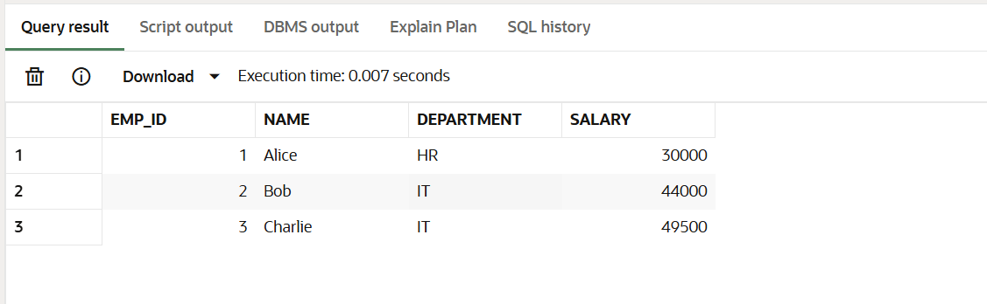

**Scenario 3:** Customers should be able to transfer funds between their accounts

**CODE:**

{Reusing accounts table from Scenario 1)

**Step 1:** Create stored procedure

CREATE OR REPLACE PROCEDURE TransferFunds (

from_account_id IN NUMBER,

to_account_id IN NUMBER,

amount IN NUMBER

) AS

from_balance NUMBER;

BEGIN

SELECT balance INTO from_balance

FROM accounts

WHERE account_id = from_account_id;

IF from_balance < amount THEN

RAISE_APPLICATION_ERROR(-20001, 'Insufficient balance');

END IF;

UPDATE accounts

SET balance = balance - amount

WHERE account_id = from_account_id;

UPDATE accounts

SET balance = balance + amount

WHERE account_id = to_account_id;

END;

/

**Step 2:** Execute procedure

BEGIN

TransferFunds(101, 102, 1000);

END;

/

**Step 3:** View result

SELECT * FROM accounts;

**OUTPUT:**

