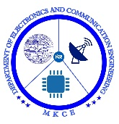

**WIRELESS SENSOR NETWORK BASED TRAIN TO**

**TRAIN IMPARTING SYSTEM**

##### A MINOR PROJECT-III REPORT

###### ***Submitted by***

|  |  |
| --- | --- |
| **KALAIYARASI M** | **927622BEC087** |
| **KAVIYA T** | **927622BEC097** |
| **MADHUMITHA V** | **927622BEC107** |
| **MONISHA A** | **927622BEC123** |

##### 

**BACHELOR OF ENGINEERING**

in

**DEPARTMENT OF ELECTRONICS AND COMMUNICATION ENGINEERING**

**M.KUMARASAMY COLLEGE OF ENGINEERING**

(Autonomous)

**KARUR – 639 113**

**DECEMBER 2024**

**M.KUMARASAMY COLLEGE OF ENGINEERING, KARUR**

**BONAFIDE CERTIFICATE**

Certified that this **18ECP105L - Minor Project III** report **“WIRELESS SENSOR BASED TRAIN TO TRAIN IMPARTING SYSTEM”** is the Bonafide work of **“KALAIYARASI M(927622BEC087), KAVIYA T(927622BEC097), MADHUMITHA V(927622BEC107), MONISHA A(927622BEC123)”** who carried out the project work under my supervision in the academic year 2024 - 2025 **ODD**.

|  |  |
| --- | --- |
| **SIGNATURE**  **Dr.A.KAVITHA, B.E.,M.E.,Ph.D., HEAD OF THE DEPARTMENT,**  Professor,  Department of Electronics and Communication Engineering, M.Kumarasamy College of Engineering,  Karur-639113. | **SIGNATURE**  **Dr.G.SHANMUGAVADIVEL, M.E.,Ph.D.,**  **SUPERVISOR**  Associate Professor,  Department of Electronics and Communication Engineering,  M.Kumarasamy College of Engineering,  Karur-639113. |

This report has been submitted for the **18ECP105L – Minor Project III** final review held at M. Kumarasamy College of Engineering, Karur on _______________________.

**PROJECT COORDINATOR**

**INSTITUTION VISION AND MISSION**

**Vision**

To emerge as a leader among the top institutions in the field of technical education.

**Mission**

**M1:** Produce smart technocrats with empirical knowledge who can surmount the global challenges.

**M2:** Create a diverse, fully -engaged, learner -centric campus environment to provide quality education to the students.

**M3:** Maintain mutually beneficial partnerships with our alumni, industry and professional associations

**DEPARTMENT VISION, MISSION, PEO, PO AND PSO**

**Vision**

To empower the Electronics and Communication Engineering students with emerging technologies, professionalism, innovative research and social responsibility.

**Mission**

**M1:** Attain the academic excellence through innovative teaching learning process, research areas & laboratories and Consultancy projects.

**M2:** Inculcate the students in problem solving and lifelong learning ability.

**M3:** Provide entrepreneurial skills and leadership qualities.

**M4:** Render the technical knowledge and skills of faculty members.

**Program Educational Objectives**

**PEO1:** **Core Competence:** Graduates will have a successful career in academia or industry associated with Electronics and Communication Engineering

**PEO2:** **Professionalism:** Graduates will provide feasible solutions for the challenging problems through comprehensive research and innovation in the allied areas of Electronics and Communication Engineering.

**PEO3:** **Lifelong Learning:** Graduates will contribute to the social needs through lifelong learning, practicing professional ethics and leadership quality

**Program Outcomes**

**PO 1: Engineering knowledge:** Apply the knowledge of mathematics, science, engineering fundamentals, and an engineering specialization to the solution of complex engineering problems.

**PO 2: Problem analysis:** Identify, formulate, review research literature, and analyze complex engineering problems reaching substantiated conclusions using first principles of mathematics, natural sciences, and engineering sciences.

**PO 3: Design/development of solutions:** Design solutions for complex engineering problems and design system components or processes that meet the specified needs with appropriate consideration for the public health and safety, and the cultural, societal, and environmental considerations.

**PO 4: Conduct investigations of complex problems:** Use research-based knowledge and research methods including design of experiments, analysis and interpretation of data, and synthesis of the information to provide valid conclusions.

**PO 5: Modern tool usage:** Create, select, and apply appropriate techniques, resources, and modern engineering and IT tools including prediction and modeling to complex engineering activities with an understanding of the limitations.

**PO 6: The engineer and society:** Apply reasoning informed by the contextual knowledge to assess societal, health, safety, legal and cultural issues and the consequent responsibilities relevant to the professional engineering practice.

**PO 7: Environment and sustainability:** Understand the impact of the professional engineering solutions in societal and environmental contexts, and demonstrate the knowledge of, and need for sustainable development.

**PO 8: Ethics:** Apply ethical principles and commit to professional ethics and responsibilities and norms of the engineering practice.

**PO 9: Individual and team work:** Function effectively as an individual, and as a member or leader in diverse teams, and in multidisciplinary settings.

**PO 10: Communication:** Communicate effectively on complex engineering activities with the engineering community and with society at large, such as, being able to comprehend and write effective reports and design documentation, make effective presentations, and give and receive clear instructions.

**PO 11: Project management and finance:** Demonstrate knowledge and understanding of the engineering and management principles and apply these to one’s own work, as a member and leader in a team, to manage projects and in multidisciplinary environments.

**PO 12: Life-long learning:** Recognize the need for, and have the preparation and ability to engage in independent and life-long learning in the broadest context of technological change.

**Program Specific Outcomes**

**PSO1:** Applying knowledge in various areas, like Electronics, Communications, Signal processing, VLSI, Embedded systems etc., in the design and implementation of Engineering application.

**PSO2:** Able to solve complex problems in Electronics and Communication Engineering with analytical and managerial skills either independently or in team using latest hardware and software tools to fulfil the industrial expectations.

|  |  |
| --- | --- |
| **Abstract** | **Matching with POs,PSOs** |
| **Train to Train collision avoidance system.** | **PO1, PO2, PO3, P04, PO5, P06, PO7, PO8, PO9, PO10, PO11, PO12, PSO1, PSO2** |

**ACKNOWLEDGEMENT**

Our sincere thanks to Thiru.M.Kumarasamy, Founder and Dr.K.Ramakrishnan, Chairman of M.Kumarasamy College of Engineering for providing extraordinary infrastructure, which helped us to complete this project in time.

It is a great privilege for us to express our gratitude to Dr.B.S.Murugan, B.Tech., M.Tech., Ph.D., Principal for providing us right ambiance to carry out this project work.

We would like to thank Dr.A.Kavitha, M.E., Ph.D., Professor and Head, Department of Electronics and Communication Engineering for her unwavering moral support and constant encouragement towards the completion of this project work.

We offer our wholehearted thanks to our Project Supervisor, Dr.G.Shanmugavadivel, M.E., Ph.D., Associate Professor, Department of Electronics and Communication Engineering for his precious guidance, tremendous supervision, kind cooperation, valuable suggestions, and support rendered in making our project to be successful.

We would like to thank our Minor Project Co-ordinator, Mrs.D.Pushpalatha, M.E., Assistant Professor, Department of Electronics and Communication Engineering for her kind cooperation and culminating in the successful completion of this project work. We are glad to thank all the Faculty Members of the Department of Electronics and Communication Engineering for extending a warm helping hand and valuable suggestions throughout the project. Words are boundless to thank our Parents and Friends for their motivation to complete this project successfully.

**ABSTRACT**

Railways are the convenient, reasonable and popular node of transport in almost all major cities of not only in India but also all over the World. Railways are the most widely used and comfortable nodes of transportation system. Now a day's in India most of the train accidents are occurs due to the human errors. It is very difficult to avoid to such train accidents because of the speed of train is very high and it requires some time to control it. In this paper the effective solution is present to avoid the train accidents by using Radio Frequency Identification (RFID). The primary goal of proposed system is to identify possible train collision ahead of time and to send the report to the main control room or driver before collision happens. Currently there is no solution to avoid train collision. So we have implemented solution based on ACD (Anti-Collision Device) system. This project introduces a Train Collision Avoidance System using RFID technology, AI machine learning, and Zigbee communication. Each locomotive is equipped with an automated surveillance system. The train tracks in railway network are divided into different frames and each segment has 2 km distance and given with distinct track numbers which are read by surveillance system inside the locomotive.RFID reader on each train detects these tags. The detected tag IDs are processed by an AI system, which analyzes the data to predict the presence of other trains on the same track. In the event of a potential collision, the system communicates through Zigbee to the train controllers, triggering an automatic braking mechanism to prevent a collision. This integrated approach enhances railway safety by providing real-time collision avoidance capabilities.

**TABLE OF CONENT**

|  |  |  |  |
| --- | --- | --- | --- |
| **CHAPTER**  **NO** | **CONTENTS** | | **PAGE NO** |
|  | **Institution Vision and Mission** | | **Iii** |
|  | **Department Vision and Mission** | | **Iii** |
|  | **Department PEOs, Pos and PSOs** | | **iv** |
|  | **Abstract** | | **Viii** |
|  | **List of Figures** | | **Xii** |
|  | **List of Abbreviations** | | **Xiii** |
| **1** | **INTRODUCTION** | | **1** |
|  | 1.1Objective | | 2 |
| **2** | **LITERATURE SURVEY** | | **3** |
|  | 2.1Train collision avoidance system by using RFID | | 3 |
|  | 2.2  2.3  2.4 | Artificial Intelligence Enabled Road Vehicle-Train Collision Risk Assessment Framework for Unmanned Railway Level Crossings. | 3  4  4 |
| A Risk-Based Decision-Making Process for Autonomous Trains Using POMDP |
| Train position detection and wayside facilities monitoring system using on-board RFID reader |
| **3** | **EXISTING SYSTEM** | | **5** |
| **4** | **PROPOSED SYSTEM** | | **5** |
| **5** | **HARDWARE DESCRIPTION** | | **9** |
|  | 5.1Protocols | | 12 |
|  | 5.2 Software and Hardware | | 14 |
|  | 5.3 Specification | | 23 |
|  | 5.4 Software Description | | 24 |
|  | 5.5 Technical Details | | 30 |
| **6** | **ADVANTAGES** | | **35** |
| **7** | **APPLICATION** | | **36** |
| **8** | **CONCLUSION** | | **37** |
| **9**    **10** | **REFERENCES**  **OUTCOME** | | **37** |

**LIST OF FIGURES**

|  |  |  |
| --- | --- | --- |
| **FIGURE No.** | **TITLE** | **PAGE No.** |
| 5.1 | Power supply | 9 |
| 5.2 | Arduino UNO | 11 |
| 5.2.1 | Delay driver | 16 |
| 5.2.3 | Darlington driver | 17 |
| 5.2.4 | LCD | 20 |
| 5.2.5 | DC motor | 21 |

**LIST OF ABBREVIATIONS**

|  |  |  |
| --- | --- | --- |
| **ACRONYM** |  | **ABBREVIATION** |
| RFID | - | Radio Frequency Indentification |
| TCAS | - | Train Collision Avoidance System |
| AI | - | Artificial intelligence |
| LCD | - | Liquid crystal Display |
| LED | - | Light Emitting Diode |
|  |  |  |

CHAPTER 1

INTRODUCTION

Railways serve as a fundamental and extensively utilized mode of transportation, providing vital connectivity and efficiency both in India and globally. Despite their extensive adoption and the comfort they provide, the occurrence of train accidents, particularly those resulting from human error, remains a pressing issue. The rapid speeds at which modern trains operate present significant challenges in accident prevention, largely due to their extended braking distances which make quick stops difficult and sometimes impossible in emergency situations. This problem is further compounded by the complexity of managing and coordinating multiple trains on a single track network, where even minor lapses in communication or operational oversight can lead to catastrophic collisions. In light of these challenges, this paper introduces an innovative solution aimed at mitigating the risk of train collisions.

We propose a Train Collision Avoidance System (TCAS) that incorporates a suite of advanced technologies, including Radio Frequency Identification (RFID), artificial intelligence (AI) machine learning, and Zigbee communication, to enhance railway safety. The core of our system lies in its ability to monitor and manage train movements with high precision. Specifically, RFID technology is employed to track train locations along segmented rail tracks, which are divided into 2 km intervals and assigned unique identifiers. This segmentation allows for precise monitoring of train positions and movements. Each locomotive is equipped with RFID readers that continuously scan and detect the unique identifiers of the track segments as the train progresses.

The data collected from these RFID readings is then fed into an AI system, which employs machine learning algorithms to analyze train positions and predict potential collision scenarios. By processing this real-time data, the AI system can identify the presence of other trains on the same track and assess the risk of a collision. When a potential collision is detected, the system uses Zigbee communication to alert train controllers and automatically activate a braking mechanism to prevent an accident. This integrated approach not only facilitates real-time monitoring and collision prediction but also ensures timely intervention to mitigate risks. By leveraging the strengths of RFID for accurate location tracking, AI for predictive analysis, and Zigbee for reliable communication, the TCAS aims to significantly enhance the safety and reliability of railway operations. This comprehensive solution is designed to address the limitations of current collision avoidance methods and provide a robust framework for preventing accidents, thereby improving overall railway safety and operational efficiency.

* 1. **OBJECTIVES**

The objective of the Wireless Sensor Network (WSN) Based Train-to-Train Imparting System* is to develop a reliable, low-cost, and energy-efficient communication framework that enhances railway safety by preventing collisions and enabling real-time data sharing between trains. This system leverages wireless sensor networks, such as ZigBee, for seamless data transmission, allowing trains to exchange critical information like location, speed, and direction. The integration of proximity detection technologies, such as RFID and GPS, ensures precise monitoring of nearby trains. A centralized control system powered by Python-based software analyzes incoming data, identifies potential risks, and automates control actions, such as slowing down or stopping trains, to avert accidents. Designed to be energy-efficient, cost-effective, and scalable, the system is adaptable to large railway networks and diverse environmental conditions. Additionally, it incorporates fail-safe mechanisms to maintain uninterrupted communication even during faults, ensuring maximum reliability and safety.

**CHAPTER - 2**

**LITERATURE SURVEY**

|  |  |
| --- | --- |
| **2.1** | [**Smita S. Bhavsar**](https://ieeexplore.ieee.org/author/37086173926)**;**[**A.N. Kulkarni**](https://ieeexplore.ieee.org/author/37086173470)**: Train collision avoidance system by using RFID-IEEE,2016**    In this paper the effective solution is present to avoid the train accidents by using Radio Frequency Identification (RFID). The primary goal of proposed system is to identify possible train collision ahead of time and to send the report to the main control room or driver before collision happens. Currently there is no solution to avoid train collision. Indian Railways have implemented solution based on ACD (Anti-Collision Device) system. Each locomotive is equipped with an automated surveillance system. The train tracks in railway network are divided into different frames and each segment has 10 km distance and given with distinct track numbers which are read by surveillance system inside the locomotive. |
| **2.2** | [**Vivek Singhal**](https://ieeexplore.ieee.org/author/37088428948)**;**[**S. S. Jain**](https://ieeexplore.ieee.org/author/37086009476)**;**[**Divya Anand**](https://ieeexplore.ieee.org/author/37088429460)**;**[**Aman Singh**](https://ieeexplore.ieee.org/author/37088429647)**;**[**Sahil Verma**](https://ieeexplore.ieee.org/author/37088429571)**;**[**Kavita**](https://ieeexplore.ieee.org/author/37088429000)**;**[**Joel J. P. C. Rodrigues**](https://ieeexplore.ieee.org/author/37396654000)**;**[**Noor Za**](https://ieeexplore.ieee.org/author/37088539481)**: Artificial Intelligence Enabled Road Vehicle-Train Collision Risk Assessment Framework for Unmanned Railway Level Crossings-IEEE,2020.**  The study delimits itself around the road vehicle-train collisions at unmanned railway level crossings on single line rail-road sections. The first objective of the study revolves around the rail-road collision risk evaluation by the development of road vehicle-train collision frequency and severity prediction model using Poisson and Gamma-log regression techniques respectively. Another study objective is the collision modification factor implementation on predicted risk factors, to reduce the road vehicle-train collision risk at the crossings |
| **2.3** | [**Mohammed Chelouati**](https://ieeexplore.ieee.org/author/37089020907)**;**[**Abderraouf Boussif**](https://ieeexplore.ieee.org/author/37085800770)**;**[**Julie Beugin**](https://ieeexplore.ieee.org/author/37085565219)**;**[**El-Miloudi El-Koursi**](https://ieeexplore.ieee.org/author/37087869459)**: A Risk-Based Decision-Making Process for Autonomous Trains Using POMDP: Case of the Anti-Collision Function-IEEE,2024.**  This paper introduces a novel risk-based decision-making approach for autonomous trains, using Partially Observable Markov Decision Processes (POMDPs) for continuous monitoring and evaluation of environmental collision risks. By consistently maintaining an acceptable risk level through ongoing risk estimation (in terms of occurrence probability and severity degree), the approach supports the decision-making capabilities of the autonomous driving system in autonomous trains, enabling safe and informed decisions despite the uncertainties in the train’s operational state and environmental conditions |
| **2.4** | [**Minoru Tanaka**](https://ieeexplore.ieee.org/author/37085764750)**;**[**Hiroshi Yoda**](https://ieeexplore.ieee.org/author/37085759535)**;**[**Minoru Nakashima**](https://ieeexplore.ieee.org/author/37090060581)**: Train position detection and wayside facilities monitoring system using on-board RFID reader-IEEE,2023.**  We developed a train position detection system using an on-board RFID reader. We confirmed that the on-board RFID reader can detect the raising and lowering positions of pantograph by reading two RFID tags associated with position and running directions of railway vehicle. The effects of RFID tag orientation and vehicle speed on the reading number of times while the railway vehicle passes the RFID tag were also confirmed. Furthermore, we developed wayside facilities monitoring system using passive contact detection tags and the on-board RFID reader. |

**3. EXISTING SYSTEM**

Currently, the railway industry relies on traditional methods for collision prevention, which predominantly include human oversight, signaling systems, and basic train control mechanisms. In many systems, train operators and control room personnel depend heavily on visual signals, radio communication, and manual coordination to manage train movements and prevent collisions. Signaling systems, while crucial, often operate with fixed signals and rely on operator judgment and timely response. These systems are designed to manage train spacing and signal adherence but can be limited by their inability to provide real-time, dynamic adjustments based on current track conditions and train positions. Furthermore, traditional methods may not account for sudden changes or unforeseen

circumstances, such as unexpected train delays or track obstructions. This reliance on human intervention and static signaling can lead to delays and potential errors, particularly in complex or high-traffic networks. Additionally, existing collision avoidance mechanisms do not fully leverage advanced technologies such as real-time tracking and automated predictive analysis, which are essential for enhancing safety in modern railway systems. As a result, there remains a significant risk of accidents due to human error, communication failures, or delays in response to potential collision scenarios.

**4. PROPOSED SYSTEM**

To address the critical issue of train collisions, we propose an advanced Train Collision Avoidance System (TCAS) designed to leverage cutting-edge technology for enhanced safety and operational efficiency. This system integrates Radio Frequency Identification (RFID) technology, artificial intelligence (AI) machine learning, and Zigbee communication to proactively prevent collisions and improve railway safety. The TCAS utilizes RFID technology to monitor train movements along segmented rail tracks. The railway network is divided into distinct 2 km track segments, each assigned a unique identifier. Each locomotive is outfitted with an automated surveillance system that includes an RFID reader. As the train progresses along the track, the RFID reader scans the unique identifiers of the track segments. This continuous tracking provides real-time data on the train’s location and its position relative to the surrounding segments.The collected RFID data is fed into an AI system embedded within the locomotive. The AI system employs machine learning algorithms to analyze the data and predict potential collision scenarios by identifying the presence of other trains on the same track. The AI system assesses factors such as train speed, distance between trains, and track occupancy to determine the likelihood of a collision.

In the event that the AI system detects a potential collision, it initiates an alert through Zigbee communication technology. Zigbee is used for its reliable, low-latency communication capabilities, ensuring that alerts are transmitted swiftly and effectively to train controllers and the central control room. This communication system enables the timely transmission of collision warnings, allowing for rapid intervention. Upon receiving a collision warning, the automatic braking mechanism is triggered. This system is designed to apply the brakes autonomously based on the collision risk assessment, reducing the likelihood of an accident by slowing or stopping the train before a collision can occur. Overall, the proposed TCAS provides a comprehensive and proactive solution to collision avoidance. By combining RFID for accurate tracking, AI for predictive analytics, and Zigbee for efficient communication, the system offers real-time collision prevention capabilities. This integrated approach not only enhances railway safety but also improves the reliability and efficiency of train operations, addressing a critical gap in current collision avoidance methods.

**BLOCK DIAGRAM**

**TRAIN 1**

MICRO CONTROLLER

RFID READER

POWER SUPPLY FOR ALL UNITS

RELAY

DRIVER

ZIGBEE

MOTOR

DISPLAY

**TRAIN 2**

MICRO

CONTROLLER

RFID READER

POWER SUPPLY FOR ALL UNITS

RELAY

DRIVER

ZIGBEE

MOTOR

DISPLAY

**SERVER UNIT**

ZIGBEE

PC/AI

USB TO TTL

ZIGBEE

PC/AI

USB TO TTL

PC/AI

USB TO TLL

ZIGBEE

1. **HARDWARE DESCRIPTION**

**POWER SUPPLY**

* The ac voltage, typically 220V, is connected to a transformer, which steps that ac voltage down to the level of the desired level of AC ( for example 12 volt ac).
* A diode rectifier then provides a full-wave rectified voltage that is initially filtered by a simple capacitor filter to produce a dc voltage.
* This resulting dc voltage usually has some ripple or ac voltage variation.
* A regulator circuit removes the ripples and also remains the same dc value even if the input dc voltage varies, or the load connected to the output dc voltage changes.
* This voltage regulation is usually obtained using one of the popular voltage regulator IC units

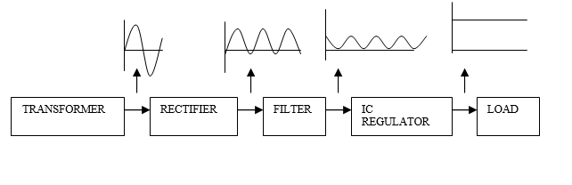

Fig 5.1

**ARDUINO UNO**

* Arduino is a development board where we connect sensors and WSN modules to make a complete successful project.
* The ATMEGA 328 P controller is known as the heart of the entire system which will check for the input and operate the output accordingly.
* It will also check for serial data receiving through Serial ports and send data through serial port to the needed peripheral devices
* It will check for the sensor values connected with it and take necessary action when the values goes abnormal such as temperature heart rate and also reduces and stop the motor speed according to the drowsiness level.
* Arduino consists of both a piece of software, or IDE (Integrated Development Environment) and a physical programmable circuit board (often referred to as a microcontroller).
* Codes can be written and uploaded to the physical board. Interactive objects can be developed b by taking inputs from sensors, and a variety of lights, motors, and other outputs can be controlled by it.
* These projects can be stand-alone, or can communicate with software running on your computer.
* ATmega328 is the microcontroller board on which Arduino Uno is based.
* Out of the 14 digital input/output pins,there are 6 pins which can be used as PWM outputs, a 16MHz ceramic resonator, 6 analog input, a USB connection, a reset button, a power jack and an ICSP header. Everything needed to support a microcontroller is present in it. To start it we just need to connect it to a USB and an AC-DC adapter.

**Features:**

1. Microcontroller: ATmega328

2. Operating Voltage: 5V Input

3. Voltage (recommended): 7-12V

4. Input Voltage (limits): 6-20V

5. Digital I/O Pins : 14 (of which 6 provide PWM output)

6. Analog Input Pins : 6

7. DC Current per I/O Pin: 40 mA

8. DC Current for 3.3V Pin: 50 mA

9. Flash Memory : 32 KB (ATmega328) of which 0.5 KB used by bootloader

10. SRAM: 2 KB (ATmega328)

11. EEPROM: 1 KB (ATmega328)

12. Clock Speed : 16 MHz

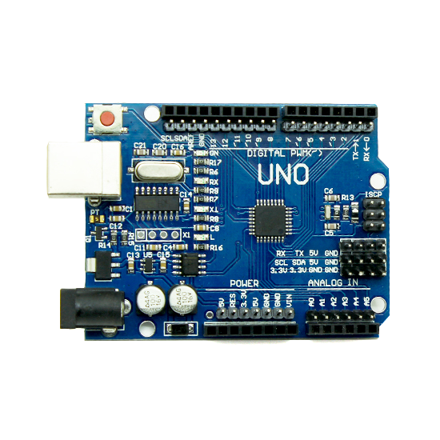

Fig 5.2

**ZIGBEE**

**ZigBee** is a [specification](http://en.wikipedia.org/wiki/Specification_(technical_standard)) for a suite of high level communication protocols using small, low-power [digital radios](http://en.wikipedia.org/wiki/Digital_radio) based on the [IEEE 802.15.4-2003](http://en.wikipedia.org/wiki/IEEE_802.15.4-2003)[standard](http://en.wikipedia.org/wiki/Standardization) for [Low-Rate Wireless Personal Area Networks](http://en.wikipedia.org/w/index.php?title=Low-Rate_Wireless_Personal_Area_Network&action=edit&redlink=1) (LR-WPANs), such as wireless light switches with lamps, electrical meters with in-home-displays, consumer electronics equipment via short-range radio. The technology defined by the [ZigBee specification](http://en.wikipedia.org/wiki/ZigBee_specification) is intended to be simpler and less expensive than other [WPANs](http://en.wikipedia.org/wiki/Wireless_personal_area_network), such as [Bluetooth](http://en.wikipedia.org/wiki/Bluetooth). ZigBee is targeted at [radio-frequency](http://en.wikipedia.org/wiki/Radio_frequency) (RF) applications that require a low data rate, long battery life, and secure networking.

**5.1 PROTOCOLS**

The protocols build on recent algorithmic research ([Ad-hoc On-demand Distance Vector](http://en.wikipedia.org/wiki/AODV)) to automatically construct a low-speed ad-hoc network of nodes. In most large network instances, the network will be a cluster of clusters. It can also form a mesh or a single cluster. The current profiles derived from the ZigBee protocols support beacon and non-beacon enabled networks.

In non-beacon-enabled networks (those whose beacon order is 15), an un slotted [CSMA/CA](http://en.wikipedia.org/wiki/CSMA/CA) channel access mechanism is used. In this type of network, ZigBee Routers typically have their receivers continuously active, requiring a more robust power supply. However, this allows for heterogeneous networks in which some devices receive continuously, while others only transmit when an external stimulus is detected. The typical example of a heterogeneous network is a [wireless light switch](http://en.wikipedia.org/wiki/Wireless_light_switch): The ZigBee node at the lamp may receive constantly, since it is connected to the mains supply, while a battery-powered light switch would remain asleep until the switch is thrown. The switch then wakes up, sends a command to the lamp, receives an acknowledgment, and returns to sleep. In such a network the lamp node will be at least a ZigBee Router, if not the ZigBee Coordinator; the switch node is typically a ZigBee End Device.

In beacon-enabled networks, the special network nodes called ZigBee Routers transmit periodic beacons to confirm their presence to other network nodes. Nodes may sleep between beacons, thus lowering their [duty cycle](http://en.wikipedia.org/wiki/Duty_cycle) and extending their battery life. Beacon intervals may range from 15.36 milliseconds to 15.36 ms * 214 = 251.65824 seconds at 250 [kbit/s](http://en.wikipedia.org/wiki/Kbit/s), from 24 milliseconds to 24 ms * 214 = 393.216 seconds at 40 kbit/s and from 48 milliseconds to 48 ms * 214 = 786.432 seconds at 20 kbit/s. However, low duty cycle operation with long beacon intervals requires precise timing, which can conflict with the need for low product cost.

In general, the ZigBee protocols minimize the time the radio is on so as to reduce power use. In beaconing networks, nodes only need to be active while a beacon is being transmitted. In non-beacon-enabled networks, power consumption is decidedly asymmetrical: some devices are always active, while others spend most of their time sleeping.

Except for the Smart Energy Profile 2.0, which will be MAC/PHY agnostic, ZigBee devices are required to conform to the IEEE [802.15.4](http://en.wikipedia.org/wiki/802.15.4)-2003 Low-Rate Wireless Personal Area Network (WPAN) standard. The standard specifies the lower [protocol layers](http://en.wikipedia.org/wiki/Protocol_layering)—the physical layer ([PHY](http://en.wikipedia.org/wiki/Physical_layer)), and the media access control ([MAC](http://en.wikipedia.org/wiki/Media_Access_Control)) portion of the data link layer ([DLL](http://en.wikipedia.org/wiki/Data_link_layer)). This standard specifies operation in the unlicensed 2.4 [GHz](http://en.wikipedia.org/wiki/Hertz) (worldwide), 915 [MHz](http://en.wikipedia.org/wiki/Megahertz) (Americas) and 868 MHz (Europe) [ISM bands](http://en.wikipedia.org/wiki/ISM_band). In the 2.4 [GHz](http://en.wikipedia.org/wiki/Hertz) band there are 16 ZigBee channels, with each channel requiring 5 [MHz](http://en.wikipedia.org/wiki/Megahertz) of bandwidth. The center frequency for each channel can be calculated as, FC = (2405 + 5 * (ch - 11)) [MHz](http://en.wikipedia.org/wiki/Megahertz), where ch = 11, 12, ..., 26.

The radios use [direct-sequence spread spectrum](http://en.wikipedia.org/wiki/Direct-sequence_spread_spectrum) coding, which is managed by the digital stream into the modulator. [BPSK](http://en.wikipedia.org/wiki/BPSK) is used in the 868 and 915 MHz bands, and [OQPSK](http://en.wikipedia.org/wiki/OQPSK) that transmits two bits per symbol is used in the 2.4 GHz band. The raw, over-the-air data rate is 250 [kbit](http://en.wikipedia.org/wiki/Kilobit)/[s](http://en.wikipedia.org/wiki/Second) per [channel](http://en.wikipedia.org/wiki/Channel_(communications)) in the 2.4 GHz band, 40 kbit/s per channel in the 915 MHz band, and 20 kbit/s in the 868 MHz band. Transmission range is between 10 and 75 [meters](http://en.wikipedia.org/wiki/Meter) (33 and 246 [feet](http://en.wikipedia.org/wiki/Foot_(length))) and up to 1500 meters for zigbee pro, although it is heavily dependent on the particular environment. The output power of the radios is generally 0 [dBm](http://en.wikipedia.org/wiki/DBm) (1 mW).

The basic channel access mode is "carrier sense, multiple access/collision avoidance" ([CSMA/CA](http://en.wikipedia.org/wiki/Carrier_Sense_Multiple_Access)). That is, the nodes talk in the same way that people converse; they briefly check to see that no one is talking before they start. There are three notable exceptions to the use of CSMA. Beacons are sent on a fixed timing schedule, and do not use CSMA. Message acknowledgments also do not use CSMA. Finally, devices in Beacon Oriented networks that have low latency real-time requirements may also use Guaranteed Time Slots (GTS), which by definition do not use CSMA.

**5.2 SOFTWARE AND HARDWARE**

The software is designed to be easy to develop on small, inexpensive microprocessors. The radio design used by ZigBee has been carefully optimized for low cost in large scale production. It has few [analog](http://en.wikipedia.org/wiki/Analog_circuit) stages and uses [digital circuits](http://en.wikipedia.org/wiki/Digital_circuit) wherever possible.

Even though the radios themselves are inexpensive, the ZigBee Qualification Process involves a full validation of the requirements of the physical layer. This amount of concern about the Physical Layer has multiple benefits, since all radios derived from that semiconductor mask set would enjoy the same RF characteristics. On the other hand, an uncertified physical layer that malfunctions could cripple the battery lifespan of other devices on a ZigBee network. Where other protocols can mask poor sensitivity or other esoteric problems in a fade compensation response, ZigBee radios have very tight engineering constraints: they are both power and bandwidth constrained. Thus, radios are tested to the [ISO 17025](http://en.wikipedia.org/wiki/ISO_17025) standard with guidance given by Clause 6 of the [802.15.4](http://en.wikipedia.org/wiki/802.15.4)-2006 Standard. Most vendors plan to integrate the radio and microcontroller onto a single chip getting smaller devices.

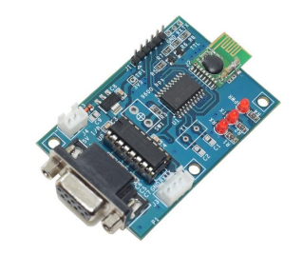

Fig 5.2.1

**FEATURES**

* Supply voltage: 5v DC
* Detection range: (10-30) m
* RS232 Output
* TTL UART also provided
* Frequency: 2.4GHz
* Tx and Rx Status LEDs
* Low power

**RELAY DRIVER**

* A relay is an electro-magnetic switch which is useful if you want to use a low voltage circuit to switch on and off a light bulb (or anything else) connected to the 220v mains supply.
* The diagram below shows a typical relay (with “normally-open” contacts).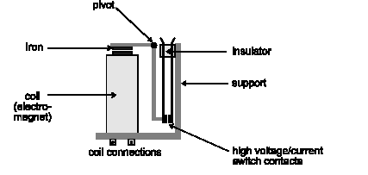

Fig 5.2.2

The current needed to operate the relay coil is more than can be supplied by most chips (op. amps etc), so a transistor is usually needed.

**DARLINGTON PAIR**

A Darlington pair is two transistors that act as a single transistor but with a much higher current gain.

The **Darlington transistor** (often called a **Darlington pair**) is a compound structure consisting of two bipolar transistors (either integrated or separated devices) connected in such a way that the current amplified by the first transistor is amplified further by the second one. This configuration gives a much higher [current](http://en.wikipedia.org/wiki/Electric_current) [gain](http://en.wikipedia.org/wiki/Gain) (written β, hfe, or hFE) than each transistor taken separately and, in the case of integrated devices, can take less space than two individual transistors because they can use a shared collector. Integrated Darlington pairs come packaged in transistor-like [integrated circuit](http://en.wikipedia.org/wiki/Integrated_circuit) packages.

The Darlington configuration was invented by [Bell Laboratories](http://en.wikipedia.org/wiki/Bell_Laboratories) engineer [Sidney Darlington](http://en.wikipedia.org/wiki/Sidney_Darlington) in 1953. He [patented](http://en.wikipedia.org/wiki/Patent) the idea of having two or three transistors on a single chip (and sharing a **single** collector), but not that of an arbitrary number (which might have covered all modern integrated circuits.

The circuit shows ‘Darlington Pair’ driver. The first transistor’s emitter feeds into the second transistor’s base and as a result the input signal is amplified by the time it reaches the output.

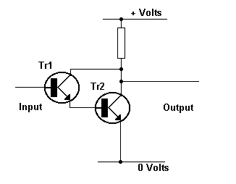

Fig 5.2.3

This circuit is used for amplifying currents, i.e., the amplified current from the first transistor is further amplified by the second transistor. Needless to say, this transistor combination exhibits a much higher current gain than if only one transistor was used. The important point to remember is that the Darlington Pair is made up of two transistors and when they are arranged as shown in the circuit they are used to amplify weak signals.

**Use of Darlington Pair**

In some application the amount of input current available to switch on a transistor is very low. This may mean that a single transistor may not be able to pass sufficient current required by the load.

As stated earlier this equals the **input current** x **the gain of the transistor (hFE)**. If it is not be possible to increase the input current then we need to increase the gain of the transistor. This can be achieved by using a Darlington Pair.A Darlington Pair acts as one transistor but with a current gain that equals:

Total current gain **(hFE total)** = current gain of transistor 1 **(hFE t1) x** current gain of transistor 2**(hFE t2)**

Total current gain **(hFE total)** = current gain of transistor 1 **(hFE t1) x** current gain of transistor 2**(hFE t2)**

So for example if you had two transistors with a current gain **(hFE)** = 100:

**(hFE total)** = 100 **x** 100

**(hFE total)** = 10,000

You can see that this gives a vastly increased current gain when compared to a single transistor.

Therefore this will allow a very low input current to switch a much bigger load

current.

**RFID READER WITH TAG**

RFID tag is used for student identification with the help of RFID tag. RFID reader is connected with the serial port of the controller to deliver data serially.

RFID reader is used to read the data from tags and sends the red data to micro controller.Scanning the details and displays in LCD display, by using RFID conductors and students need not to sign in the book while travelling in the college bus and key are used for transmitting.

A **Radio Frequency Identification Reader (RFID reader)** is a device used to gather information from an RFID tag, which is used to track individual objects. Radio Frequency waves are used to transfer data from the tag to a reader. The RFID tag it must be within the range of an RFID reader, in order to be read. RFID technology allows several items to be quickly scanned and enables fast identification of a particular product, even when it is surrounded by several other items.

**FEATURES**

* Supply voltage: 12v DC
* Output: UART RS232
* TTL UART also provided
* In-built buzzer indicator
* Signal LED is placed

**LCD**

* Information like vehicle collision or emergency alert can be displayed through LCD.
* Abnormal conditions also will be displayed through LCD.
* LCD will be connected with the digital pins ( RC0, RC1, RC2, RC3 ) of the controller as 4 bit mode or 8 bit mode.
* In addition we also need to connect RS, EN ,RW pins of the LCD with controller.
* It is supplied with 5 volt dc and ground.
* It is a 16 character, 2-line alphanumeric LCD display connected to the controller.
* An LCD (Liquid Crystal Display) screen is an electronic display module and has a wide range of applications.
* A 16x2 LCD display is very basic module and is very commonly used in various devices and circuits.
* A 16x2 LCD means it can display 16 characters per line and there are 2 such lines.
* In this LCD each character is displayed in 5x7 pixel matrix.
* The 16 x 2 intelligent alphanumeric dot matrix display is capable of displaying 224 different characters and symbols.
* This LCD has two registers, namely, Command and Data.
* Command register stores various commands given to the display.
* Data register stores data to be displayed.
* The process of controlling the display involves putting the data that form the image of what you want to display into the data registers, then putting instructions in the instruction register.

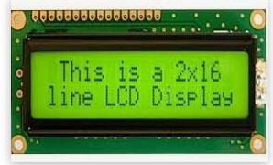

Fig 5.2.4

**DC MOTORS**

DC motors are part of the electric motors using DC power as energy source. These devices transform electrical energy into mechanical energy. The basic principle of DC motors is same as electric motors in general, the magnetic interaction between the rotor and the stator that will generate spin.

**Simple motor has six parts:**

1.Armature or rotor

2.Commutator

3.Brushes

4.Axle

5.Field magnet

6.DC power supply some sort

**Working principle of DC motor**

Graphically, the working principles of DC motors can be seen in Figure 1 below.

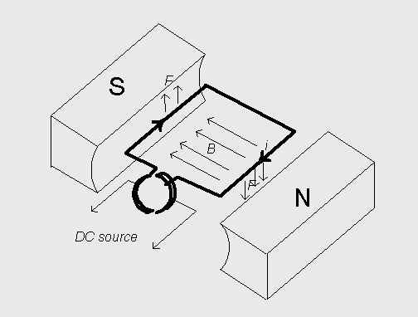

Fig 5.2.5

When DC electric current flowing in the coil in accordance with the direction of the arrow, while the direction of the magnetic field B is from north to south pole, the coil will be driven by the force F in the direction as shown in Figure 1. This condition occurs continuously so will result in rotation on the axis of the coil. The direction of the electric current in the coil is fixed, because of the split ring on the end of the coil.

**The major classes of DC motors are**

* + Shunt wound.
  + Series wound.
  + Compound wound.
  + Separately excited**.**

These types of motors differ only in the connection of the field circuits The armatures, commutators, and so forth are nearly identical with each other and with those of the generators. All four major classes of motors are widely used. This is in contrast to the generators, in which the compound wound type is used for nearly all general power applications.

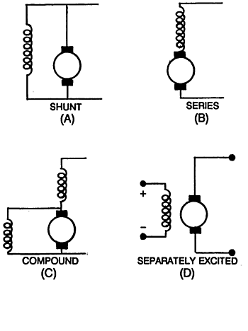

Fig 5.2.6

**Brush less motor**

A DC Brush less Motor uses a permanent magnet [external rotor](http://www.dynetic.com/brushless%20terminology.htm#rotor), three phases of driving coils, one or more [Hall effect devices](http://www.dynetic.com/brushless%20terminology.htm#hall effect) to sense the position of the rotor, and the associated drive electronics. The coils are activated, one phase after the other, by the drive electronics as cued by the signals from the Hall effect sensors, they act as three-phase synchronous motors containing their own [variable frequency drive electronics](http://www.dynetic.com/brushless%20terminology.htm#VFD).

**Brushed Motor**

A Brushed Motor has a rotating set of wound wire coils called an armature which acts as an electromagnet with two poles. A mechanical rotary switch called a [commutator](http://www.dynetic.com/brushless%20terminology.htm#commutation) reverses the direction of the electric current twice every cycle, to flow through the armature so that the poles of the electromagnet push and pull against the permanent magnets on the outside of the motor. As the poles of the armature electromagnet pass the poles of the permanent magnets, the commutator reverses the polarity of the armature electromagnet. During the instant of switching polarity, inertia keeps the classical motor going in the proper direction.

**5.3 SPECIFICATION**

**30RPM 12V DC** geared motors for robotics applications. Very easy to use and available in standard size. Nut and threads on shaft to easily connect and internal threaded shaft for easily connecting it to wheel.

**Features**

* 45RPM 12V DC motors with Gearbox
* 6mm shaft diameter with internal hole
* 125gm weight
* Same size motor available in various rpm
* 2kgcm torque
* No-load current = 60 mA(Max), Load current = 300 mA(Max)

**5.4 SOFTWARE DESCRIPTION**

**Arduino Software(IDE)**

Get the latest version from the download page. You can choose between the Installer (.exe) and the Zip packages. We suggest you use the first one that installs directly everything you need to use the Arduino Software (IDE), including the drivers. With the Zip package you need to install the drivers manually. The Zip file is also useful if you want to create a [portable installation](https://www.arduino.cc/en/Guide/PortableIDE).

When the download finishes, proceed with the installation and please allow the driver installation process when you get a warning from the operating system.

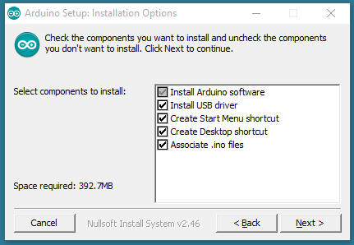

Choose the components to install

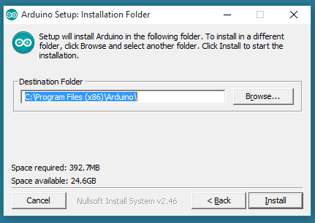

Choose the installation directory (we suggest to keep the default one)

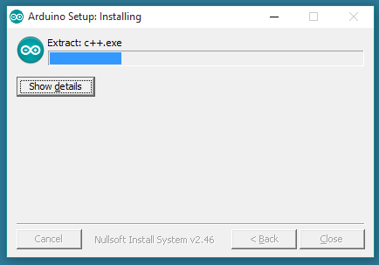

The process will extract and install all the required files to execute properly the Arduino Software (IDE).

**Arduino Boot loader Issue**

The current boot loader burned onto the Arduino UNO is not compatible with ROBOTC. In its current form, you will be able to download the ROBOTC Firmware to the ArduinoUNO, but you will not able to download any user programs.

The reason for this is because there is a bug in the Arduino UNO firmware that does not allow flash write commands to start at anywhere but the beginning of flash memory (0x000000). See the bottom of this page for more technical details.

Because ROBOTC is not able to burn a new bootloader as of today, you will need to use the Arduino's Open Source language with a modified bootloader file to re-burn your bootloader on your Arduino UNO boards. The enhanced bootloader is backwards compatible with the original one. That means you'll still be able to program it through the Arduino programming environment as before, in addition to ROBOTC for Arduino.

**Hardware Needed**

To burn a new version of the Arduino boot loader to your UNO, you'll need an AVR ISP Compatible downloader.

**Using an AVR ISP (In System Programmer)**

* Your Arduino UNO (to program)
* An AVR Programmer such as the [AVR Pocket Programmer](http://www.sparkfun.com/products/9825)
* An AVR Programming Cable (the pocket programmer comes with one)

If you have extra Arduino boards, but no ISP programmer, SparkFun.com has a cool tutorial on how to flash a bootloader using an Arduino as an ISP.

**Using another Arduino as an ISP**

* Your Arduino UNO (to program)
* A Working Arduino (doesn't matter what kind)
* Some Male-to-Male Jumper Cables

**Software Needed**

ROBOTC is not currently able to burn a bootloader onto an Arduino board, so you'll need to download a copy of the latest version of the Arduino Open-Source programming language.

* Arduino Official Programming Language - [Download Page](http://arduino.cc/en/Main/Software%7CArduino)

In addition, you'll need the ROBOTC modified bootloader. You can download that here:

* ROBOTC Modified UNO Bootloader - [Modified Bootloader](http://cdn.robotc.net/downloads/arduino/stk500boot_v2_mega2560.hex)

**Bootload Download Instructions**

* Download the [Arduino Open Source Software](http://arduino.cc/en/Main/Software) and a copy of the [Modified Bootloader](http://cdn.robotc.net/downloads/arduino/stk500boot_v2_mega2560.hex) File
* Copy the Modified Bootloader File into the /Arduino-1.0/hardware/arduino/bootloaders/stk500v2/ and overwrite the existing bootloader.

[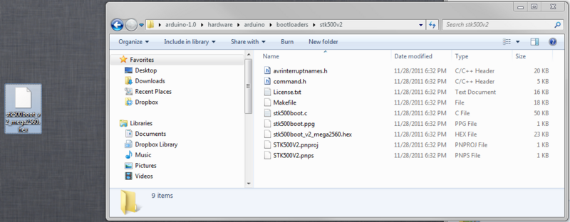](http://www.robotc.net/wikiarchive/File:CopyBootloader.png)

* Power up your Arduino UNO (either via USB or external power)
* Plug in your AVR ISP Programmer to your computer (make sure you have any required drivers installed)
* Connect your AVR ISP Programmer into your Arduino UNO Board via the ISP Header (the 2x3 header pins right above the Arduino Logo)
* Launch the Arduino Open Source Software

[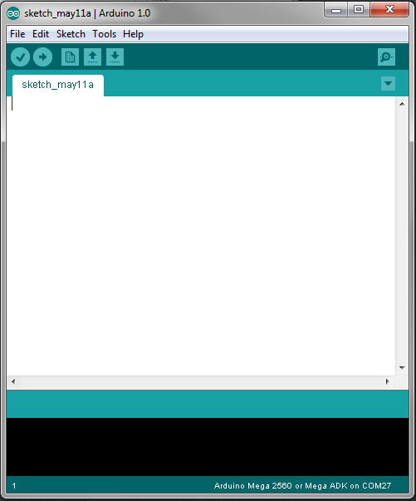](http://www.robotc.net/wikiarchive/File:ArduinoLaunch.png)

* + Change your settings in the Arduino Software to look for an Arduino UNO
  + Change your settings in the Arduino Software to select your ISP Programmer Type (Check your programmer's documentation for the exact model)

[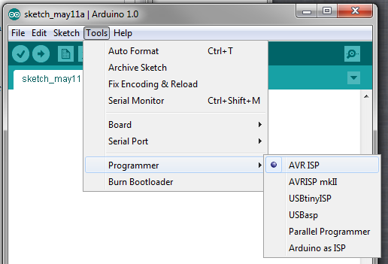](http://www.robotc.net/wikiarchive/File:ArduinoSelectProgrammer.png)

Select the "Burn Bootloader" option under the "Tools" menu. The modified bootloader will now be sent to your Arduino. This typically take a minute or so.

[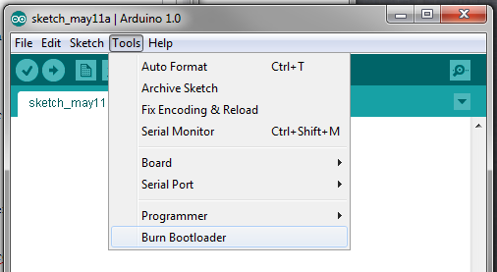](http://www.robotc.net/wikiarchive/File:BurnBootloader.png)

You should be all set to download ROBOTC firmware and start using your Arduino UNO with ROBOTC.

**5.5 Technical Details**

The Arduino Boot loader sets the "erase Address" to zero every time the boot loader is called. ROBOTC called the "Load Address" command to set the address in which we want to write/verify when downloading program.

When writing a page of memory to the arduino, the Arduino boot loader will erase the existing page and write a whole new page.

In the scenario of downloading firmware, everything is great because the Erase Address and the Loaded Address both start at zero.

In the scenario of writing a user program, we start writing at memory location 0x7000, but the Boot loader erases information starting at location zero because the "Load Address" command doesn't update where to erase.

Our modification is to set both the Load Address and the Erase Address so the activity of writing a user program doesn't cause the firmware to be accidentally erased.

The Arduino UNO can be powered via the USB connection or with an external power supply. The power source is selected automatically. External (non-USB) power can come either from an AC-to-DC adapter (wall-wart) or battery. The adapter can be connected by plugging a 2.1mm center-positive plug into the board's power jack. Leads from a battery can be inserted in the Gnd and Vin pin headers of the POWER connector.

The board can operate on an external supply of 6 to 20 volts. If supplied with less than 7V, however, the 5V pin may supply less than five volts and the board may be unstable. If using more than 12V, the voltage regulator may overheat and damage the board. The recommended range is 7 to 12 volts.

They differs from all preceding boards in that it does not use the FTDI USB-to-serial driver chip. Instead, it features the programmed as a USB-to-serial converter.

**The power pins are as follows:**

1. VIN. The input voltage to the Arduino board when it's using an external power source (as opposed to 5 volts from the USB connection or other regulated power source). You can supply voltage through this pin, or, if supplying voltage via the power jack, access it through this pin.
2. The regulated power supply used to power the microcontroller and other components on the board. This can come either from VIN via a non-board regulator, or be supplied by USB or another regulated 5V supply.
3. 3V3.A3.3voltsupplygeneratedbytheon-boardregulator.Maximumcurrentdrawis50mA.
4. GND. Ground pins.

The ATMEGA has 256 KB of flash memory for storing code (of which 8 KB is used for the boot loader), 8 KB of SRAM and 4 KB of EEPROM (which can be read and written with the [EEPROM library](http://www.arduino.cc/en/Reference/EEPROM)).

Each of the 54 digital pins on the Mega can be used as an input or output, using [pinMode()](http://arduino.cc/en/Reference/PinMode), [digitalWrite()](http://arduino.cc/en/Reference/DigitalWrite), and [digitalRead()](http://arduino.cc/en/Reference/DigitalRead) functions. They operate at 5 volts. Each pin can provide or receive a maximum of 40 mA and has an internal pull-up resistor (disconnected by default) of 20-50k Ohms. In addition, some pins have specialized functions:

**Serial:** 0 (RX) and 1 (TX); Serial 1: 19 (RX) and 18 (TX); Serial 2: 17 (RX) and 16 (TX); Serial 3: 15 (RX) and 14 (TX). Used to receive (RX) and transmit (TX) TTL serial data. Pins 0 and 1 are also connected to the corresponding pins of the ATMEGA USB-to-TTL Serial chip.

**External Interrupts:**  2 (interrupt 0), 3 (interrupt 1), 18 (interrupt 5), **19 (interrupt 4), 20 (interrupt 3), and 21 (interrupt 2).** These pins can be configured to trigger an interrupt on a low value, a rising or falling edge, or a changing value. See the [attach Interrupt()](http://arduino.cc/en/Reference/AttachInterrupt) function for details.

**PWM: 0to13.** Provide 8-bit PWM output with the [analogWrite()](http://arduino.cc/en/Reference/AnalogWrite) function.

**SPI: 50 (MISO), 51 (MOSI), 52 (SCK), 53 (SS).** These pins support SPI communication, which, although provided by the underlying hardware, is not currently included in the Arduino language. The SPI pins are also broken out on the ICSP header, which is physically compatible with the Duemilanove and Diecimila.

**LED: 13.** There is a built-in LED connected to digital pin 13. When the pin is HIGH value, the LED is on, when the pin is LOW, it's off.

**I2C: 20 (SDA) and 21 (SCL).** Support I2C (TWI) communication using the [Wire library](http://wiring.org.co/reference/libraries/Wire/index.html) (documentation on the Wiring website). Note that these pins are not in the same location as the I2C pins on the Duemilanove.

The Arduino UNO has 16 analog inputs, each of which provide 10 bits of resolution (i.e. 1024 different values). By default they measure from ground to 5 volts, though is it possible to change the upper end of their range using the AREF pin and analog Reference() function.

**Programming**

The Arduino UNO can be programmed with the Arduino software ([download](http://arduino.cc/en/Main/Software)). For details, see the [reference](http://arduino.cc/en/Reference/HomePage) and [tutorials](http://arduino.cc/en/Tutorial/HomePage).

The Arduino UNO on the Arduino UNO comes pre burned with a [bootloader](http://arduino.cc/en/Tutorial/Bootloader)that allows you to upload new code to it without the use of an external hardware programmer. It communicates using the original STK500 protocol ([reference](http://www.atmel.com/dyn/resources/prod_documents/doc2525.pdf), [C header files](http://www.atmel.com/dyn/resources/prod_documents/avr061.zip)).

You can also bypass the bootloader and program the microcontroller through the ICSP (In-Circuit Serial Programming) header; see [these instructions](http://arduino.cc/en/Hacking/Programmer) for details.

**Automatic (Software) Reset**

Rather than requiring a physical press of the reset button before an upload, the Arduino UNO is designed in a way that allows it to be reset by software running on a connected computer. One of the hardware flow control lines (DTR) of the ATmega8U2 is connected to the reset line of the Arduino UNO via a 100 nanofarad capacitor. When this line is asserted (taken low), the reset line drops long enough to reset the chip. The Arduino software uses this capability to allow you to upload code by simply pressing the upload button in the Arduino environment. This means that the bootloader can have a shorter timeout, as the lowering of DTR can be well-coordinated with the start of the upload.

This setup has other implications. When the Arduino UNO is connected to either a computer running Mac OS X or Linux, it resets each time a connection is made to it from software (via USB). For the following half-second or so, the bootloader is running on the UNO. While it is programmed to ignore malformed data (i.e. anything besides an upload of new code), it will intercept the first few bytes of data sent to the board after a connection is opened. If a sketch running on the board receives one-time configuration or other data when it first starts, make sure that the software with which it communicates waits a second after

Opening the connection and before sending this data.

The Mega contains a trace that can be cut to disable the auto-reset. The pads on either side of the trace can be soldered together to re-enable it. It's labeled "RESET-EN". You may also be able to disable the auto-reset by connecting a 110 ohm resistor from 5V to the reset line; see this forum thread for details.

**USB Over current Protection**

**Physical Characteristics and Shield Compatibility**

The Arduino UNO has a reset table poly fuse that protects your computer's USB ports from shorts and over current. Although most computers provide their own internal protection, the fuse provides an extra layer of protection.Ifmorethan500mAisappliedtotheUSBport, the fuse will automatically break the connection until the short or overload is removed.

The maximum length and width of the UNO PCB are 4 and 2.1 inches respectively, with the USB connector and power jack extending beyond the former dimension. Three screw holes allow the board to be attached to a surface or case. Note that the distance between digital pins 7 and 8 is 160 mil (0.16"), not an even multiple of the 100 mil spacing of the other pins.

The UNO is designed to be compatible with most shields designed for the Diecimila or Duemilanove. Digital pins 0 to 13 (and the adjacent AREF and GND pins), analog inputs 0 to 5, the power header, and ICSP header are all in equivalent locations. Further the main UART (serial port) is located on the same pins (0 and 1), as are external interrupts 0 and 1 (pins 2 and 3 respectively). SPI is available through the ICSP header on both the Mega and Duemilanove / Diecimila.

**6. ADVANTAGES**

1. The primary advantage of the Train Collision Avoidance System (TCAS) is its ability to significantly reduce the risk of train collisions. By using RFID technology and AI machine learning to predict potential collision scenarios, the system provides a proactive approach to accident prevention.
2. The integration of RFID and AI allows for continuous, real-time monitoring of train positions and track conditions. This dynamic tracking enables immediate responses to potential collision threats, ensuring timely intervention.
3. The system's automatic braking mechanism, triggered by Zigbee communication, reduces reliance on human intervention, which minimizes the risk of human error and speeds up response times in critical situations.
4. By providing real-time data and predictions, TCAS helps optimize train scheduling and operations. This can lead to better utilization of the railway network and reduced delays caused by accidents or manual oversight.
5. The AI system's predictive analytics offer a more sophisticated approach to collision avoidance compared to traditional methods, which often rely on fixed signals and manual judgment.
6. The system's modular design, with RFID technology and AI, can be scaled and adapted to various railway networks, including those with different track configurations and traffic densities.
7. By preventing collisions and improving operational efficiency, the system can potentially lower maintenance and repair costs associated with accidents and damage to infrastructure.

**7. APPLICATION**

1. **Urban and Suburban Rail Networks**: In major cities and suburban areas with high train traffic, TCAS can enhance safety and reduce the risk of accidents, leading to smoother and more reliable services.
2. **High-Speed Rail Systems**: For high-speed trains, where braking distances are longer and the potential for severe accidents is higher, the TCAS provides a crucial safety layer to prevent collisions.
3. **Freight and Cargo Trains**: The system can be applied to freight trains, where collisions can result in significant economic losses and safety hazards. TCAS ensures the safe and efficient movement of cargo.
4. **Remote and Rural Railways**: In less densely populated or remote areas, where traditional signaling and oversight might be limited, TCAS provides an automated and reliable solution for collision prevention.
5. **Railway Network Upgrades**: When upgrading existing railway networks, integrating TCAS can enhance the safety features of modernized systems and ensure compatibility with advanced technology.
6. **International Rail Connections**: For railways connecting different countries or regions, TCAS can offer a standardized solution for collision avoidance, improving safety on cross-border rail routes.
7. **Emergency Response**: The system’s ability to provide early warnings and automated responses can be crucial in emergency situations, allowing for faster and more effective management of potential hazards.

**8. CONCLUSION**

In conclusion, the proposed Train Collision Avoidance System (TCAS) represents a significant advancement in railway safety technology. By integrating Radio Frequency Identification (RFID), artificial intelligence (AI) machine learning, and Zigbee communication, this system addresses the critical issue of train collisions with a proactive and automated approach. The use of RFID technology allows for precise tracking of train positions along segmented tracks, while the AI system’s predictive analytics enable early detection of potential collision scenarios. The real-time data processing and communication through Zigbee ensure that train controllers receive timely alerts and can initiate automatic braking to prevent accidents. This comprehensive solution not only enhances safety by reducing reliance on human oversight and static signaling systems but also improves operational efficiency and reliability across diverse railway networks. As a result, TCAS offers a robust framework for preventing train collisions, ultimately contributing to a safer and more reliable transportation system.

**9. REFERENCES**

1. M Geetanjali, K.P Shantha Krishnan, L. D. Shree Vishwa Shamanthan and G. Raji, "RF Based Train Collision Avoidance System", 2013 Annual IEEE India conference 978-1-4799-2275-8/13.
2. Kathirvel and S. Palaniappan, "Collision Avoidance of Trains by Creating Mutual Communication Using Embedded System", IJCSMC, vol. 4, no. 4, April 2015.
3. G. Anjali bissa, S. Jayasudha, R. Narmatha and B. Rajmohan, "Train Collision Avoidance System Using Vibration Sensors And Zigbee Technology", International Journal of Research in Enginnering and Advanced Technology, vol. 1, no. 1, March 2013, ISSN 2320-8791.
4. D. Narendar Singh and Ravi Teja Ch. V, "Vehicle Speed Limit Alerting and Crash Detection System at Various Zones", International Journal of Latest Trends in Engineering and Technology (IJLTET), vol. 2, no. 1, January 2013.
5. Kurhe Jyoti, Gophane Prajakta, Kadam Madhuri and Panchal Anubha, "Train Collision Detection and Avoidance", International Journal of Engineering Science and Computing, March 2016.
6. Nayan Jeevagan, Pallavi Santosh, Rishabh Berlia and Shubham Kandoi, "RFID Based Vehicle Identification During Collisions", *IEEE 2014 Global* Humanitarian Technology Conference Gate Protection System by Konkan Railway.
7. K. Govindaraju, F. Parvez Ahmed, S. Thulasi Ram and T. Devika, "A Novel Approach Of TrainPrevention System From CollisionUsing Avr Microcontroller", International Journal Of Innovative Research In Electrical Electronics Instrumentation &Control Engineering, vol. 2, February 2014.
8. T. Dhanabalu, S. Sugumar, S. Suryaprakash and A. VijayAnand, "Sensor Based Identification System For Train Collision Avoidance", IEEE Sponsored2nd International Conference on Innovations in Information Embedded and Communication Systems ICIIECS'15.
9. P. C. Sharma and Amitabh, "Safety as Key Business Theme! - Indian Railways Perspective", International Railway Safety Conference Perth, 2004.
10. Xianhui Che, Ian Wells, Gordon Dickers and Paul Kear, "TDMA frame design for a prototype underwater RF communication network", Ad Hoc Networks Journal, vol. 10, pp. 317-327, 2012.
11. T. B. Wolf and M. J. Kochenderfer, "Aircraft collision avoidance using Monte Carlo real-time belief space search", Journal of Intelligent and Robotic Systems, 2011.

**OUTCOME**

**PLAGIARISM REPORT:**