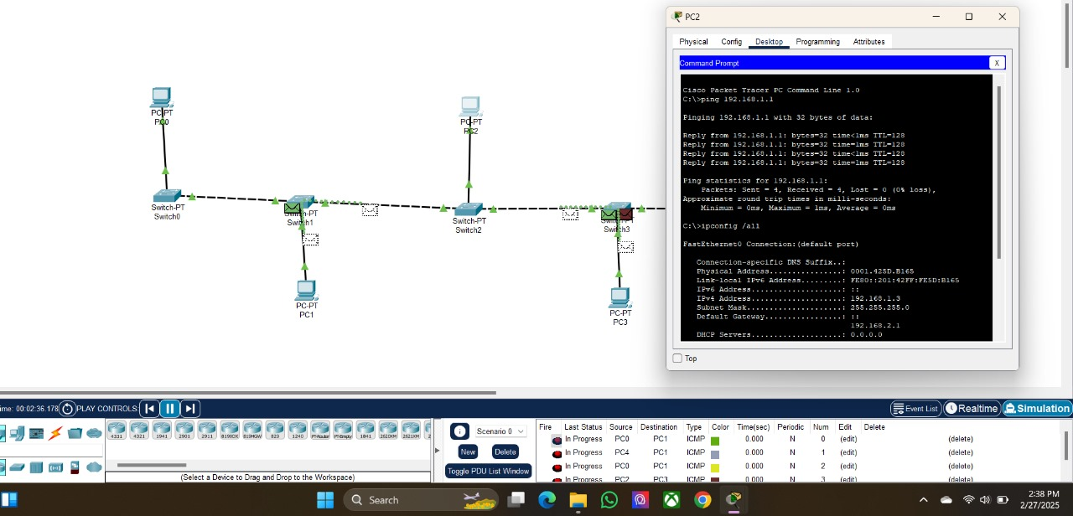

MONISHA K

EX:03 192412055