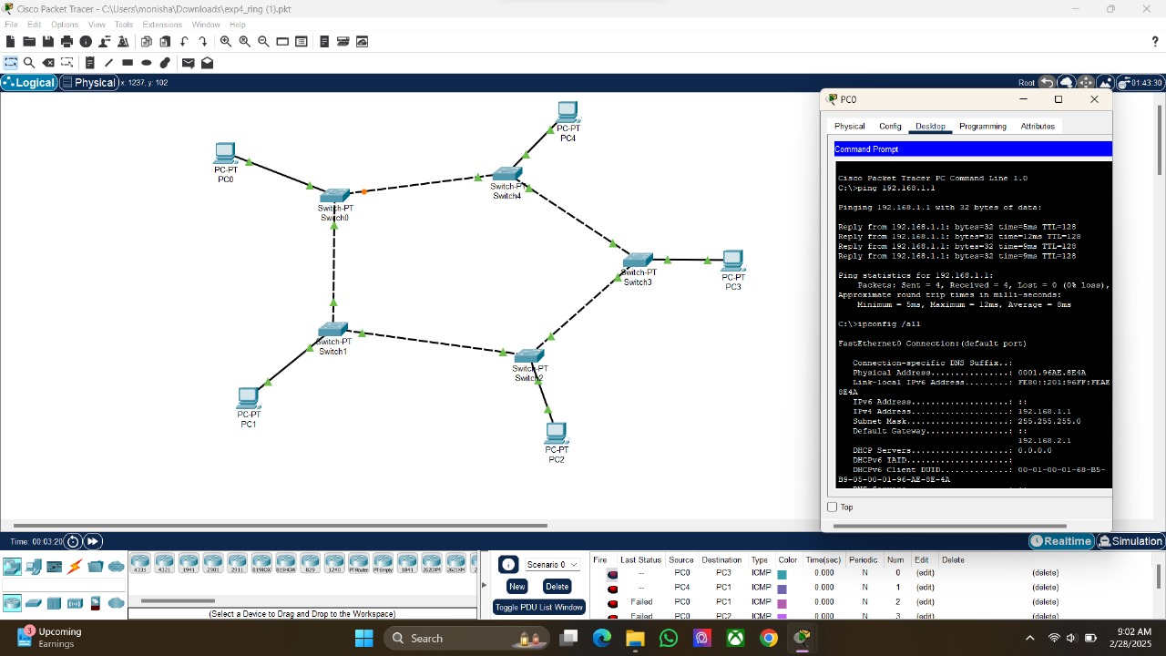

MONISHA.K

192412055

EXP:04