WEEK 4 REPORT

PREDICTIVE MODELING AND OPTIMIZATION
LOGISTICS DATA ANALYSIS

Submitted by
MONISHA V

November 2026

1. Introduction
Predictive modeling uses historical data and machine learning techniques to estimate future outcomes. In logistics, predicting shipping duration can support delivery planning, shipment monitoring and operational decision-making. This task applies regression models to estimate the actual number of shipping days for an order.

2. Problem Definition
The objective is to predict actual shipping duration using available order and shipment-related information. The target variable is “Days for shipping (real)”. Multiple regression algorithms are compared using test data, and cross-validation is used to assess consistency.

3. Dataset Description
The cleaned logistics dataset contains 180,519 records and 39 columns. The initial data check reported zero missing values. The cleaned dataset prepared during the previous analysis task was reused for predictive modeling.

4. Data Preprocessing and Feature Selection
Eight input features were selected: Days for shipment (scheduled), Shipping Mode, Order Item Quantity, Sales, Order Item Discount, Product Price, Benefit per order and Order Item Profit Ratio. The target was Days for shipping (real). Delivery Status and Late_delivery_risk were excluded because they are directly associated with delivery outcomes and could introduce target leakage. The dataset was split into 144,415 training records and 36,104 testing records (80:20).

5. Model Selection and Implementation
Three regression algorithms were trained: Linear Regression, Decision Tree Regressor and Random Forest Regressor. The models were compared to identify which produced the lowest prediction error and best explanatory score on the test set.

6. Performance Evaluation
The models were evaluated using Mean Absolute Error (MAE), Root Mean Squared Error (RMSE) and R². Lower MAE and RMSE indicate smaller prediction errors, while a higher R² indicates that the model explains a greater proportion of variation in shipping duration.

Model Comparison Results
Model | MAE (days) | RMSE (days) | R² Score
Linear Regression | 0.9813 | 1.2661 | 0.3919
Decision Tree | 0.9844 | 1.2704 | 0.3877
Random Forest | 0.9872 | 1.2680 | 0.3900
Linear Regression achieved the lowest MAE (0.9813 days) and RMSE (1.2661 days), and the highest R² score (0.3919). It was therefore selected as the best-performing model. Its MAE indicates an average absolute prediction error of approximately one shipping day. The R² score means that the model explains about 39.19% of the variation in shipping duration, so its predictive performance is moderate rather than highly accurate.

7. Cross-Validation
Five-fold cross-validation was performed for Linear Regression. The MAE scores were 0.9796, 0.9901, 0.9792, 0.9800 and 0.9788 days. The average cross-validation MAE was 0.9816 days. This is close to the test-set MAE of 0.9813 days, suggesting consistent error across the validation folds.

8. Sample Prediction
A sample prediction estimated shipping duration as 3.99 days, while the actual duration was 5 days. The absolute difference for this example was approximately 1.01 days.

9. Results and Visualizations
The following figures compare the three regression models and illustrate the relationship between actual and predicted shipping duration.
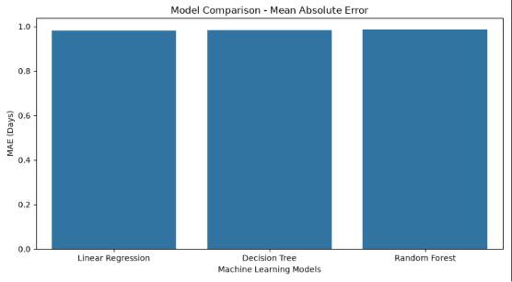
Figure 1: Comparison of Mean Absolute Error (MAE).
Linear Regression has the lowest MAE, followed closely by Decision Tree and Random Forest. The differences between the models are small.
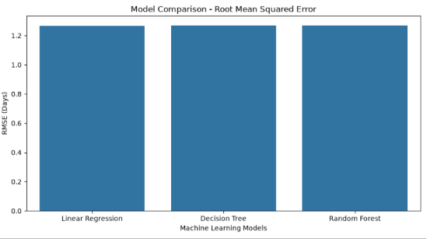
Figure 2: Comparison of Root Mean Squared Error (RMSE).
Linear Regression has the lowest RMSE among the three evaluated models.
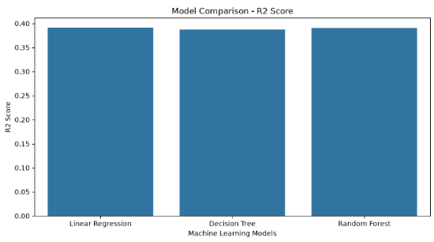
Figure 3: Comparison of R² scores.
Linear Regression has the highest R² score (0.3919), although the scores of all three models are relatively close.
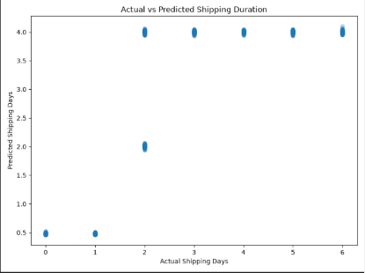
Figure 4: Actual versus predicted shipping duration.
This plot displays predicted shipping days against actual shipping days. It provides a visual inspection of prediction patterns; the evaluation metrics above summarize overall performance.

10. Optimization Strategies
- Use predicted shipping duration as an additional reference for shipment planning.
- Flag orders where predicted duration is greater than the scheduled shipping time for closer monitoring.
- Review delivery performance across shipping modes and investigate possible operational causes of delays.
- Where available, add relevant information such as dispatch time, warehouse processing duration, route distance and traffic conditions.
- Retrain and compare models periodically using newer shipment records.
These are recommendations for operational review. The current modeling experiment does not establish that any one strategy will directly cause a reduction in delivery delays.

11. Recommendations
Linear Regression can be retained as the baseline model because it performed best among the three tested algorithms. Further improvement can be explored by adding relevant features, examining prediction errors for different shipping modes and testing additional regression algorithms. Performance should be checked on new data before operational use.

12. Conclusion
The Week 4 predictive modeling task was completed using 180,519 logistics records. Three regression models were trained to predict actual shipping duration. Linear Regression performed best, with an MAE of 0.9813 days, RMSE of 1.2661 days and R² score of 0.3919. Five-fold cross-validation produced an average MAE of 0.9816 days. The results demonstrate how machine learning can be applied to estimate shipping duration and provide a basis for further model improvement and logistics planning.

13. Generated Project Outputs
- Model comparison CSV file
- Cross-validation results CSV file
- Three trained model files
- Saved best model file
- Four visualization images

