🎓
Student Skill Management System
System Architecture Document
A Full-Stack CRUD Web Application
Prepared for Academic Submission
Technology Stack: Django REST Framework · React · SQLite/PostgreSQL

1. Introduction

1.1 Purpose
The Student Skill Management System is a full-stack CRUD (Create, Read, Update, Delete) web application designed to help institutions maintain a complete, structured profile of each student’s technical skills, certifications, and projects in one place. This document describes the system’s architecture, technology stack, database design, and data flow to support the academic evaluation of the project.

1.2 Scope
The system covers four core modules:
- Student Management — add, view, edit, and delete student records
- Skill Management — maintain a master list of skills and assign them to students with a proficiency level
- Certification Management — record certifications earned by each student
- Project Management — record projects completed by each student, including the technologies used
An additional feature, Skill Gap Analysis, compares a student’s current skills against the skills recommended for their branch and highlights what is missing.

2. System Architecture Overview
The application follows a three-layer, client-server architecture with a clear separation between the presentation layer, the application/business logic layer, and the data layer. This separation allows the frontend and backend to be developed, tested, and scaled independently.
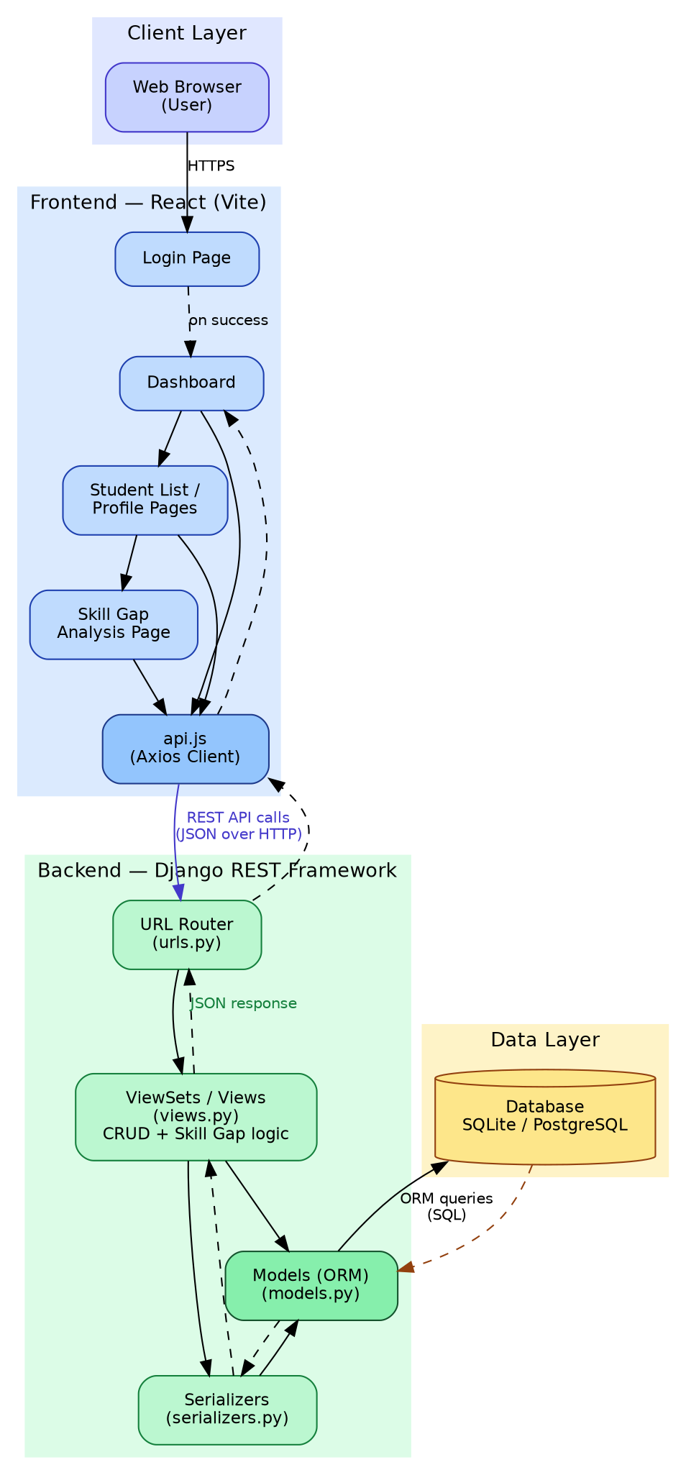
Figure 1: High-level system architecture

2.1 Client Layer
The client layer is a standard web browser through which the user (administrator) interacts with the application over HTTP/HTTPS.

2.2 Frontend Layer — React (Vite)
The frontend is a Single Page Application (SPA) built with React and bundled using Vite. It is responsible for rendering the user interface and managing client-side navigation using React Router. Key responsibilities:
- Rendering pages: Login, Dashboard, Student List, Student Profile, Skills, Skill Gap Analysis
- Managing UI state (forms, selected records, edit modes) using React’s built-in state (useState/useEffect)
- Communicating with the backend exclusively through a centralized API client (api.js) using Axios
- Client-side route protection, redirecting unauthenticated users to the login page

2.3 Backend Layer — Django REST Framework
The backend exposes a RESTful API built with Django and Django REST Framework (DRF). It is organized into four standard layers:
- URL Router (urls.py) — maps incoming HTTP requests to the correct view using DRF’s DefaultRouter
- Views / ViewSets (views.py) — contain the business logic for each CRUD operation and the Skill Gap comparison logic
- Serializers (serializers.py) — convert Django model instances to/from JSON, and validate incoming data
- Models (models.py) — define the database schema using Django’s Object-Relational Mapper (ORM)

2.4 Data Layer
The system uses a relational database — SQLite for local development and PostgreSQL/MySQL as drop-in replacements for production — accessed exclusively through Django’s ORM. No raw SQL is used in the application logic, which keeps the code portable across database engines.

3. Technology Stack
Layer | Technology | Purpose
Frontend | HTML, CSS, JavaScript (React + Vite) | User interface and client-side interaction
Frontend Framework | React 18, React Router | Component-based dynamic interface and routing
HTTP Client | Axios | Communication between frontend and REST API
Backend | Django 5 + Django REST Framework | Server-side logic and REST API endpoints
Database | SQLite (dev) / PostgreSQL or MySQL (production) | Persistent relational data storage
API Testing | Postman / curl | Testing REST API requests and responses
Version Control | Git / GitHub | Source code management

4. Database Design
The schema is fully normalized. Many-to-many relationships are implemented using explicit junction tables rather than comma-separated text fields, which keeps the data queryable and consistent.
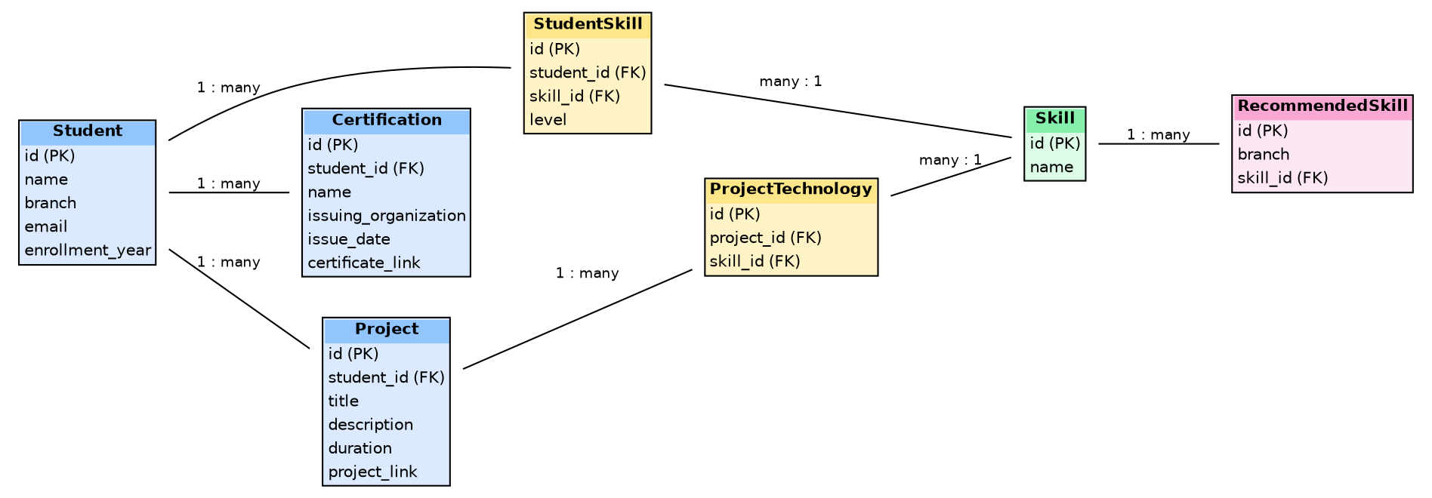
Figure 2: Entity-Relationship diagram

4.1 Entities
Table | Description
Student | Core student record: name, branch, email, enrollment year
Skill | Master list of skills (Python, Java, SQL, React, etc.)
StudentSkill | Junction table linking a Student to a Skill, with a proficiency level (Beginner/Intermediate/Advanced)
Certification | A certification earned by a student (name, issuer, issue date, certificate link)
Project | A project completed by a student (title, description, duration, project link)
ProjectTechnology | Junction table linking a Project to the Skills/technologies used in it
RecommendedSkill | Maps a branch to the skills recommended for students in that branch, used by the Skill Gap feature

4.2 Key Design Decisions
- StudentSkill and ProjectTechnology are separate junction tables rather than multi-value text fields, so a skill can be shared across many students and many projects without duplication.
- The skill level (Beginner/Intermediate/Advanced) is stored on the relationship (StudentSkill), not on the Skill itself, since the same skill can be at a different level for different students.
- RecommendedSkill is keyed by branch (not by student), so recommendations are configured once per branch and automatically apply to every student in that branch.

5. API Design
The backend exposes a RESTful API under the /api/ prefix. All endpoints return JSON and follow standard HTTP status codes and verbs.
Resource | Method | Endpoint | Purpose
Students | GET / POST | /api/students/ | List all students / create a student
Students | GET / PUT / DELETE | /api/students/<id>/ | Retrieve full profile / update / delete
Skills | GET / POST | /api/skills/ | List / add a master skill
Student Skills | GET / POST / PATCH / DELETE | /api/student-skills/ | Assign, update level, or remove a skill
Certifications | GET / POST / DELETE | /api/certifications/ | Add / remove certifications
Projects | GET / POST / DELETE | /api/projects/ | Add / remove projects
Project Technologies | POST / DELETE | /api/project-technologies/ | Link/unlink a technology to a project
Skill Gap | GET | /api/students/<id>/skill-gap/ | Compare current vs. recommended skills

6. Request / Response Flow Example
The following describes the flow when a user views a student’s Skill Gap Analysis page:
- 1. The user clicks "View Skill Gap Analysis" on the Student Profile page.
- 2. React Router navigates to /students/:id/skill-gap and the SkillGapPage component mounts.
- 3. The component calls getSkillGap(id) in api.js, which sends a GET request to /api/students/<id>/skill-gap/.
- 4. Django’s URL router forwards the request to SkillGapView.
- 5. The view queries StudentSkill for the student’s current skills and RecommendedSkill for the student’s branch.
- 6. It computes the set difference (recommended − current) to find missing skills.
- 7. The view returns a JSON response containing current_skills, recommended_skills, and missing_skills.
- 8. React renders the three lists as color-coded pill components (green = current, blue = recommended, red = missing).

7. Authentication & Access Control
The current build uses a simplified client-side login gate (a hardcoded demo credential check in React, backed by a localStorage flag) to represent the Login → Dashboard flow required by the project brief. This is suitable for an academic CRUD demonstration but is explicitly not production-grade security.
For a production deployment, the recommended upgrade path is:
- Replace the client-side check with a real Django authentication endpoint (Session or Token-based, using rest_framework.authtoken or djangorestframework-simplejwt)
- Protect all API views with permission_classes = [IsAuthenticated]
- Optionally add role-based access control, so a student role can only view their own profile while an admin role can manage all students

8. Deployment Considerations
In development, the two applications run as separate processes on different ports:
- Django backend: http://127.0.0.1:8000 (via python manage.py runserver)
- React frontend: http://localhost:5173 (via npm run dev, Vite dev server)
Cross-Origin Resource Sharing (CORS) is enabled on the backend (via django-cors-headers) to allow the frontend origin to call the API during development. For production, the React app would typically be built into static files (npm run build) and served either by Django itself or by a separate static host, with the API reachable at a single public domain.

9. Conclusion
The Student Skill Management System demonstrates a complete, working implementation of all four CRUD operations across four related entities, backed by a normalized relational database and a decoupled REST API. The layered architecture (React SPA ↔ Django REST API ↔ relational database) mirrors patterns used in real-world production systems, making the project both a valid academic CRUD demonstration and a reasonable starting point for further feature development.

