EXPT NO:7A | DATA VISUALIZATION USING TABLEAU

Aim:
To connect, analyze, visualize, and create interactive dashboards using Tableau for effective retail sales intelligence and data analytics.

Algorithm:

Algorithm: Retail Sales Visualization using Tableau Step 1: Data Loading
- Connect the Retail Sales dataset to Tableau.
- Verify the imported fields: OrderDate, CustomerName, Region, Product, Quantity, UnitPrice, and Discount.
- The dataset contains retail transaction records with customer, product, regional, quantity, price, discount, and order date information.

Step 2: Sales Bar Chart
- Create a worksheet for product-wise sales.
- Place Product on Columns.
- Place Revenue on Rows.
- Select the Bar Chart visualization.
- Enable data labels to display the revenue of each product.

Step 3: Region-wise Sales Visualization
- Create a worksheet using Region and Revenue.
- Aggregate Revenue using SUM.
- Visualize the contribution of each region using a Pie Chart.
- Display region names and corresponding revenue as labels.

Step 4: Monthly Sales Trend
- Create a Line Chart using OrderDate and Revenue.
- Place OrderDate on Columns and Revenue on Rows.
- Enable labels to display monthly revenue.

- Use the chart to compare retail sales across different months.

Step 5: Revenue Percentage
- Create a calculated field named Revenue Percentage
Use theformula:
SUM([Revuenue]) / TOTAL(SUM([Revenue]))
- Display Product, Revenue, and Revenue Percentage in a worksheet.

Step 6: Region Filter
- Add Region to the Filters shelf.
- Select a region such as North or South.
- Observe the updated retail sales based on the selected region.

Step 7: Minimum Revenue Parameter
- Create a parameter named Minimum Revenue.
- Set the required minimum revenue value.
- Apply the parameter to display only products whose revenue meets or exceeds the selected value.
- For example, when Minimum Revenue = 10000, display products generating 10000 or more.

Step 8: Dashboard Creation
- Create a new Tableau Dashboard.
- Add the Product Sales, Region Contribution, Revenue Percentage, Monthly Sales Trend, and Minimum Revenue visualizations.
- Arrange the worksheets clearly.
- Add the Region filter and Minimum Revenue parameter.
- Format the dashboard with suitable titles and labels.

Step 9: Story Creation
- Create a Tableau Story using the completed dashboard.
- Add story points for:
  - Overall Retail Sales Performance
  - Region-wise Sales Analysis
  - Top Selling Products
  - Final Sales Analysis
- Present the visual insights using the story.

Step 10: Analysis
- Analyze the charts to identify the highest and lowest revenue-generating products.
- Compare revenue among regions.
- Observe how the Region filter and Minimum Revenue parameter dynamically change the visualizations.
- Use the dashboard and story to summarize the overall retail sales performance.

Output:
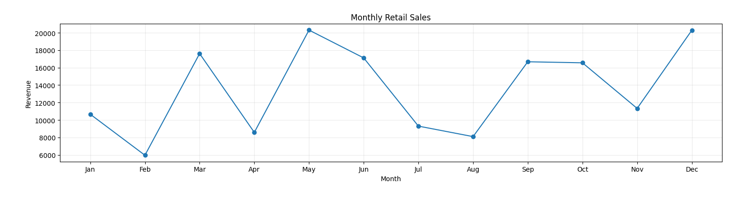

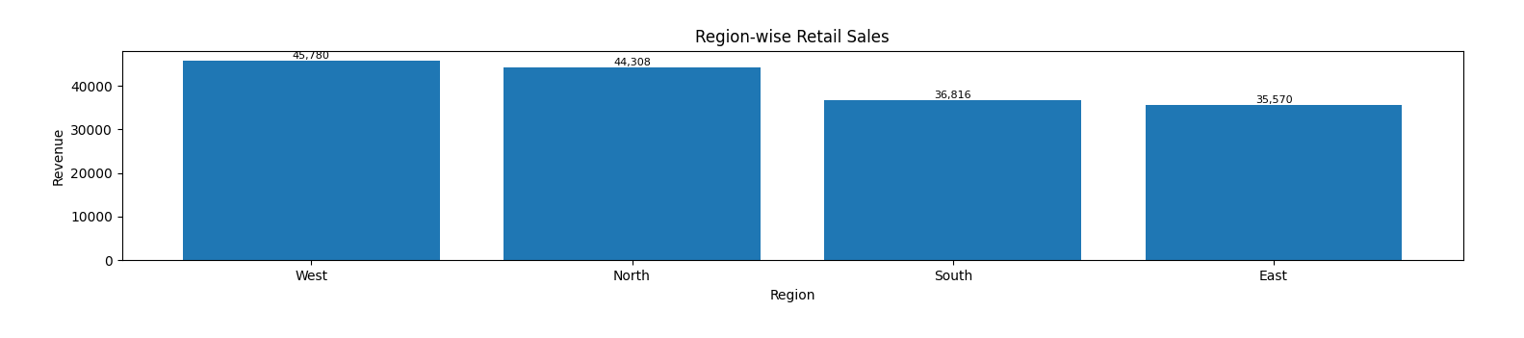
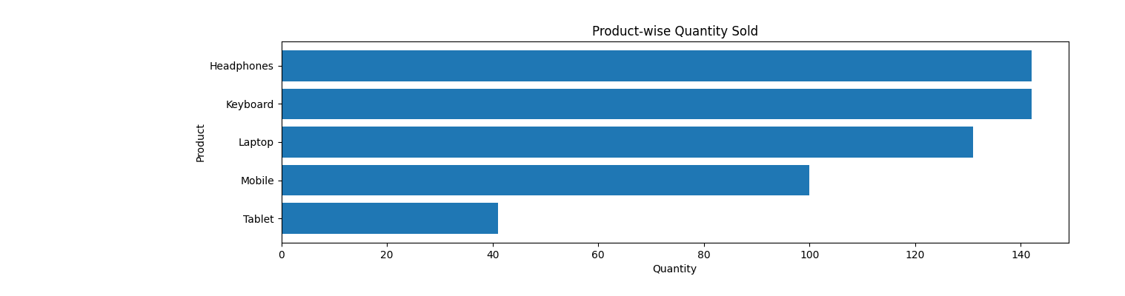

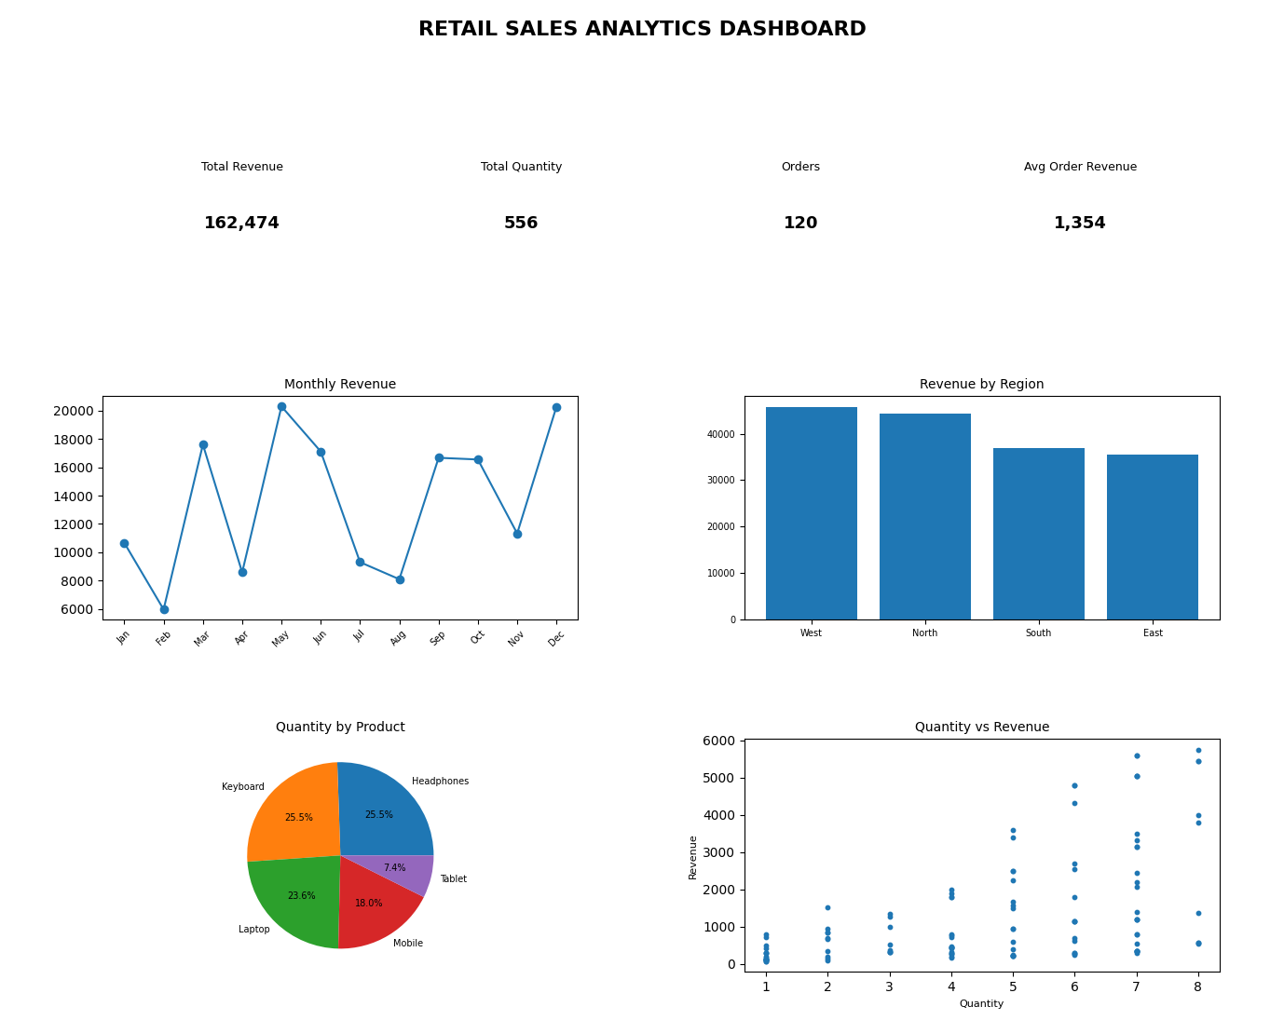

Result:

EXPT NO:7B | DATA VISUALIZATION USING TABLEAU

AIM:

To import, transform, analyze, and visualize the Retail Sales dataset using Tableau Desktop and create interactive worksheets and dashboards to analyze revenue, products, regions, quantities, discounts, and order dates.

ALGORITHM:
- Start.
- Open Tableau Desktop.
- Connect to the Retail Sales CSV dataset using Connect → Text File.
- Import and verify the dataset and its fields: OrderDate, CustomerName, Region, Product, Quantity, UnitPrice, Discount, and Revenue.
- Clean and transform the data by handling missing values, correcting data types, converting OrderDate to date format, and removing duplicate records if required.
- Open a new Worksheet and select suitable fields for visualization.
- Create a Bar Chart to compare products based on their revenue.
- Create a Pie/Donut Chart to display the distribution of revenue across regions.
- Create a Line Chart to analyze monthly retail revenue using OrderDate.
- Create a Table to display important sales information such as OrderDate, CustomerName, Region, Product, Quantity, and Revenue.
- Create suitable Calculated Fields such as Revenue Percentage and Average Order Revenue for detailed analysis.
- Add Filters for fields such as Region, Product, and OrderDate to make the visualizations interactive.
- Combine the worksheets to create an interactive Retail Sales Tableau Dashboard.
- Stop.

OUTPUT:
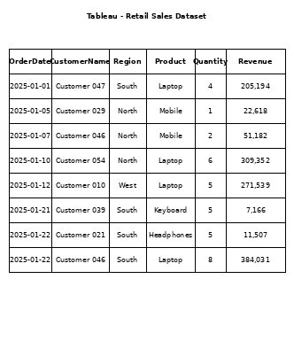

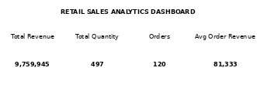

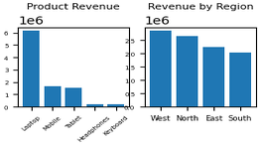
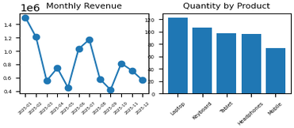

Result:

