EXPT NO:6A | DATA VISUALIZATION USING POWER BI

AIM:
To import, transform, analyze, and visualize data using Power BI Desktop and create interactive dashboards and reports for decision-making.

ALGORITHM:
- Start the Power BI application.
- Import the Research Student dataset into Power BI using Get Data.
- Load the dataset into Power BI.
- Check the columns and clean the data using Power Query if required.
- Remove duplicate records and handle missing values.
- Create required calculated fields/measures.
- Create a bar chart to compare student-related categories.
- Create a pie chart to display category-wise distribution.
- Create a line chart to represent trends between numerical attributes.
- Create a card visual to display important summary values.
- Add suitable titles, labels, filters, and slicers.
- Arrange the visuals into a Power BI dashboard.
- Analyze the visualizations and identify important patterns.
- Save the Power BI report.
- Stop.

OUTPUT:
Importing
Data into Power BI:
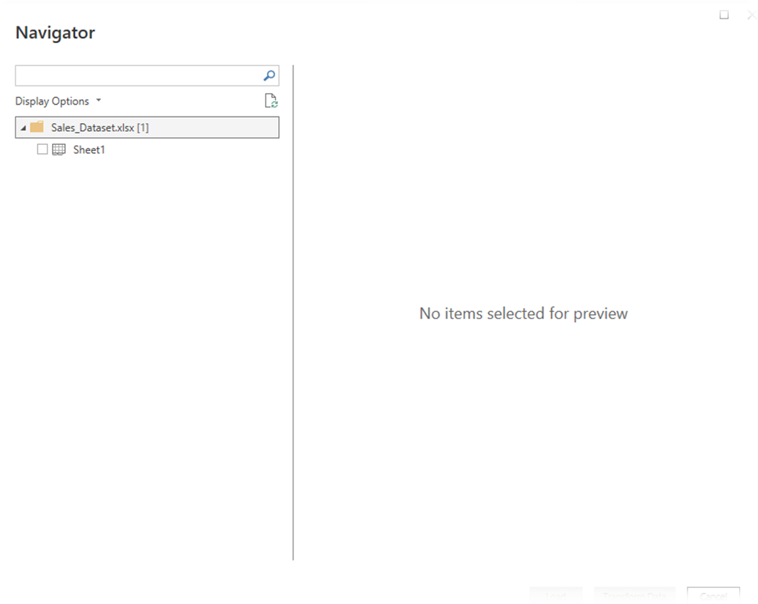

Imported dataset displayed in Data View:
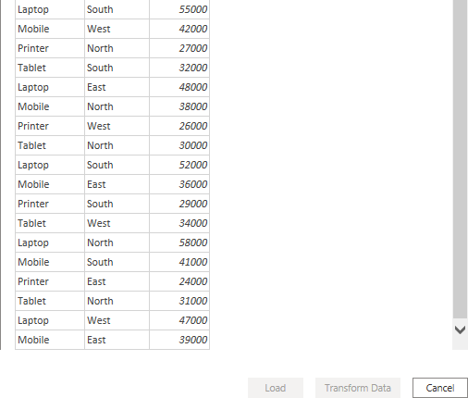

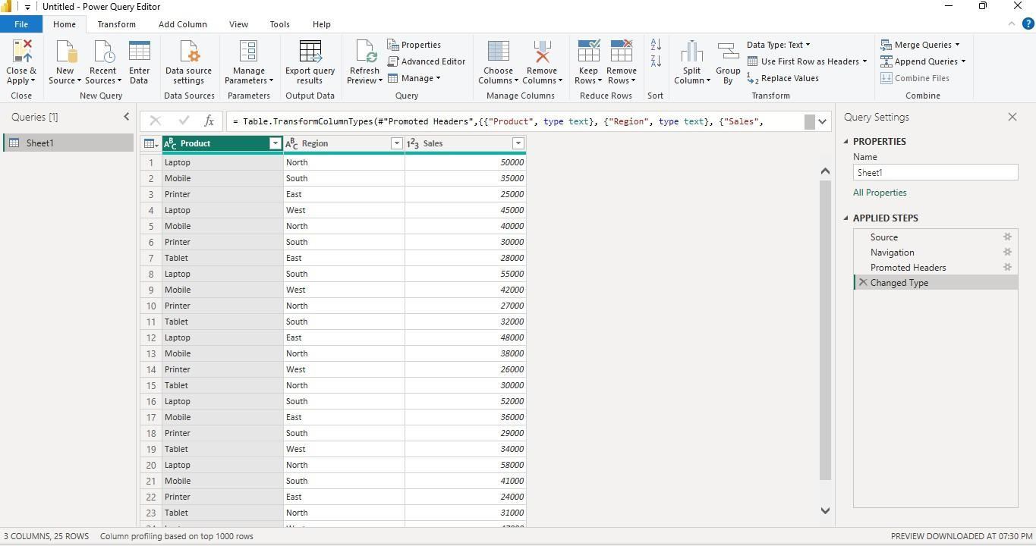
Cleaned dataset loaded successfully:
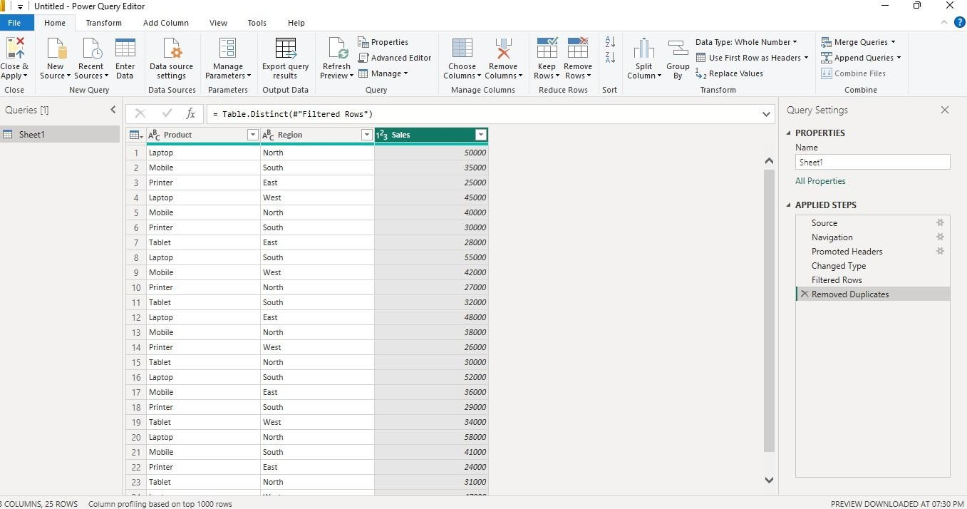
Creating a Bar Chart Product-wise Sales

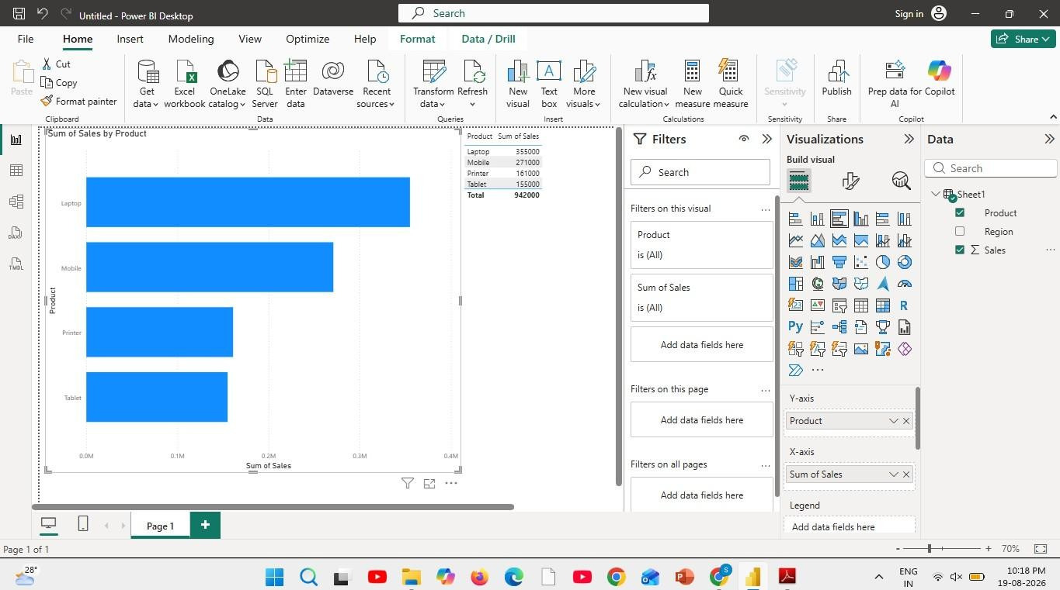
Sales comparison across products.
Creating a Pie Chart Sales Contribution
Percentage contribution of each product
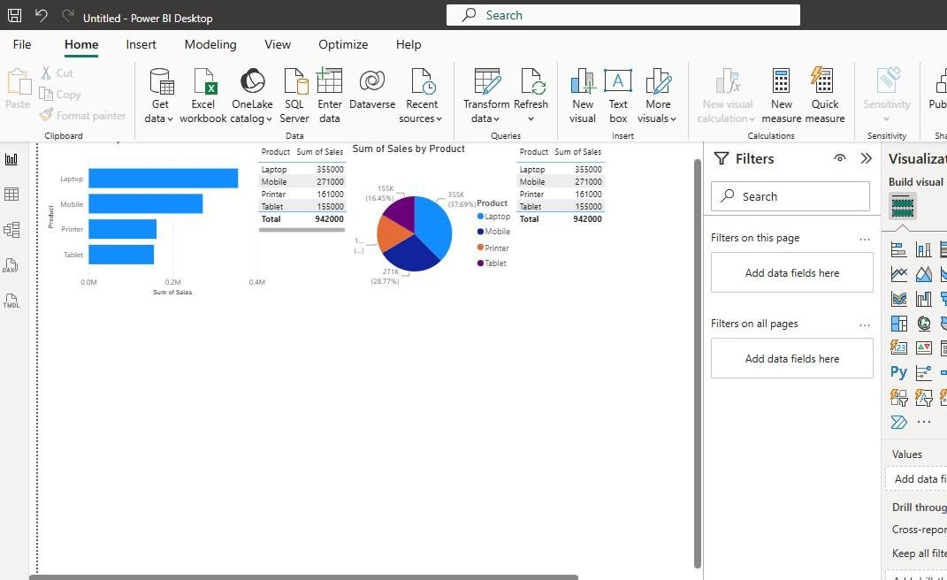

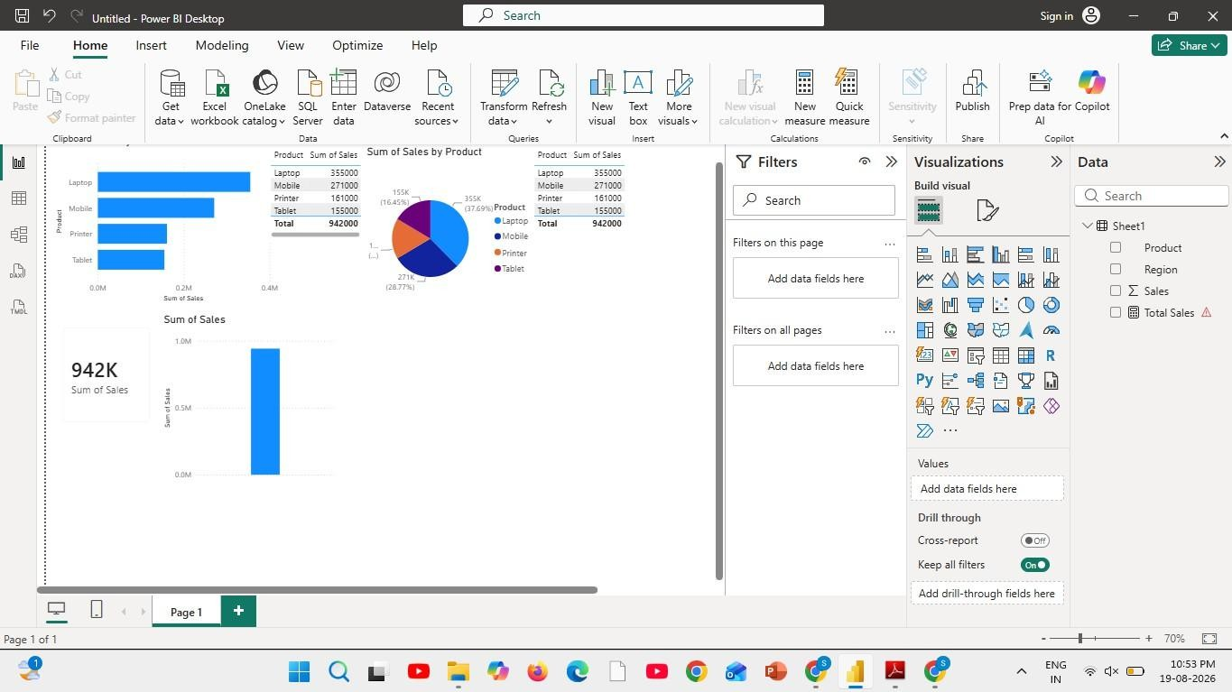
Creating a KPI Card
Creating Slicers:
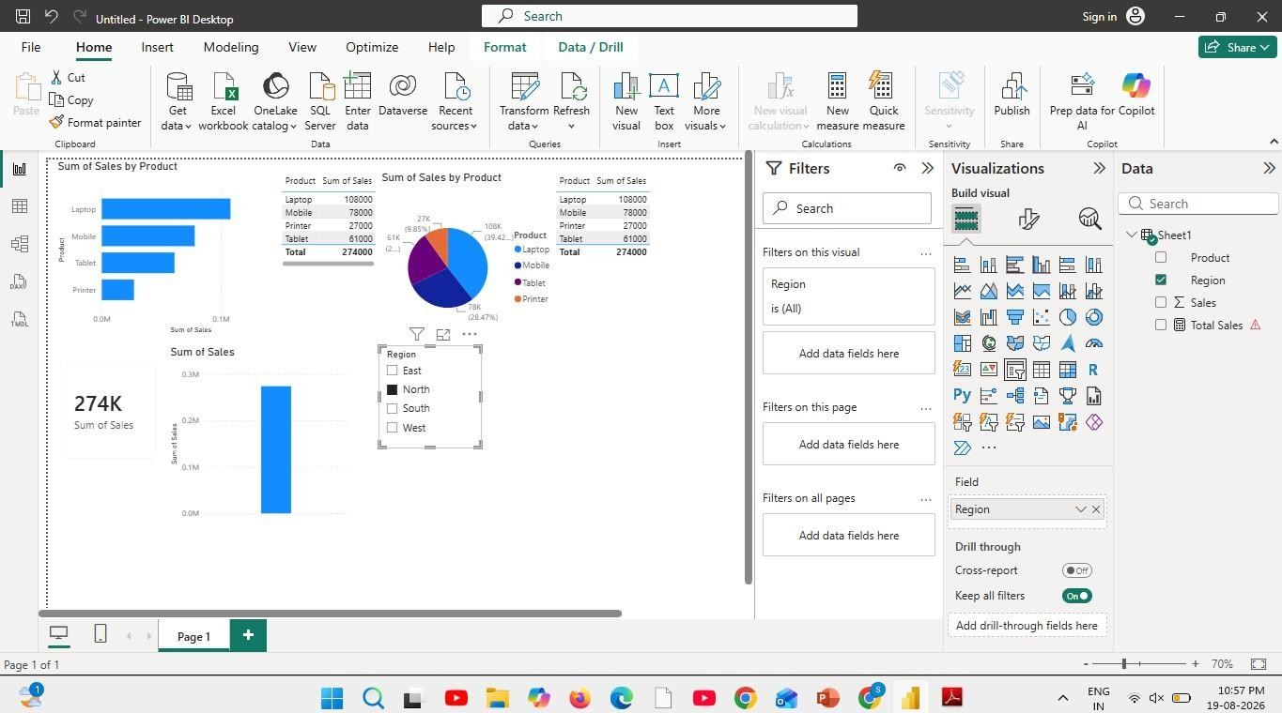
Creating DAX Calculations:

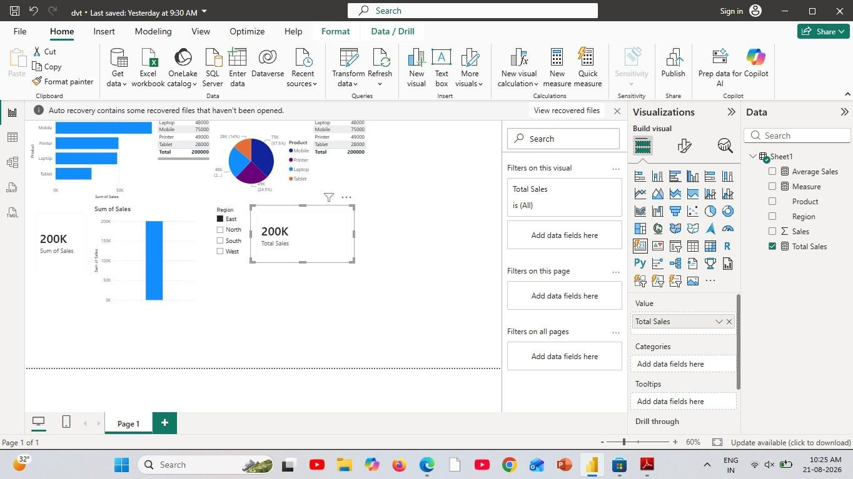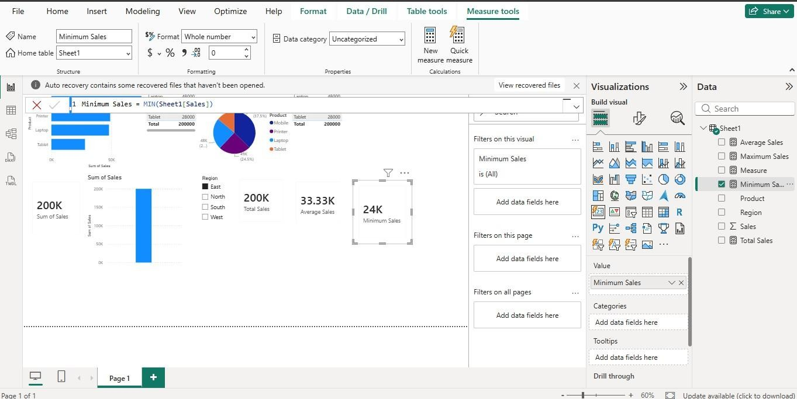

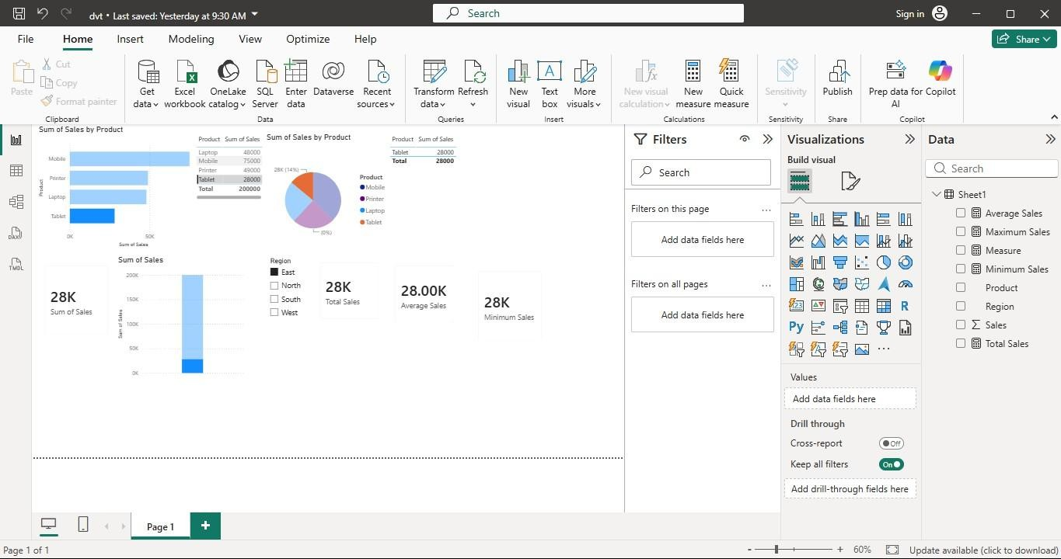
Creating Dashboard:
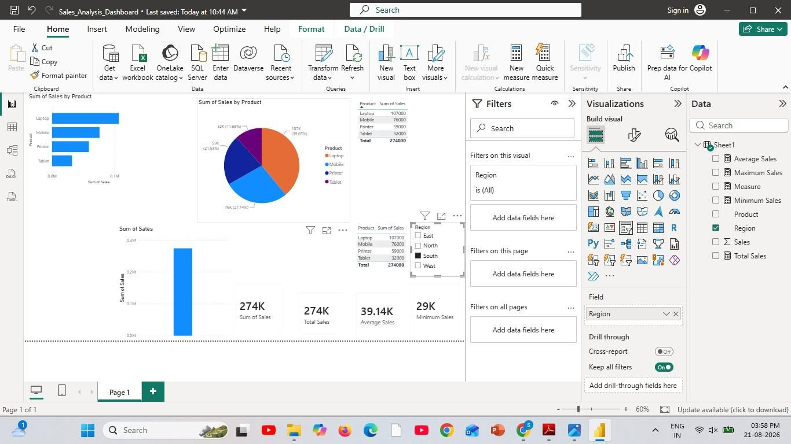

Result:

EXPT NO:6B | DATA VISUALIZATION USING POWER BI (ADVANCED STATISTICS ANALYTICS)

Aim:
To load the Sales dataset into Power BI, transform and clean the data using Power Query, create calculated fields and measures, and develop interactive visualizations to analyze sales based on revenue, quantity, products, regions, discounts, customers, and monthly performance.

Algorithm:
ALGORITHM 1: IMPORTING DATA INTO POWER BI
Step 1
Open Power BI Desktop.
Step 2
Select:
Home → Get Data
Step 3
Choose Text/CSV.
Step 4
Browse and select the Sales Dataset CSV file.
Step 5
Click Load to import the dataset.
Step 6
Verify the imported sales columns and records in the Data View.

ALGORITHM 2: DATA TRANSFORMATION USING POWER QUERY
Step 1
Select Transform Data.
Step 2
Open the Power Query Editor.
Step 3
Check the column names and assign appropriate data types to date, numerical, and categorical columns.
Step 4
Remove duplicate sales transaction records if required.

Step 5
Handle missing or null values in columns such as CustomerName, Region, Product, Quantity, UnitPrice, and Discount.
Step 6
Clean and standardize categorical values such as Region and Product.
Step 7
Remove unnecessary columns if required.
Step 8
Click Close & Apply to load the transformed sales dataset into Power BI.

ALGORITHM 3: ADVANCED DATA TRANSFORMATIONS
Step 1
Select the Quantity column and ensure that it has an appropriate whole-number data type.
Step 2
Select the UnitPrice column and convert it into a decimal data type.
Step 3
Select the Discount column and convert it into a numeric data type.
Step 4
Select the OrderDate column and convert it into an appropriate Date data type.
Step 5
Handle missing values in numerical columns by replacing them appropriately or filtering invalid records.
Step 6
Create additional categories or groups where required, such as sales ranges or product groups for comparison.
Step 7
Click Close & Apply to load the cleaned sales dataset into the Power BI model.

ALGORITHM 4: CREATING CALCULATED COLUMN AND MEASURES
Step 1
Navigate to Report View or Table View.
Step 2
Right-click the dataset table and select New Column.
Step 3
Create a calculated column to determine the sales amount after discount:

Net Revenue =
[Quantity] * [UnitPrice] * (1 - [Discount] / 100)
Step 4
Create a measure to calculate total revenue:
Total Revenue =
SUM([Revenue])
Step 5
Create a measure to calculate total quantity:
Total Quantity =
SUM([Quantity])
Step 6
Create a measure to calculate the average revenue:
Average Revenue =
AVERAGE([Revenue])
Step 7
Create additional measures such as total orders, average discount, or average unit price for further analysis.

ALGORITHM 5: DASHBOARD VISUALIZATION & REPORTING
Step 1
Select a Line Chart and map OrderDate to the X-axis and Revenue to the Y-axis to analyze monthly sales trends.
Step 2
Select a Bar/Column Chart and map Product or Region to the X-axis and Revenue to the Y-axis.
Step 3
Select a Donut/Pie Chart to display the regional contribution to total sales revenue.
Step 4
Select a Bar Chart to identify the top products by revenue.
Step 5
Create another chart to compare quantity sold across products.
Step 6
Add Card Visuals to display important summary values such as:
- Total Orders
- Total Revenue
- Total Quantity

Step 7
Add Slicer visuals for Region, Product, and OrderDate to enable interactive filtering.
Step 8
Arrange all the visuals into a meaningful and interactive Sales Analytics Dashboard.
Step 9
Add suitable titles, labels, legends, and formatting to improve the readability of the dashboard.
Step 10
Analyze the dashboard to identify patterns such as top products, leading regions, monthly revenue trends, quantity-revenue relationships, and discount effects.
Step 11
Save the Power BI report as a .pbix file.

Output:
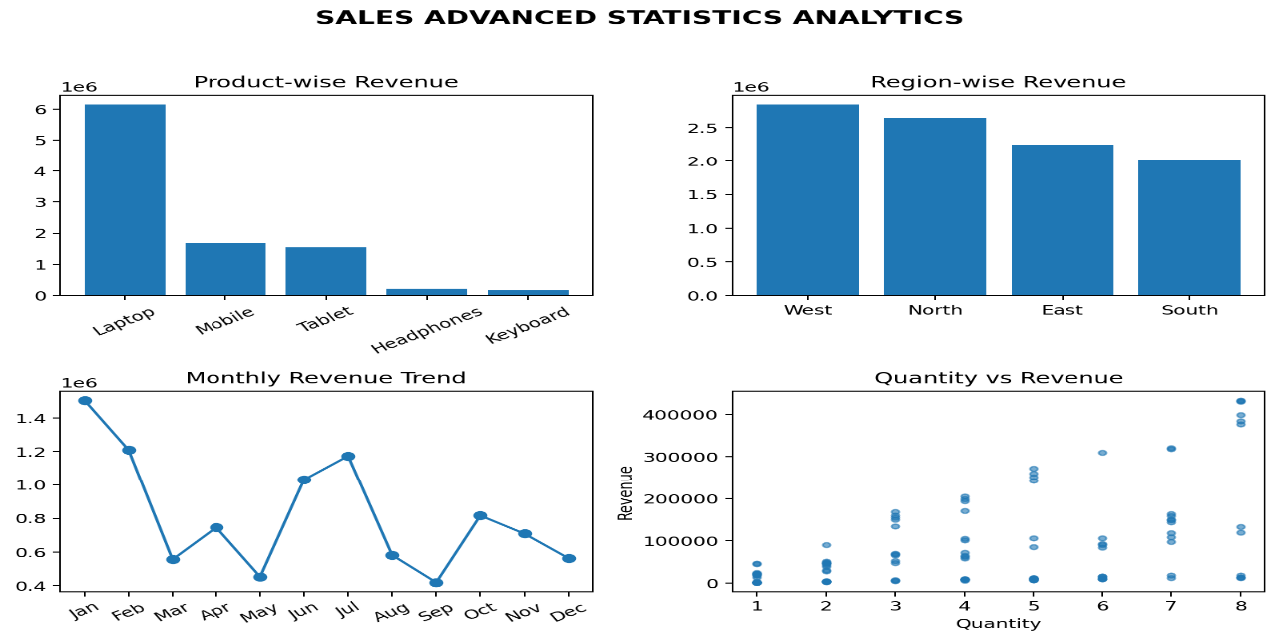

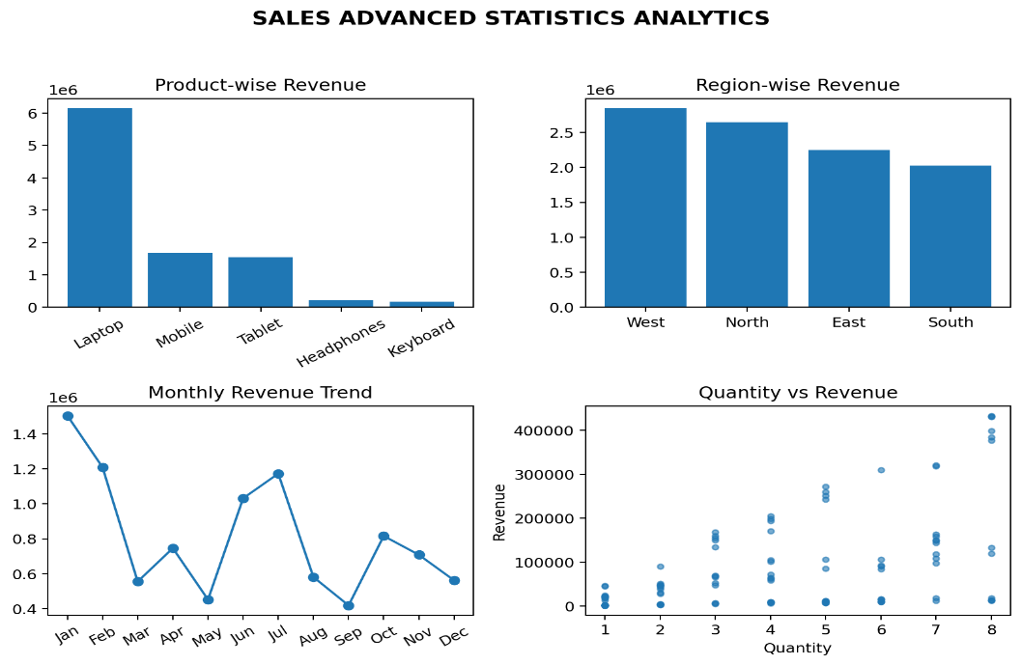

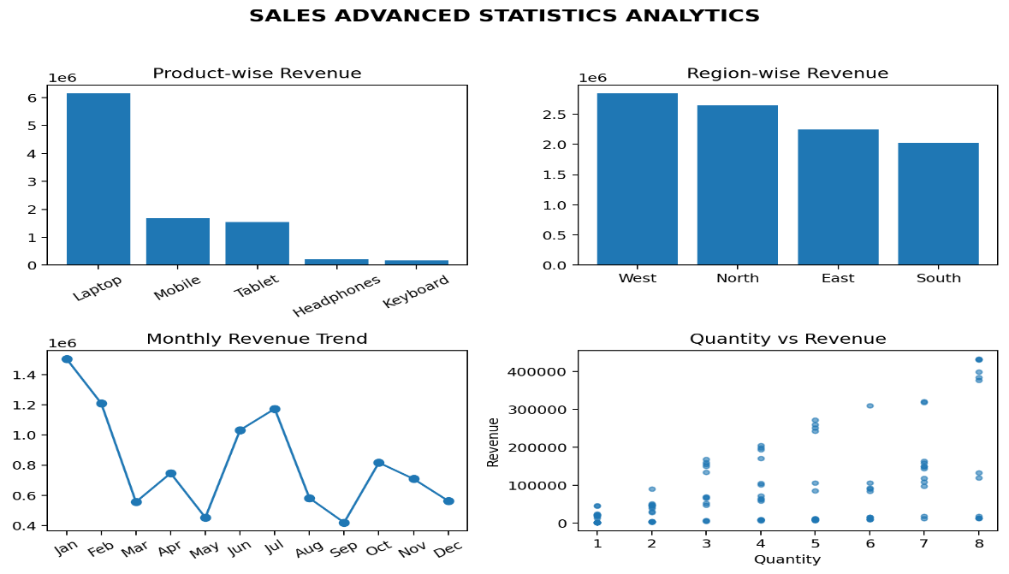

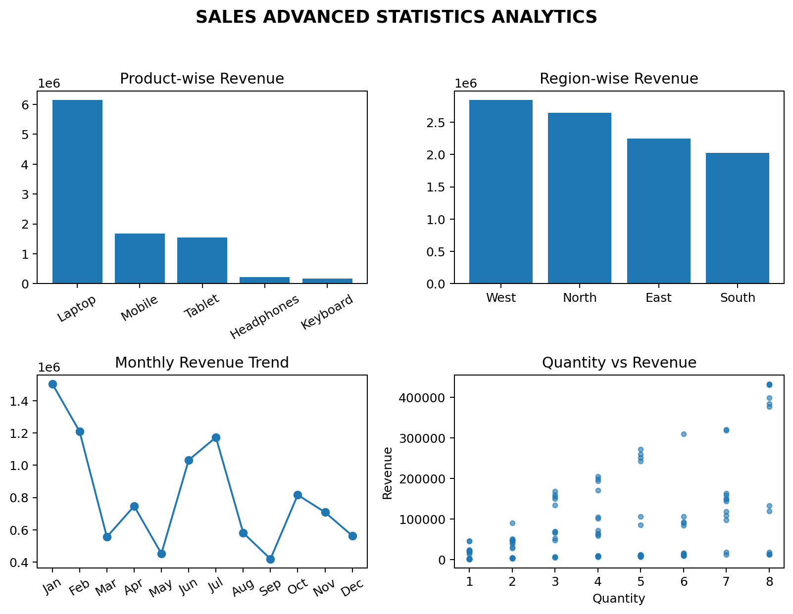

Result:

EXPT NO:6C | DATA VISUALIZATION USING POWER BI (SALES DATA ANALYSIS)

Aim:
To clean, preprocess, and transform the Sales dataset, load the clean data model into Power BI, and build an interactive visual dashboard to analyze sales revenue, product performance, regional sales, quantity, discounts, and monthly trends.

Algorithm:
- Import Dataset: Load Sales_Dataset.csv into your environment.
- Deduplication: Identify and delete duplicate sales rows across all fields
- Review Missing Columns: Identify columns with excessive missing/null data and remove them only if required.

Impute Missing Values:
Replace missing values in numeric sales fields using an appropriate value or median; replace missing categorical values using the mode where required.
- Handle Data Type & Syntax Errors:

Replace text anomalies (like "NA" strings) in numeric columns (Quantity, UnitPrice, Discount, Revenue) with
0 to prevent load errors.

Format OrderDate as Date, Quantity as Whole Number, and UnitPrice, Discount, and Revenue as Decimal.

- Load Clean Data: Load the cleaned sales table into Power BI Desktop via Get Data > Text/CSV (or click Apply & Close from Power Query Editor).

Create Core Metric:
Right-click the table name → Select New Measure.
Define measures such as: Total Revenue = SUM(Sales_Dataset[Revenue]) and Total Orders = COUNTROWS(Sales_Dataset).

Output:

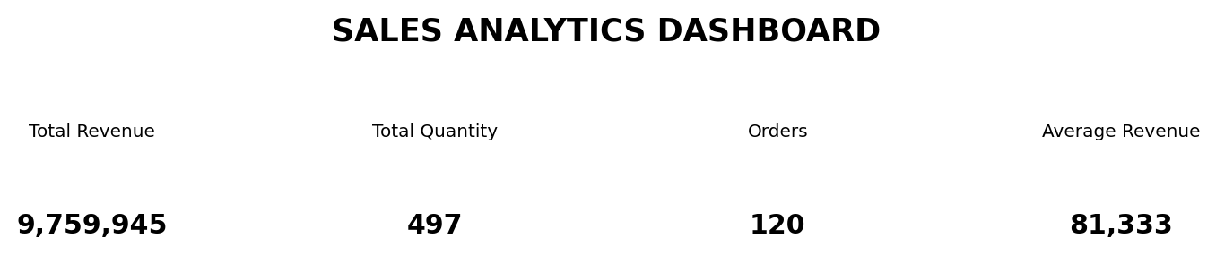

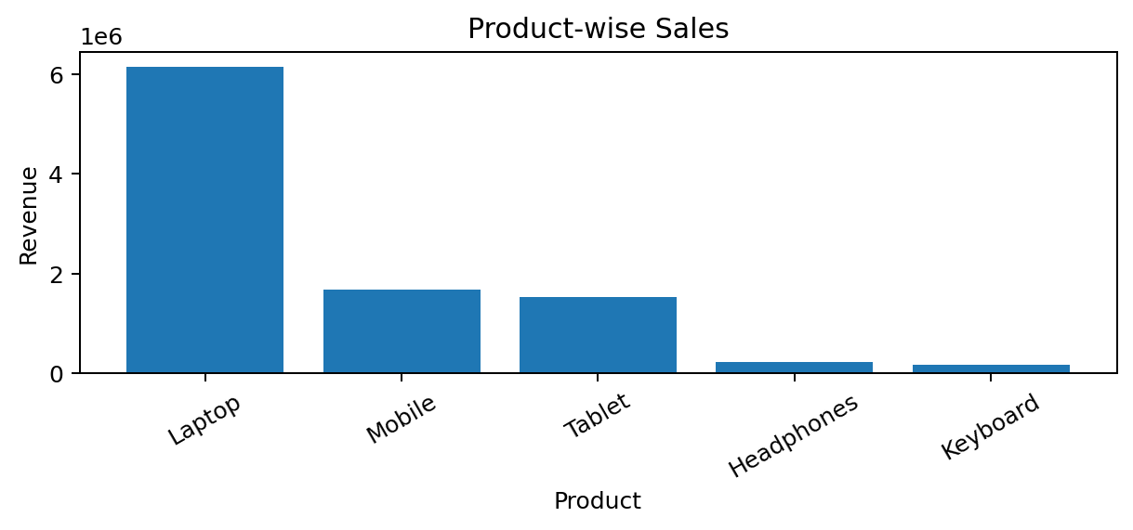

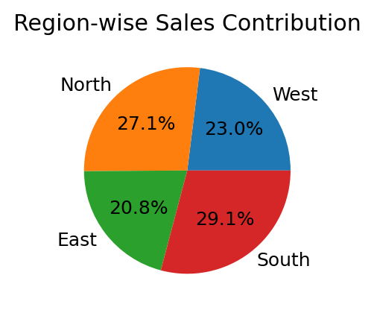

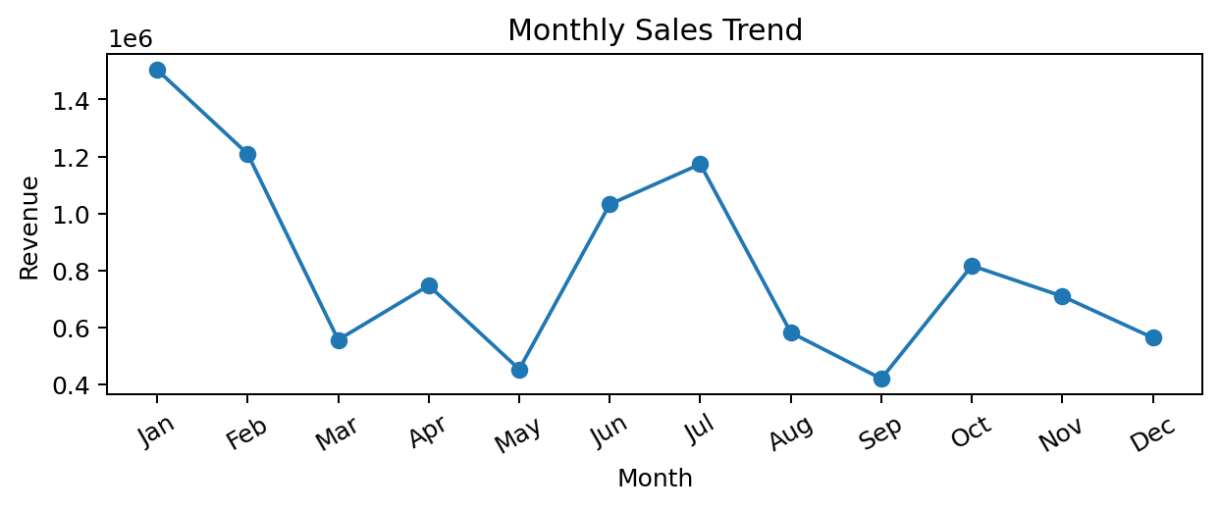

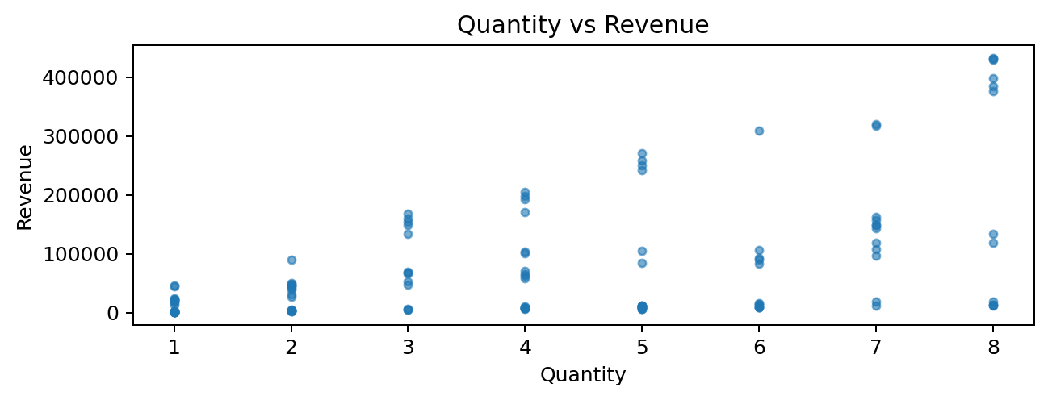

Result:

