**Project Report: Exploring Data Visualizations**

1. **Introduction:**

Welcome to the comprehensive project report on data visualization! In today's data-driven environment, the ability to effectively analyze and interpret data is critical for making sound decisions and getting actionable insights. This project will use a range of visualization approaches to investigate a vast and diversified dataset known as "merged_dataset.json".

The dataset contains a diverse mix of attributes, such as demographic data, job-related information, customer transactions, and so on. We use visualization technologies like D3.js, Tableau, and Python to find hidden patterns, correlations, and trends in the data.

The primary goal of this project is twofold: first, to demonstrate the versatility and efficacy of various visualization methods for extracting meaningful insights from complex datasets; and second, to provide actionable insights that can drive decision-making processes and inform strategic initiatives.

Throughout this study, we will deconstruct the dataset, using several visualization tools to highlight key results and trends. Each visualization, from bar graphs and scatter plots to heatmaps and colored maps, provides a window into the underlying data, revealing unique perspectives and insights.

Join us on this adventure as we explore the broad landscape of data visualisations, uncovering the tales buried behind the numbers and realizing the potential for informed decision-making and strategic planning.

1. **Methodology**

**2.1 Data Collection and Preparation:**

The technique begins with the collecting of the dataset, "merged_dataset.json," which covers a wide range of attributes such as demographics, job titles, employment information, customer transactions, and more. The dataset was carefully vetted to ensure its relevance and completeness for this project.

Prior to visualization, the dataset was thoroughly cleaned and preprocessed to remove any inconsistencies, missing values, and outliers. This included duties including data imputation, standardization, and transformation to assure the integrity and quality of the data for analysis.

**2.2 Selection of Visualization Tools:**

To successfully explore and evaluate the dataset, a number of visualization tools were chosen based on their capabilities, applicability for different types of data, and versatility in producing meaningful visuals. The selected tools included:

* D3.js is a robust JavaScript library for building interactive and dynamic data visualizations in web browsers.
* Tableau is a renowned data visualization software that provides intuitive and interactive visualizations for data exploration and presentation.
* Python is a versatile programming language with tools for building static and interactive visualizations, including Matplotlib, Seaborn, and Plotly.

**2.3 Visualisation Techniques:**

The visualization approaches used in this project included a wide variety of charts, graphs, and maps, each intended to highlight various characteristics of the dataset. These techniques included the following:

* Bar graphs are used to compare category data and show trends across time.
* Bubble charts are useful for displaying correlations between numerous variables using the size and color of bubbles.
* Heatmaps are useful for depicting data density or correlation between variables using color gradients.
* Colored maps are used to depict geographical data, with different colors indicating various features or metrics.

**2.4 Implementation of Visualizations:**

The implementation phase involves building, tweaking, and fine-tuning the visualizations with the tools and techniques chosen. Each visualization was created with the goal of being intuitive, interactive, and visually appealing, with particular attention paid to color schemes, labels, legends, and tooltips.

**2.5 Analysis and Interpretation:**

After the visualizations were created, they were evaluated and interpreted to derive useful insights and trends from the data. This entailed identifying trends, correlations, outliers, and any noteworthy observations that could help with decision-making or strategic planning.

**2.6 Documentation and Reporting:**

Finally, the analysis results were documented and put into a complete project report that acts as a repository for insights, visualizations, and suggestions. The paper includes a comprehensive summary of the methodology, findings, and consequences of the analysis, making it a valuable resource for stakeholders and decision-makers.

1. **Data Visualisation Descriptions**

**3.1 D3.js Visualisation**

**3.1.1 Bar Graph Visualisation**

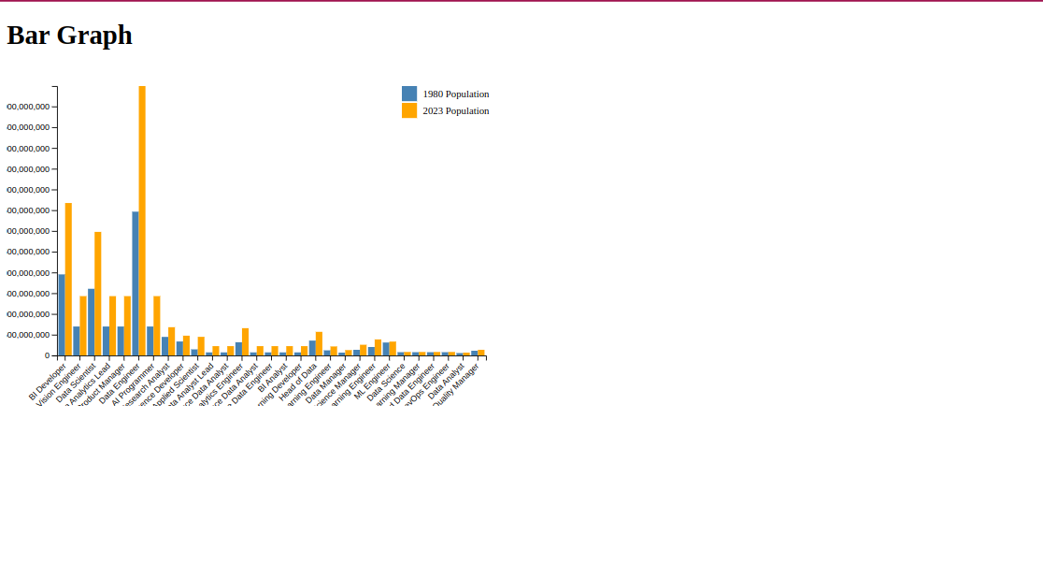

The bar graph visualization depicts a comparative examination of job title populations during 1980–2023. Visualizing the distribution of job titles across time allows us to see patterns in job attractiveness and shifts in workforce dynamics.

Insights:

Certain job titles had high population expansion, indicating rising demand or growing businesses.

In contrast, several job categories had population declines, indicating changes in market demand or technology improvements affecting employment responsibilities.

**3.1.2 Bubble Chart Visualisation**

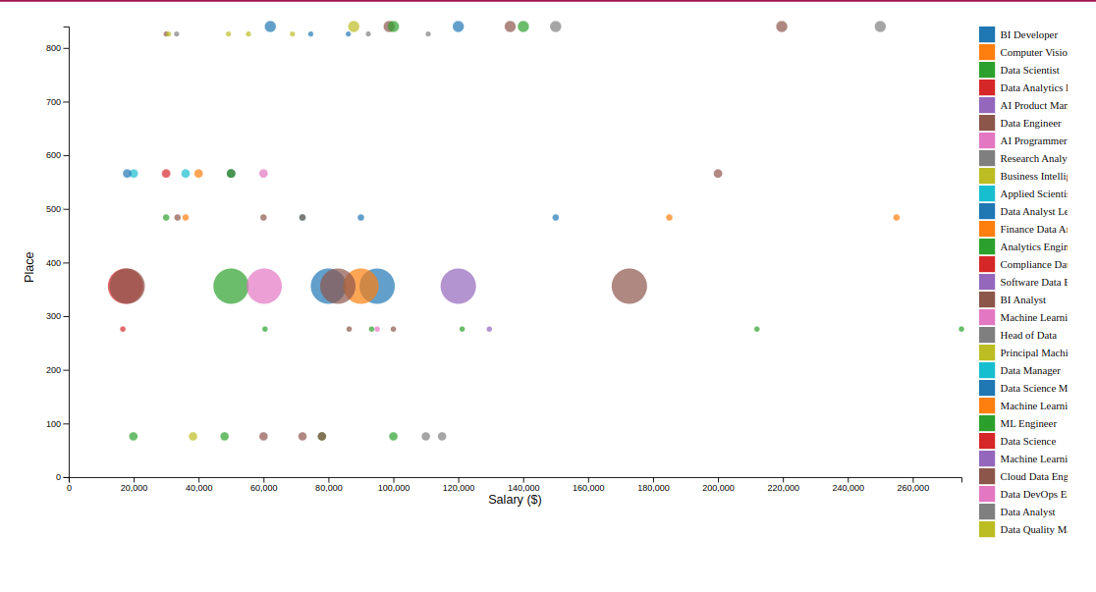

The bubble chart visualizes the association between pay, location, and population. Each bubble represents a distinct data point, with the size corresponding to the population and the color representing salary range. This visualization allows for the observation of salary differences across various areas and population densities.

Insights:

High-density bubbles in specific regions indicate areas with a concentration of high-paying occupations and a dense population.

Varying bubble sizes indicate salary disparities between areas, with larger bubbles signifying higher population density.

**3.1.3 Heat Map Visualisation**

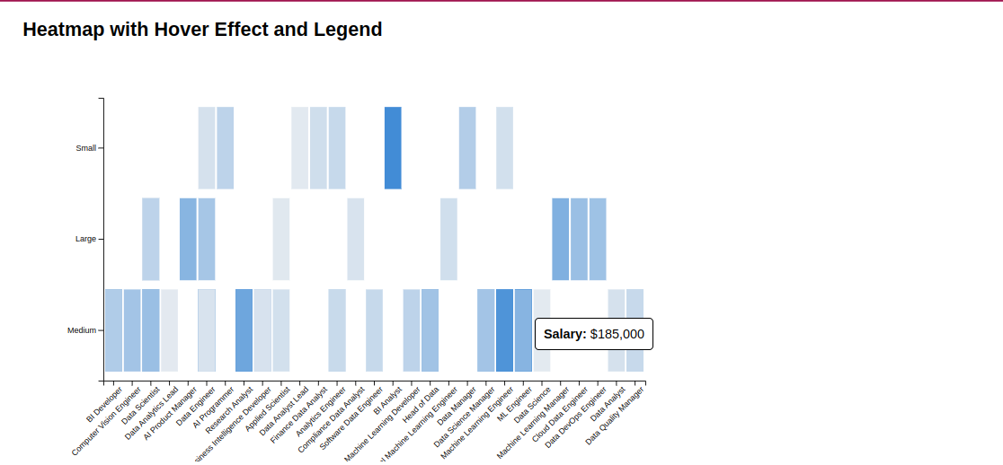

The heat map visualization provides a detailed picture of wage distributions by job title and firm size. By color-coding wage ranges, this graphic allows for rapid insights into salary differences and patterns in the dataset.

Insights:

Heat map gradients show salary clusters within specific job titles and firm sizes, suggesting areas with high and low remuneration.

Darker tones indicate greater wage ranges, while lighter shades reflect lower salary categories, making salary trends easy to identify.

**3.2 Tableau Visualisations**

**3.2.1 Colored Map**

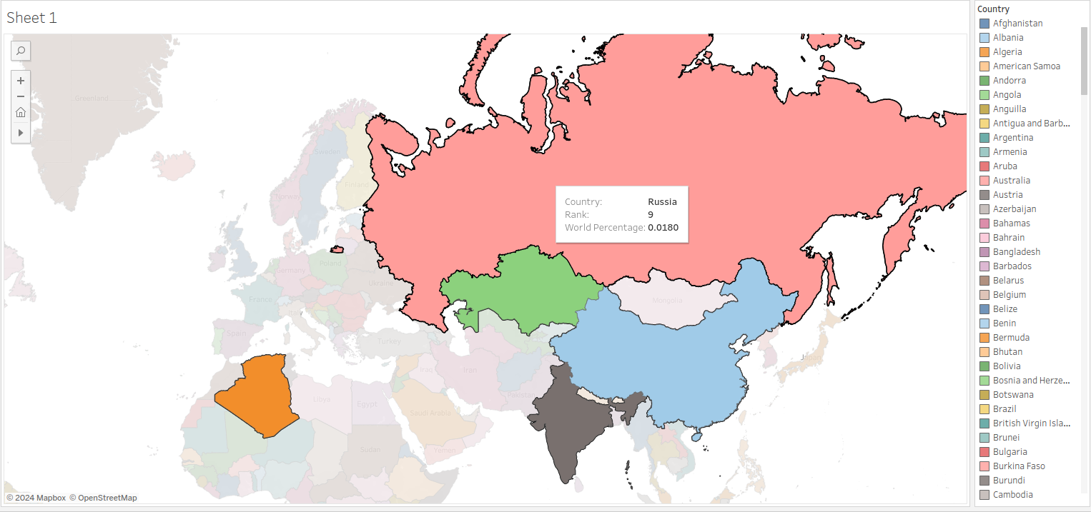

The colored map depiction displays countries according to their rankings and global percentages. By color-coding countries based on their rankings and percentages, we can learn about global distribution patterns and market shares.

Insights:

Countries with deeper hues have higher rankings and bigger world percentages, indicating their dominance in the worldwide market.

Lighter-colored countries have lower ranks and a smaller global share, indicating nascent markets or specialist sectors.

**3.2.2 Colored Bar Graph**

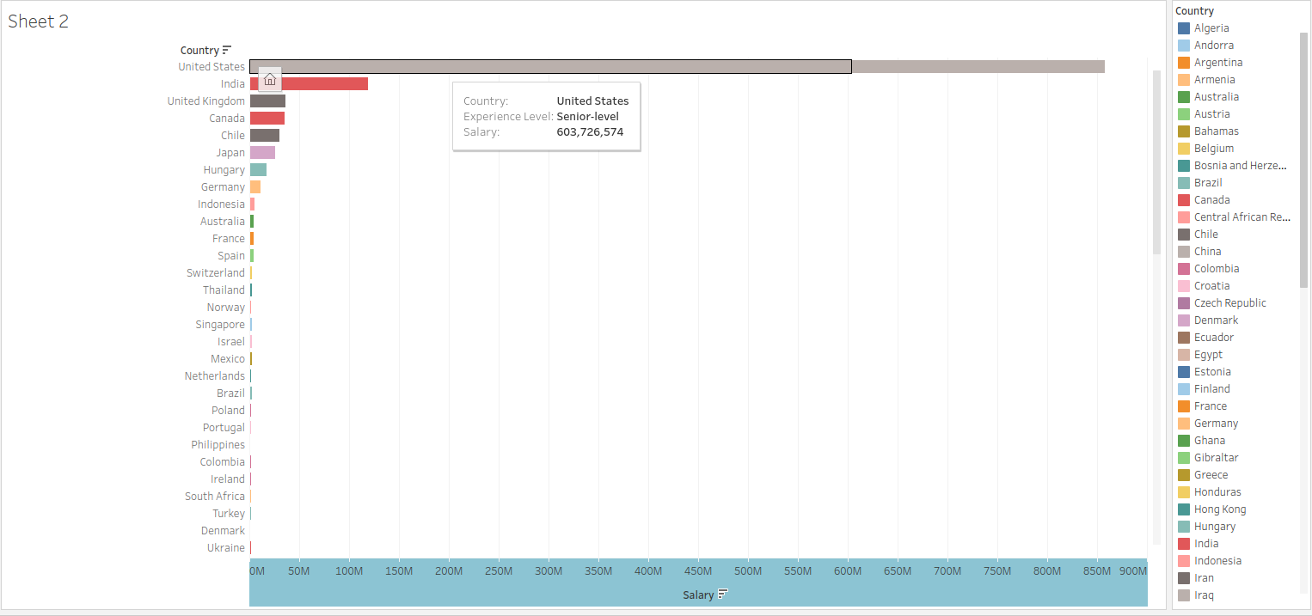

The colorful bar graph visualizes pay distributions across nations and experience levels. By visualizing wage data across countries and experience levels, we may uncover inequalities and trends in compensation structures.

Insights:

Bars of differing lengths reflect wage ranges for different nations and experience levels, allowing for comparisons and trend analysis.

Discrepancies in bar heights reveal differences in income levels across nations and experience groups, providing insight into worldwide compensation patterns.

**3.2.3 Colored Bubble Chart**

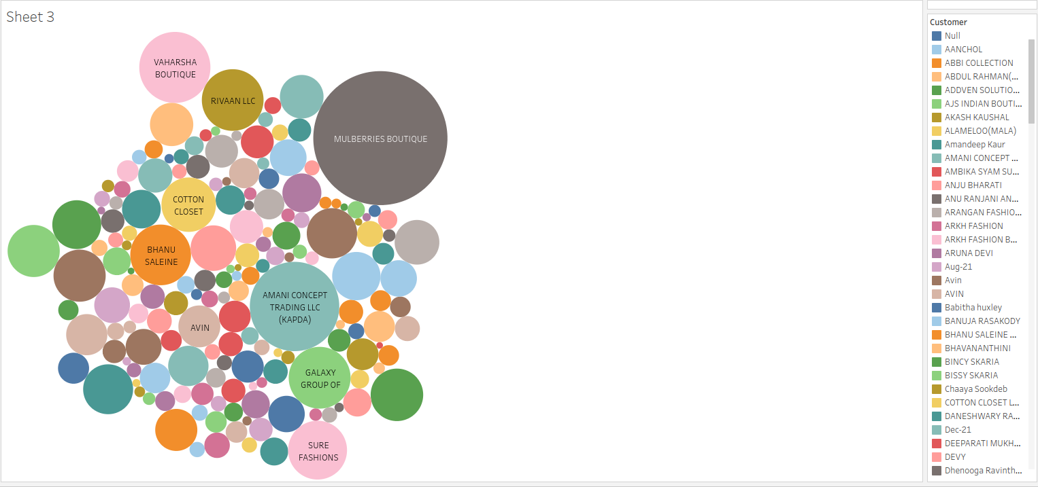

The colorful bubble chart illustrates the relationship between customers and gross amounts. Visualizing gross amounts in connection to customer transactions allows us to discover high-value consumers and transaction frequencies.

Insights:

Larger bubbles reflect consumers with higher transaction values, showing their importance in terms of revenue generating.

Variable bubble colors and sizes allow for rapid detection of transaction patterns and client groupings based on gross amounts.

**3.2.4 Colored Bar Graph**

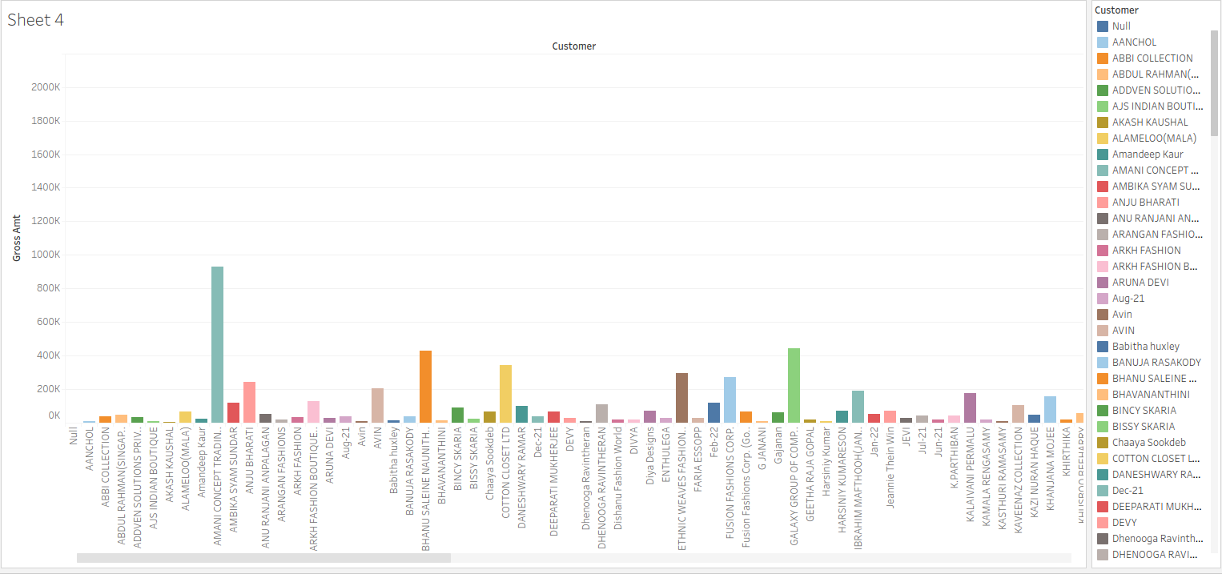

The colorful bar graph visualizes gross amounts over time for various consumers. By visualizing gross amounts over time for specific customers, we can track revenue patterns and client spending habits.

Insights:

Bar heights represent gross amounts for individual customers and years, enabling trend analysis and anomaly discovery.

Color gradients show substantial changes over time, with darker colors signifying greater values and lighter shades denoting lower values.

**3.3 Python Visualisations**

**3.3.1 Line Plot**

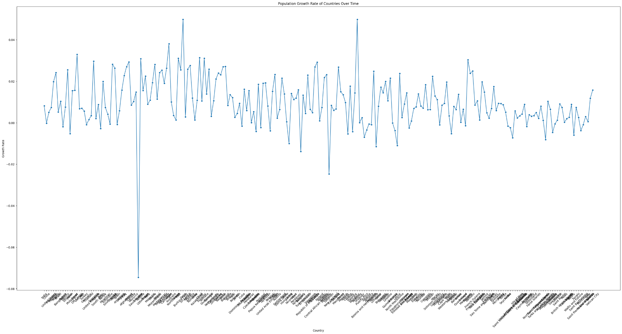

The line plot visualizes population patterns over time. By graphing population statistics against time, we may examine demographic transitions and population growth patterns.

**3.3.2 Scatter Plot**

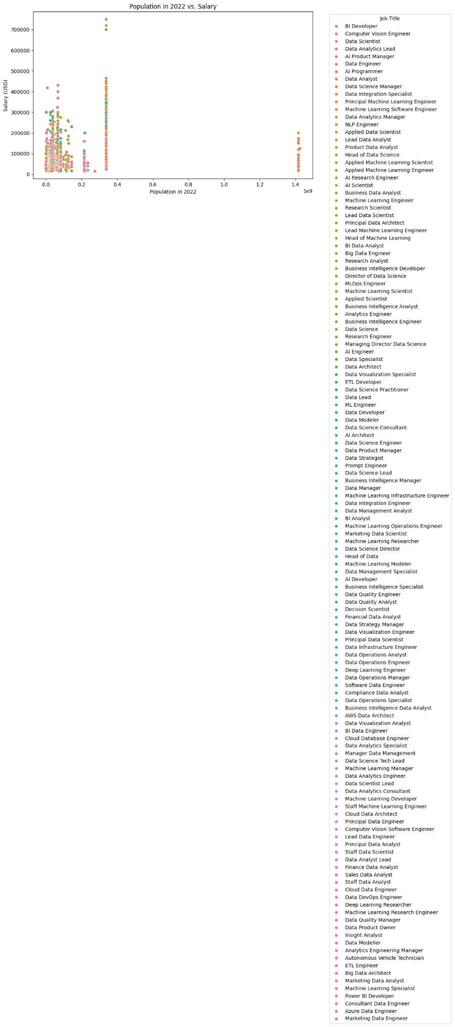

The scatter plot visualizes the association between age and salary. Individual data points can be plotted depending on age and pay to detect connections and patterns between the two variables.

**3.3.3 Violin Plot**

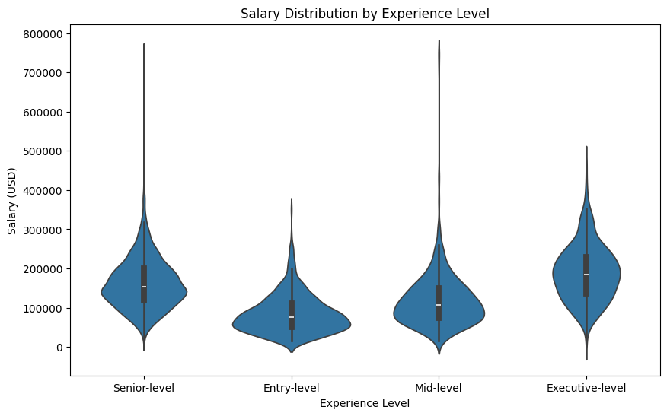

The violin plot visualizes the salary distribution across different expertise levels. Visualizing wage distributions within each experience group allows us to discover differences and trends in compensation structures.

**3.3.4 Histogram**

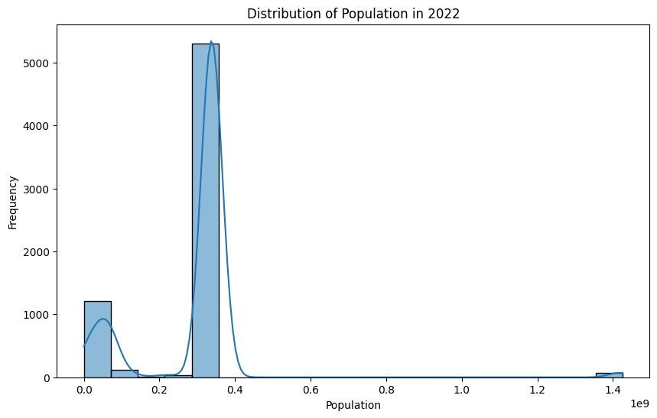

The histogram visualizes the distribution of population sizes in 2022. By plotting population data in a histogram, we can detect patterns and trends in population distribution across the dataset.

1. **Webpage**

We have created a webpage containing screenshots of all visualizations along with additional information and insights. The webpage provides a comprehensive overview of the visualizations and their interpretations.

1. **Conclusion**

Through the utilization of diverse visualization techniques, we've gained valuable insights into the dataset, ranging from workforce dynamics and salary distributions to global market trends and demographic patterns. These insights can inform strategic decision-making processes and guide future analyses to drive organizational success.

1. **References**

* <https://www.hindawi.com/journals/am/2022/4291978/>
* https://www.researchgate.net/publication/335712719_The_Impact_
* of_Demographic_Factors_on_E- commerce_Adoption_A_Review_of_the_Literature
* https://www.researchgate.net/publication/343306685_E- commerce_Market_Segmentation_Based_on_Demographics_and_ Psychographics_of_Online_Shoppers
* https://www.researchgate.net/publication/342947138_The_Relatio nship_Between_E-commerce_Sales_and_Demographic_Factors_A_Case_Study_of_
* <https://www.kaggle.com/datasets/rajkumarpandey02/2023-world-population-by-country>
* <https://www.kaggle.com/datasets/sazidthe1/data-science-salaries>
* <https://www.kaggle.com/datasets/thedevastator/unlock-profits-with-e-commerce-sales-data>