**Unlocking Insights into the Global Air Transportation Network with Tableau**

Introduction:

Unlocking Insights into the Global Air Transportation Network with Tableau" embarks on a journey to unravel this data tapestry. This endeavor leverages the power of Tableau, a robust data visualization and analytics tool, to shed light on the inner workings of the aviation sector.The aviation industry is a dynamic ecosystem, characterized by a multitude of moving parts – airports, airlines, routes, passengers, cargo, and regulations. Understanding this complexity is crucial for optimizing operations, ensuring safety, and enhancing the passenger experience. Tableau acts as the beacon, illuminating the path towards these goals.

Purpose:

Optimizing Operations: Using Tableau to analyze data can help airlines and airports optimize their operations, leading to improved efficiency, reduced costs, and better resource allocation.By visualizing and understanding data related to safety incidents and compliance with regulations, Tableau can assist in identifying areas for safety improvements within the aviation industry.

Empathy Map:

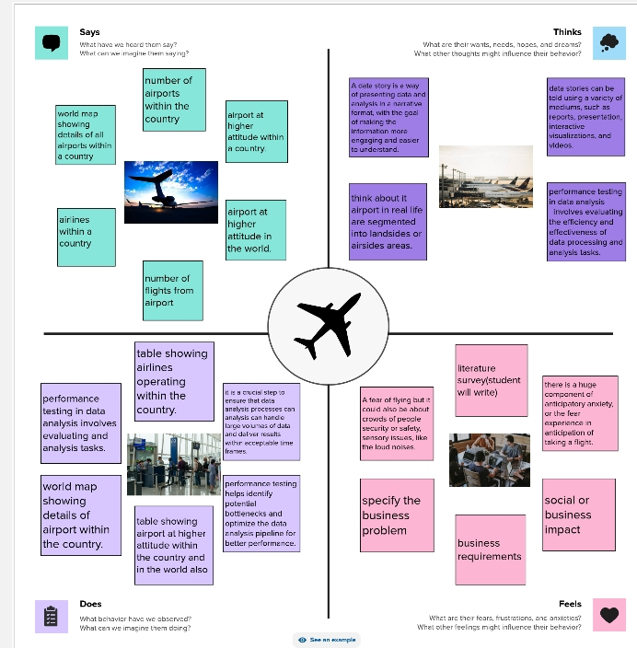

Brainstorming Map:

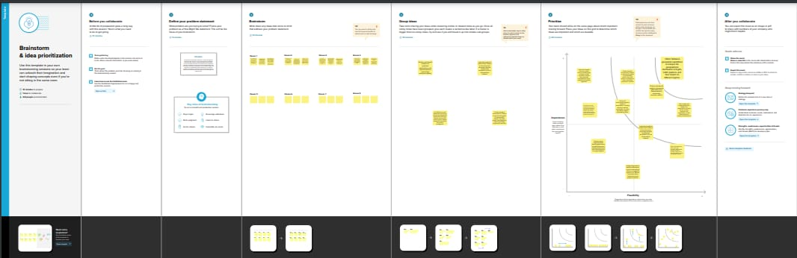

Result:

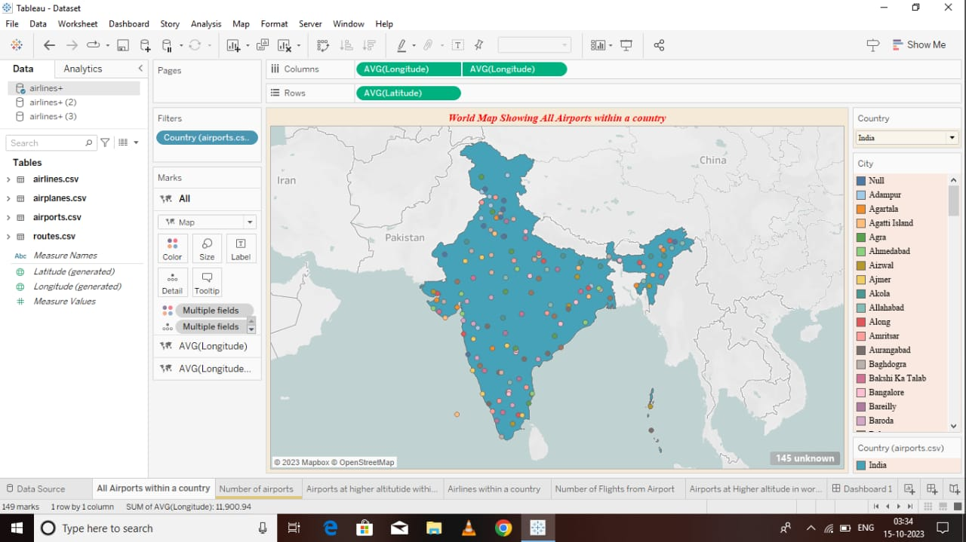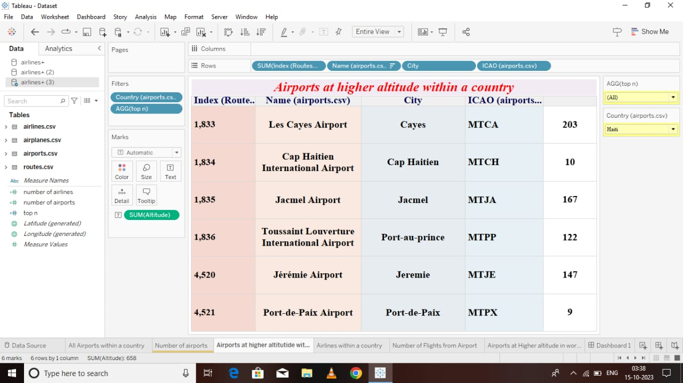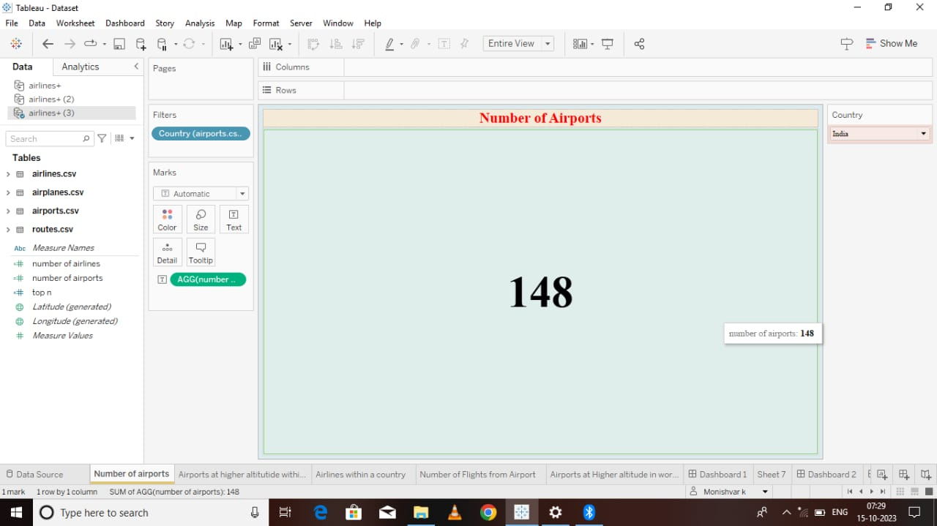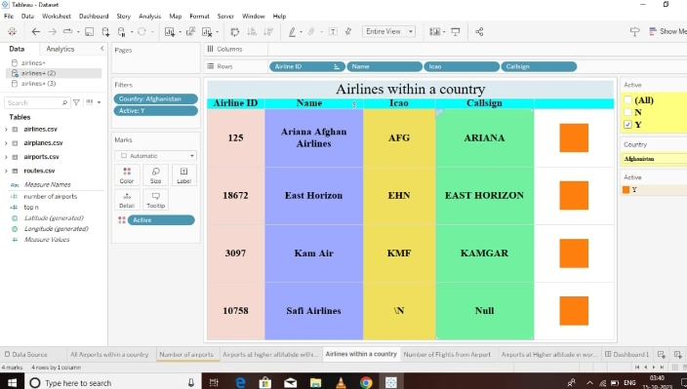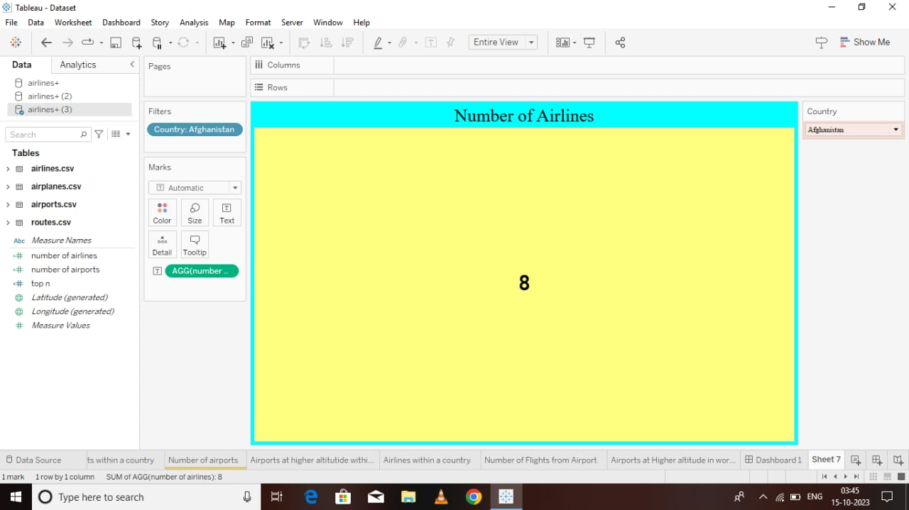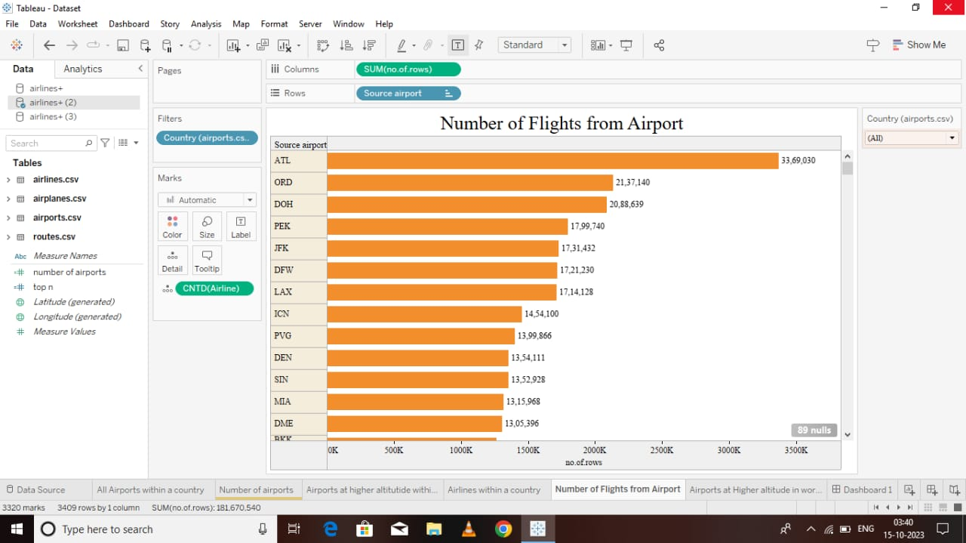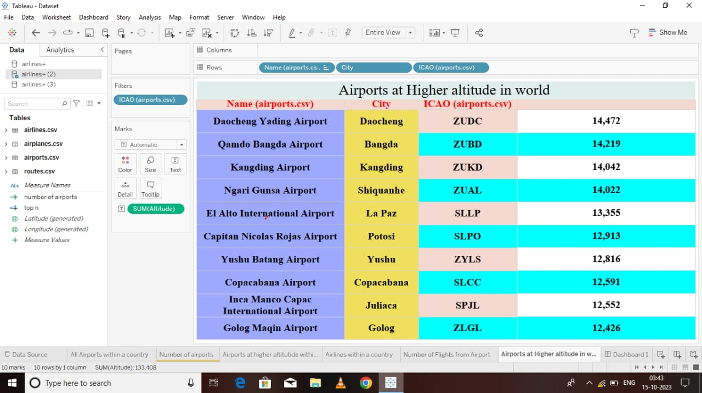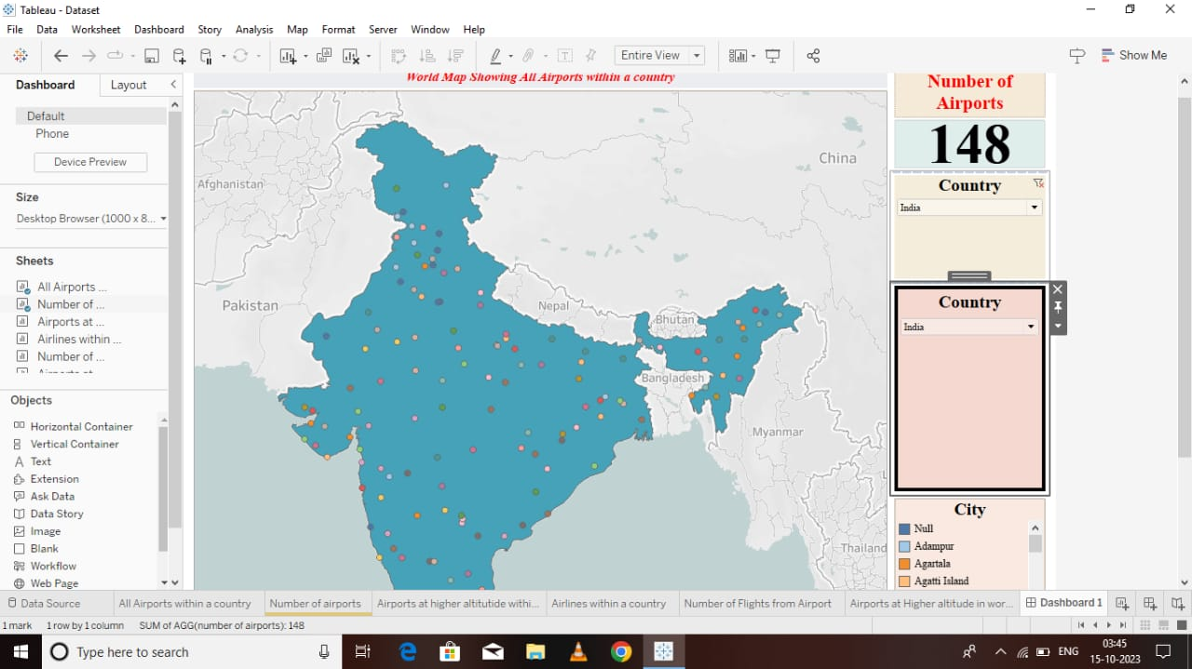

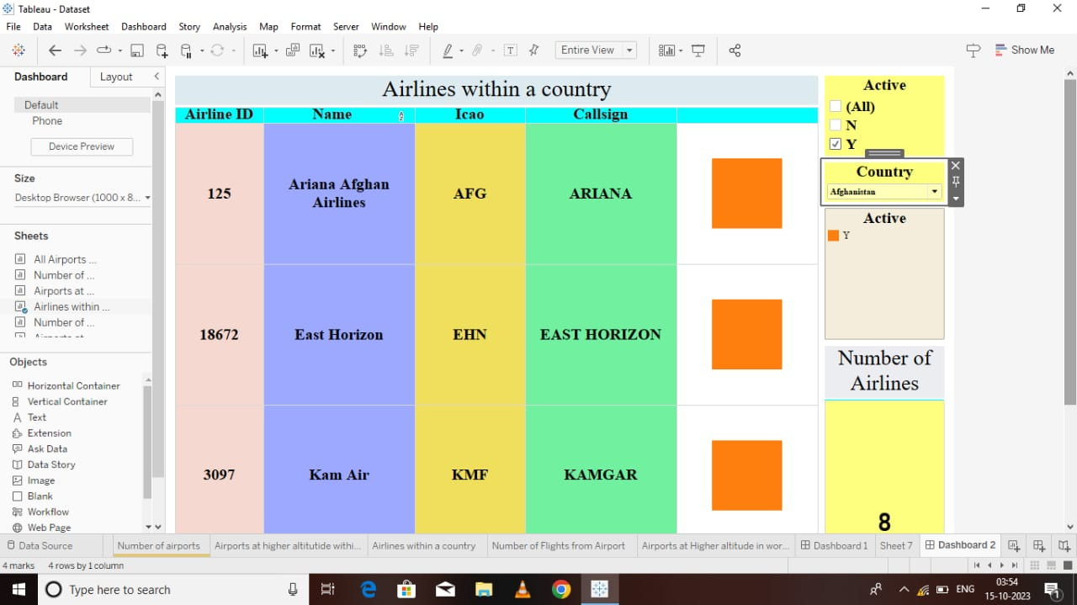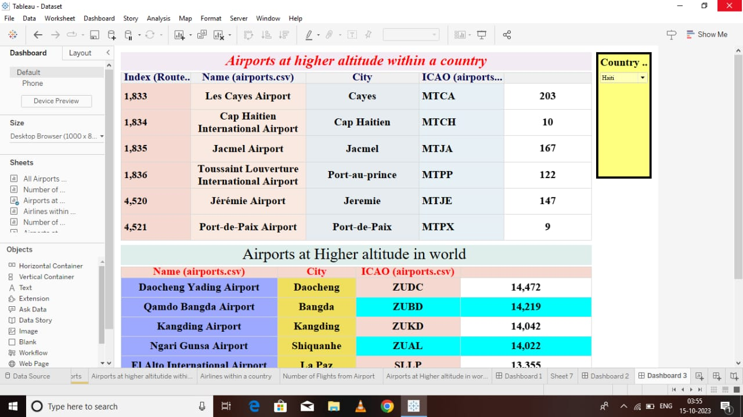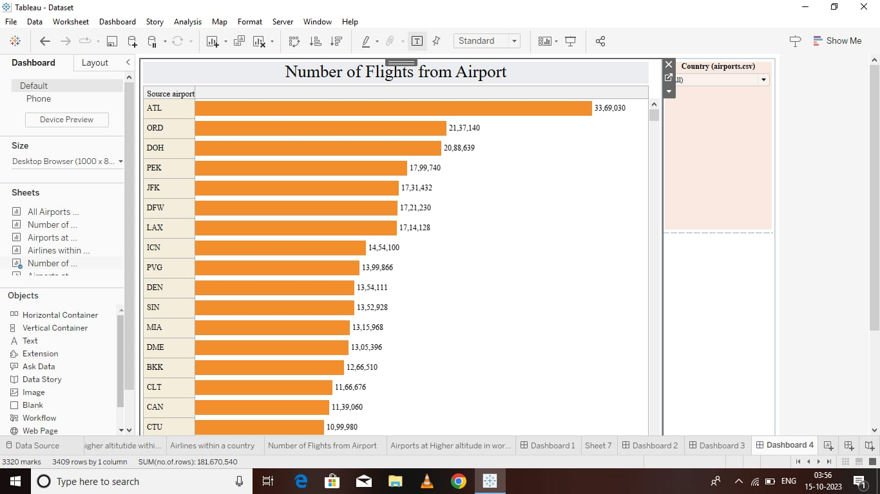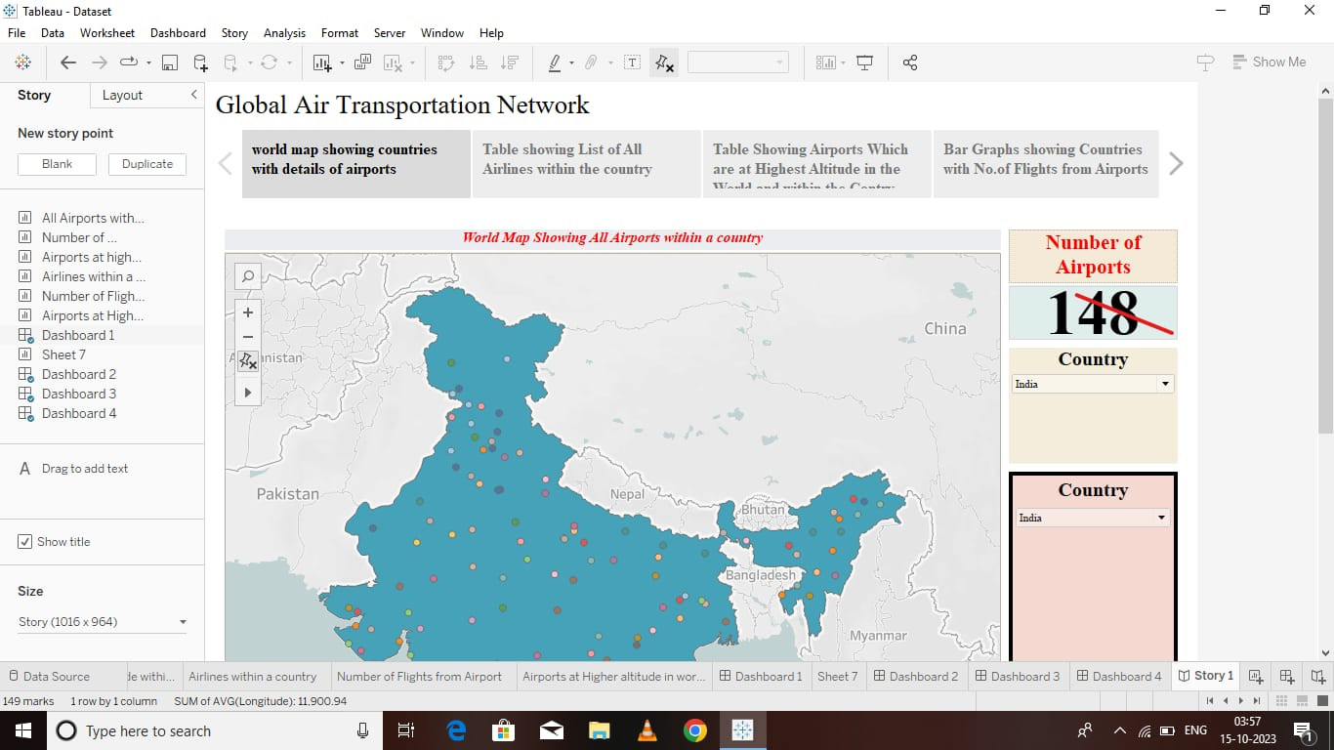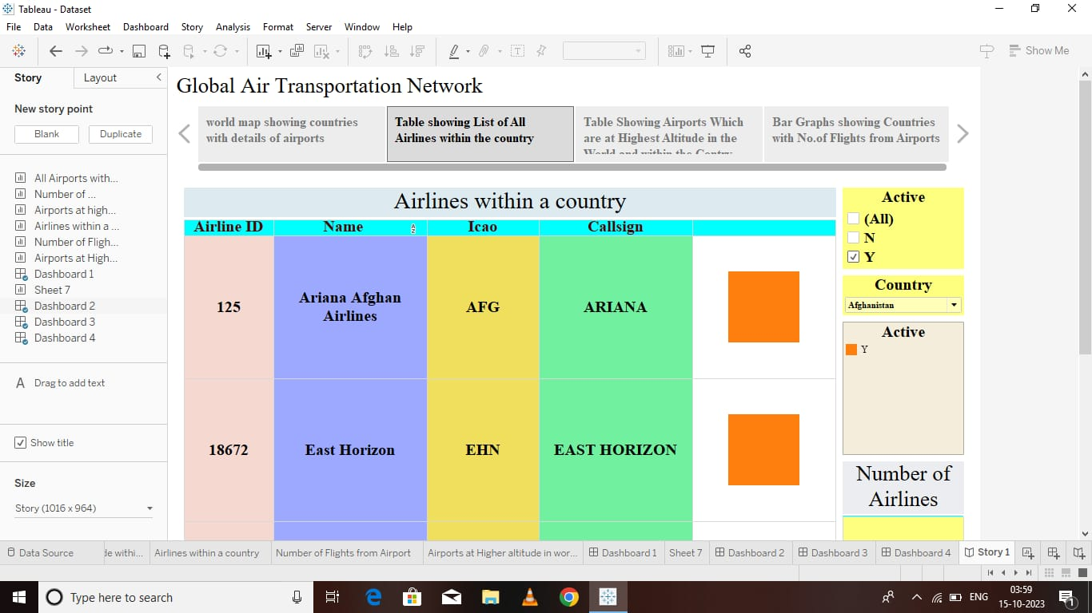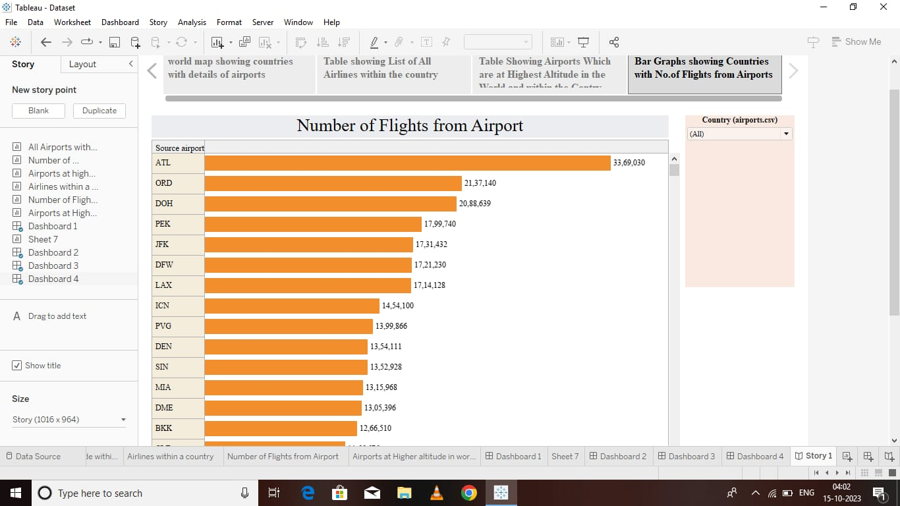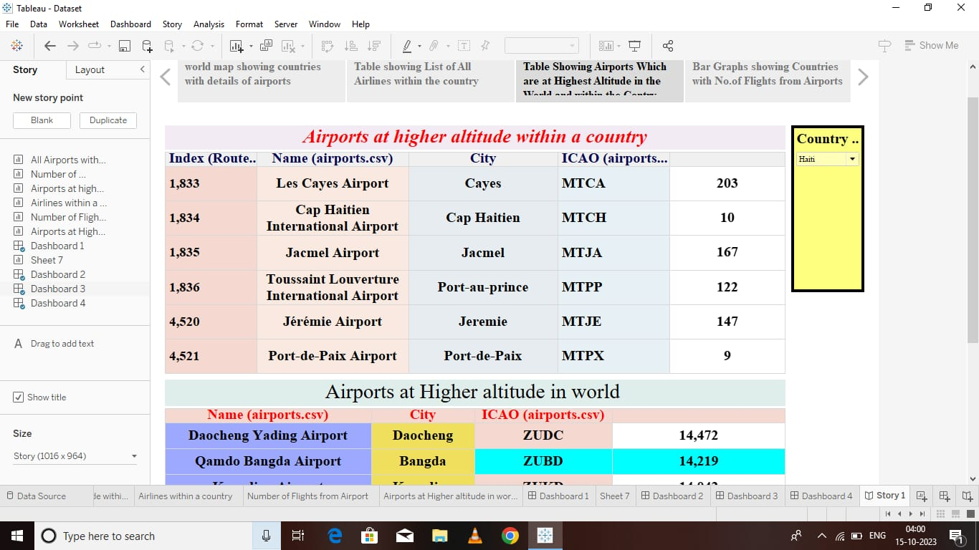

**Advantages**:

Using Tableau, stakeholders in the aviation industry can make informed decisions based on data and analysis, leading to more effective strategies and operations.

The insights gained from Tableau can help airlines and airports optimize their routes, schedules, and resource allocation, resulting in improved efficiency and cost savings.

Analyzing safety data with Tableau can identify potential risks and areas for safety improvement, contributing to a safer air transportation network.

By understanding passenger behaviors and preferences, airlines can tailor their services to offer a more enjoyable and convenient travel experience.

Tableau can assist in identifying the most profitable routes, improving load factors, and adjusting routes to seasonal demand.

**Disadvantages:**

The aviation industry generates vast and complex datasets. Managing and analyzing this data with Tableau can be challenging, requiring extensive data preparation and cleaning.

Licensing and implementing Tableau can be costly. Smaller airlines and airports with limited budgets may find it challenging to invest in this

Tableau has a learning curve, and aviation professionals may need to undergo training to effectively use the tool, which can be time-consuming.

Handling sensitive passenger and operational data requires robust security measures. Mishandling data can lead to privacy breaches and regulatory violations.

Integrating Tableau with existing systems and databases within the aviation industry may be complex and time-consuming.

**Application:**

Title of the Project: "Unlocking Insights into the Global Air Transportation Network with Tableau."

Clear and specific objectives that the project aims to achieve. These could include improving operational efficiency, enhancing safety, optimizing routes, etc.

Explanation of the data collection, cleaning, and analysis methods. How will Tableau be used to extract insights from the data?

Discussion on how sensitive passenger and operational data will be handled with respect to data privacy and ethical considerations.

Any additional documents, references, or supporting materials, such as a project team's qualifications or relevant case studies.

**Conclusion:**

In the dynamic and interconnected world of global air transportation, the ability to harness data and transform it into actionable insights is not just a choice but a necessity. Our journey to unlock these insights with Tableau holds the promise of a brighter, more efficient, and safer future for the aviation industry.As we conclude this endeavor, we find ourselves on the precipice of a new era in aviation. The power of data-driven decision-making, facilitated by Tableau, has the potential to redefine the way airlines, airports, regulators, and passengers interact with the global air transportation network.By leveraging the capabilities of Tableau, we aim to optimize operations, improve safety measures, enhance the passenger experience, and foster innovation within the aviation sector. The benefits extend beyond the balance sheets and operational efficiency; they reach the hearts and minds of travelers who rely on this industry every day.The insights we unlock will not only lead to smarter business strategies and more efficient routes but also to an aviation industry that is better equipped to meet the evolving needs of our society. In a world that values convenience, safety, and sustainability, our use of Tableau empowers us to embrace change, adapt to challenges, and soar to new heights.In closing, our commitment to "Unlocking Insights into the Global Air Transportation Network with Tableau" reflects not just our dedication to the aviation industry but also our belief in the transformative power of data. Together, we embark on this journey, armed with the knowledge that the skies have no limits, and with Tableau as our compass, we shall chart a course to a brighter future for global air transportation.

**Future Scope:**

**Future developments in data analytics and artificial intelligence will enhance the capabilities of Tableau. This can lead to more sophisticated predictive analytics, anomaly detection, and trend forecasting in the aviation industry.**

**As data processing and visualization technologies advance, the project can evolve to provide real-time insights, allowing airlines and airports to respond swiftly to changing conditions.**

**Integration with AI systems can provide decision-makers with intelligent recommendations based on data, making it easier to implement changes and optimizations.**

**Tailoring services and experiences to individual passenger preferences is an exciting area of development. By using data insights, airlines can create highly personalized travel experiences.**

**Making insights more accessible to a broader range of stakeholders, including passengers, can improve the aviation industry's transparency and accountability.**

**Project by ; Guided by;**

**1) Monishvar.K. Arulmozhi.M**

**2) Vishnu.M**

**3) Dillibabu.R**

**4) Praveen Kumar.S**