Hotel Revenue Analytics & Management Dashboard

Hotel Revenue Analytics & Management Dashboard
Author: Monish
Project: Hotel-analytics (GitHub)
Date: May 2026
---

1. Project Overview
This project analyzes hotel revenue and operational performance for the fictional Atliq hotel chain across Delhi, Mumbai, Bangalore, and Hyderabad. Using 134,573 booking records and daily capacity aggregates from May–July 2022, the goal is to measure occupancy, pricing (ADR), revenue efficiency (RevPAR), cancellation risk, channel mix, and city-level performance to support revenue-management decisions.
The work follows an end-to-end analytics pipeline:
Raw CSV → Python profiling & cleaning → PostgreSQL star schema → SQL KPI validation → Power BI dashboard→Git
Deliverables include six validated SQL outputs (screenshots in screenshots/), an interactive Power BI dashboard (powerbi/hotel_anlytics_dashboard_BI.pbix), and reproducible Jupyter notebooks and SQL scripts in this repository.
---

2. Dataset Summary

Files and grain
| Dataset | Rows (clean) | Grain / purpose |
|--------|----------------|-----------------|
| fact_bookings | 134,573 | One row per booking (transaction level) |
| fact_aggregated_bookings | 9,194 | Daily property × room category: successful bookings & capacity |
| dim_hotels | 25 | Property master (name, Luxury/Business, city) |
| dim_rooms | 4 | Room types RT1–RT4 |
| dim_date | 92 (expanded to full 2022 in PostgreSQL) | Calendar: week number, weekday/weekend |
Raw booking file: ~134,590 rows before cleaning (17 invalid rows removed).
Analysis window: Check-in dates from 2022-05-01 to 2022-07-31.

Key features (`fact_bookings` — 12 columns)
- Identifiers: `booking_id`, `property_id`
- Dates: `booking_date`, `check_in_date`, `checkout_date`
- Stay details: `no_guests`, `room_category` (RT1–RT4)
- Channel: `booking_platform` (7 channels)
- Outcome: `booking_status` (Checked Out, Cancelled, No Show)
- Financials: `revenue_generated`, `revenue_realized`
- Guest feedback: `ratings_given` (optional)

Booking status distribution (all bookings)
| Status | Count | Share |
|--------|------:|------:|
| Checked Out | 94,399 | 70.1% |
| Cancelled | 33,416 | 24.8% |
| No Show | 6,758 | 5.0% |

Missing and anomalous data (raw profiling)
| Issue | Count / detail | Handling |
|-------|----------------|----------|
| Missing ratings_given | 77,897 (~57.9%) | Expected — only completed stays with feedback; left as null |
| Missing no_guests | 3 | Rows with no_guests ≤ 0 removed (17 rows total after filters) |
| Invalid no_guests | Negative values (e.g. -3, -2) | Filtered: keep only no_guests > 0 |
| revenue_generated outliers | Values above mean + 3× std (e.g. 9,100,000 vs realized 9,100) | Outlier rows removed |
| Missing capacity (aggregated fact) | 2 rows | Imputed with median capacity |
| dim_date April gaps | Missing dates broke BI relationships | PostgreSQL: generate_series for 2022 + ON CONFLICT DO NOTHING |

Property footprint (`dim_hotels`)
- 25 properties — 4 cities × mix of Luxury and Business brands (e.g. Atliq Grands, Exotica, Palace, Seasons)
- Example cities: Delhi (5), Mumbai (6), Hyderabad (6), Bangalore (6)

Room categories (bookings)
| Room | Bookings |
|------|----------:|
| RT2 | 49,500 |
| RT1 | 38,441 |
| RT3 | 30,561 |
| RT4 | 16,071 |
---

3. Exploratory Data Analysis using Python
Analysis was performed in Jupyter notebooks under scripts/python/.

Notebook 1 — Data exploration (`1.Hotel_analysis data explaoration.ipynb`)
- Data loading: Imported five raw CSVs from `data/raw/` with Pandas.
- Initial exploration: Used `df.info()` and `df.describe()` on `fact_bookings` and `fact_aggregated_bookings`.
- Schema review: Confirmed 12 booking columns; validated property IDs against `dim_hotels`.
- Quality checks: Identified missing ratings, negative guest counts, extreme `revenue_generated` values, and string date formats (`DD-MM-YYYY`).
- Distribution review: Explored `booking_status`, platforms, room categories, and revenue fields by property and room type.

Notebook 2 — Data cleaning (`2.Hotel_analysis data cleaning.ipynb`)
- Date standardization: Parsed `booking_date`, `check_in_date`, `checkout_date` with `pd.to_datetime(, dayfirst=True)`.
- Guest count cleansing: Removed bookings where `no_guests ≤ 0` (data entry errors).
- Revenue cleansing: Removed `revenue generated` outliers above mean + 3× standard deviation (corrected erroneous magnitudes).
- Capacity imputation: Filled 2 missing `capacity` values in aggregated bookings with the median capacity.
- Derived metric (aggregated): Retained/computed occupancy rate at daily grain where applicable.
- Export: Saved cleaned files to `data/clean/` (`clean.csv`).
Result: fact_bookings_clean.csv — 134,573 rows (from ~134,590 raw).

Notebook 3 — PostgreSQL load (`3.Hotel_analysis data load to postgresql.ipynb`)
- Loaded cleaned DataFrames into database `hotel_analytics` using SQLAlchemy.
- Tables: `fact_bookings`, `fact_aggregated_bookings`, `dim_hotels`, `dim_rooms`, `dim_date`.
- Post-load validation queries confirmed row counts and non-null keys on primary columns.
Security note: Move database credentials to `.env` before publishing the repository publicly.

Data modeling (`scripts/sql/hotel-analytics-data-modeling.sql`)
- Cast columns to appropriate PostgreSQL types (DATE, INT, NUMERIC, TEXT).
- Defined primary keys and foreign keys for star-schema integrity.
- Repaired `dim_date` : inserted all 2022 dates; dropped conflicting `mmm yy` column; standardized week number format.
---

4. Data Analysis using SQL (Hospitality KPIs)
Structured analysis in PostgreSQL answered core revenue-management questions. Scripts live in scripts/sql/; results were exported as screenshots in screenshots/.

KPI definitions used
| KPI | Formula (as implemented) |
|-----|----------------------------|
| Occupancy % | SUM(successful_bookings) / SUM(capacity) × 100 |
| ADR | SUM(revenue_realized) / SUM(successful_bookings) for Checked Out only |
| RevPAR | SUM(revenue_realized) / SUM(capacity) for Checked Out only |
| Cancellation rate | COUNT(Cancelled) / COUNT(*) × 100 per property |
| Realisation % | revenue_realized / revenue_generated (dashboard/DAX context) |
---

1. Occupancy % by property (`1.occupancy_analysis.sql`)
Question: How efficiently are rooms being utilized?
Sample results (25 properties):
| property_id | total_successful_bookings | total_capacity | occupancy_rate % |
|-------------|--------------------------:|---------------:|-----------------:|
| 16563 | 7,111 | 10,723 | 66.32 |
| 17561 | 5,183 | 7,819 | 66.29 |
| 16561 | 4,418 | 6,716 | 65.78 |
| 16560 | 4,693 | 8,740 | 53.70 |
| 17564 | 3,982 | 8,924 | 44.62 |
| 18559 | 5,256 | 11,776 | 44.63 |
Insight: Occupancy ranges from roughly 44% to 66% across properties — material gap between top and bottom performers.

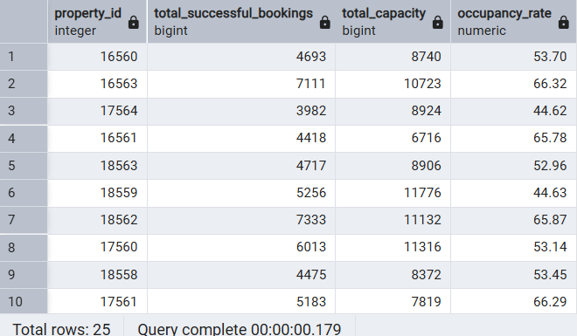

2. ADR — Average Daily Rate (`2.ADR-(Average Daily Rate)-analysis.sql`)
Question: What average revenue is earned per sold room night?
- Joins `fact_bookings` to `fact_aggregated_bookings` on `property_id` + `check_in_date`.
- Filters `booking_status = 'Checked Out'`.
- Returns ADR by property and check-in date .
Portfolio-level ADR (checked-out bookings): ~₹14,925 per booking row; Power BI aggregate ADR ≈ ₹12,696 (filtered slicer context).

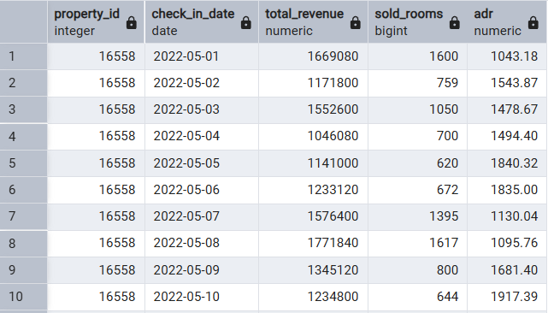

3. RevPAR — Revenue per Available Room (`3.RevPAR-analysis.sql`)
Question: How much revenue is generated per available room (capacity)?
- Same join logic as ADR; divides realized revenue by capacity .
Portfolio-level RevPAR (computed from clean data): ~₹6,062 (revenue ÷ total capacity); dashboard headline RevPAR ≈ ₹7,351 (filter context / DAX).

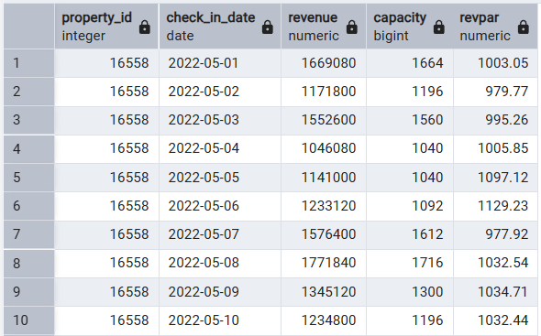

4. Cancellation rate by property (`4.Cancellation-Rate-analysis.sql`)
Question: Where is revenue leaking from cancelled reservations?
Sample results:
| property_id | cancellation_rate % |
|-------------|--------------------:|
| 17558 | 25.66 |
| 16561 | 25.51 |
| 16562 | 25.28 |
| 16558 | 25.07 |
| 17559 | 24.00 (lowest in sample) |
Portfolio average: ~24.9% cancellation rate per property (range ~24.0%–26.4%).

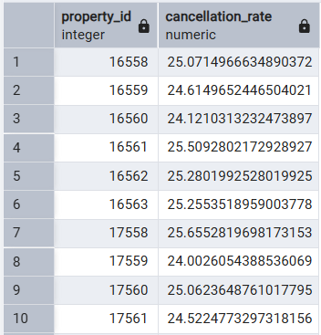

5. Booking platform analysis (`5.Booking-Platform-Analysis.sql`)
Question: Which channels drive volume and realized revenue?
Results (Checked Out only):
| Platform | Total bookings | Revenue (₹) |
|----------|---------------:|------------:|
| others | 38,583 | 577,060,185 |
| makeyourtrip | 18,824 | 280,115,970 |
| logtrip | 10,413 | 155,060,985 |
| direct online | 9,398 | 139,727,545 |
| tripster | 6,725 | 101,201,190 |
| journey | 5,716 | 84,861,235 |
| direct offline | 4,740 | 70,890,545 |
Insight: “others” is the largest channel by both bookings and revenue; OTA partners (makeyourtrip, logtrip) are the next largest contributors.

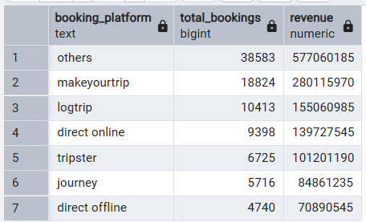

6. City analysis (`6.City-Analysis.sql`)
Question: Which cities generate the most revenue and guest satisfaction?
| City | Revenue (₹) | Avg rating |
|------|-------------:|-----------:|
| Mumbai | 551,783,535 | 3.65 |
| Bangalore | 345,762,900 | 3.41 |
| Hyderabad | 268,584,900 | 3.66 |
| Delhi | 242,786,320 | 3.78 |
Insights:
- Mumbai leads realized revenue (~ ₹552M ).
- Delhi leads average guest rating (~ 3.78 ).
- Bangalore is second in revenue but lowest average rating (~ 3.41 ).

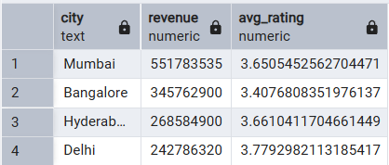

Supporting SQL views (`create-view-in-hospitality-kpis.sql`)
- `vw_refined_bookings`: Flags for checked-out, cancelled, and no-show bookings (BI-friendly).
- `vw_property_performance`: Property × date rollups for revenue and cancellation analysis.
---

5. Dashboard in Power BI
File: powerbi/hotel_anlytics_dashboard_BI.pbix
Connection: PostgreSQL (hotel_analytics) with star-schema relationships (dimensions → facts).
Measures: DAX for Revenue, RevPAR, Occupancy %, ADR, Realisation %, DSRN, cancellation %, and ratings.

Headline KPIs (portfolio view — May–Jul 2022)
| Metric | Value |
|--------|------:|
| Revenue | ₹1.71B |
| RevPAR | 7,351 |
| Occupancy % | 57.86% |
| ADR | 12,696 |
| Realisation % | 70.15% |
| DSRN | 636.75 |

Key visuals
1. Slicers: City, room class, month/day filters for interactive exploration.
2. KPI cards: Revenue, RevPAR, DSRN with week-on-week indicators.
3. Weekday vs weekend table: RevPAR, Occupancy %, ADR, Realisation by day_type.
4. Donut chart: Revenue mix — Luxury 61.6% vs Business 38.4%.
5. Trend lines: ADR, RevPAR, and Occupancy % over time.
6. Platform combo chart: Realisation % and ADR by booking platform (~69–70% realisation across channels).
7. Detail matrix: City/property metrics including cancellation % and average rating (data bars).

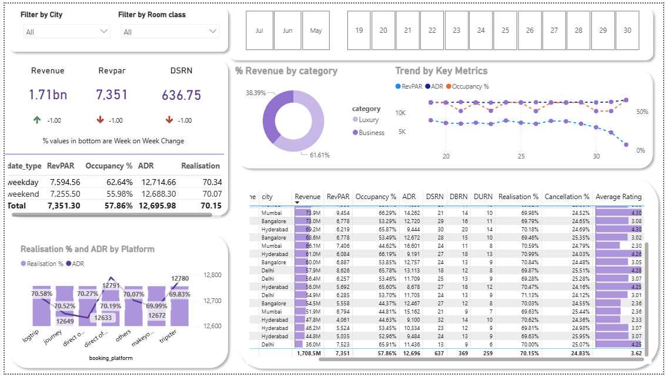Revenue mix and realization (validated from clean data)
- Category mix (checked-out revenue): Luxury 61.6% , Business 38.4% .
- Overall realisation (all bookings): 85.1% of generated revenue is realized; dashboard realisation ~70% reflects KPI definition and filter context (e.g. checked-out vs all statuses).

6. Business Recommendations
Based on SQL validation and the Power BI dashboard:
1. Reduce cancellation leakage — Property cancellation rates cluster around 25%. Prioritize deposit policies, overbooking strategy, and channel-specific cancellation rules for high-cancel OTAs.
2. Lift underperforming occupancy — Properties near 44–45% occupancy (e.g. 17564, 18559) need targeted promotions vs leaders at ~66%. Consider dynamic pricing and local event calendars.
3. Optimize channel economics — “others” and makeyourtrip drive the most revenue; negotiate commissions and shift mix toward direct online/offline where ADR and realisation are competitive.
4. City-specific strategies — Mumbai: protect revenue leadership with capacity planning. Delhi: leverage highest ratings in marketing. Bangalore: investigate low ratings (3.41) despite strong revenue.
5. Segment pricing — Luxury generates ~62% of revenue; maintain premium ADR while using Business properties to fill shoulder dates and improve RevPAR.
6. Data quality governance — Continue outlier checks on revenue_generated, guest counts, and complete dim_date for reliable time-series and BI relationships.

7. Tech Stack & Repository Map
| Layer | Tools / paths |
|-------|----------------|
| Profiling & ETL | Python, Pandas, Jupyter (scripts/python/1–3) |
| Database | PostgreSQL, SQLAlchemy |
| Analytics SQL | scripts/sql/1–6, modeling & views |
| Visualization | Power BI, DAX |
| Version control | Git, GitHub |
| Evidence | screenshots/*.png |
End of Report

