**1-1 Explanation of the parameters chosen**

For classification problems, the artificial neural network we use consists of two hidden layers and an output layer. The number of two hidden layers is 10. The input layer consists of six featurs. The output layer has two outputs representing the classes corresponding to the dataset. The number of samples considered was 310, of which 248 were used for training and the rest for test data. Through comparative experiments, we finally configure the learning rate is 0.1 and the number of epochs is 1000.

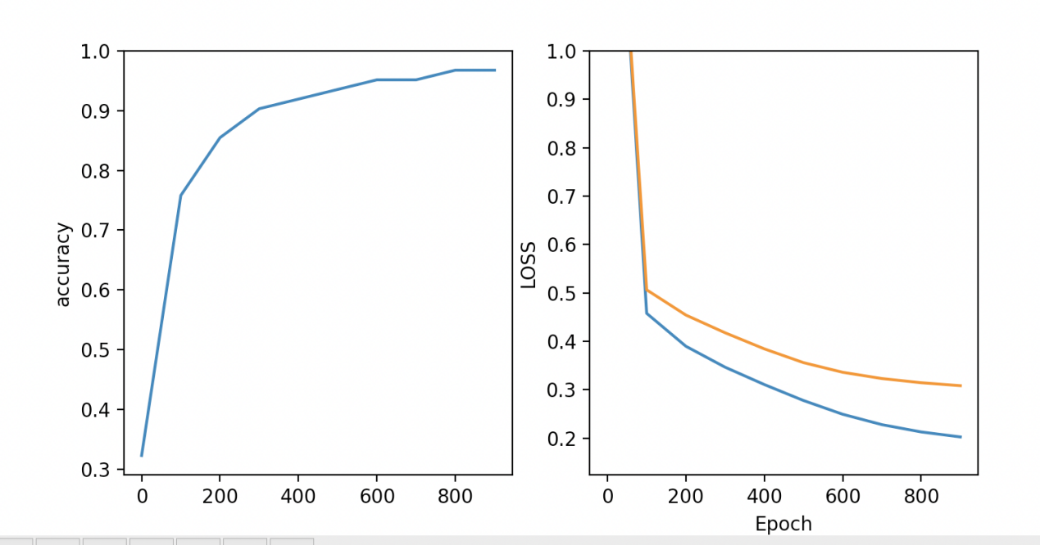

**1-2 reports on the difficulties encountered.**

At the beginning of the experiment, we replaced the two categories of the output layer with the number 0,1. Because there was a natural ordering relationship between integers, the experimental results were not ideal. So we converted the two categories into thermal coding mode, which greatly improved the classification accuracy.

**2 Classification results per cross-validation fold for classification**

|  |  |
| --- | --- |
| epoch | accuracy |
| 0000 | 0.56451613 |
| 0100 | 0.7580645 |
| 0200 | 0.8548387 |
| 0300 | 0.9032257 |
| 0400 | 0.9193548 |
| 0500 | 0.9354838 |
| 0600 | 0.95161288 |
| 0700 | 0.95161288 |
| 0800 | 0.96774190 |
| 0900 | 0.96774190 |

|  |
| --- |
| Accurate: 0.86 |
| Accurate: 0.95 |
| Accurate: 0.91 |
| Accurate: 0.88 |
| Accurate: 0.89 |
| Accurate: 0.84 |
| Accurate: 0.92 |
| Accurate: 0.96 |
| Accurate: 0.92 |
| Accurate: 0.92 |
| Average Accurate: 0.905 |

**3 Average cross-validation accuracy results,**