Project Name: A database Project On “A Spa and Saloon Management”

Introduction:

                  A database is structured collection of data. Databases may be stored on a computer and examined using a program. These programs are often called `databases', but more strictly are database management systems (DMS). The database management system provides ways to organize, store, retrieve and interact with the data in the database. There are several kinds of Database Management System (DBMS) such as follows:

* Oracle, DB2 (IBM), MS SQL Server, MS Access, Ingres, Postgre SQL, MySQL etc.

 I have used ‘Oracle’ DBMS for my Hospital Database Management Project. ORACLE is a fourth-generation relational database management system. In general, a database management system (DBMS) must be able to reliably manage a large amount of data in a multi-user environment so that many users can concurrently access the same data. All this must be accomplished while delivering high performance to the users of the database. A DBMS must also be secure from unauthorized access and provide efficient solutions for failure recovery. The ORACLE Server provides efficient and effective solutions for the major database features.

Short Description of Project:­­­­­­

My project “Spa And Saloon management” is based on database, Object oriented. As there are many areas where we keep the records in database for which I am using oracle DBMS which is one of the best and easiest to keep our information.

The project Spa and Saloon Management system contain the information of Customer, Employee, Feedbacks, Appointment, Services and the Bill of  bill of the customers. It is consisted   by the following schema:

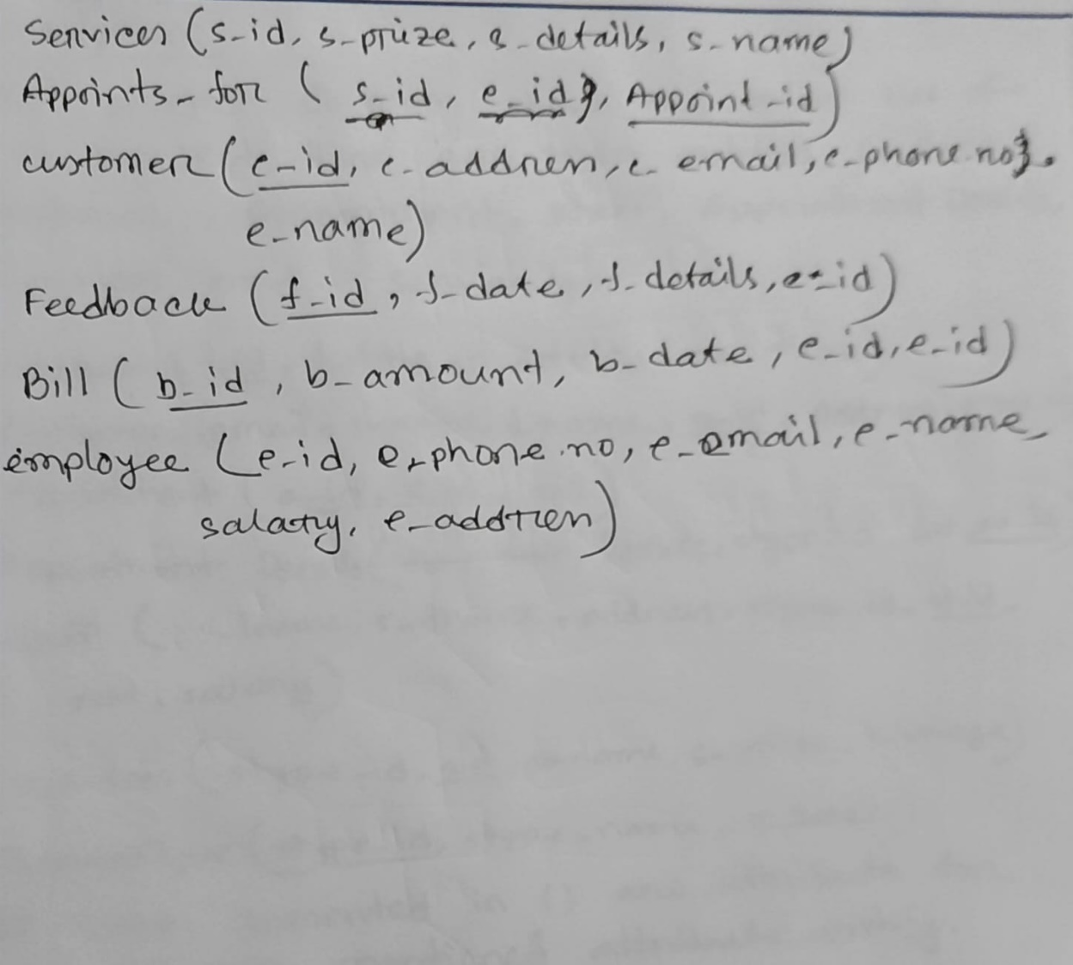

ER Diagram:

­­­­­­­­­­­­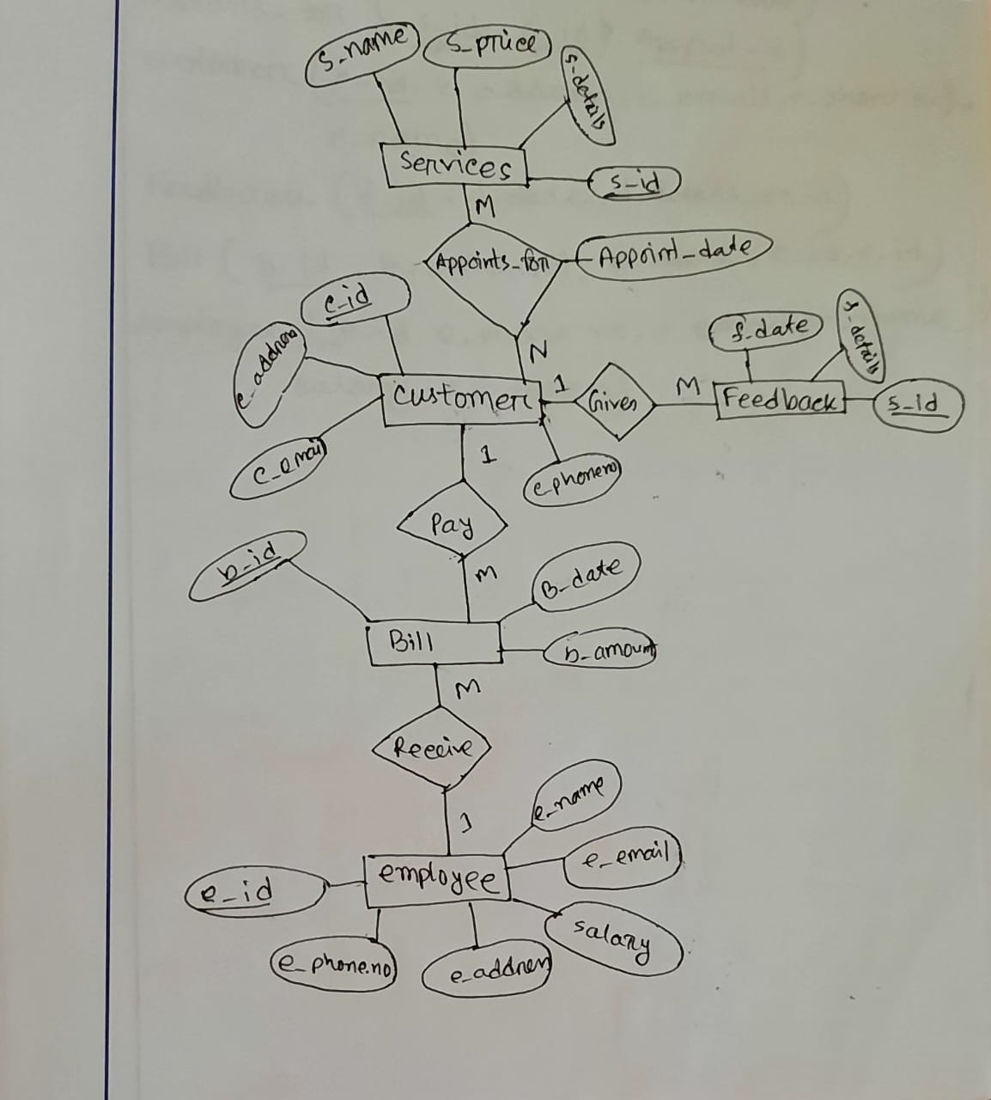

Schema Diagram:

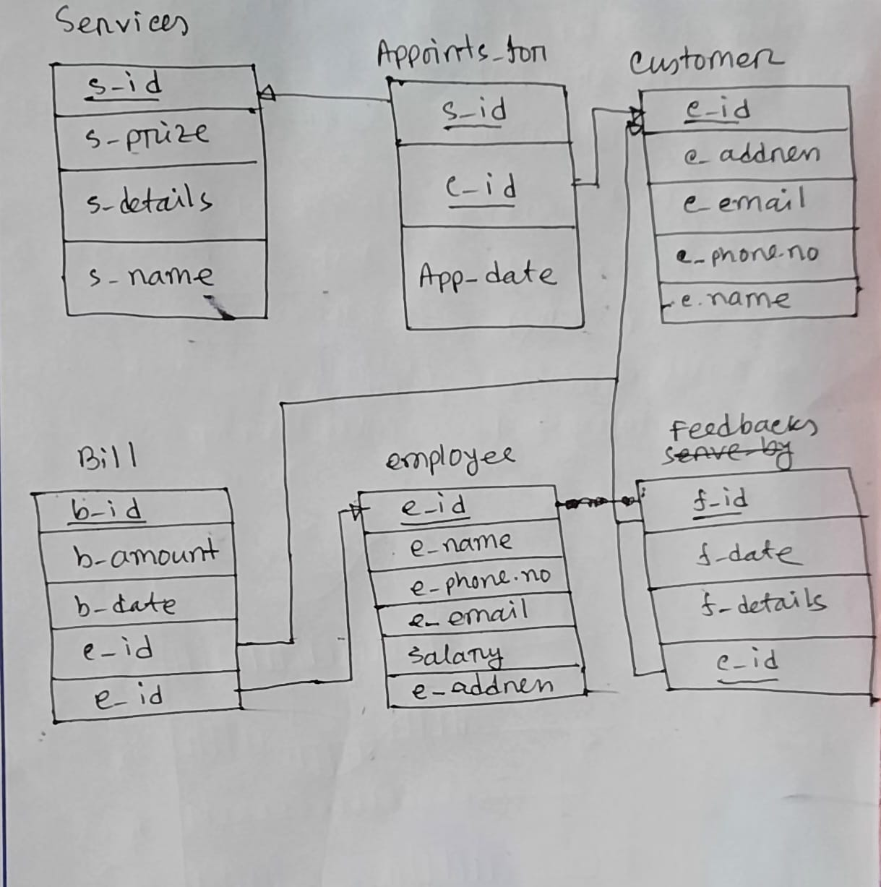

Discussion:

                  In my   project, I have used Data Definition Language (DDL) such as table creation and Data modification Language (DML) such as INSERTION, UPDATE and DELATE.

I have also used PL/SQL (Procedural Language/Structured Query Language) in my project. PL/SQL (Procedural Language/Structured Query Language) is Oracle Corporation's procedural language extension for SQL and the Oracle relational database. PL/SQL includes procedural language elements such as conditions and loops. We can declare constants and variables, procedures and functions, types and variables of those types, and triggers. We can handle exceptions (runtime errors) with this too.

Conclusion:

                   Since Spa and Saloon is associated with the lives of common people and their day to day routines, so I decided to work on this project. The manual handling of the records is time consuming and highly prone to error. The purpose of the project is to automate or make the online process of day to day activities like Customer, Employee, Feedbacks, Appointment, Services and the Bill.