Test no 1

Name: Write a C program to check whether a number is divisible by 5 & 11 or not ?

#include<stdio.h>

main()

{

int a,b,c;

printf("Enter tha number :");

scanf("%d",&a);

b=a%5 ;

c=a%11 ;

(b==0)&&(c==0)?(printf("divisible")): (printf("not divisible"))

return 0;

}

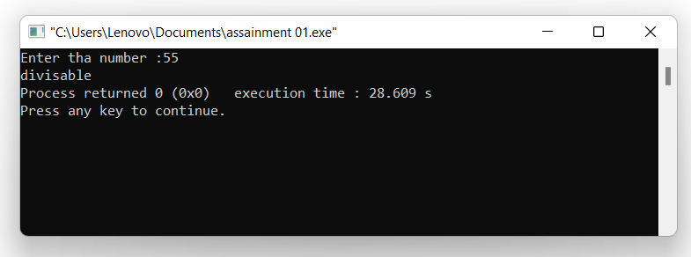

Test no 2

Name : write a C program to Input any alphabet and check whether it is Vowel or Consonant ?

#include <stdio.h>

int main()

{

char c;

printf("Enter an alphabet: ");

scanf("%c", &c);

(c=='a'||c=='e'||c=='i'||c=='o'||c=='u'||c=='A'||c=='E'||c=='I'||c=='O'||c == 'U')?printf("%c is a vowel"):printf("%c is a consonent.");

return 0;

}

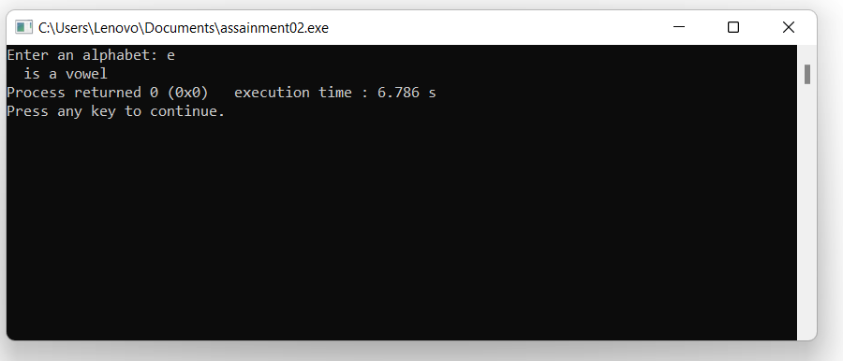

Test no 3

Name : write a c program to calculate profit or loss ?

#include<stdio.h>

main()

{

int a,b,c;

printf("Enter tha baying prise :");

scanf("%d",&a);

printf("Enter the selling prise :");

scanf("%d",&b);

c=b-a;

printf("%d",c);

(c>0)? printf(" profit "):printf(" loss ");

return 0;

}

