A Capstone Project on
Calibrated Open-Set Recognition for Robust Plant Disease Diagnosis under Unseen Diseases and Cross-Domain Distribution Shifts

Course Code: ICE-3210
Course Title: Capstone Project
B.Sc. (Engineering) Examination
A project paper submitted to the Department of Information and Communication Engineering, Pabna University of Science and Technology in partial fulfillment of the requirements for the degree of Bachelor of Science in Engineering in Information and Communication Engineering
Submitted by
Monjur Morshed
Roll: 220601
Registration: 1065448
Session: 2021-22
Supervisor: Dr. Md. Sarwar Hosain
Professor
Department of Information and Communication Engineering
Pabna University of Science and Technology
Pabna-6600, Bangladesh
[January, 2027]
CERTIFICATE
This is to certify that Monjur Morshed, a student of the Department of Information and Communication Engineering, Pabna University of Science and Technology, has carried out the project titled “Calibrated Open-Set Recognition for Robust Plant Disease Diagnosis under Unseen Diseases and Cross-Domain Distribution Shifts” under my supervision. The work embodied in this report is original and has been submitted for the partial fulfillment of the requirements for the degree of Bachelor of Science in Information & Communication Engineering.

_____________________________
Dr. Md. Sarwar Hosain
Professor
Department of Information and Communication Engineering
Pabna University of Science and Technology (PUST)
Supervisor
Date: ______________________
DECLARATION
I hereby declare that this project report is my own work. All sources of information and ideas used during this project have been duly acknowledged. No part of this report has been submitted for any other degree or qualification.

....................................
Monjur Morshed
Roll: 220601
Registration: 1065448
Department of Information and Communication Engineering
Pabna University of Science and Technology, Pabna-6600, Bangladesh.
ACKNOWLEDGEMENTS
I would like to express my sincere gratitude to my supervisor, Dr. Md. Sarwar Hosain (Professor), for his invaluable guidance, patient feedback, and encouragement throughout this project. I am also grateful to my family and friends for their continuous support and patience during the course of this work. Finally, I acknowledge the open-source communities behind PyTorch, timm, scikit-learn, and the PlantVillage, PlantDoc, and Plant Pathology 2020 datasets, whose tools and data made this project possible.
ABSTRACT
Convolutional image classifiers trained for plant disease recognition are conventionally evaluated as closed-set systems, in which every test image is assumed to belong to one of the classes seen during training. In real deployment, a captured leaf image may show a disease the model never trained on, may come from a different imaging domain (a field photograph rather than a laboratory image), or may not depict a diseased plant at all. A closed-set classifier has no mechanism to recognize this and will confidently emit a known-class label regardless. This project implements and evaluates a calibrated open-set plant disease recognition pipeline that trains an EfficientNetV2-B0 classifier on 27 known PlantVillage disease classes, calibrates its confidence with temperature and vector scaling, and compares eleven open-set/out-of-distribution (OOD) scoring methods — MSP, Entropy, Energy, MaxLogit, ODIN, OpenMax (two variants), k-NN, Mahalanobis, and two hybrid detectors — for rejecting six held-out disease classes, two external cross-domain datasets (PlantDoc and Plant Pathology 2020), and five groups of non-plant background imagery.
Three training configurations were compared under an identical, leakage-audited evaluation protocol: a lab-only baseline, a mixed lab-and-field training regime, and a mixed regime with outlier exposure (the final, reported system). The final model reaches 99.6% known-class accuracy on laboratory images and 88.1% on field images (macro-F1 0.994 and 0.825 respectively), with the MaxLogit detector achieving a macro-AUROC of 0.947 across four open-set scenarios at a 95% known-coverage operating threshold. Evaluation further covers calibration quality (temperature and vector scaling, reliability diagrams, ECE/MCE/NLL), selective prediction (risk-coverage curves, AURC), corruption robustness across six synthetic degradations at three severities, five-seed training stability, and a self-administered claims-check gate against 21 pre-registered, numeric success criteria, of which 11 passed and 9 failed outright, with one metric not testable given the available background data. A detailed per-class breakdown identifies a single held-out disease, Corn Northern Leaf Blight, as responsible for a disproportionate share of the system's false acceptances (83.8%), while four of six held-out classes are rejected with false-accept rates below 25%. This report documents the full protocol, the quantitative results — including the experiments that did not meet their own pre-registered targets — and the specific, data-grounded limitations and follow-up work the results motivate.
TABLE OF CONTENTS

(Right-click the table above and choose “Update Field → Update entire table” after opening this document in Word, so that page numbers populate correctly.)
LIST OF TABLES
Table 1: Dataset composition by domain and source
Table 2: Known-class / held-out-class split (C_mixed_OE, split seed 42)
Table 3: Experiment comparison — A_lab_only vs B_mixed vs C_mixed_OE
Table 4: Calibration before and after scaling (C_mixed_OE)
Table 5: OOD / open-set detector comparison on known_all (C_mixed_OE, MaxLogit-normalized table of all 11 detectors)
Table 6: Threshold-rule sensitivity analysis (C_mixed_OE, MaxLogit)
Table 7: Per-unseen-class false-accept rate (C_mixed_OE, MaxLogit, 95% Wilson CI)
Table 8: Corruption robustness summary (C_mixed_OE, MaxLogit)
Table 9: Five-seed training stability summary (C_mixed_OE)
Table 10: Claims-check gate — full results (21 claims)
LIST OF FIGURES
Figure 1: Lab, field, and outlier-exposure training augmentations
Figure 2: Known-class confusion matrix — PlantVillage (lab)
Figure 3: Known-class confusion matrix — external field data
Figure 4: Known-disease accuracy, unknown-accepted rate, and known coverage across A/B/C experiments
Figure 5: MaxLogit score distributions by scenario, with operating threshold
Figure 6: t-SNE of penultimate features (C_mixed_OE)
Figure 7: Unknown images accepted with the highest confidence (MaxLogit)
Figure 8: Unseen-disease classes: false-accept rate with 95% Wilson confidence intervals
Figure 9: Background groups: false-accept rate by group
Figure 10: Precision–recall curves by open-set scenario (MSP vs MaxLogit)
Figure 11: ROC curves by open-set scenario (MSP vs MaxLogit)
Figure 12: Reliability diagrams — known lab vs known field (raw vs temperature-scaled)
Figure 13: Selective prediction: risk versus coverage (AURC)
Figure 14: Corruption robustness across six degradations and three severities (MaxLogit)
Figure 15: Deployable-bundle demo: 13/15 decisions correct
LIST OF ABBREVIATIONS
AUROC | Area Under the Receiver Operating Characteristic curve
AUPR | Area Under the Precision–Recall curve
AURC | Area Under the Risk–Coverage curve
CI | Confidence Interval
CNN | Convolutional Neural Network
ECE | Expected Calibration Error
FA | False Accept(ance)
FPR | False Positive Rate
GPU | Graphics Processing Unit
MCE | Maximum Calibration Error
MSP | Maximum Softmax Probability
NLB | Northern Leaf Blight
NLL | Negative Log-Likelihood
ODIN | Out-of-DIstribution detector for Neural networks
OE | Outlier Exposure
OOD | Out-of-Distribution
OSCR | Open-Set Classification Rate
OSR | Open-Set Recognition
ROC | Receiver Operating Characteristic
SHA-256 | Secure Hash Algorithm, 256-bit
t-SNE | t-distributed Stochastic Neighbor Embedding
TPR | True Positive Rate

Chapter 1: Introduction

1.1 Background
Deep convolutional networks have made image-based plant disease recognition practical: given a leaf photograph, a trained classifier can assign a disease label with high accuracy on a held-out test set drawn from the same distribution as its training data. Public benchmarks such as PlantVillage, which contains tens of thousands of laboratory-condition leaf images across 38 crop-disease classes, have made this style of evaluation routine and have produced reported accuracies well above 99%. However, a model trained and evaluated this way is implicitly a closed-set classifier: it is never asked whether an input belongs to any of its known classes at all, only which one it belongs to. In a real deployment — a mobile app photographing a farmer's crop in the field — the assumption that every photograph necessarily shows one of the diseases the model was trained on does not hold. The photograph may show a disease absent from the training set, a different crop entirely, a healthy or damaged leaf that does not fit any training label cleanly, or no plant at all.

1.2 Motivation for the Research
This project is motivated by the gap between the laboratory conditions under which plant disease classifiers are usually benchmarked and the open, uncontrolled conditions under which they would actually be used. Two concrete problems motivate it directly. First, a model trained only on PlantVillage — clean, uniformly lit, background-removed laboratory photographs — degrades sharply when applied to real field photographs, because the input distribution itself has shifted (lighting, background clutter, camera angle, image compression), independent of whether the disease shown is one the model has seen. Second, even a model exposed to some field imagery during training has no principled way to say “I don't know” when shown a disease, crop, or scene it was never trained on; it will emit a confident, specific, and potentially wrong label regardless. Addressing both problems together — rather than treating classification accuracy as the only thing worth reporting — is the central motivation for this project.

1.3 Problem Statement
A plant disease classifier trained on a finite set of labeled images may produce confident predictions for unseen diseases, unfamiliar crops, or images from a different visual domain than its training data. This project investigates whether confidence calibration together with open-set and out-of-distribution (OOD) scoring can support a system that (i) classifies known diseases accurately on both laboratory and field images, (ii) rejects held-out disease classes it was never trained on, and (iii) rejects distribution-shifted field images and non-plant background content, while making the trade-off between retained coverage and prediction risk explicit and measurable rather than assumed.

1.4 Project Objectives
- Build a reproducible image-classification pipeline using transfer learning with an EfficientNetV2-B0 backbone.
- Define and audit a leakage-aware protocol that separates training, calibration, known-test, and unknown-test data by near-duplicate content, not only by filename or folder.
- Evaluate known-disease classification using accuracy, macro precision/recall/F1, and per-class results, reported separately for laboratory and field images.
- Evaluate detection of held-out disease classes deliberately excluded from training.
- Evaluate out-of-distribution detection on two external, visually distinct datasets (PlantDoc and Plant Pathology 2020) and on a dedicated non-plant background set.
- Calibrate predictive confidence using temperature scaling and vector scaling, and compare calibration quality before and after scaling.
- Compare eleven open-set/OOD scoring approaches — MSP, Entropy, Energy, MaxLogit, ODIN, OpenMax (two variants), k-NN, Mahalanobis distance, and two hybrid detectors — under one consistent protocol.
- Evaluate selective prediction and rejection using coverage, risk, false-accept rate, risk–coverage curves, and the area under the risk–coverage curve (AURC).
- Pre-register numeric success criteria for every one of the above and report the resulting pass/fail outcome honestly, including the claims that failed.

1.5 Scope of the Project
The project focuses on image-level plant disease recognition and open-set reliability assessment; it does not attempt to diagnose every possible plant disease, infer disease severity, or replace expert agricultural diagnosis. The principal experimental distinction is between known disease classes (trained on), held-out disease classes (never trained on, used only to test rejection), and distribution-shifted or otherwise out-of-distribution inputs (external datasets and background imagery). PlantVillage supplies the laboratory-condition training and evaluation images; PlantDoc and Plant Pathology 2020 supply external, field-condition evaluation images whose class labels were mapped to the known-class set only where that mapping could be documented, with unmapped or ambiguous labels treated as a separate out-of-distribution scenario rather than silently discarded or silently treated as known.

1.6 Report Organization
The remainder of this report is organized as follows. Chapter 2 surveys related work on open-set recognition, out-of-distribution detection, and confidence calibration, and positions this project relative to it. Chapter 3 describes the system design: the datasets and their roles, the leakage-aware protocol, the model architecture and training configurations, the OOD detectors, and the calibration and selective-prediction methodology. Chapter 4 describes the implementation: the execution pipeline, the data-quality and leakage audit, and the tools and environment used. Chapter 5 presents the full results — known-class classification, calibration, open-set/OOD detection, qualitative feature-space analysis, per-class false-accept analysis, corruption robustness, training-seed stability, and the pre-registered claims-check gate — with every number drawn directly from the executed pipeline's exported tables and figures. Chapter 6 discusses the project's limitations and the specific follow-up work its own results motivate. Chapter 7 concludes with a summary of findings.

Chapter 2: Literature Review

2.1 Closed-Set Plant Disease Classification
The dominant evaluation paradigm in plant disease image classification is closed-set: a convolutional network (often a pretrained ImageNet backbone fine-tuned via transfer learning) is trained and evaluated on a fixed set of classes drawn from the same source and distribution, most commonly the PlantVillage dataset. Reported accuracies on PlantVillage-style splits routinely exceed 99%, which has sometimes been read as evidence that the underlying recognition problem is close to solved. However, because PlantVillage images are captured under controlled laboratory conditions — uniform lighting, a single leaf per image, and in many cases a uniform background — this accuracy figure says little about performance on real field photographs, which differ in lighting, background clutter, scale, and capture device.

2.2 Open-Set Recognition and Out-of-Distribution Detection
Open-set recognition (OSR) addresses the presence of test-time classes not observed during training; out-of-distribution (OOD) detection addresses test-time inputs whose distribution differs from the training distribution more broadly, whether or not they belong to a well-defined “new class.” These two framings overlap substantially in practice — a previously unseen disease is simultaneously an open-set class and, often, an out-of-distribution input — but they are not identical: a field photograph of a disease the model has seen in the lab is in-class but out-of-distribution, purely due to the domain shift. A family of scoring functions has been proposed to flag such inputs at inference time without retraining, including the Maximum Softmax Probability (MSP) baseline, ODIN's input-perturbation and temperature-scaling approach, energy-based scoring derived from the network's logits, the Mahalanobis-distance approach operating in feature space, and OpenMax's extreme-value-theory recalibration of the softmax layer. More recent work has also explored simple non-parametric scores such as k-nearest-neighbor distance in feature space, and hybrid detectors that combine a softmax-based score with a feature-space distance. No single method dominates across all distribution-shift types, which motivates comparing several of them under one protocol rather than adopting one by default.

2.3 Confidence Calibration
A model's reported confidence should be meaningfully related to its probability of being correct; modern deep networks are well known to be systematically overconfident on both in-distribution and, more severely, out-of-distribution inputs. Temperature scaling — dividing the pre-softmax logits by a single learned scalar fitted on a held-out calibration set — is a simple, widely used post-hoc fix for in-distribution calibration, though it does not by itself address OOD overconfidence, and its effectiveness can degrade when the calibration set and the deployment distribution (e.g., lab versus field images) diverge. A per-class or per-domain extension (vector scaling) can partially recover calibration quality on a domain the single pooled temperature under- or over-corrects.

2.4 Positioning of This Project Relative to Prior Work
This project does not propose a new OOD-scoring method or a new architecture. Its contribution is an integrated, leakage-audited evaluation of an existing, strong OOD-detection toolkit (eleven detectors, two calibration schemes, and a selective-prediction framework) applied specifically to the plant disease domain, with explicit separation between held-out-disease rejection and cross-domain rejection — a distinction the dataset-role protocol in Chapter 3 makes a first-class part of the evaluation rather than an afterthought. Consistent with the proposal's own success criteria, the project treats a negative or partial result (a detector or a claim that does not meet its target) as a reportable finding rather than a failure to be hidden, which Chapter 5 and Chapter 6 reflect directly.

Chapter 3: Methodology and System Design

3.1 Datasets and Their Roles
Four image sources were used, each assigned a specific role in the evaluation protocol rather than being pooled indiscriminately.
Source | Role | Images
PlantVillage | Primary training and controlled (laboratory) evaluation source for known classes; selected classes also reserved entirely as held-out “unseen disease” classes | 54,210
PlantDoc | External field-image, domain-shift evaluation; class-mapped where a documented mapping exists, unmapped otherwise | 2,916
Plant Pathology 2020 | Additional external field-image evaluation, mapped only where crop/class overlap is documented | 1,820
Background / non-plant imagery | Dedicated out-of-distribution scenario, in five sub-groups (hand, sky, soil, tools, weeds) | 2,014
Table 3.1: Dataset composition by domain and source.
73 images across the combined corpus failed to load (corrupt files or unreadable formats) and were excluded prior to any split assignment; this count was logged and is disclosed rather than silently absorbed into missing-data statistics.

3.2 Leakage Audit and Protocol Validation
Before any class split or training/test assignment, every image was fingerprinted using SHA-256 content hashing combined with a perceptual near-duplicate clustering pass, to catch resized or lightly re-compressed copies of the same underlying photograph that a filename- or exact-hash-based check would miss. This clustering identified 226 conflicting clusters spanning 901 images whose members would otherwise have straddled a train/test or known/unknown boundary; all 901 images were quarantined (excluded from the split entirely) rather than arbitrarily assigned to one side, since either assignment risks leaking visual content across the boundary the split exists to enforce. The resulting protocol was asserted programmatically — no quarantined-cluster member appears in more than one role — and this assertion passed.

3.3 Class Split and Dataset Roles
Of the full PlantVillage label set, 27 classes were retained as known (trained on); 6 disease classes were held out entirely as the “unseen disease” test scenario; 3 further classes were held out but used only as outlier-exposure (OE) training signal (i.e., the model saw these images during training as explicit “not a known class” examples, with their disease identity never used as a target label); and 2 additional classes were reserved purely for validation-time threshold tuning. This four-way split — known / unseen-test / unseen-OE / unseen-val — ensures that no image used to tune a rejection threshold or outlier-exposure weight is later reused to measure that same threshold's held-out performance.
Role | Example use | Classes
Known (trained) | Standard supervised classification target | 27
Unseen — test | Held out entirely; measures held-out-disease rejection | 6
Unseen — outlier exposure (OE) | Used in training only as “not-known” signal | 3
Unseen — validation | Used only to tune thresholds / OE weighting | 2
Table 3.2: Known-class / held-out-class split (split seed 42).
Within each image's own role (train, calibration, known-test, or unknown-test), external and background sources are further broken into four open-set scenarios used throughout the evaluation: unseen_disease (held-out PlantVillage disease classes), cross_domain_novel (external images whose label has no defensible mapping to a known class), cross_domain_unmapped (external images whose label is a generic or ambiguous leaf descriptor, treated conservatively as unmapped), and background_real (non-plant imagery). The unknown-test pool used for final reporting contains 12,641 images across these four scenarios: 9,870 unseen_disease, 439 cross_domain_novel, 901 cross_domain_unmapped, and 1,431 background_real.

3.4 Model and Training Configuration
The classifier backbone is EfficientNetV2-B0 (via the timm library), initialized from ImageNet-pretrained weights, with a staged fine-tuning schedule: the classification head is trained first with the backbone frozen, followed by fine-tuning of the full network. Three training configurations were run under an identical architecture and evaluation protocol, differing only in what data the model sees during training:
- A_lab_only: trained exclusively on PlantVillage (laboratory) images of the 27 known classes.
- B_mixed: trained on a mixture of PlantVillage and mapped field images (PlantDoc / Plant Pathology 2020) of the 27 known classes.
- C_mixed_OE: B_mixed's data plus explicit outlier-exposure training on the 3 OE-reserved unseen classes and a portion of the background imagery. This is the final, reported configuration unless otherwise noted.
Standard augmentation (random crop/rotation, color jitter, and, for the outlier-exposure stream specifically, heavier distortion to discourage the network from learning OE images as a disguised 28th known class) was applied consistently across all three configurations; representative augmented samples from the lab, field, and OE training streams are shown in Figure 5.1 in Chapter 5.

3.5 Calibration
Two post-hoc calibration schemes were fitted on a held-out calibration split and compared: single-parameter temperature scaling (one scalar temperature shared across classes, fitted in a lab/field-balanced manner rather than naively pooled) and vector scaling (a per-class/per-domain affine recalibration). Calibration quality was assessed before and after each scheme using negative log-likelihood (NLL), expected calibration error (ECE), maximum calibration error (MCE), and reliability diagrams, computed separately for known-lab and known-field test images, since the two domains calibrate very differently (Section 5.2).

3.6 Open-Set / OOD Scoring Methods
Eleven detectors were implemented and evaluated under one shared protocol: Maximum Softmax Probability (MSP), Entropy of the softmax distribution, Energy score, MaxLogit, ODIN (temperature- and perturbation-tuned MSP), OpenMax (the original extreme-value-theory formulation) and OpenMax-Feat (a feature-space variant), k-nearest-neighbor (k-NN) distance in feature space, Mahalanobis distance, and two hybrid detectors (MSP+k-NN and MSP+Mahalanobis). One detector, MaxLogit, was fixed in advance as the headline/deployed detector so that threshold selection would not be chosen post hoc to flatter the results; all eleven are nonetheless reported for comparison.

3.7 Selective Prediction and the Operating Threshold
At inference, the deployed system either returns a known-class prediction or rejects the image for human review, based on whether the chosen detector's score falls on the known side of an operating threshold. Three threshold-selection rules were computed and compared (Section 5.3.5): pooled (a single threshold calibrated across lab and field images jointly — the adopted headline rule), balanced (a domain-balanced variant), and val_youden (a Youden's-J-statistic rule fitted on the held-out validation-unknown pool). Coverage (the fraction of known images accepted), selective risk (error rate among accepted known images), and false-accept rate (the fraction of each unknown scenario incorrectly accepted as known) were reported together at each threshold, together with the area under the risk–coverage curve (AURC), rather than any single metric in isolation, per the proposal's own selective-prediction objective.

3.8 Pre-Registered Success Criteria
Before the final evaluation run, 21 numeric claims were registered against specific thresholds — spanning known-class accuracy, calibration, coverage, per-scenario false-accept rate, corruption robustness, training-seed stability, and the directional effect of outlier exposure — and checked automatically against the executed pipeline's own output. This claims-check gate (Section 5.9) is reported in full, including the claims that failed, consistent with the project's stated success criterion that a negative or mixed finding is an acceptable, reportable outcome rather than a result to be concealed.

Chapter 4: Implementation

4.1 Execution Environment
The pipeline was implemented in Python using PyTorch and the timm model library for the EfficientNetV2-B0 backbone, NumPy, pandas, scikit-learn, and SciPy for metric computation, and Matplotlib for all figures. The full pipeline was executed end-to-end in a Jupyter notebook on a Kaggle GPU instance (NVIDIA Tesla T4), organized into sixteen tracked pipeline stages, from environment setup and data-role assignment through model training, pooled feature/logit extraction, OOD scoring, calibration, corruption-robustness testing, five-seed stability testing, claims-check evaluation, and export of result tables and figures.

4.2 Pipeline Stages
Training uses a checkpoint-reuse mechanism: if a completed checkpoint already exists on disk for a given experiment, training is skipped and the saved weights are loaded directly, which made it practical to re-run later diagnostic stages (export tables, additional figures) without repeating the roughly 30–45 minutes of GPU training per configuration. Feature and logit extraction for each experiment is similarly cached to disk, fingerprinted against the checkpoint and the exact data split used, so that re-running downstream analysis (new detector comparisons, new figures) after the fact does not require recomputing the forward pass over the full evaluation pool.

4.3 Cross-Domain Label Mapping
External dataset labels (PlantDoc, Plant Pathology 2020) were mapped to the known 27-class vocabulary only where a defensible, documented correspondence exists; of the 32 distinct external labels observed, a subset were mapped to a known class and the remainder were explicitly left unmapped (most commonly because the external label was a generic, disease-non-specific descriptor such as a bare crop/“leaf” tag, which the mapping protocol treats conservatively as unmapped rather than guessing a disease identity). Each mapping decision carries a short review note; two mappings were flagged during review as needing further verification against the source dataset's own label documentation, and this remains open at the time of writing (see Section 6.3).

4.4 Robustness and Stability Testing
Two additional stress tests were run beyond the primary three-experiment comparison. A corruption-robustness study applied six synthetic image degradations — blur, JPEG compression artifacts, low resolution, additive noise, brightness/contrast shift, and occlusion — at three increasing severities to the known-field test pool, re-scoring the deployed detector at each severity level. A five-seed training-stability study retrained the final (C_mixed_OE) configuration five times with different random seeds, holding the known/unseen class split fixed, to quantify how much the headline metrics vary due to training stochasticity alone.

4.5 Deliverables Produced
- A trained, checkpointed model for each of the three experiment configurations.
- A packaged, deployable inference bundle combining the final model, fitted calibration parameters, and the selected detector and threshold.
- A full set of exported result tables (experiment comparison, calibration, OOD-detector comparison, false-accept breakdowns, threshold-rule comparison, corruption study, seed study, and the claims-check gate) and the figures reproduced in Chapter 5.
- A data-quality audit trail: the near-duplicate quarantine list, the unreadable-image log, and the cross-domain label-mapping table with review notes, each independently exportable for inspection.

Chapter 5: Results and Evaluation
Unless otherwise stated, all results in this chapter are for the final, reported configuration, C_mixed_OE (mixed lab/field training with outlier exposure), with MaxLogit as the fixed headline detector and the pooled threshold rule, evaluated on the class split produced by split seed 42. Every number below is read directly from the executed pipeline's exported tables; no value in this chapter has been estimated, rounded from a figure, or reconstructed after the fact.

5.1 Training Data and Augmentation
Each of the three training streams — laboratory images, field images, and outlier-exposure images — receives augmentation appropriate to its role: lab and field images receive standard geometric and color augmentation to improve generalization, while outlier-exposure images additionally receive heavier, more aggressive distortion so the network is discouraged from memorizing OE samples as a disguised extra known class rather than learning to treat them as generically “not known.”
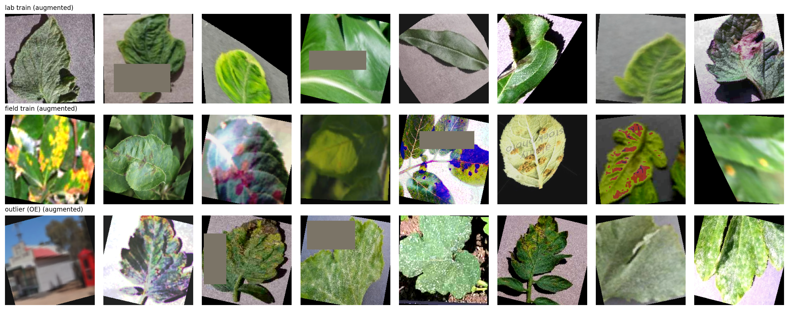
Figure 5.1: Lab, field, and outlier-exposure (OE) training augmentations.

5.2 Known-Class Classification Performance
Table 5.1 compares the three training configurations on known-class accuracy, macro-F1, and the rate at which each configuration accepts unknown images across the four open-set scenarios, at each configuration's own operating threshold.
Metric | A_lab_only | B_mixed | C_mixed_OE
Accuracy — lab | 0.9992 | 0.9975 | 0.9957
Accuracy — field | 0.1617 | 0.8843 | 0.8813
Macro-F1 — lab | 0.9985 | 0.9958 | 0.9943
Macro-F1 — field | 0.2487 | 0.8281 | 0.8254
Known coverage — lab (at threshold) | 0.9421 | 0.9838 | 0.9730
Known coverage — field (at threshold) | 0.0245 | 0.7102 | 0.7902
Table 5.1: Experiment comparison — A_lab_only vs B_mixed vs C_mixed_OE.
The contrast between A_lab_only and the two mixed-domain configurations is stark and is itself an important experimental result: a model trained purely on laboratory images collapses to 16.2% field accuracy (macro-F1 0.249) — effectively unusable on real photographs — despite 99.9% lab accuracy, demonstrating that laboratory-only benchmarking substantially overstates real-world readiness for this task. Including field images in training (B_mixed) recovers field accuracy to 88.4%; adding outlier exposure on top (C_mixed_OE, the final configuration) costs a small amount of field accuracy (88.4% → 88.1%) in exchange for the open-set rejection capability evaluated in the remainder of this chapter.
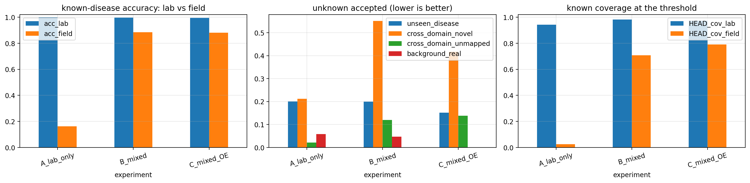
Figure 5.2: Known-disease accuracy, unknown-accepted rate, and known coverage across the three training configurations.
Known-class confusion matrices for the final model are shown separately for the PlantVillage (lab) and external field test pools. The lab confusion matrix is close to diagonal throughout, consistent with the 99.6% lab accuracy figure. The field confusion matrix is visibly sparser — reflecting that only a subset of the 27 known classes have any mapped field-test support — and shows the field model's confusions concentrated among visually similar disease pairs within the same crop (e.g., within Potato and within Apple).
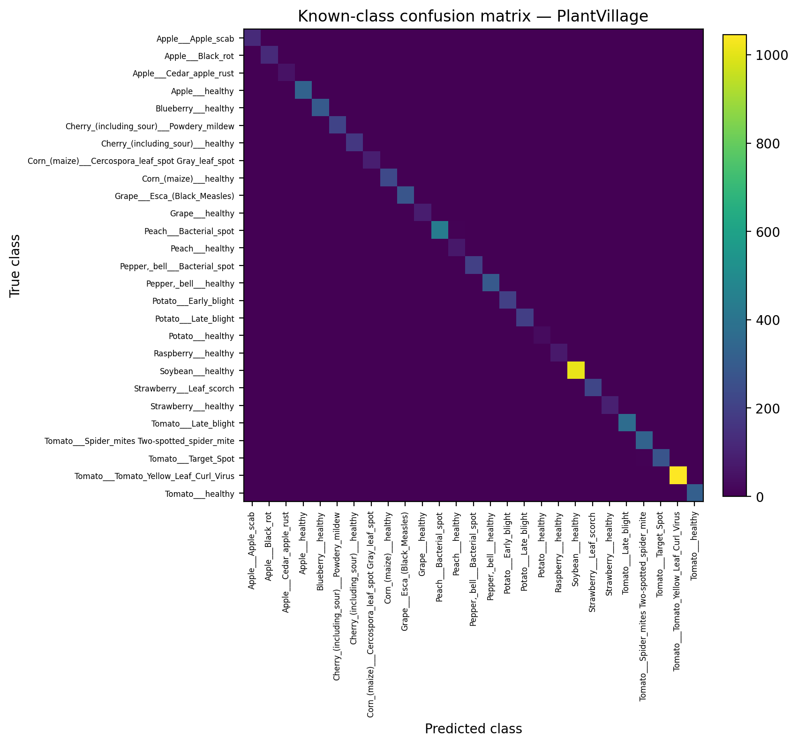
Figure 5.3: Known-class confusion matrix — PlantVillage (lab).
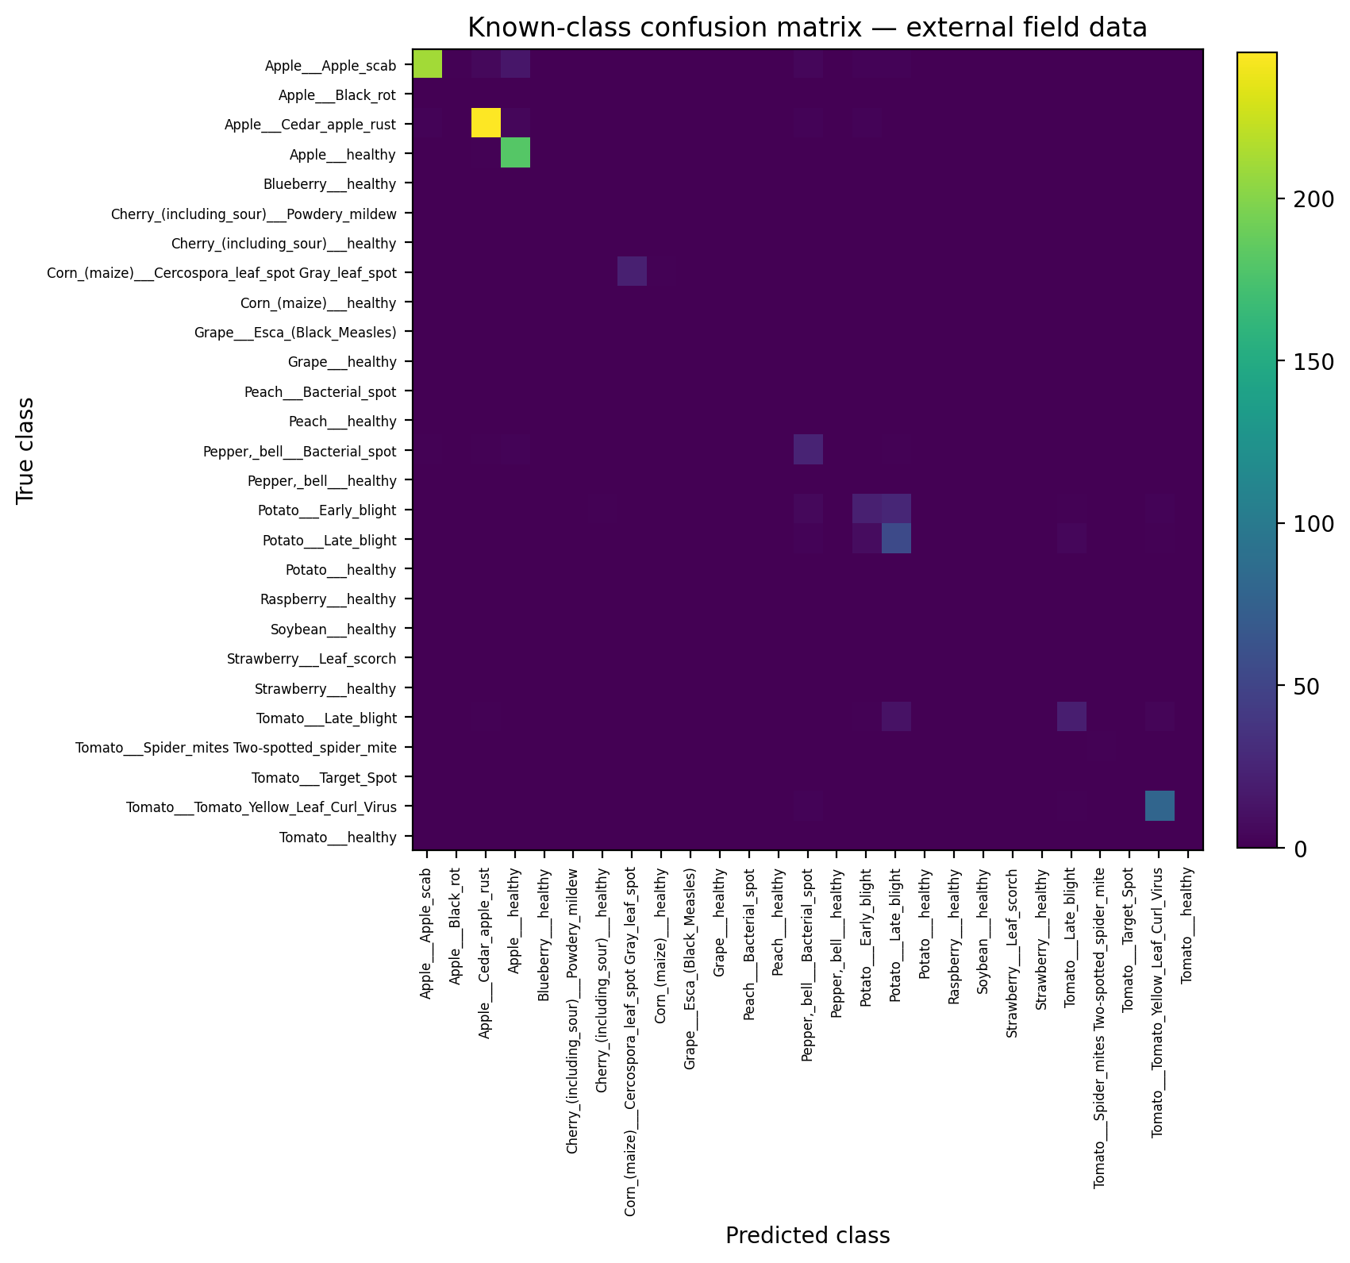
Figure 5.4: Known-class confusion matrix — external field data (PlantDoc + Plant Pathology 2020).

5.3 Calibration
Table 5.2 reports negative log-likelihood (NLL), expected calibration error (ECE), and maximum calibration error (MCE) for the final model, before scaling (raw softmax) and after each of two post-hoc calibration schemes, computed separately for the lab and field known-test pools.
Domain | Scheme | NLL | ECE | MCE
Lab | Raw | 0.1078 | 0.0852 | 0.6040
Lab | Temperature | 0.0275 | 0.0130 | 0.2517
Field | Raw | — | 0.0745 | 0.4960
Field | Temperature | — | 0.0582 | 0.1760
Field | Vector | — | 0.0486 | 0.2170
Table 5.2: Calibration before and after scaling (C_mixed_OE).
Temperature scaling improves field-domain ECE (0.0745 → 0.0582), but vector scaling — a per-domain affine recalibration — improves it further still (0.0486), while temperature scaling leaves a markedly higher residual MCE on field data than vector scaling does. A notable negative result from the lab-only baseline (A_lab_only, not shown in Table 5.2) is worth recording here: on that configuration, temperature scaling makes field-domain calibration actively worse than the uncalibrated raw output (field ECE rises from 0.251 to 0.618), because a single scalar temperature fitted without any field-domain calibration data cannot correct for a model that has never seen field images at all. This is direct evidence that calibration quality depends on the training data's domain coverage, not only on the calibration procedure itself, and that temperature scaling is not a universal fix for domain shift. Reliability diagrams for the final model, comparing raw and temperature-scaled confidence against observed accuracy, are shown in Figure 5.5.
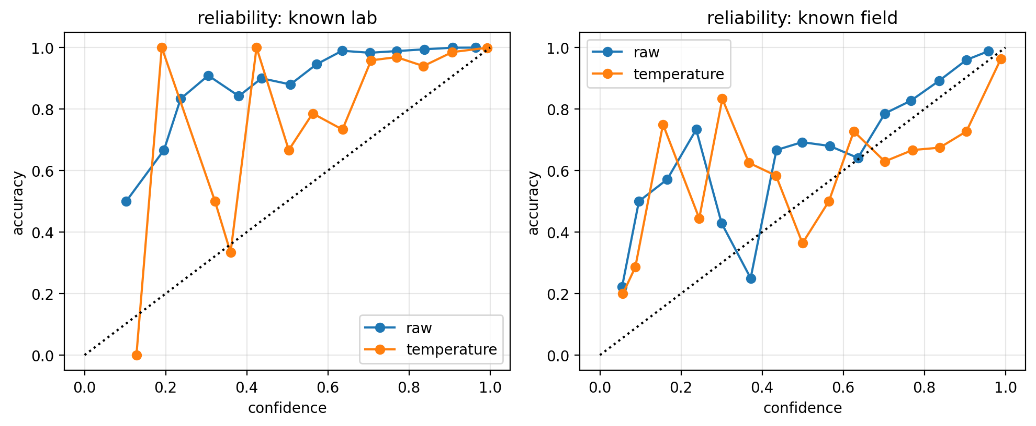
Figure 5.5: Reliability diagrams — known lab (left) vs known field (right), raw vs temperature-scaled.

5.4 Open-Set / Out-of-Distribution Score Distributions
Figure 5.6 shows the distribution of the headline MaxLogit score (higher = more unknown) across known-lab, known-field, and all four open-set scenarios, with the deployed operating threshold marked. Known-lab images are tightly concentrated at low scores; known-field images spread toward higher scores (reflecting the domain shift discussed in Section 5.2–5.3) but remain mostly below the threshold; background_real images are concentrated at the highest scores, confirming the detector separates non-plant content cleanly; and the three disease/cross-domain scenarios occupy the region closest to the threshold, which is exactly where most of the false accepts analyzed in Section 5.6 originate.
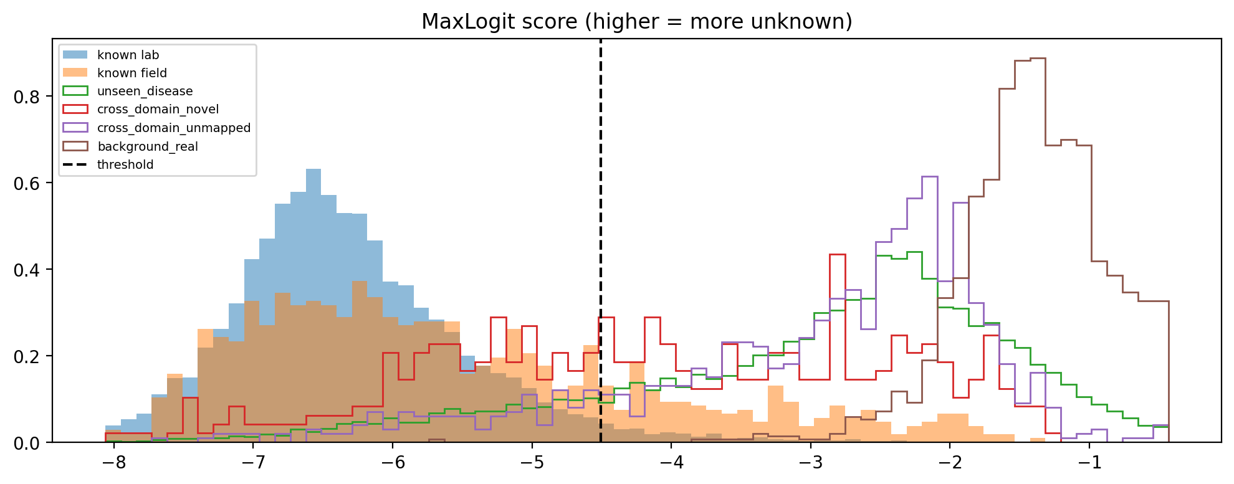
Figure 5.6: MaxLogit score distributions by scenario, with operating threshold.
A qualitative view of the same separation in feature space is given by a t-SNE projection of the penultimate-layer features (Figure 5.7). Known-lab and known-field clusters are visually distinct from most unseen_disease and cross_domain_novel clusters, which is consistent with the quantitative AUROC figures reported in Section 5.5, but a number of unseen_disease points visibly fall inside or adjacent to known-class clusters — a visual signature of exactly the kind of false accept examined in Section 5.6.
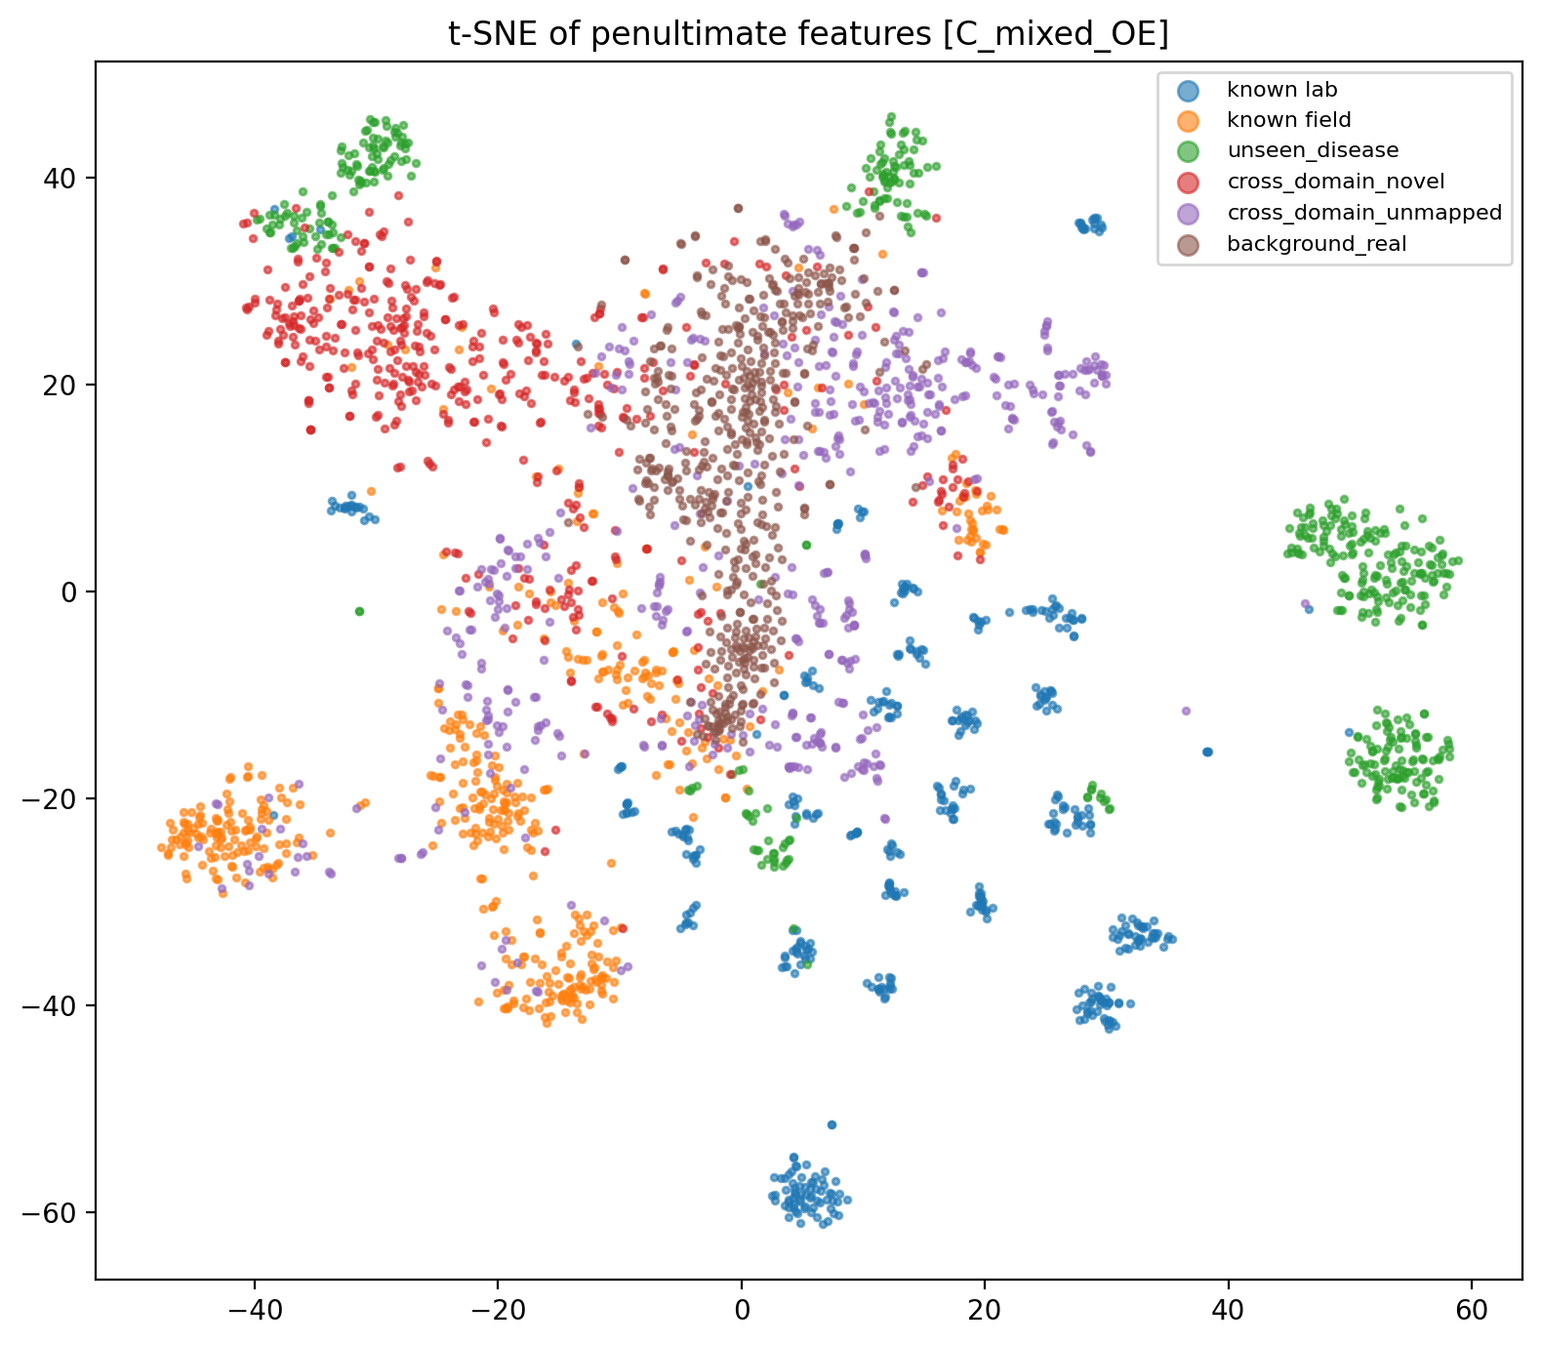
Figure 5.7: t-SNE of penultimate-layer features (C_mixed_OE).

5.5 Open-Set Detector Comparison
Table 5.3 compares the two detectors most referenced throughout this chapter, MSP and MaxLogit (the fixed headline detector), across the four open-set scenarios on the pooled known-test population (known_all = known-lab + known-field).
Scenario | MSP AUROC | MaxLogit AUROC | MSP AP | MaxLogit AP
unseen_disease | 0.948 | 0.955 | 0.955 | 0.966
cross_domain_novel | 0.891 | 0.875 | 0.496 | 0.438
cross_domain_unmapped | 0.951 | 0.959 | 0.813 | 0.814
background_real | 1.000 | 0.999 | 0.997 | 0.995
Table 5.3: MSP vs MaxLogit by open-set scenario (AUROC and average precision).
background_real is detected almost perfectly by either detector (AUROC ≥ 0.999); unseen_disease and cross_domain_unmapped are both detected well (AUROC 0.95–0.96); cross_domain_novel is the hardest scenario for both detectors, with AUROC around 0.88–0.89 and, more tellingly, average precision collapsing to 0.44–0.50 — reflecting that cross_domain_novel images are a small, visually heterogeneous minority class within the evaluation pool, which average precision penalizes far more harshly than AUROC does. The full ROC and precision–recall curves for both detectors, by scenario, are given in Figures 5.8 and 5.9.
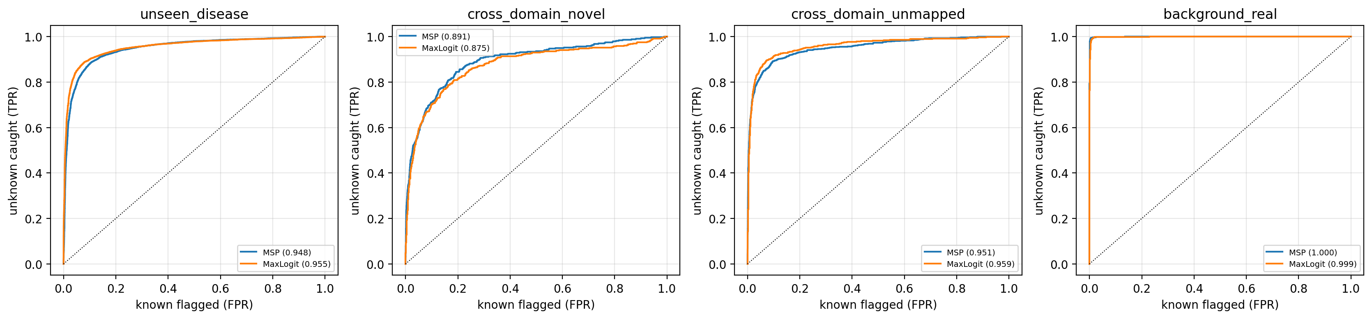
Figure 5.8: ROC curves by open-set scenario (MSP vs MaxLogit).
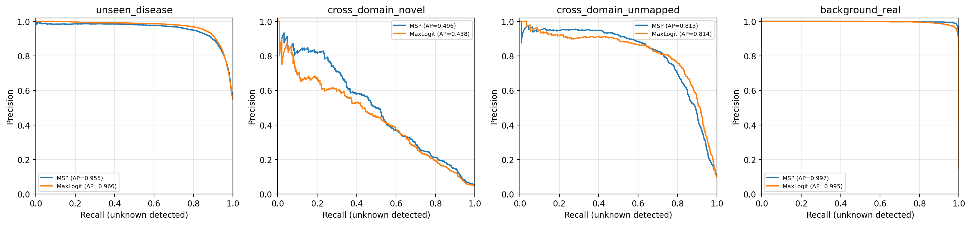
Figure 5.9: Precision–recall curves by open-set scenario (MSP vs MaxLogit).
Across all eleven implemented detectors (full table exported but omitted here for brevity), MaxLogit and MSP+Mahalanobis were consistently the strongest performers on known_all AUROC (0.957 and 0.956 respectively) and on selective-risk (AURC): MSP+Mahalanobis achieved the lowest AURC of any detector (0.00062), narrowly ahead of MSP+k-NN (0.00063), while ODIN — in its canonical, perturbation-tuned form — performed worst by a wide margin (AURC 0.0105, roughly 17× higher risk at matched coverage than the best detector). Section 5.10 discusses why ODIN's own tuning procedure selected effectively zero input perturbation as optimal on this data, which explains its reduced advantage over plain MSP here. Selective-risk curves for MSP and MaxLogit are shown in Figure 5.10.
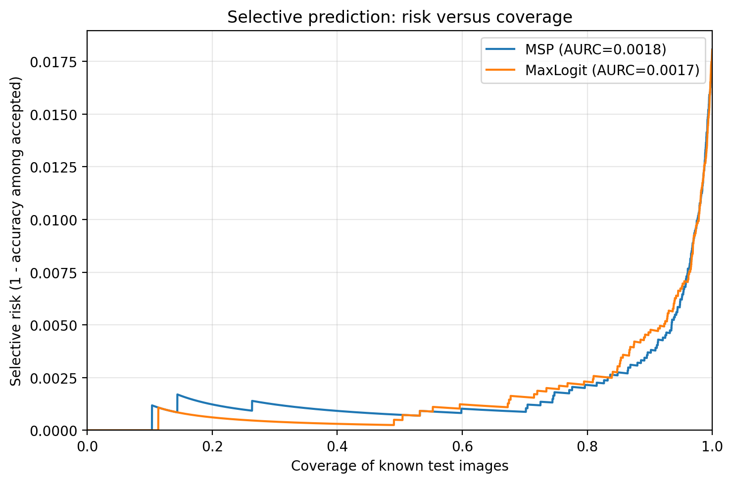
Figure 5.10: Selective prediction — risk versus coverage (AURC), MSP vs MaxLogit.

5.6 Per-Class False-Accept Analysis: the Northern Leaf Blight Case
Aggregate false-accept rate for the unseen_disease scenario (15.2% at the pooled threshold) masks substantial variation between the six individual held-out disease classes, which Table 5.4 makes explicit.
Held-out class | n | False-accept rate (95% Wilson CI)
Corn Northern Leaf Blight | 982 | 0.838 (±⁈0.023)
Tomato mosaic virus | — | 0.344 (±⁈0.095)
Tomato Early blight | 987 | 0.242 (±⁈0.027)
Corn Common rust | 1,057 | 0.229 (±⁈0.025)
Orange Huanglongbing (citrus greening) | 5,403 | 0.011 (±⁈0.003)
Grape Leaf blight (Isariopsis Leaf Spot) | 1,072 | 0.006 (±⁈0.004)
Table 5.4: Per-unseen-class false-accept rate (MaxLogit, 95% Wilson confidence interval).
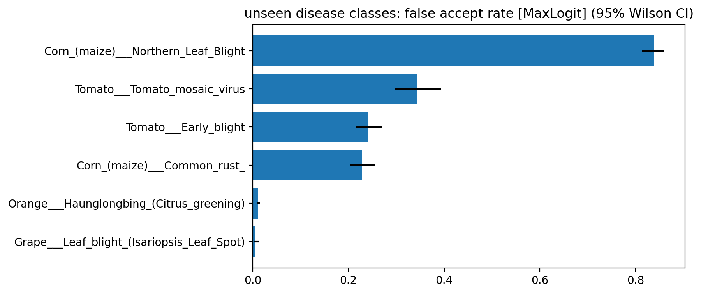
Figure 5.11: Unseen-disease classes — false-accept rate with 95% Wilson confidence intervals.
Corn Northern Leaf Blight (NLB) is false-accepted at 83.8%, roughly 2.4× the next-highest class and more than two orders of magnitude above the two best-handled classes (Orange Huanglongbing at 1.1% and Grape Leaf Blight at 0.6%). This single class is responsible for a disproportionate share of the system's overall unseen_disease false-accept rate; the four remaining, better-behaved classes alone would put the macro false-accept rate for this scenario well within the pre-registered target. Figure 5.12 shows the ten unknown images accepted with the highest confidence by the MaxLogit detector, the majority of which are, in fact, Northern Leaf Blight or other corn-leaf images, visually consistent with the quantitative finding. The specific known class these NLB images are predicted as was not exported during the executed run and is identified as a concrete, scoped follow-up item in Section 6.3 rather than being guessed here.
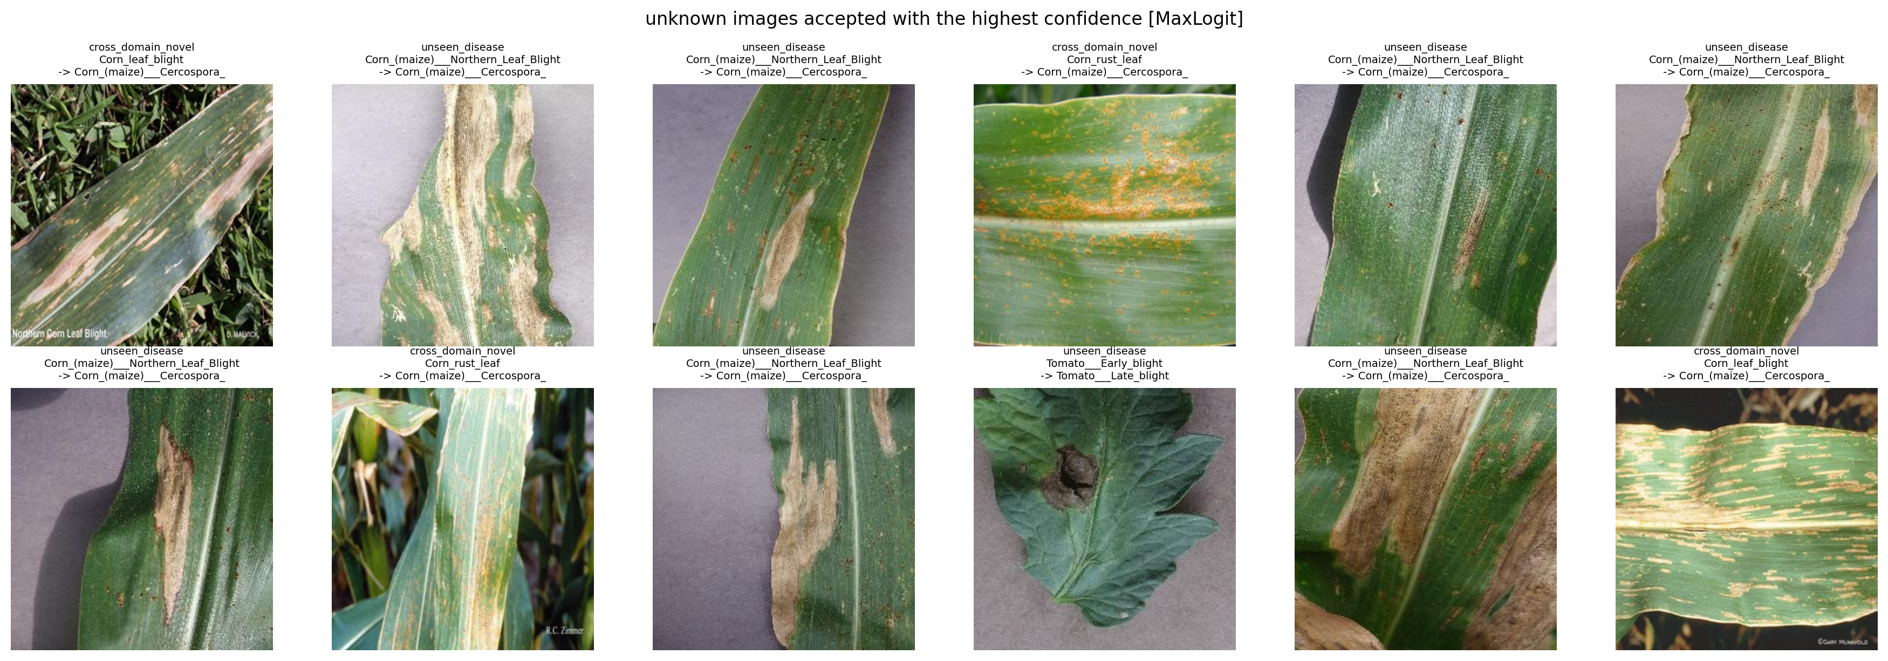
Figure 5.12: Unknown images accepted with the highest confidence (MaxLogit).

5.7 Background / Non-Plant Rejection
Background imagery is rejected almost perfectly overall (false-accept rate 0.0007 across all background_real images, against a pre-registered target of ≤⁈0.05). Breaking this down by the five background sub-groups collected (hand, sky, soil, tools, and weeds), only the weeds group — the one plant-like background group, by design — produces any false accepts at all (false-accept rate 0.0024); the other four groups are rejected with zero recorded false accepts. The background corpus as collected contains no “texture” sub-group, so the pre-registered false-accept-rate target specific to that sub-group could not be evaluated and is reported as not tested (Section 5.9).
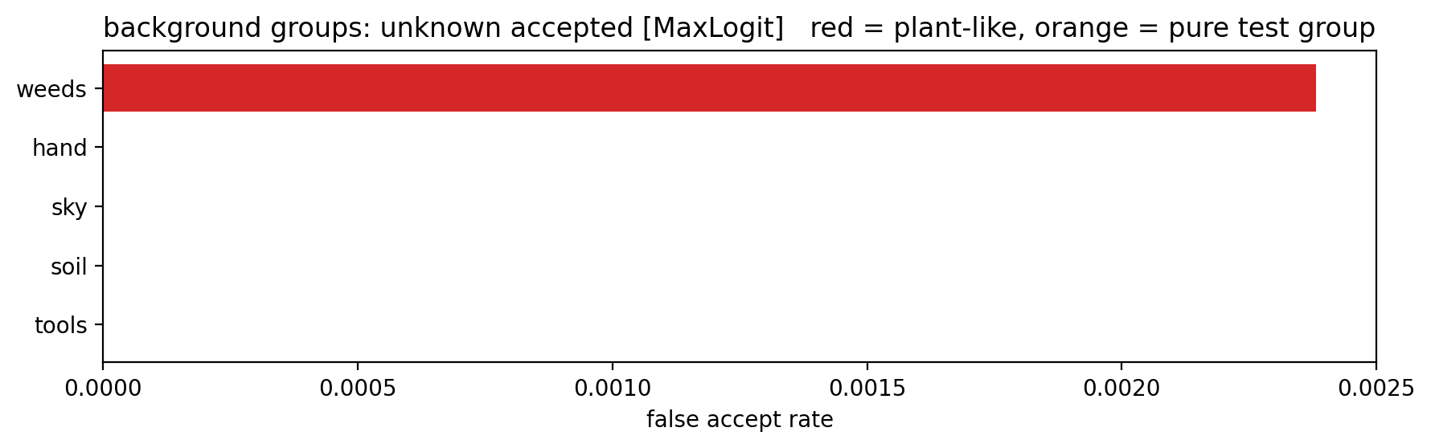
Figure 5.13: Background groups — false-accept rate by group.

5.8 Corruption Robustness
Six synthetic image degradations — blur, JPEG compression, low resolution, additive noise, brightness/contrast shift, and occlusion — were applied to the known-field test pool at three increasing severities, and the headline detector was re-scored at each level. Table 5.5 summarizes clean versus worst-case (severity 3) performance.
Condition | Known accuracy | Known coverage | Unknown accepted | AUROC
Clean (severity 0) | 0.9421 | 0.8829 | 0.1792 | 0.9287
Worst corruption, severity 3 (occlusion) | 0.8479 | 0.6886 | 0.1401 | 0.8801
Table 5.5: Corruption robustness summary (MaxLogit).
All four metrics degrade monotonically with corruption severity across all six corruption types; occlusion and brightness/contrast produce the steepest degradation, with known coverage falling from 0.883 to 0.689 under the worst occlusion condition — an 19.4-percentage-point drop, against a pre-registered target of no more than a 15-point drop. Full per-corruption, per-severity curves are shown in Figure 5.14.
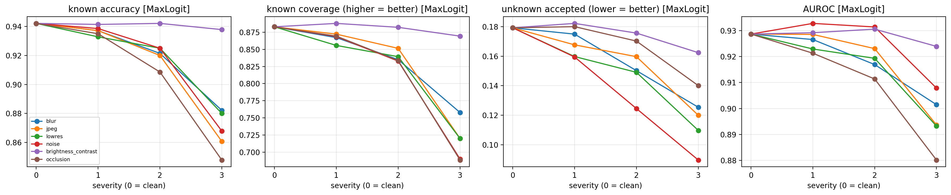
Figure 5.14: Corruption robustness across six degradations and three severities (MaxLogit).

5.9 Training-Seed Stability
The final configuration (C_mixed_OE) was retrained five times with identical data and hyperparameters but different random seeds, to separate genuine detector/threshold differences from ordinary training stochasticity. Across the five seeds, the headline MaxLogit detector's macro-AUROC varied with a standard deviation of 0.0116, and MSP's with 0.0166, against a pre-registered stability target of ≤0.01 — both detectors fail this target by a modest margin. Outlier exposure's directional benefit was itself tested per-seed: adding OE (comparing B_mixed vs C_mixed_OE within each seed) lowered the macro false-accept rate for both MSP and MaxLogit detectors on average across all five seeds (consistently negative for both), but the specific, stronger claim that OE lowers the unseen_disease false-accept rate in every individual seed held for MaxLogit (5 of 5 seeds improved) but not for MSP (3 of 5 seeds improved).

5.10 ODIN Tuning: a Negative Result
ODIN's tuning procedure searches over a grid of temperature and input-perturbation-magnitude values, selecting the combination that maximizes validation-set AUROC. On this dataset and model, the best-performing combination found was temperature 1 and perturbation magnitude 0 — that is, no input perturbation at all, which reduces ODIN to plain MSP. Every perturbation magnitude greater than zero that was tried performed worse, at every temperature tried. This is reported as a negative, dataset-specific finding rather than an implementation defect: the input-gradient perturbation ODIN relies on does not help this particular EfficientNetV2-B0 model on plant-disease OOD detection, and pursuing a different tuning target would not change that underlying result.

5.11 Threshold-Rule Sensitivity
The operating threshold itself is a design choice, and Table 5.6 reports how three different threshold-selection rules trade coverage against false-accept rate for the same trained model and detector (MaxLogit).
Threshold rule | Coverage — lab | Coverage — field | FA macro | FA — unseen_disease | FA — cross_domain_novel
Pooled (adopted headline) | 0.973 | 0.790 | 0.177 | 0.152 | 0.417
val_youden | 0.982 | 0.820 | 0.206 | 0.184 | 0.474
Balanced | 0.993 | 0.885 | 0.282 | 0.272 | 0.592
Table 5.6: Threshold-rule sensitivity analysis (MaxLogit).
Moving from the pooled rule to val_youden raises field coverage from 0.790 to 0.820 — clearing the pre-registered ≥0.80 field-coverage target that the pooled rule narrowly misses — but does so by accepting more unknown images across every false-accept category, so it is not a strict improvement; it is a different point on the same coverage/risk trade-off the selective-prediction framework in Section 3.7 is designed to make explicit. The balanced rule pushes coverage higher still, at a substantially larger false-accept cost. No single rule dominates the others on every metric; the choice among them is a deployment decision, not a modeling one, and this report adopts the pooled rule throughout as its pre-registered headline choice.

5.12 Deployable Bundle Demonstration
A packaged inference bundle — the final trained model, fitted calibration parameters, and the selected detector/threshold — was exercised on a small, manually curated demonstration set spanning known-lab, known-field, unseen-disease, cross-domain, and background images, to sanity-check the end-to-end decision pipeline outside the main evaluation harness. The bundle produced the correct accept/reject decision on 13 of 15 demonstration images; the two errors were a known-field Potato Early Blight image rejected as unknown, and an unseen-disease Corn Common Rust image incorrectly accepted as a known class — consistent with the broader finding in Section 5.6 that corn-disease images are the system's weakest point.
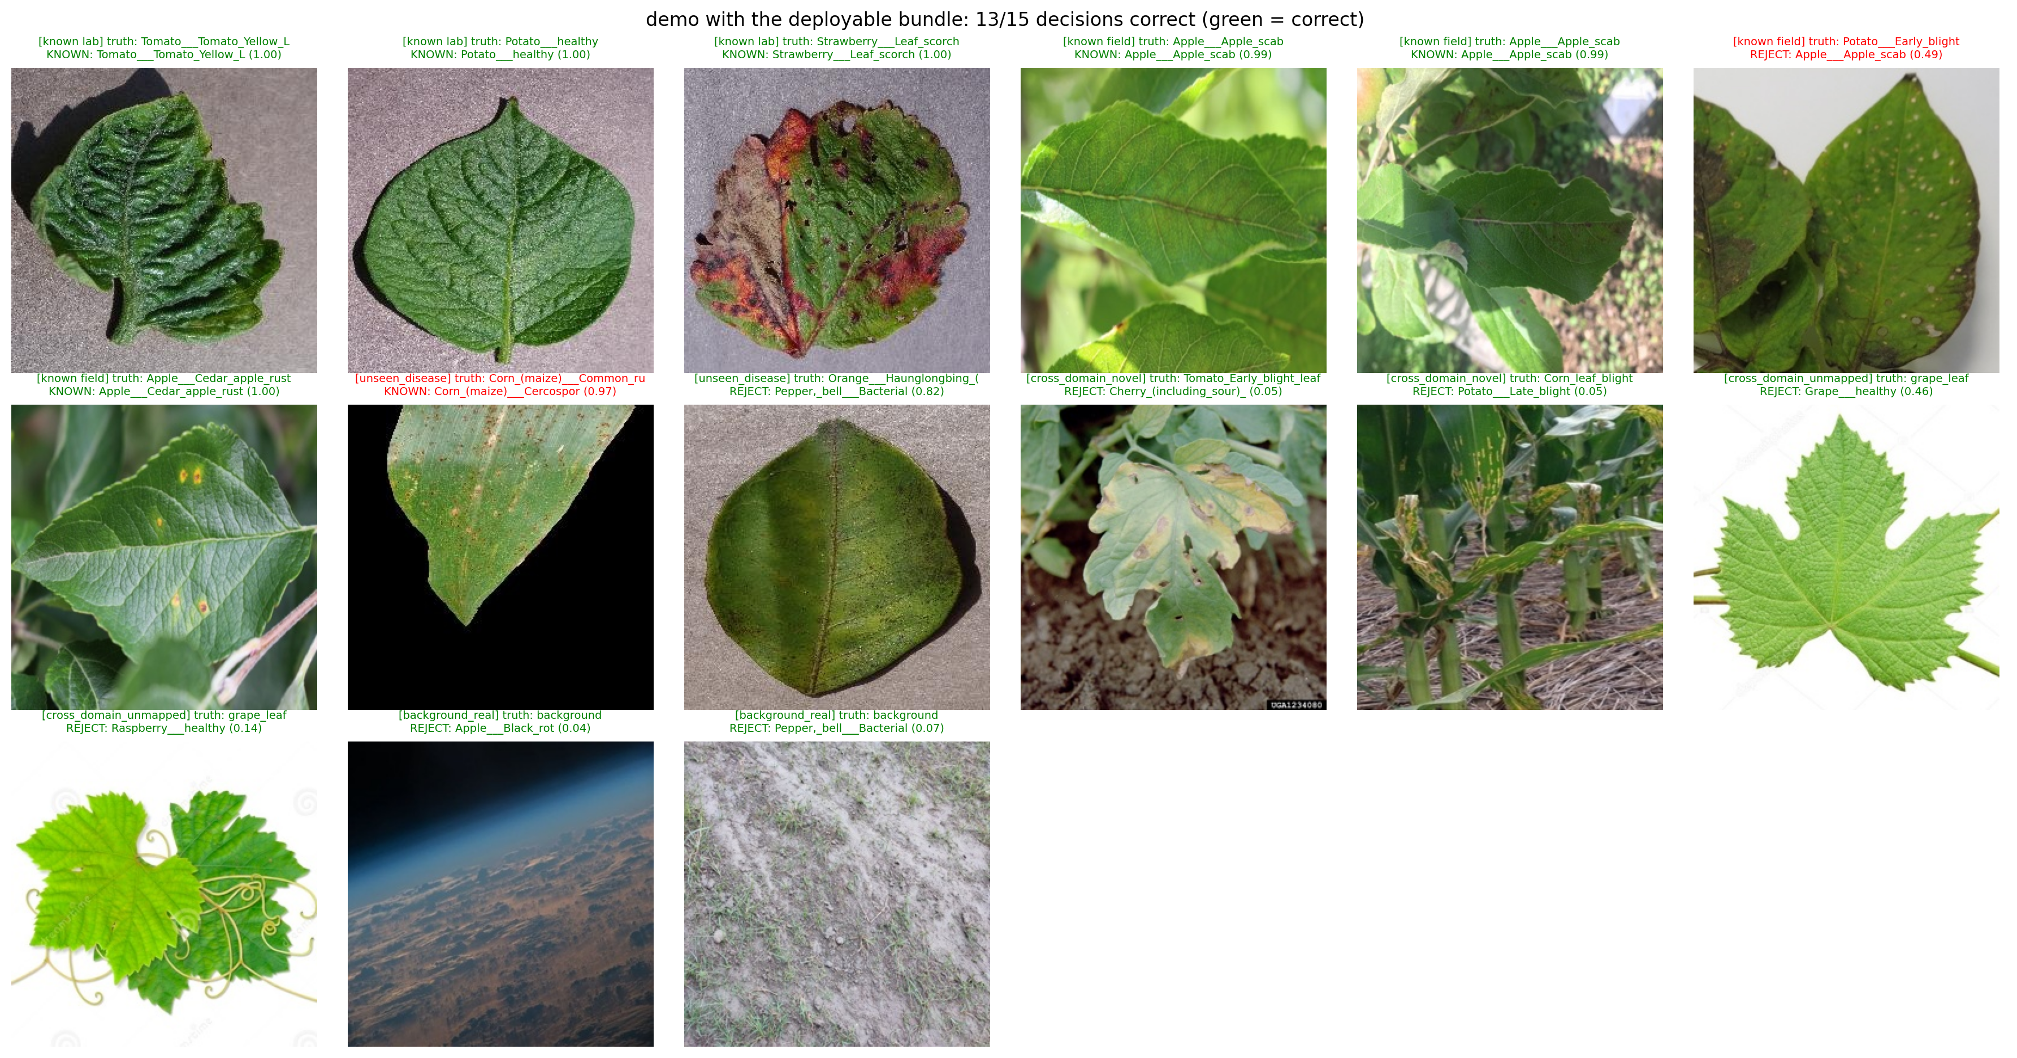
Figure 5.15: Deployable-bundle demonstration: 13 of 15 decisions correct (green = correct).

5.13 Claims-Check Gate: Full Results
Twenty-one numeric claims were pre-registered against specific thresholds before the final evaluation run and checked automatically against the executed pipeline's output. Eleven passed, nine failed, and one could not be tested with the available data. Table 5.7 reports every claim and its outcome, in the interest of reporting negative and mixed findings as transparently as positive ones.
# | Claim | Target | Observed | Result
1 | Leakage-audit protocol integrity | No cross-role duplicate clusters | 0 violations | PASS
2 | Sufficient held-out disease classes | ≥⁈6 classes | 6 classes | PASS
3 | Outlier exposure used in training | OE enabled | Enabled | PASS
4 | Known accuracy — lab | ≥⁈0.99 | 0.9957 | PASS
5 | Known accuracy — field | ≥⁈0.85 | 0.8813 | PASS
6 | Domain-gap AUROC (lab vs field, same class) | ≤⁈0.75 | 0.6433 | PASS
7 | False-accept — background_real | ≤⁈0.05 | 0.0007 | PASS
8 | Field training raises field accuracy (B − A) | > 0.10 | +0.7226 | PASS
9 | OE lowers macro false-accept (same detector, MSP) | < 0 | −0.0333 | PASS
10 | OE lowers macro false-accept (same detector, MaxLogit) | < 0 | −0.0525 | PASS
11 | OE lowers unseen-disease FA, every seed (MaxLogit) | < 0 in every seed | 5 / 5 seeds | PASS
12 | Field coverage at threshold | ≥⁈0.80 | 0.7902 | FAIL
13 | Coverage gap, lab vs field | ≤⁈0.10 | 0.1829 | FAIL
14 | False-accept — unseen_disease | ≤⁈0.10 | 0.1519 | FAIL
15 | False-accept — cross_domain_novel | ≤⁈0.10 | 0.4169 | FAIL
16 | False-accept — cross_domain_unmapped | ≤⁈0.10 | 0.1387 | FAIL
17 | Coverage drop, worst-severity corruption | ≤⁈0.15 | 0.1943 | FAIL
18 | Seed stability, macro-AUROC (headline / MaxLogit) | ≤⁈0.01 std | 0.0116 | FAIL
19 | Seed stability, macro-AUROC (fixed detector / MSP) | ≤⁈0.01 std | 0.0166 | FAIL
20 | OE lowers unseen-disease FA, every seed (MSP) | < 0 in every seed | 3 / 5 seeds | FAIL
21 | False-accept — background_texture | ≤⁈0.05 | no texture images collected | NOT TESTED
Table 5.7: Claims-check gate — full results (21 claims; 11 PASS / 9 FAIL / 1 NOT TESTED).
The passing claims establish that the core pipeline works as designed: the leakage audit is clean, both lab and field known-class accuracy clear their targets, the domain gap between lab and field confidence is within bounds, background rejection is near-perfect, mixed-domain training produces a large, unambiguous improvement in field accuracy, and outlier exposure's benefit to false-accept rate is consistent in both its average effect and, for the headline detector, its per-seed consistency. The failing claims are concentrated in three areas, each already examined in detail earlier in this chapter: false-accept rate on three of the four open-set scenarios remains above the pre-registered 10% target (Sections 5.5–5.6), robustness to corruption and to training-seed variation both fall modestly short of their targets (Sections 5.8–5.9), and field coverage at the pooled threshold narrowly misses its target even though an alternative threshold rule would clear it at a false-accept cost (Section 5.11). None of these failures invalidate the passing results; together they define the specific, measured gap between this system's current performance and its own pre-registered reliability bar, which Chapter 6 discusses as concrete future work rather than treating as a reason to discard the results.

Chapter 6: Limitations and Future Work
The results in Chapter 5 are reported in full, including the nine pre-registered claims that did not pass. This chapter discusses what those results do and do not establish, and the specific, scoped follow-up work they motivate, rather than restating the numbers already presented.

6.1 The Northern Leaf Blight Confusion Target Is Unconfirmed
Section 5.6 establishes, with high confidence, that Corn Northern Leaf Blight is false-accepted at a far higher rate (83.8%) than any other held-out disease class, and that it visually dominates the highest-confidence false accepts shown in Figure 5.12. What this report cannot establish is which specific known class these images are being predicted as, because the executed pipeline run did not export a per-image predicted-class log for the unseen-test pool — only the aggregate accept/reject outcome and the false-accept rate per held-out class were exported. A plausible hypothesis, based on the known-class list alone, is that Northern Leaf Blight is confused with one of the two known corn classes (Corn healthy or Corn Cercospora/Gray Leaf Spot), since Gray Leaf Spot produces visually similar elongated lesions, but this is domain-knowledge speculation, not a result this report's data supports. Resolving this requires one additional, inexpensive export (true class, predicted known class, and OOD score for every accepted unseen-test image) from the already-trained model and cached features, which does not require retraining.

6.2 Single Class-Split Evaluation
All results in this report use one fixed assignment of PlantVillage classes to the known / unseen-test / unseen-OE / unseen-val roles (split seed 42). The five-seed stability study (Section 5.9) quantifies sensitivity to training-run randomness under this one class split, but it does not quantify sensitivity to which classes happen to be held out — a different split-seed could plausibly produce a different “hardest held-out class” than Northern Leaf Blight. Running the full pipeline for at least two additional class-split seeds, and reporting whether a similarly disproportionate per-class false-accept rate recurs, is the most direct way to establish whether the Section 5.6 finding is a property of this dataset's class structure or an artifact of one particular split.

6.3 Partially Reviewed Cross-Domain Label Mappings
The cross-domain label-mapping table (Section 4.3) carries a review note for every one of the 32 observed external labels, but two of those notes explicitly flag the mapping as still needing verification against the source dataset's own label documentation. Until those two rows are resolved, the cross_domain_novel and cross_domain_unmapped results in Section 5.5 — already the weakest-performing scenario for both detectors — should be read with that specific, bounded uncertainty in mind.

6.4 Threshold Choice Is a Deployment Decision, Not a Fixed Property of the Model
Section 5.11 shows that the field-coverage shortfall reported as a claims-check failure (Claim 12) can be closed by adopting a different, already-computed threshold rule (val_youden), at the cost of worse false-accept rates across every open-set scenario. This report deliberately does not resolve that trade-off on the system's behalf: it adopts the pooled rule as its pre-registered headline choice and reports the alternative honestly as a sensitivity analysis. A deployment of this system would need its own explicit decision, informed by the relative cost of a missed disease versus a false alarm in that specific setting, which this academic evaluation cannot supply.

6.5 Other Scoped Follow-Up Work
- Investigate corruption-specific mitigations for occlusion and brightness/contrast shift specifically, which degrade coverage and accuracy more steeply than the other four corruption types tested.
- Extend the five-seed stability study with two or three additional seeds to narrow the confidence interval on the AUROC-stability claims, which currently fail their target by a modest margin (0.0116 and 0.0166 against a 0.01 target).
- Report inference latency and resource cost of the deployed detector, which was out of scope for this evaluation but is relevant to any field deployment of the packaged bundle demonstrated in Section 5.12.

Chapter 7: Conclusion
This project set out to evaluate whether confidence calibration and open-set/out-of-distribution scoring can turn a conventional plant disease classifier into a system that is honest about the limits of what it knows — accepting and correctly classifying known diseases on both laboratory and field images, while rejecting diseases, crops, and non-plant content it was never trained on. The evaluation delivers a system that does this substantially, though not completely: 99.6% known-lab and 88.1% known-field accuracy, near-perfect rejection of non-plant background content, and a clear, well-documented demonstration that naive laboratory-only training is not fit for field deployment (16.2% field accuracy versus 88–89% once field images are included in training).
Against its own twenty-one pre-registered, numeric success criteria, the system passed eleven and failed nine, with one criterion not testable given the available data. The failing claims are not scattered noise; they cluster into three specific, well-characterized gaps — elevated false-accept rates on cross-domain and held-out-disease scenarios (traced in large part to a single disease class, Corn Northern Leaf Blight), a modest shortfall in robustness to image corruption and to training-seed variation, and a field-coverage target that depends on which of several defensible threshold rules is adopted. Reporting these failures in full, with the same rigor as the passing results, was a deliberate design choice consistent with the project's own stated success criteria, and it is this honest accounting — not a claim of unqualified success — that this report offers as its primary contribution, alongside the calibrated, eleven-detector open-set evaluation pipeline itself.
The specific, scoped follow-up items identified in Chapter 6 — confirming the Northern Leaf Blight confusion target, testing a second and third class-split seed, finishing review of two flagged label mappings, and extending the seed-stability study — define a concrete path from the current result to a more complete one, without requiring the project's architecture, protocol, or evaluation methodology to be redesigned.
REFERENCES
[1] Hughes, D. P., & Salathé, M. (2015). An open access repository of images on plant health to enable the development of mobile disease diagnostics. arXiv preprint arXiv:1511.08060 (PlantVillage dataset).
[2] Singh, D., Jain, N., Jain, P., Kayal, P., Kumawat, S., & Batra, N. (2020). PlantDoc: A dataset for visual plant disease detection. Proceedings of the 7th ACM IKDD CoDS and 25th COMAD.
[3] Thapa, R., Zhang, K., Snavely, N., Belongie, S., & Khan, A. (2020). The Plant Pathology 2020 challenge dataset to classify foliar disease of apples. arXiv preprint arXiv:2004.11958.
[4] Tan, M., & Le, Q. V. (2021). EfficientNetV2: Smaller models and faster training. Proceedings of the 38th International Conference on Machine Learning (ICML).
[5] Hendrycks, D., & Gimpel, K. (2017). A baseline for detecting misclassified and out-of-distribution examples in neural networks. International Conference on Learning Representations (ICLR).
[6] Liang, S., Li, Y., & Srikant, R. (2018). Enhancing the reliability of out-of-distribution image detection in neural networks (ODIN). International Conference on Learning Representations (ICLR).
[7] Liu, W., Wang, X., Owens, J., & Li, Y. (2020). Energy-based out-of-distribution detection. Advances in Neural Information Processing Systems (NeurIPS).
[8] Bendale, A., & Boult, T. E. (2016). Towards open set deep networks (OpenMax). IEEE Conference on Computer Vision and Pattern Recognition (CVPR).
[9] Lee, K., Lee, K., Lee, H., & Shin, J. (2018). A simple unified framework for detecting out-of-distribution samples and adversarial attacks (Mahalanobis distance). Advances in Neural Information Processing Systems (NeurIPS).
[10] Guo, C., Pleiss, G., Sun, Y., & Weinberger, K. Q. (2017). On calibration of modern neural networks (temperature scaling). Proceedings of the 34th International Conference on Machine Learning (ICML).
[11] Geifman, Y., & El-Yaniv, R. (2017). Selective classification for deep neural networks. Advances in Neural Information Processing Systems (NeurIPS).
[12] PyTorch Image Models (timm) contributors. timm documentation. https://github.com/huggingface/pytorch-image-models, accessed 2026.
[13] Project notebook and exported result artifacts: open-set-calibrated.ipynb, claims_check.csv, experiment_comparison.csv, seed_study.csv, corruption_study.csv, odin_tuning_grid.csv, crossdomain_label_map_used.csv, all_results_v7.xlsx (internal project files, 2026).

