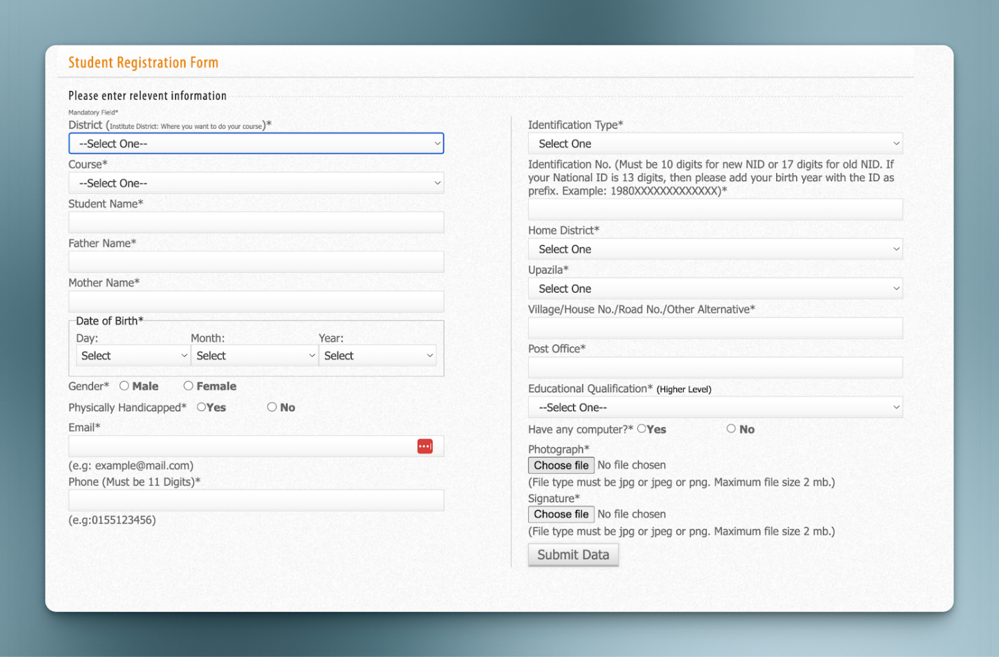

Complete the following project: <https://www.figma.com/design/gGT9Y8dwDmQZ9YjUU7yzpw/Lawyer-Landing-Page---Lawliet--Community-?node-id=17-18&t=4xv05MznrTvIGVOl-0>