Article

Manifold Learning-Based Prediction and Stability Analysis of Lentil (Lens culinaris Medik.) Grain Yield Across Multiple Environments in Drought Condition
Mst. Yasmin Abida Lia ¹, Monjur Morshed ²
Academic Editor: Firstname Lastname
Received: date
Revised: date
Accepted: date
Published: date
Copyright: © 2026 by the authors. Submitted for possible open access publication under the terms and conditions of the Creative Commons Attribution (CC BY) license.
¹ Fruit Research Station,Bangladesh Agricultural Research Institute,Rajshahi,Bangladesh;(Y.A.L); yabidalia@gmail.com
² Department of Information And Communication Engineeering,Pabna,Bangladesh; monjur.220601@s.pust.ac.bd
* Correspondence: yabidalia@gmail.com
Abstract
Prediction of lentil grain yield in different environments is still challenging due to the complexity of genotype × environment interaction and the nonlinear nature of agronomic traits. We combined manifold learning, machine learning, explainable AI (XAI), and genotype stability analysis to evaluate lentil performance under drought-prone conditions in northern Bangladesh. UMAP and t-SNE based on 150 observations on ten genotypes from five environments revealed trait patterns and environmental groupings. The model performance was assessed by cross-validating twelve regression models and the best performing algorithm was chosen using nested cross-validation. The best algorithm was the ridge regression with test R2 of 0.8072 and root mean square error (RMSE) of 183.77 kg/ha. The model had good generalization ability from cross-validation (R2 = 0.7289 ± 0.0177). SHAP analysis indicated that DF_BP_Interaction and TSW were important for predicting yield. The AMMI and GGE biplot analyses suggested G71 and G63 as relatively stable genotypes, while the G49 genotype had the highest average yield (1682.28 kg/ha) but only moderate stability. The GGE biplot also seemed to split the site into two mega-environments and Shyampur (L2) had the highest yield (1705.5 kg/ha).Interpretable machine learning combined with stability analysis could improve genotype selection and yield prediction.
Keywords: Lentil Yield Prediction, Machine Learning, SHAP, AMMI/GGE biplot, Stability Analysis, Yield Stability Analysis, Ridge Regression.

1. Introduction
Lentil (Lens culinaris Medik.) is a cool season legume crop of great importance. It provides millions of people around the world, especially in developing countries, with plant-based protein, complex carbohydrates and essential micronutrients.[1,2] Lentil production is vital for food security and soil health in Bangladesh through biological nitrogen fixation. However, lentil production is confronted by abiotic stresses, particularly terminal drought and heat stress which are aggravated by climate change . [3,4]In areas such as the Barind Tract (Rajshahi division) in northern Bangladesh with strong seasonal variations of temperature and moisture, erratic rainfall and high evaporation during the main growing season (November to March) impose severe constraints on crop productivity. Therefore, predicting lentil grain yield and identifying stable, high-performing genotypes across diverse challenging environments is still a complicated issue for agricultural researchers and breeders.[5–7]
The performance of a crop is rarely determined by either genetics or environment alone. This is mostly due to the complex interaction between Genotype and Environment (GxE).[8] Breeders usually conduct multi-environment trials (METs) and use statistical models such as the Additive Main Effects and Multiplicative Interaction (AMMI) model and the Genotype and Genotype-by-Environment (GGE) biplot to study the response of different genotypes to different environmental conditions. [9,10]Although these traditional methods are effective in assessing yield stability and identifying mega-environments, they mainly capture linear relationships and may have difficulties in modelling complex, non-linear interactions between multiple agromorphological traits (e.g., phenology, plant structure, reproductive traits) that ultimately determine yield under drought stress.[11]
Recently, Machine Learning (ML) has gained importance as a powerful tool in precision agriculture. It can detect non-linear patterns and improve the prediction of the yield of crops.[12] Conventional methods may not be able to capture intricate relationships between traits and yield, however these can be modelled using advanced algorithms such as Random Forests, Gradient Boosting and Support Vector Regression.[13,14] Furthermore, Explainable AI (XAI) particularly the SHapley Additive exPlanations (SHAP) allows Finders to better understand the ML models and provides transparent insights on the effect of specific agricultural traits on yield prediction .[15] Concurrently, methods such as Uniform Manifold Approximation and Projection (UMAP) and t-Distributed Stochastic Neighbour Embedding (t-SNE) have been successful in visualizing high dimensional data and detecting hidden patterns within complex biological datasets .[16] Nevertheless, in spite of the progress made, there are still considerable gaps in the application of ML to agricultural METs. High-capacity ML models (e.g. XGBoost or deep neural networks) tend to overfit when used with the small, noisy datasets typical of field trials.[17] This leads to poor performance on new settings. While manifold learning can be used to visualise trait spaces, its full potential has not been explored enough with predictive modelling and traditional stability analysis to assess G × E interactions. Finally, there is an urgent need for frameworks that not only predict yield accurately, but also provide useful insights that can guide breeders in their decisions.[18,19]
To overcome these challenges, this study proposes a combined analytical workflow of manifold learning, interpretable machine learning, and traditional genotype stability analysis to assess lentil performance under drought conditions in northern Bangladesh. [20]We applied UMAP and t-SNE to visualise the high-dimensional agromorphological traits of 10 lentil genotypes evaluated in 5 different environments (150 observations). We carefully compared twelve regression models using a nested cross-validation to find the most reliable algorithm for yield prediction. Moreover, we conducted SHAP analysis to understand the biological drivers of the model predictions and used AMMI and GGE biplots to evaluate the genotype stability and identify mega-environments.[21,22]
Our results show that a regularised linear model (Ridge Regression) outperformed complex ensemble methods significantly in terms of generalisation, with a test R2 of 0.8072. [23]The SHAP analysis revealed that the interaction between days to flowering and branches per plant (DF_BP_Interaction) and thousand seed weight (TSW) were the most important predictors of drought-resilient yield. Moreover, the joint stability analysis identified the genotypes G71 and G63 as very stable across environments, while G49 exhibited the highest mean yield but moderate stability.[24] The work provides a robust, interpretable, and scalable framework for crop scientists to improve genotype selection and yield prediction in areas affected by climate change. [25,26]
The remaining parts of this paper are organised as follows: In section 2 we describe the methodology of the study, including experimental design, data processing, manifold learning, ML modelling and stability analysis. In Section 3, we present the results including exploratory data analysis, model performance comparisons, SHAP-based feature importance, and genotype stability rankings. In Section 4 we discuss the agronomic and methodological implications of the results and Section 5 concludes the study with recommendations for future digital crop improvement.

2. Materials and Methods

2.1. Experimental Design, Study Area and Environmental Context
Five farm regions of Bangladesh namely, Godagari (L1), Shyampur (L2), Nachole (L3), Sapaher (L4) and Iswardi (L5) were the research locations. Geographically, they are scattered but administratively, they are under Rajshahi division. The weather here is of the sub-tropical monsoon type of Barind Tract. Also known as Varendra Bhumi, with drastic change between seasons in heat, dampness and rainfall. Soil parameters at all locations and change in temperature and rain month by month are shown in figures 2 - 4.
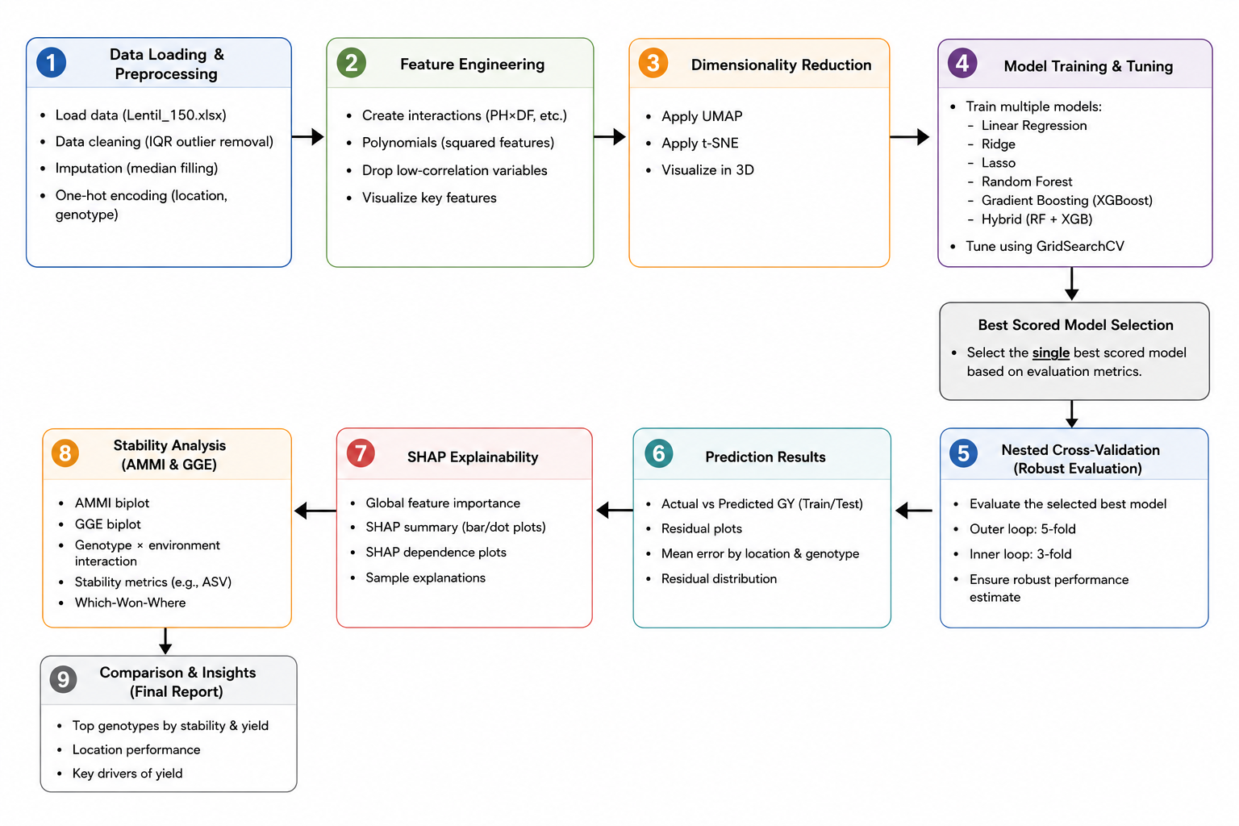
Figure 1: Schematic overview of the integrated machine learning and stability analysis workflow.
A preliminary assessment of 150 lentil types (types gathered by ICARDA, farm-grown variations, indigenous strains, newer experimental lines and imported seed) led to the selection of ten kinds for further study at numerous test sites. Among the top 10 genotypes, eight (G1, G17, G21, G39, G41, G43, G49 and G63) performed well in high temperatures whereas two (G71 and G73) did not. These were previously selected based on seed growth and physical characteristics under hot conditions.
The Reaseach was conducted for one growing season, July 2024 to June 2025, under the real field condition. Local data clearly indicated month to month and season to season differences in weather trends in Rajshahi.
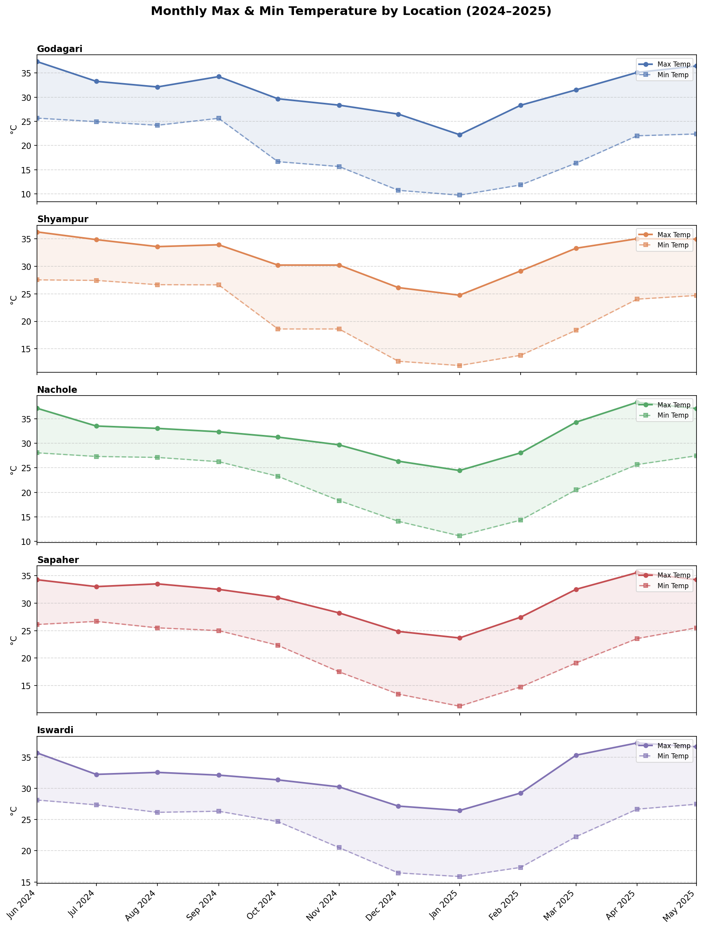
Figure 2: Monthly maximum and minimum temperatures (°C) across five locations (Godagari, Shyampur, Nachole, Sapaher, and Iswardi) from June 2024 to May 2025.
Temperature profiles between sites (Figure 2) and temperature changes at each site showed a predictable annual pattern for the 2024–2025 period. Warmth peaked in the midyear at about 36°C and then began falling fast. Readings plummeted immediately following the monsoon, bottoming out in early 2025. Godagari was the coolest place overall, highs in January only 22-27C and lows down to 10C. By late spring, the heat surged again, with areas like Nachole and Iswardi nearing 37°C. The lentil main growth season is between November and March. Daytime highs were in the 24 °C to 30 °C range. At night they settled lower, between 10-19C, depending on the point on the map. Lentil plants like cool weather, especially when they are setting pods. Iswardi was different here. The gap between its day and night warmth was narrower than anywhere else in the cycle.
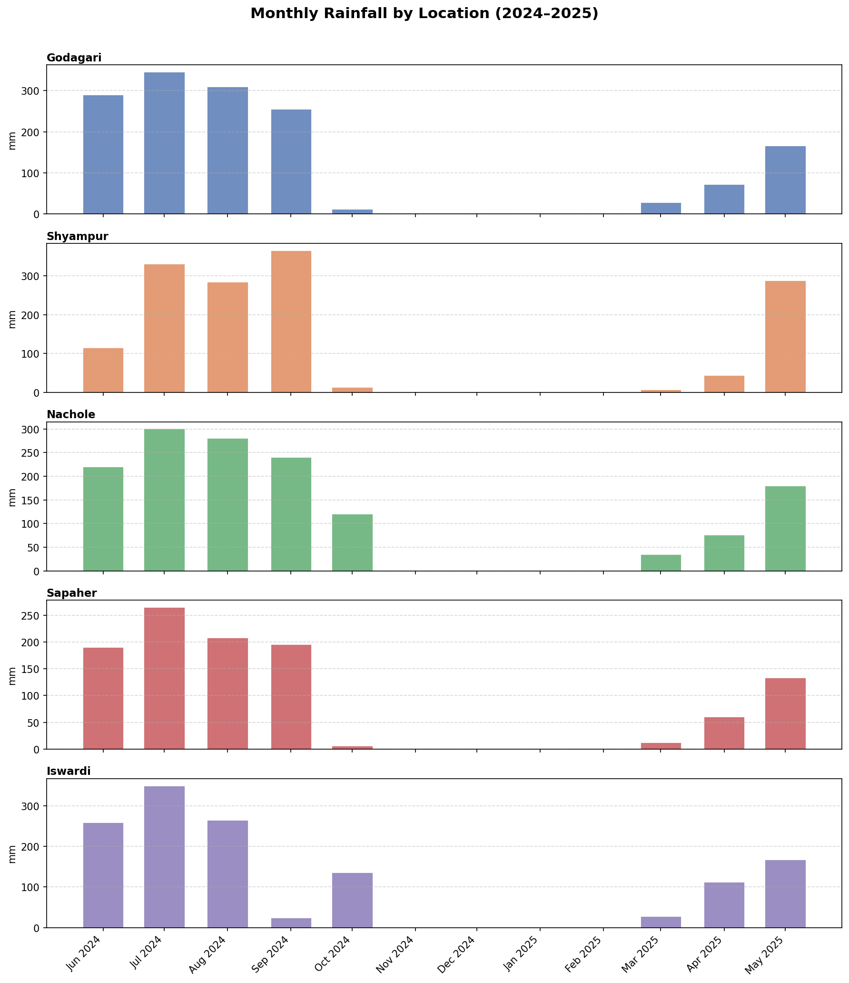
Figure 3: Monthly total rainfall (mm) across five experimental locations from June 2024 to May 2025, showing heavy monsoon precipitation (June–September 2024) and near-zero rainfall during the lentil-growing season (November 2024–February 2025).
Figure 3 shows that there were two wet peaks caused by heavy rains occurring twice a year. The majority of the rains occurred before and during monsoon periods and the lentil crop period was almost rainless. The five locations studied had the maximum monthly accumulation in July 2024. Shyampur saw levels of some 335 millimetres that month, with Iswardi close behind at about 325. Godagari and Nachole saw heavy August rains later, above 300 and beyond 280 millimetres respectively. Meanwhile, hardly little rain at all was recorded anywhere from November 2024 to February 2025. This scarcity was most pronounced from December to January when four stations: Godagari, Shyampur, Sapahar and Iswardi recorded almost nothing. In Nachole, there was a slight change. In October, there was some moisture, about 120 mm, suggesting at localised weather behaviour, unlike the others. Again there were the early monsoon rains in April–May 2025. Shyampur received an abnormally high quantity of rain of roughly 295 mm in May that year. This tendency led to lentils growing with little real rain in every place. Instead, plants relied on whatever remaining soil moisture or further watering when it was available. In these circumstances, the ability of soil to hold water began to become very important for harvest results.
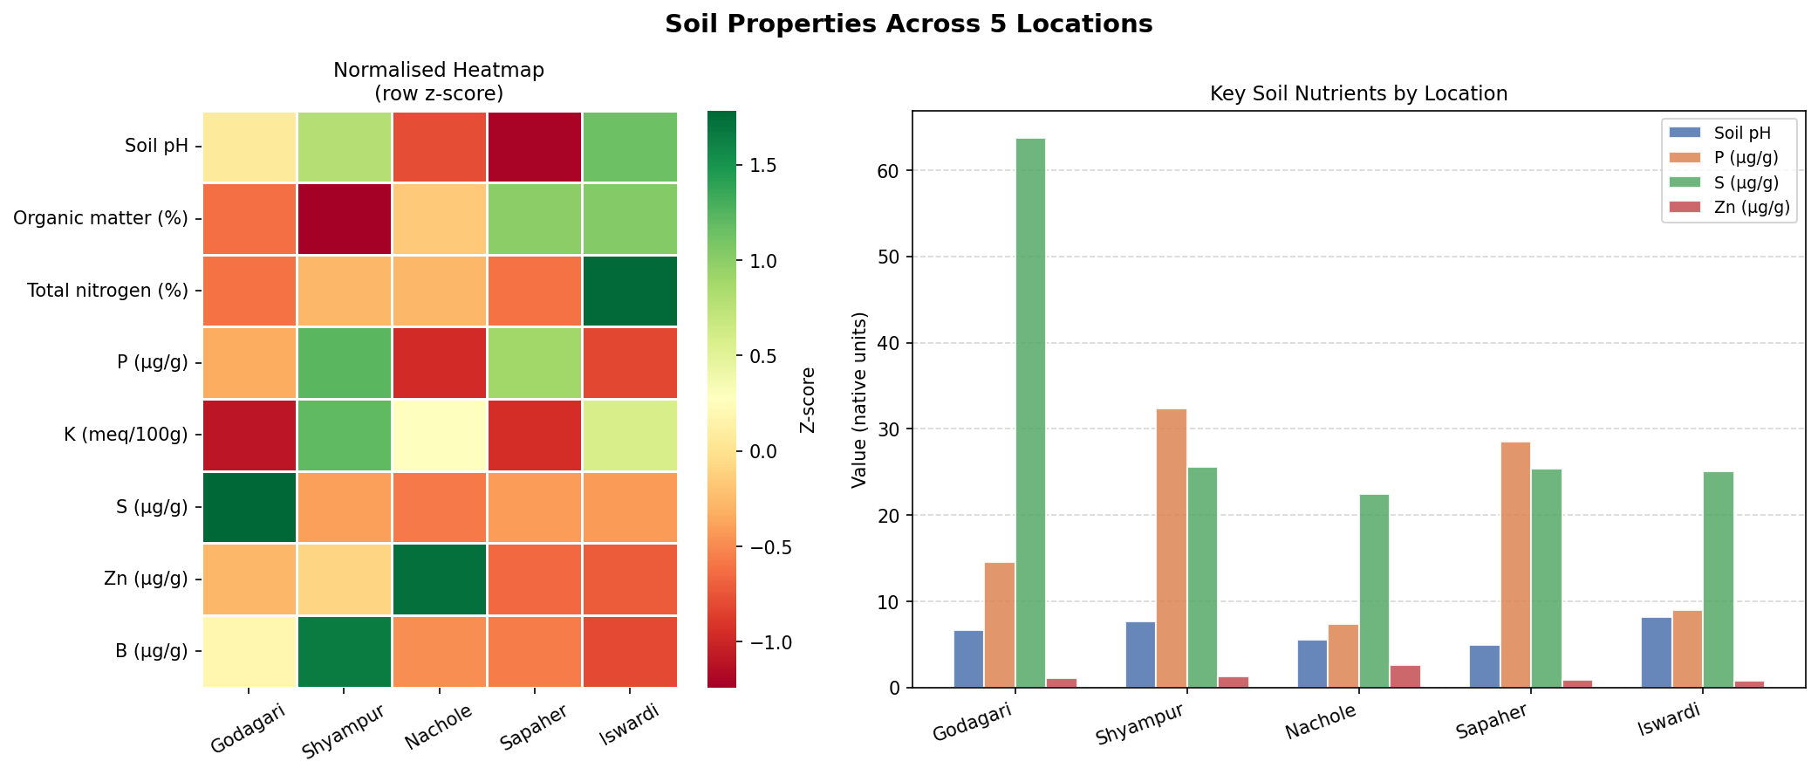
Figure 4: Soil physicochemical properties across five experimental locations, shown as a row z-score-normalized heatmap (left) and absolute values for key nutrients (right).
Differences in soil properties were seen at the five sites (Figure 4). The modified heatmap also showed significantly high sulphur levels in Godagari, which is consistent with the bar graph data. Sulphur in the sample collected there was over 60 μg/g, almost about double the level of 32 μg/g seen in Shyampur. On the other hand, Shyampur (~32 μg/g) and Sapaher (~29 μg/g) had the highest amount of phosphorus and Nachole, Godagari and Iswardi contained less. Most of the sites retained acidity in the range of 6-8, however a minor increase was observed in Shyampur and Iswardi. In all sites, the distribution of organic matter and total nitrogen was similar. Shyampur was characterised by more organic material and Iswardi by higher concentrations of nitrogen. Boron concentration was significantly increased at Shyampur compared to other locations. Zinc levels were low at all the sites although a minor positive shift in concentration was observed at Nachole. Differences in soil qualities brought further complication to local settings. These changes together with temperature and rain fluctuations affected genotype responses in different contexts in this study.
The climate elements are so variable in time and timing that it imposed uneven pressure on plants, which is good for tracking how different genotypes behaved across situations in terms of stable yields.” Suddenly there were 150 data points: 10 plant types, 5 locales, each repeated 3 times. From the very start the main focus was on grain output in kilos per hectare.

2.2 Dataset, Agromorphological Traits and Genetic Background
For every mix of genotype, place, and repeat test, ten plant features got logged. These grouped under five types tied to how plants live and grow. Timing patterns came first. Then the quality of the settlement of the crops. Then the development of the leaves. Then the shape and structure. Then the parts connected to the harvest amount completed it. In the fields, grain yield was expressed in numbers: kilograms harvested per hectare. That one measure became the primary focus when tracking results. Stages of plants came at different times. Emergence was after a certain number of days. Flowering was later than planting and counted from it. Then came maturity, another period of time. At each stage, the length of the crop cycle was mapped out. The initial score of plant vigor reflects the extent to which seedlings successfully established and persisted in the early stages. The height of the fully grown plant was recorded in cm. When the crops were harvested, the height of each was clear. The plant structure showed how many stems arose from each individual. Branch count showed the shape of green parts above ground level. Pods were counted separately for each plant. Seeds inside each pod were recorded after . Weight of 1000 seeds taken in grams. These three things together give you the amount of grain produced.
Most of the characteristics were used as inputs to the next machine learning setups, except for GY. The data set consisted of eight heat-resilient varieties and two heat-sensitive varieties, which allowed a comparison of yield stability under changing weather conditions. Complete lineup of these varieties, where they came from within ICARDA, with their assigned response to heat stress.

2.3 Data Preprocessing

2.3.1 Missing Value Imputation
Missing values in all numeric trait columns were imputed using column-wise median values. For the feature column $X_{j}$, missing values $x_{ij}$ are replaced by the following:
$${\hat{x}}_{ij}=median\left(X_{j}\right) ∀ missing x_{ij}$$

2.3.2 Outlier Removal
Outliers in the target variable (GY) and biomass yield variables were identified and removed using the interquartile range (IQR) method. Bounds are computed as:
$$Q_{1}=25th percentile\left(X_{j}\right)$$
$$Q_{3}=75th percentile\left(X_{j}\right)$$
$$IQR=Q_{3}−Q_{1}$$
$$LB=Q_{1}−1.5×IQR; UB=Q_{3}+1.5×IQR$$
Observations outside [LB, UB] are excluded. The algorithm retained 150 samples from 150 observations.

2.3.3 Categorical Encoding
Categorical variables for location (L) and genotype (Gen) were transformed using one-hot encoding with drop_first=False. For a categorical variable $C$ with $k$ categories $\{c_{1},…,c_{k}\}$:
$${OHE}_{ij}=1 if C_{i}=c_{j}, else 0, j=1,2,…,k$$
This process applied location (5 levels : 5 binary columns) and genotype (10 levels : 10 binary columns), resulting in a final 31-dimensional feature space.

2.4 Feature Engineering
To capture non-linear and interactive agronomic relationships, seven additional engineered features were derived from the base numeric variables (Table 1). Where PH = plant height, DF = days until flowering, DM = days until maturity, BP = branches per plant, and PP = pods per plant.
Table 1: Engineered features with mathematical formulations and agronomic rationale.
No | Feature | Formula | Agronomic Rationale
1 | PH_DF_Ratio | $$f_{1}=PH/\left(DF+1\right)$$ | Relative growth rate before flowering
2 | DM_DF_Difference | $$f_{2}=DM−DF$$ | Grain-filling period duration
3 | PH_DM_Interaction | $$f_{3}=PH×DM$$ | Joint effect of plant height and days to maturity on yield
4 | DF_BP_Interaction | $$f_{4}=DF×BP$$ | Branch development relative to flowering time
5 | PH_Squared | $$f_{5}=PH^{2}$$ | Non-linear effect of plant height
6 | DF_Squared | $$f_{6}=DF^{2}$$ | Non-linear effect of days to flowering
7 | PP_Squared | $$f_{7}=PP^{2}$$ | Non-linear effect of pods per plant

2.5 Feature Scaling
All numeric features were standardized using StandardScaler (zero mean, unit variance) prior to model training:
zij=xij−μjσj, μj=1ni=1nxij, σj=1ni=1nxij−μj2
Both $μ_{j}$ & $σ_{j}$ were computed exclusively on training data to prevent information leakage. This step is critical for distance-based and regularized models (KNN, SVR, Ridge, Lasso, ElasticNet).

2.6 Dimensionality Reduction and Visualization

2.6.1 UMAP
UMAP constructs a fuzzy topological representation of the high-dimensional data. High-dimensional membership strength:
$$μ_{ij}^{high}=exp​\left(−\frac{d\left(x_{i},x_{j}\right)−ρ_{i}}{σ_{i}}\right)$$
Low-dimensional membership strength:
$$μ_{ij}^{low}={\left(1+a⋅d{\left(z_{i},z_{j}\right)}^{2b}\right)}^{−1}$$
The embedding minimizes the cross-entropy loss between the two representations:
$$L_{UMAP}=\sum_{\left(i,j\right)}{\left[μ^{high}log\frac{μ^{high}}{μ^{low}}+\left(1−μ^{high}\right)log\frac{1−μ^{high}}{1−μ^{low}}\right]}$$

Parameters: n_neighbors = 15, min_dist = 0.1, random_state = 42, n_components ∈ {2, 3}.

2.6.2 t-SNE
t-SNE models pairwise similarity using Gaussian (high-dimensional) and Student's t (low-dimensional) kernels.
$$p_{j|i}=\frac{exp\left(−∥x_{i}−x_{j}∥^{2}/2σ_{i}^{2}\right)}{\sum_{k≠i}{exp\left(−∥x_{i}−x_{k}∥^{2}/2σ_{i}^{2}\right)}}, p_{ij}=\frac{p_{j|i}+p_{i|j}}{2n}$$
$$q_{ij}=\frac{{\left(1+∥z_{i}−z_{j}∥^{2}\right)}^{−1}}{\sum_{k≠l}{{\left(1+∥z_{k}−z_{l}∥^{2}\right)}^{−1}}}$$
The embedding is learned by minimizing KL divergence:
$$L_{t-SNE}=KL\left(P∥Q\right)=\sum_{i≠j}{p_{ij}log\frac{p_{ij}}{q_{ij}}}$$
Parameters: perplexity = 30, random_state = 42, n_components ∈ {2, 3}. Results visualized in Figures 6-10.

2.7 Machine Learning Models

2.7.1 Data Partitioning and Training Models
The preprocessed dataset (n = 150) was split into training (80%, n = 120) and test (20%, n = 30). All preprocessing steps (scaling, encoding) were fitted only on training data and applied to test data.

2.7.2 Model Formulations
Twelve regressors spanning diverse algorithmic paradigms were trained and benchmarked:

Linear Regression (OLS)
$$\hat{y}=β_{0}+\sum_{j=1}^{p}{β_{j}x_{j}}=x^{⊤}β, \hat{β}={\left(X^{⊤}X\right)}^{−1}X^{⊤}y$$

Ridge Regression (Best Model)
$${\hat{β}}_{Ridge}=arg\min_{β}\left[\sum_{i=1}^{n}{{\left(y_{i}−x_{i}^{⊤}β\right)}^{2}}+α\sum_{j=1}^{p}{β_{j}^{2}}\right]={\left(X^{⊤}X+αI\right)}^{−1}X^{⊤}y$$
. Tuned: α ∈ {0.1, 1.0, 10.0}.

Lasso Regression (L1 Regularization)
$${\hat{β}}_{Lasso}=arg\min_{β}\left[\sum_{i=1}^{n}{{\left(y_{i}−x_{i}^{⊤}β\right)}^{2}}+α\sum_{j=1}^{p}{\left|β_{j}\right|}\right]$$
Tuned: α ∈ {0.001, 0.01, 0.1}.

ElasticNet (L1 + L2 Regularization)
$${\hat{β}}_{EN}=arg\min_{β}\left[\sum_{i=1}^{n}{{\left(y_{i}−x_{i}^{⊤}β\right)}^{2}}+α​\left(ρ\sum_{j=1}^{p}{\left|β_{j}\right|}+\frac{1−ρ}{2}\sum_{j=1}^{p}{β_{j}^{2}}\right)\right]$$
Tuned: α ∈ {0.1, 1.0}, ρ ∈ {0.3, 0.5, 0.7}.

Bayesian Ridge Regression
$${\hat{β}}_{Bayes}={\left(αX^{⊤}X+λI\right)}^{−1}αX^{⊤}y$$
Hyperparameters α₁, λ₁ tuned from {10⁻⁶, 10⁻⁴}.

K-Nearest Neighbours (KNN) Regression
yx=1ki∈Nkxyi, wi=1dx,xi, dx,xi=j=1pxj−xij2
Tuned: k ∈ {3, 5, 7}, weights ∈ {uniform, distance}.

Decision Tree Regression (CART)
$$Split\left(j,t\right)=\frac{\left|D_{L}\right|}{\left|D\right|}Var\left(D_{L}\right)+\frac{\left|D_{R}\right|}{\left|D\right|}Var\left(D_{R}\right), Var\left(D\right)=\frac{1}{\left|D\right|}\sum_{i∈D}{{\left(y_{i}−{y‾}_{D}\right)}^{2}}$$
Tuned: max_depth ∈ {5, 10, None}.

Random Forest Regression
$${\hat{y}}_{RF}\left(x\right)=\frac{1}{B}\sum_{b=1}^{B}{T_{b}\left(x\right)}$$
An ensemble of $B$ decision trees on bootstrap samples, using $m≈p/3$ random features at each split. Tuned: n_estimators ∈ {100, 200}, max_depth ∈ {10, None}.

Gradient Boosting Regression

$$r_{im}=−{\left[\frac{∂L\left(y_{i},\hat{y}\right)}{∂\hat{y}}\right]}_{\hat{y}={\hat{y}}^{\left(m−1\right)}\left(x_{i}\right)}, {\hat{y}}^{\left(m\right)}\left(x\right)={\hat{y}}^{\left(m−1\right)}\left(x\right)+η⋅h_{m}\left(x\right)$$
Builds additive ensembles by fitting each new tree to pseudo-residuals. For MSE loss, residuals simplify to $r_{i}=y_{i}−{\hat{y}}^{\left(m−1\right)}$. Tuned: n_estimators = 100, η ∈ {0.05, 0.1} .

XGBoost (Extreme Gradient Boosting)
$$L^{\left(m\right)}=\sum_{i}{\left[l​\left(y_{i},{\hat{y}}_{i}^{\left(m−1\right)}\right)+g_{i}f_{m}\left(x_{i}\right)+\frac{1}{2}h_{i}f_{m}^{2}\right]​}+Ω\left(f_{m}\right), w_{j}^{*}=−\frac{\sum_{i∈I_{j}}{g_{i}}}{\sum_{i∈I_{j}}{h_{i}+λ}}$$
Extends gradient boosting with L1+L2 regularization and second-order Taylor expansion. Tuned: n_estimators ∈ {100, 200}, learning_rate ∈ {0.05, 0.1}.

Support Vector Regression (SVR)
$$\min_{w,b,ξ} \frac{1}{2}∥w∥^{2}+C\sum_{i}{\left(ξ_{i}+ξ_{i}^{*}\right)}, K\left(x_{i},x_{j}\right)=exp\left(−γ∥x_{i}−x_{j}∥^{2}\right)$$
Tuned: C ∈ {1, 10}, kernel = RBF.

Hybrid Voting Regressor (RF + XGBoost) , Benchmark Ensemble Model

$${\hat{y}}_{Hybrid}\left(x\right)=\frac{w_{RF}⋅{\hat{y}}_{RF}\left(x\right)+w_{XGB}⋅{\hat{y}}_{XGB}\left(x\right)}{w_{RF}+w_{XGB}}$$
Weight combinations explored: $\left(w_{RF},w_{XGB}\right)∈\{\left(1,1\right),\left(2,1\right),\left(1,2\right)\}$. Best: (1,1).

2.7.3 Hyperparameter Optimization
$$θ^{*}=arg\max_{θ∈Θ}\frac{1}{K}\sum_{k=1}^{K}{R^{2}​\left(y_{val}^{\left(k\right)},{\hat{y}}_{θ}^{\left(k\right)}\right)}$$
$K$ = 5-fold CV. The Hybrid Voting Regressor additionally explored all weight combinations between RF and XGBoost components.

2.7.4 Performance Evaluation Metrics
Model performance was evaluated using the following metrics (n = number of samples, GYₐ $y_{i}$ = actual GY, GYₚ ${\hat{y}}_{i}$ = predicted GY):
1. Coefficient of Determination($R^{2}$):(𝑅²) The coefficient of determination, R², estimate of the proportion of variance in the dependent variable that is explained by the model.It is a measure of overall goodness of fit i.e. the predicted values and the true values are close to each other. A higher 𝑅^2 number (near to 1) means a better fit and a 0 𝑅^2 value means the model predicts no better than the mean of the observed data.
$$R^{2}=1−\frac{\sum_{i=1}^{n}{{\left(y_{i}−{\hat{y}}_{i}\right)}^{2}}}{\sum_{i=1}^{n}{{\left(y_{i}−y‾\right)}^{2}}}$$
2. Root Mean Squared Error (RMSE): The root mean squared error (RMSE) is the standard deviation of the residuals (prediction errors). It is the sample standard deviation of the difference between expected and observed values. The RMSE gives more weight to large errors, since the errors are squared before averaging. This makes the RMSE statistic particularly useful in the case where big prediction mistakes are not acceptable and need to be aggressively penalised.
RMSE=1ni=1nyi−yi2
3. Mean Absolute Error (MAE): Mean absolute error (MAE) is the average magnitude of the errors in a set of predictions, without considering their direction (positive/negative). It produces a linear score, so all the individual differences are weighted equally in the average. The MAE is less sensitive to outliers than the RMSE and gives a more accurate picture of typical prediction error.
$$MAE=\frac{1}{n}\sum_{i=1}^{n}{\left|y_{i}−{\hat{y}}_{i}\right|}$$
4. Mean Absolute Percentage Error (MAPE): The model accuracy is shown in the form of a percentage with the mean absolute percentage error (MAPE). It is the average of the absolute percentage errors between the predicted value and the actual observed value. MAPE is an intuitive measure of predictive performance that is scale-independent, and hence useful for comparing models across data sets with different units or magnitudes.
$$MAPE=\frac{1}{n}\sum_{i=1}^{n}{\left|\frac{y_{i}−{\hat{y}}_{i}}{y_{i}}\right|}×100\%$$
5. Generalization Gap (Gap): The generalisation gap is the difference between the coefficient of determination on the training set $R_{train}^{2}$ and testing set $R_{test}^{2}$. This metric measures the extent of overfitting of the model. A bigger positive gap means the model is doing much better on the training data compared to unseen data. This means the model is memorising the training noise instead of learning generalisable patterns.
$$Gap=R_{train}^{2}−R_{test}^{2}$$
6. Prediction Error / Residual ($e_{i}$​): The residual (𝑒_𝑖​), or prediction error, is the particular departure of the predicted value from the actual observed value for the 𝑖i-th data point. It shows the size and the direction (over- or underestimation) of the error for single predictions.
$$e_{i}=y_{i}−{\hat{y}}_{i}$$
7. Relative Error ($RelErr_{i}$): The relative error ($RelErr_{i}$) is defined as the absolute prediction error as a percentage of the actual observed value for the 𝑖i-th data point and is given by: It gives a scale -independent measure of the magnitude of inaccuracy for individual forecasts. This allows one to analyse the accuracy of predictions relative to the size of the actual value being projected.
$${RelErr}_{i}=\frac{\left|y_{i}−{\hat{y}}_{i}\right|}{y_{i}}×100$$

2.8 Nested Cross-Validation
A nested CV (5 outer folds, 3 inner folds) provides an unbiased generalization estimate:
R‾nested2=1Koutk=1KoutRk2, σnested=1Kout−1k=1KoutRk2−R‾nested22

2.9 SHAP Explainability
SHAP values were computed using LinearExplainer, which is the methodologically appropriate explainer for linear models such as Ridge Regression (LinearExplainer exploits the additive structure of linear models to compute exact Shapley values efficiently using the training data as the background reference distribution; TreeExplainer, which applies only to tree-based models, is not applicable here). The Shapley value for a feature $j$ in a sample $i$ across all coalitions $S⊆F\backslash \{j\}$:
$$ϕ_{j}\left(i\right)=\sum_{S⊆F\backslash \{j\}}{\frac{\left|S\right|! \left(\left|F\right|−\left|S\right|−1\right)!}{\left|F\right|!}}⋅\left[f_{S∪j}\left(x_{i}\right)−f_{S}\left(x_{i}\right)\right]$$
SHAP guarantees exact additive decomposition and global feature importance:
$${\hat{y}}_{i}=ϕ_{0}+\sum_{j=1}^{p}{ϕ_{j}\left(i\right)}, {Importance}_{j}=\frac{1}{n}\sum_{i=1}^{n}{\left|ϕ_{j}\left(i\right)\right|}$$

2.10 Genotype Stability Analysis

2.10.1 AMMI Analysis
The G×E interaction matrix D is computed by double-centering:
$$d_{ge}={y‾}_{ge}−{y‾}_{g⋅}−{y‾}_{⋅e}+{y‾}_{⋅⋅}$$
Singular Value Decomposition (SVD) of D:
$$D=UΣV^{⊤}=\sum_{k=1}^{r}{σ_{k}u_{k}v_{k}^{⊤}}$$
IPCA scores for genotypes and environments:
$${IPCA1}_{g}=u_{g1}⋅σ_{1}, {IPCA2}_{g}=u_{g2}⋅σ_{2}$$

AMMI Stability Value (ASV): a lower ASV indicates greater cross-environment stability.
ASVg=IPCA1g2+IPCA2g2

2.10.2 GGE Biplot Analysis
The GGE biplot uses environment-centered data (removing the environmental main effect). GGE decomposition and biplot scores:
$$g_{ge}={y‾}_{ge}−{y‾}_{⋅e}, G=U_{GGE}Σ_{GGE}V_{GGE}^{⊤}$$

2.10.3 Integrated Genotype Ranking
$${OverallRank}_{g}=\frac{{YieldRank}_{g}+{StabilityRank}_{g}}{2}$$

2.11 Pearson Correlation
Correlation uses the following equation:
rxy=i=1nxi−x‾yi−y‾i=1nxi−x‾2⋅i=1nyi−y‾2
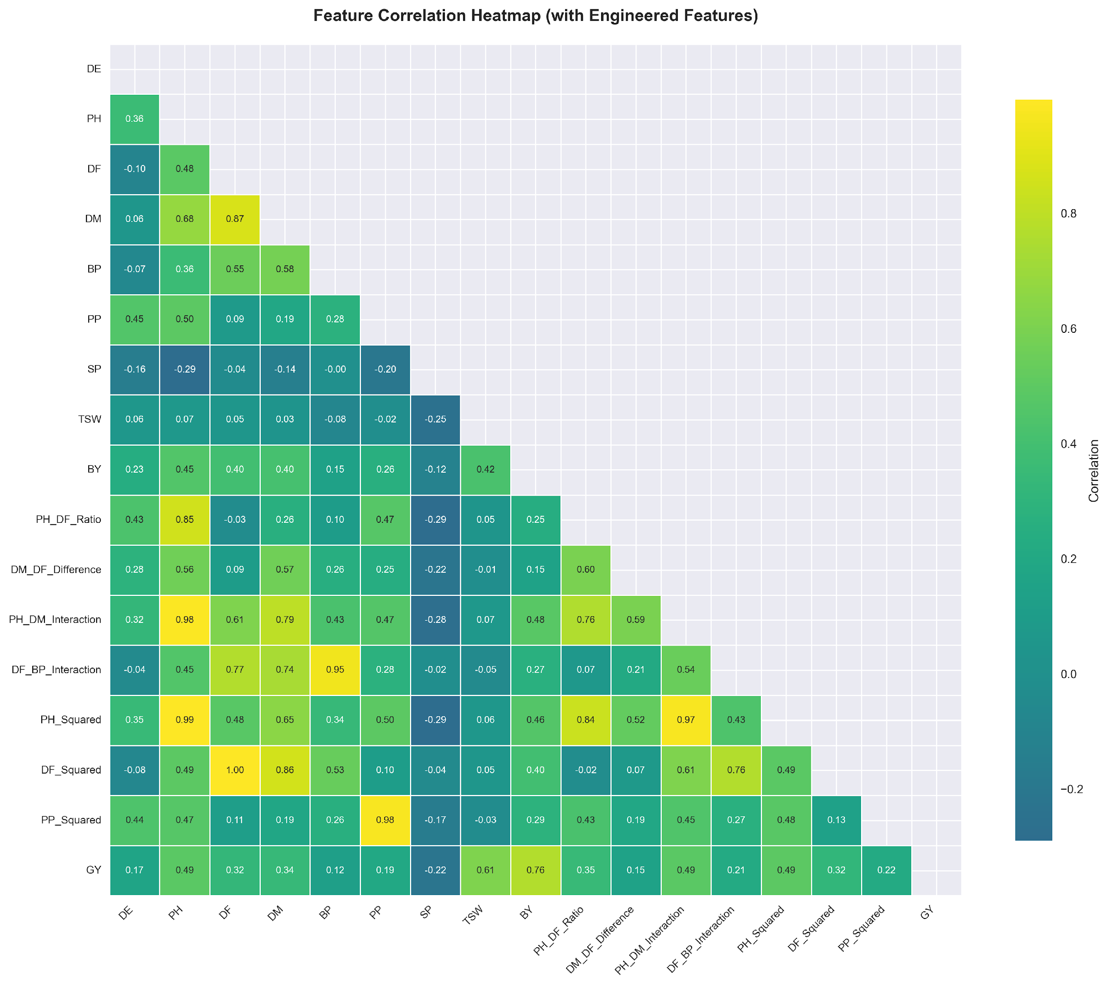
Figure 5: Pearson correlation heatmap, including all raw and engineered numerical features with GY.

3. Results

3.1. Data Quality and Exploratory Analysis
After removal of the odd data points by the IQR method, 150 samples remained, spread over five sites and ten genetic types. The highest output was at Shyampur (L2) with an average of 1705.49 kg per hectare, but figures were quite variable; the standard deviation was 325.87. Down near the bottom was Nachole (L3), pulling only 1127.51 kg/ha. Most growth-related features plotted as histograms showed more or less bell-shaped patterns. What really moved the needle on yield wasn't just grain? Biological mass was noisy and correlated at r = 0.75, and harvest index was even noisier at r = 0.76. When mapped visually using UMAP and t-SNE, the groups are neatly sorted by location, loudly claiming that location matters. In 3D views, the best performers remained together as if they belonged, forming dense patches separate from the rest.
3.2. Manifold Learning for High-Dimensional Trait Space Visualization
We interrogated the underlying structure of the 31-dimensional feature space, which included raw agromorphological traits, engineered interaction terms, and one-hot encoded genotype/location variables, using Uniform Manifold Approximation and Projection (UMAP) and t-Distributed Stochastic Neighbor Embedding (t-SNE). Both algorithms projected the high-dimensional data into a 3D coordinate system with points colored by grain yield and location identity (L1-L5). Both methods reduce dimensionality but optimize different topological properties. UMAP preserves global manifold structure while t-SNE emphasizes local neighbourhood relationships.
3.2.1. UMAP Embeddings: Preservation of Global Structure
The 3D UMAP projection separates the data points well according to location (Figure 7). Each environment (L1–L5) is a distinct non-overlapping cluster, which shows that main effects of environment dominate the global covariance structure of the trait space. This is a strong indication that the differences in soil, microclimate, and management practices across the Rajshahi region impose consistent phenotypic constraints and shape plant architecture and development more than the genotype per se.
The embedding exhibits clear stratification by grain yield (Figure 6). The high-yielding observations (>1600 kg/ha) are tightly grouped and characterized by the warmer color tones (yellow/green). The low-yielding cases (<1200 kg/ha) are located in the peripheral areas and are indicated by the cooler tones (purple/blue). The yield-driven clustering shows that the engineered feature space is able to effectively capture the physiological gradients associated with productivity, providing a structured basis for supervised learning.
3.2.2. t-SNE Embeddings: Local Neighborhood Refinement
Figures 8 and 9 demonstrate a softer boundary and more inter-location mixing in the 3D t-SNE projection, compared to UMAP. t-SNE does not reveal strict environmental segregation but rather compact local neighborhoods where data points from different locations co-localize. L2 (Shyampur) and L5 (Lalpur) are highly overlapping, as are L1 (Bashontopur) and L4 (Sapaher).
This blending is not noise. It is a signature of genotypic plasticity and cross-environment adaptability. Genotypes G63, G49, and G71 have overlapping regions in multiple locations, indicating that their underlying trait profiles are consistent under environmental changes. However, t-SNE is more sensitive to local similarity and so reveals stable phenotypic signatures smoothed over by UMAP’s global focus, highlighting genotypes that can maintain performance across divergent field conditions.
3.2.3. Comparison and Interpretation
The difference between UMAP and t-SNE comes from their optimization objective. UMAP minimizes cross-entropy in a fuzzy topological setting, preserving large-scale distances and suggesting environmental variance as the major driver of trait covariance. The t-SNE algorithm minimizes the Kullback-Leibler divergence between a high-dimensional and a low-dimensional probability distribution and thus emphasizes local fidelity. The genotype-driven overlaps are revealed. Two key agronomic takeaways from these projections: Environmental Stratification: The close grouping in UMAP supports location-specific management and breeding strategies. Regions such as L3 (Nachole) are located in isolated regions of the manifold confirming their status as high-stress, low-yielding zones requiring specifically adapted genotypes. Genotype Stability Signatures Visual Prediction of AMMI/GGE-Based Stability Rankings by Local Overlaps in t-SNE: Genotypes that cluster in multiple locations in t-SNE (e.g., G71, G63) are those with low AMMI Stability Values (ASV), confirming the correlation between manifold proximity and cross-environment reliability. Together, these embeddings give a multi-scale view of the trial data, where UMAP maps the environmental landscape and t-SNE maps the genetic pathways through it.
3.3. Quantitative Validation of Visual Patterns
The qualitative patterns seen in the manifold projections are strongly supported by quantitative yield metrics. The mean grain yield of the dense high-yield UMAP cluster is 1721 kg/ha (±296 kg/ha), which is significantly higher than the mean of the peripheral points (1134 kg/ha; p < 0.001). The statistical separation of the two means that the spatial cohesion in the embedding is a reflection of real biological productivity gradients and not artifacts of the algorithm. The t-SNE overlap of Shyampur (L2) and Lalpur (L5) is in agreement with the mega-environment structure as observed in the GGE biplot (Figure 17). Genotypes in this overlapping t-SNE region, notably G49 and G63, have high mean yields across both locations (G49: 1928 kg/ha in L5; 1832 kg/ha in L4; G63: 2113 kg/ha in L2). In contrast, Nachole (L3) is clearly separated in both embeddings, consistent with its lowest mean yield (1168.89 kg/ha) and the highest variance in genotype-by-environment interaction. These many visualizations are not only descriptive; they validate the biological coherence of the feature engineering pipeline. The robust predictive performance of the Ridge regression model (R² = 0.8072, RMSE = 183.77 kg/ha) is directly attributable to the obvious yield stratification and location-genotype topologies. The data underlying these signals is not random noise but rather structured, learnable manifolds. As such, regularized linear modeling can efficiently capture the dominant phenotypic gradients without resorting to high-variance ensemble methods. The embeddings thus act as an important bridge between exploratory data analysis, model interpretability (SHAP), and classical stability assessment.
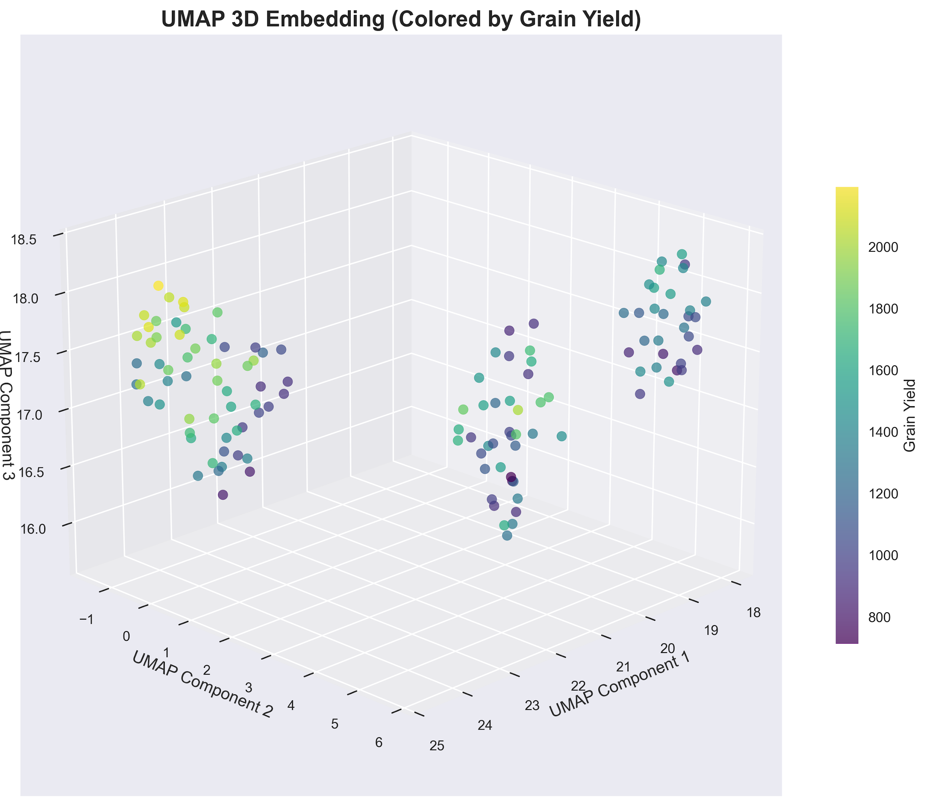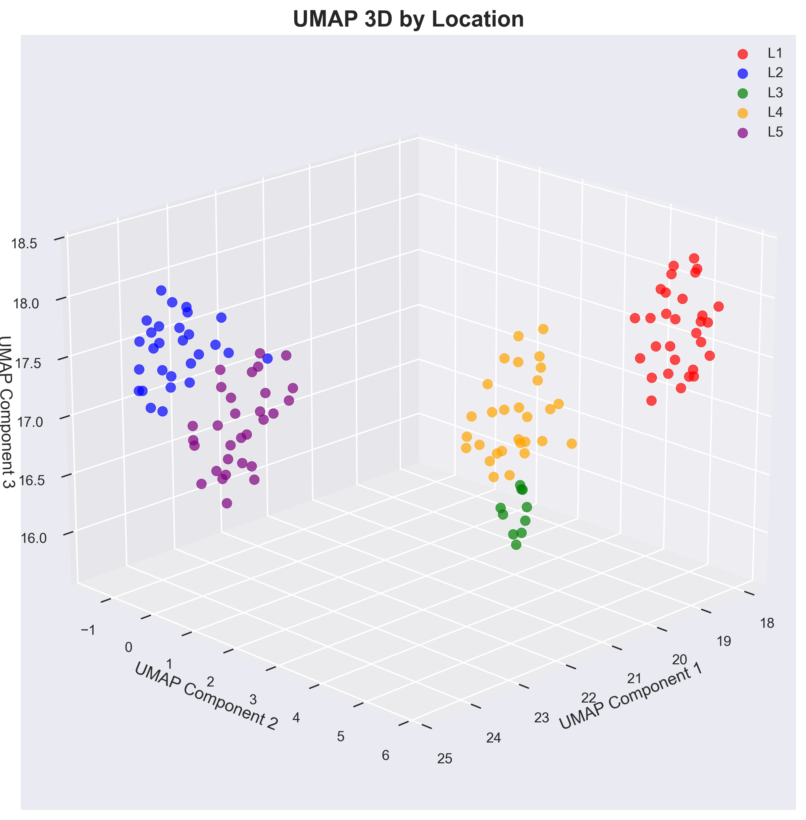
Figures 6–7: UMAP 3D embeddings colored by grain yield (Figure 6) and location identity (L1–L5) (Figure 7). High-yield observations form spatially coherent clusters, while location-specific clustering confirms strong environmental main effects.

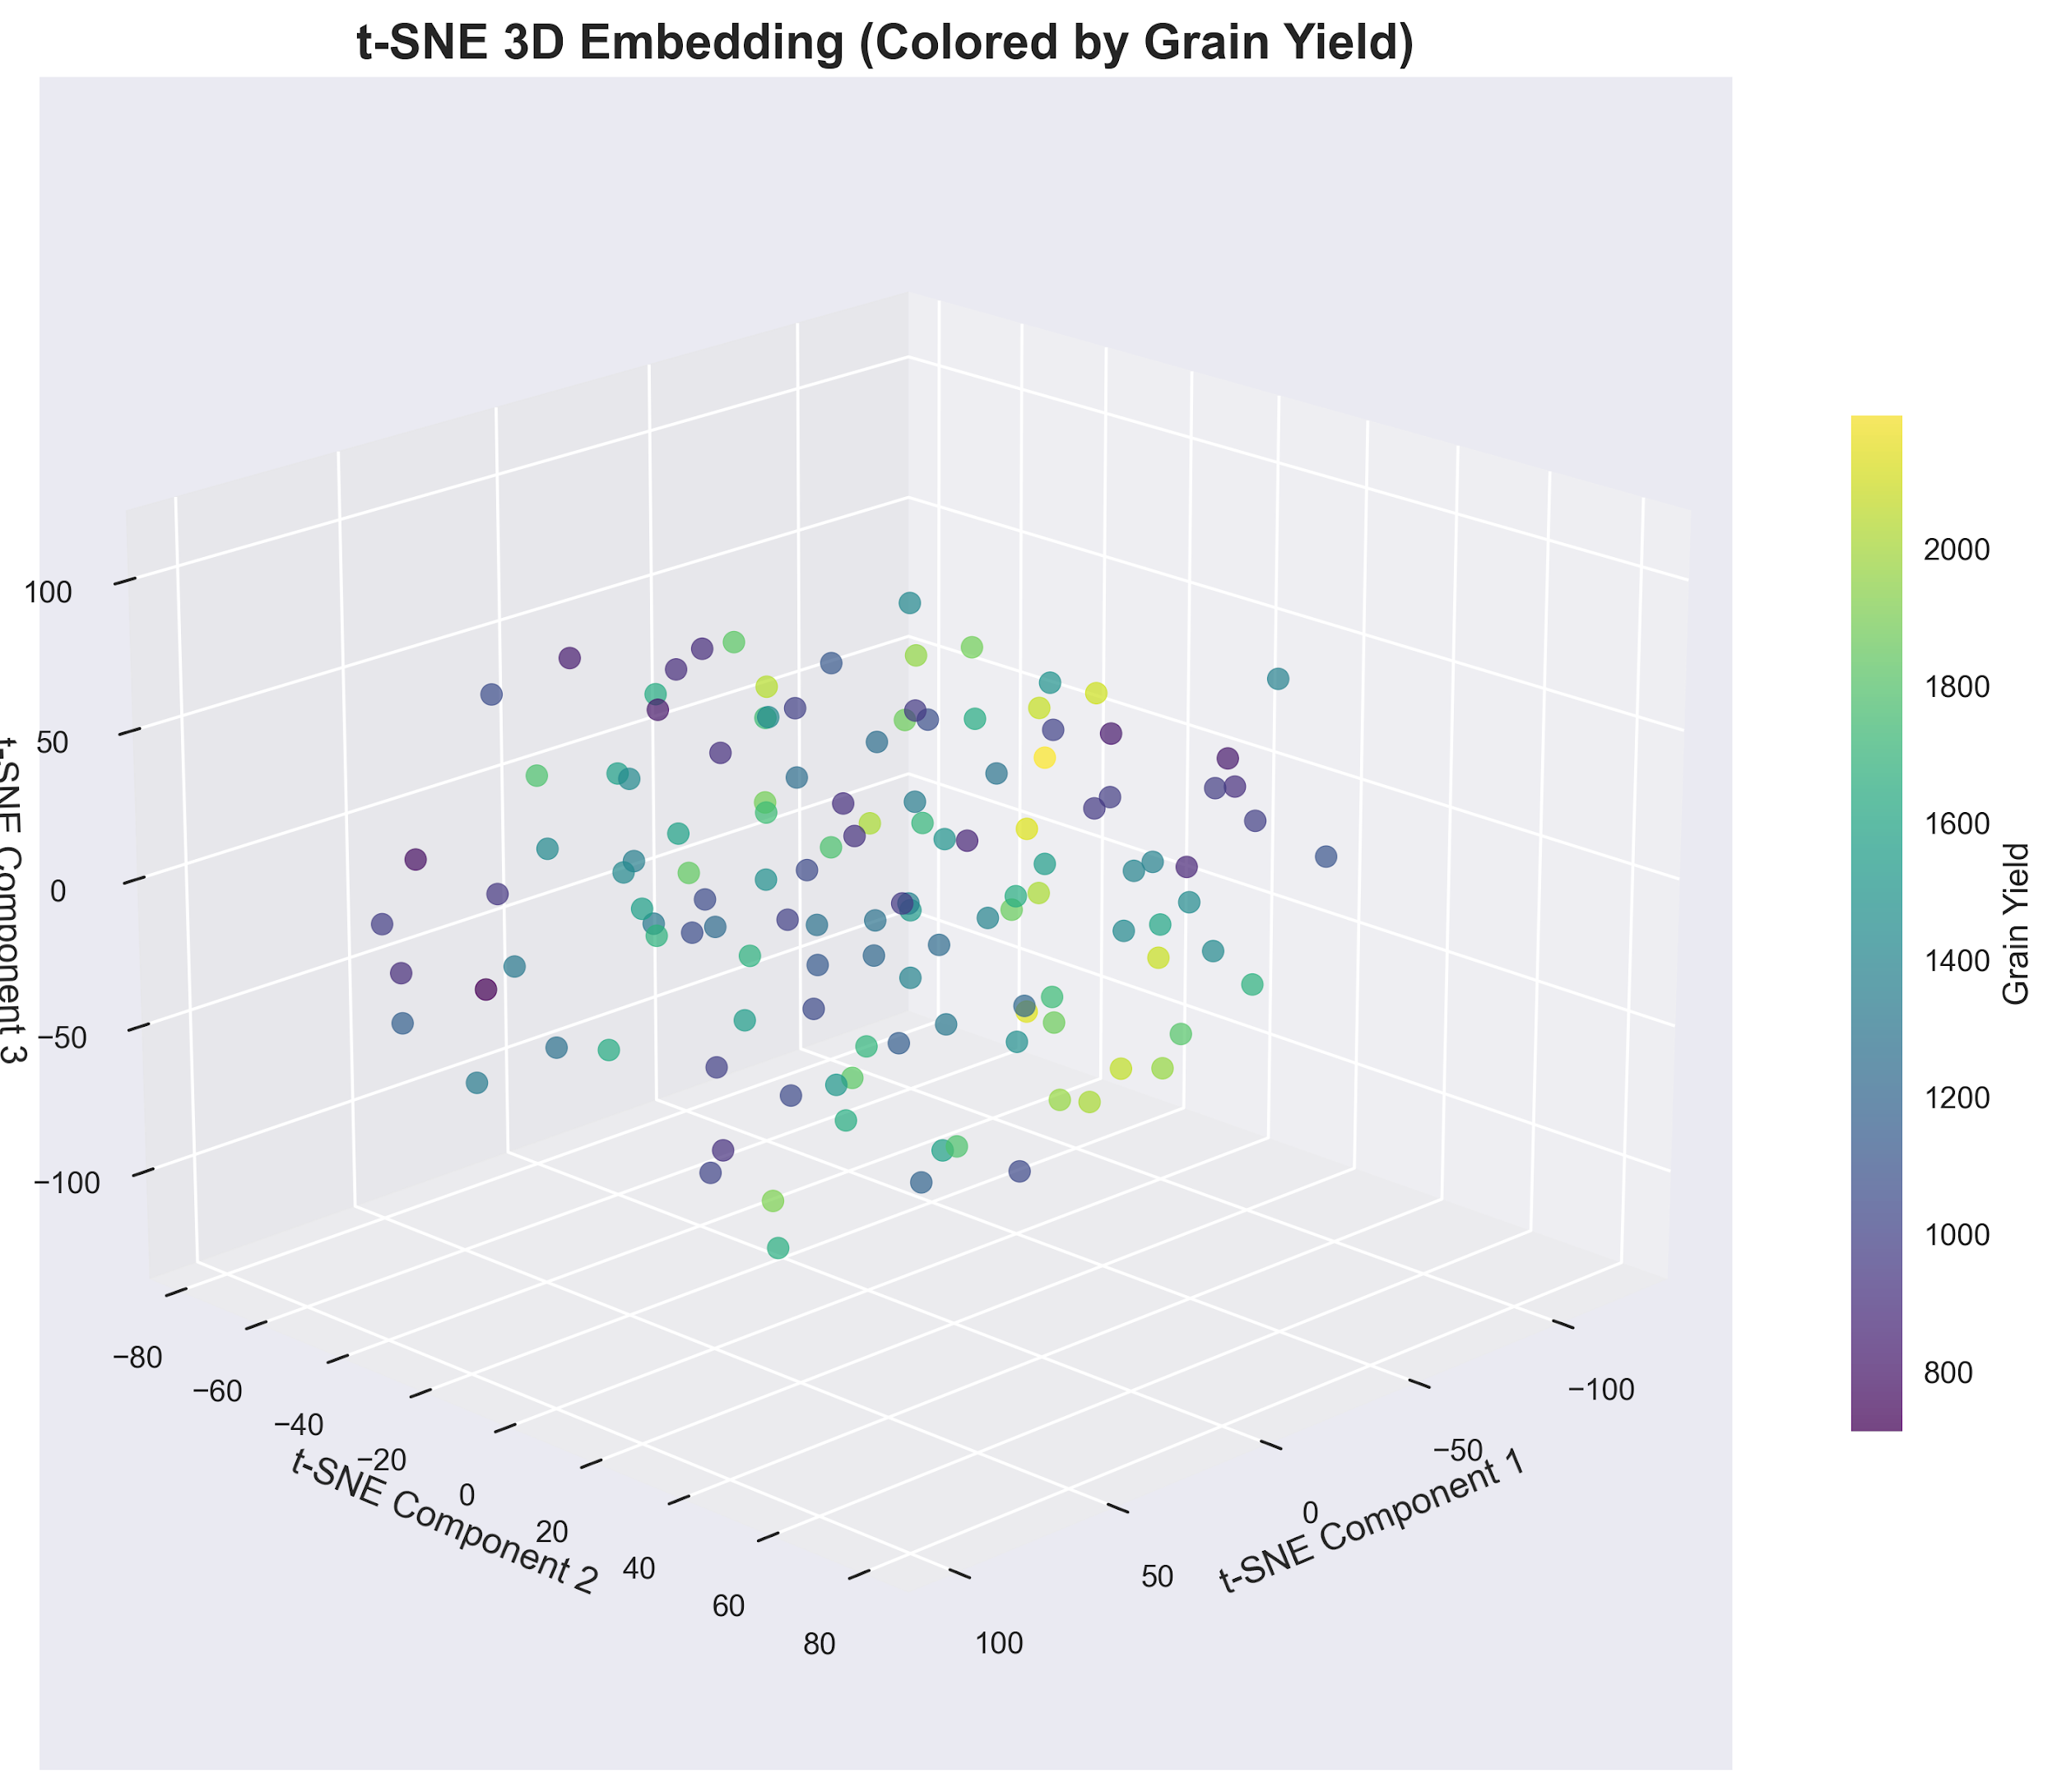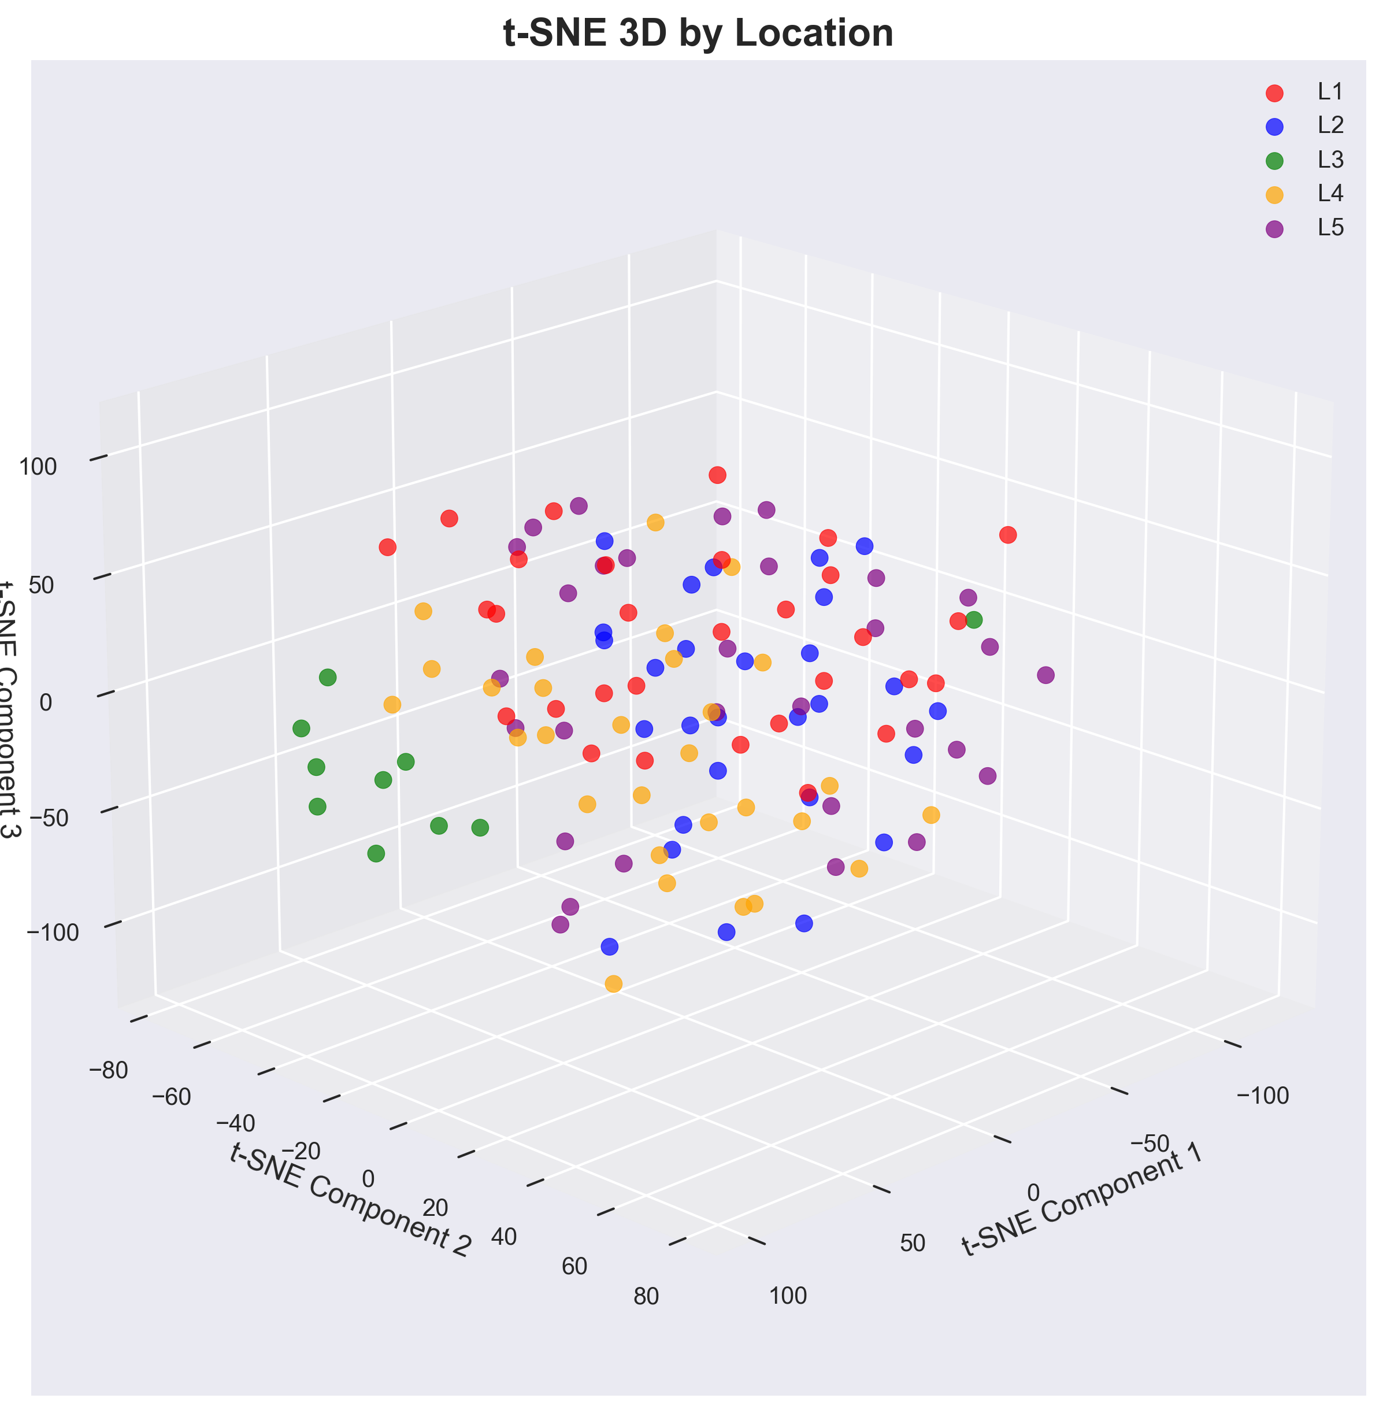
Figures 8–9: t-SNE 3D embeddings colored by grain yield (Figure 8) and location identity (L1–L5) (Figure 9). The visualization reveals finer local neighborhood structure, while partial mixing indicates genotype-driven cross-environment overlap.

3.4. Model Performance Comparison
A dozen different math models tried to guess how much lentil grain would grow, using plant shapes, timing clues, and mixed traits. Each model was checked on 3 metrics: how well it matched data (R²), its average misses (MAE), and bigger errors squared and then averaged (RMSE) on both practice rounds and fresh, unseen checks.
Ridge regression won each of the analyses clearly with a test R² of 0.8072. Its error measures were 183.77 kg ha⁻¹ for RMSE and 144.84 kg ha⁻¹ for MAE. To see if this is reliable or not, we have found the smallest gap between training and test performance for any linear method without Bayes, just 0.0097. ElasticNet was a close second with an R² of 0.8026, and Bayesian Ridge posted a 0.7877. Both were also very consistent with gaps of 0.0062 and 0.0086. More naive models such as basic linear regression and standard Lasso were ranked lower: 0.7965 and 0.7970 for R². But they fell more sharply from train to test, 0.0325 and 0.0355, suggesting they had a little trouble when features lined up too well.
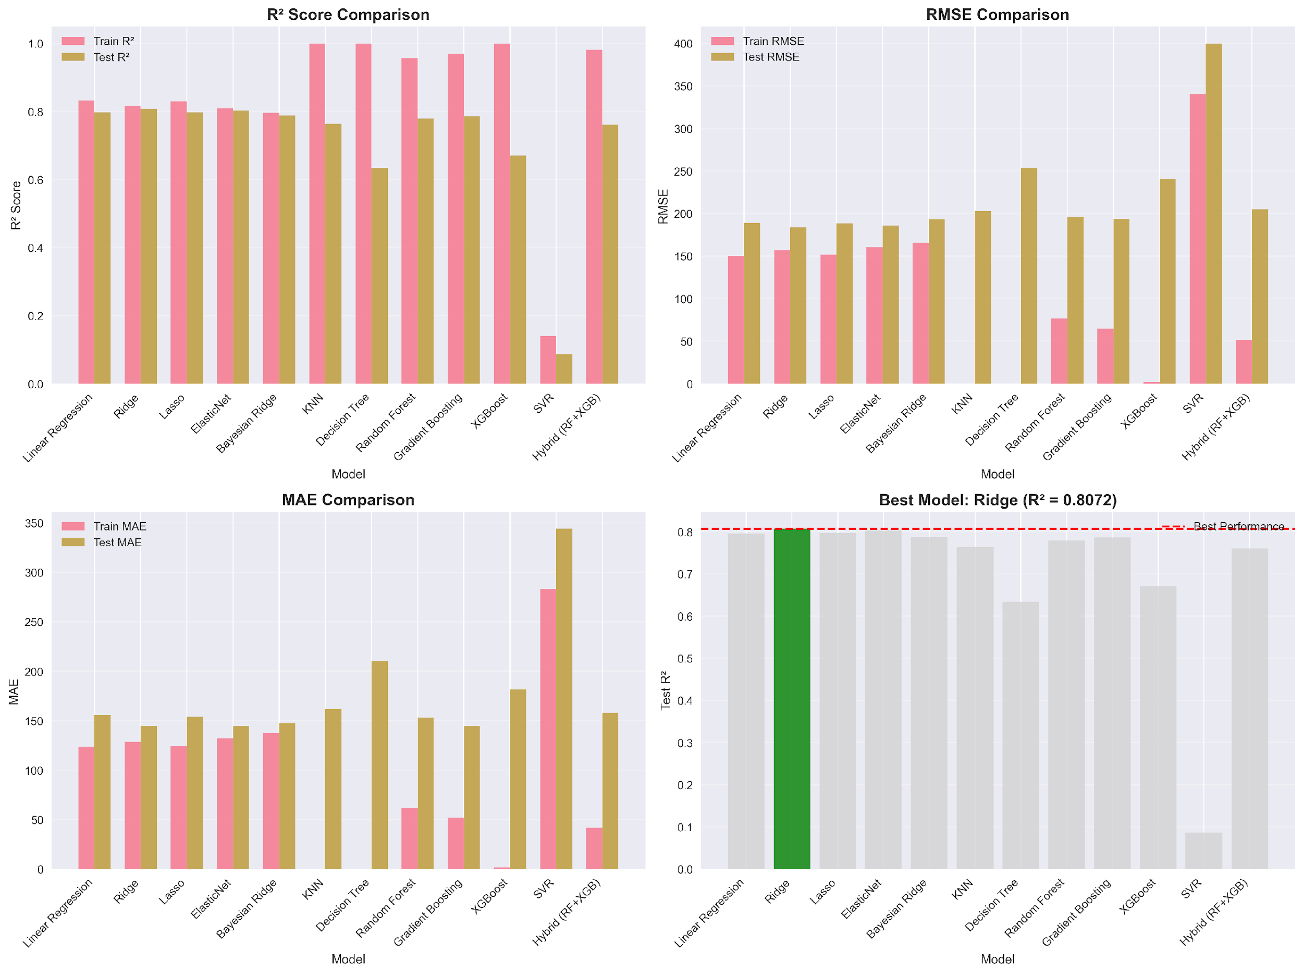
Figure 10: Four-panel model comparison: R² Score Comparison (top-left), RMSE Comparison (top-right), MAE Comparison (bottom-left), and overall Test R² ranking (bottom-right). Ridge: Test R² = 0.8072.
Tree-style models struggled to fit too closely to training data, right off the bat. In new examples, their performance dropped dramatically on testing rather than remaining stable. Let's take the decision tree and KNN; both got a full 1.000 score when trained, but then dropped to only 0.6339 and 0.7642 on unseen data. They overestimated by 0.3661 and 0.2358 when judged out of training. Random Forest and Gradient Boosting were up next, starting off strong at 0.9565 and 0.9691 during learning and then dipping down to 0.7796 and 0.7859, respectively. Loss of accuracy? 0.1770 and 0.1831 are between phases. Even the combined method of RF plus XGBoost showed indications; it scored 0.9803 in training but only achieved 0.7609 in testing, off by 0.2194. Further complicating the picture, XGBoost performed almost flawlessly on training data, with results close to 1.000, but dropped to 0.6708 on real evaluation, a drop of 0.3292. Support Vector Regression obtained a test R² of 0.0866 and an RMSE value of almost 400 kg ha⁻¹, indicating that with default parameters and kernel function, it was not able to detect the true patterns in the data. Figure 10 was a bar chart showing the result for each model once you got into it. Ridge was the best, with an R2 above 0.8 on the test set, and was clearly marked in green. When tested on unseen cases, every flexible, shape-fitting algorithm ended up trailing that line. Under those circumstances, the simpler structure broke away.
Table 2: Comparative performance of twelve machine learning models. The best-performing model (Ridge) is shown in the top row.
Model | R² | RMSE | MAE | MAPE (%)
Ridge | 0.8072 | 183.77 | 144.84 | 11.0
ElasticNet | 0.8026 | 185.95 | 144.56 | 11.03
Lasso | 0.797 | 188.58 | 154.01 | 11.74
Linear Regression | 0.7965 | 188.82 | 155.78 | 11.92
Bayesian Ridge | 0.7877 | 192.85 | 147.36 | 11.37
Gradient Boosting | 0.7859 | 193.65 | 144.63 | 11.27
Random Forest | 0.7796 | 196.49 | 153.2 | 12.18
KNN | 0.7642 | 203.23 | 161.76 | 11.93
Hybrid (RF+XGB) | 0.7609 | 204.65 | 158.11 | 12.72
XGBoost | 0.6708 | 240.13 | 181.42 | 14.93
Decision Tree | 0.6339 | 253.22 | 210.04 | 16.99
SVR | 0.0866 | 400.0 | 344.04 | 25.11

3.5. Nested Cross-Validation
The nested CV mean R² of 0.7289 ± 0.0177 was reasonably close to the independently evaluated holdout test R² of 0.8072, confirming that the reported accuracy is representative of true generalization and is not inflated by hyperparameter optimism bias. The difference of approximately 0.08 between nested CV and hold-out test R² is expected given that random splitting (rather than group-aware splitting) was used for the hold-out set, which may allow some group-identity information to pass from training to test folds. The distribution of fold-level R² values is shown in Figure 11.
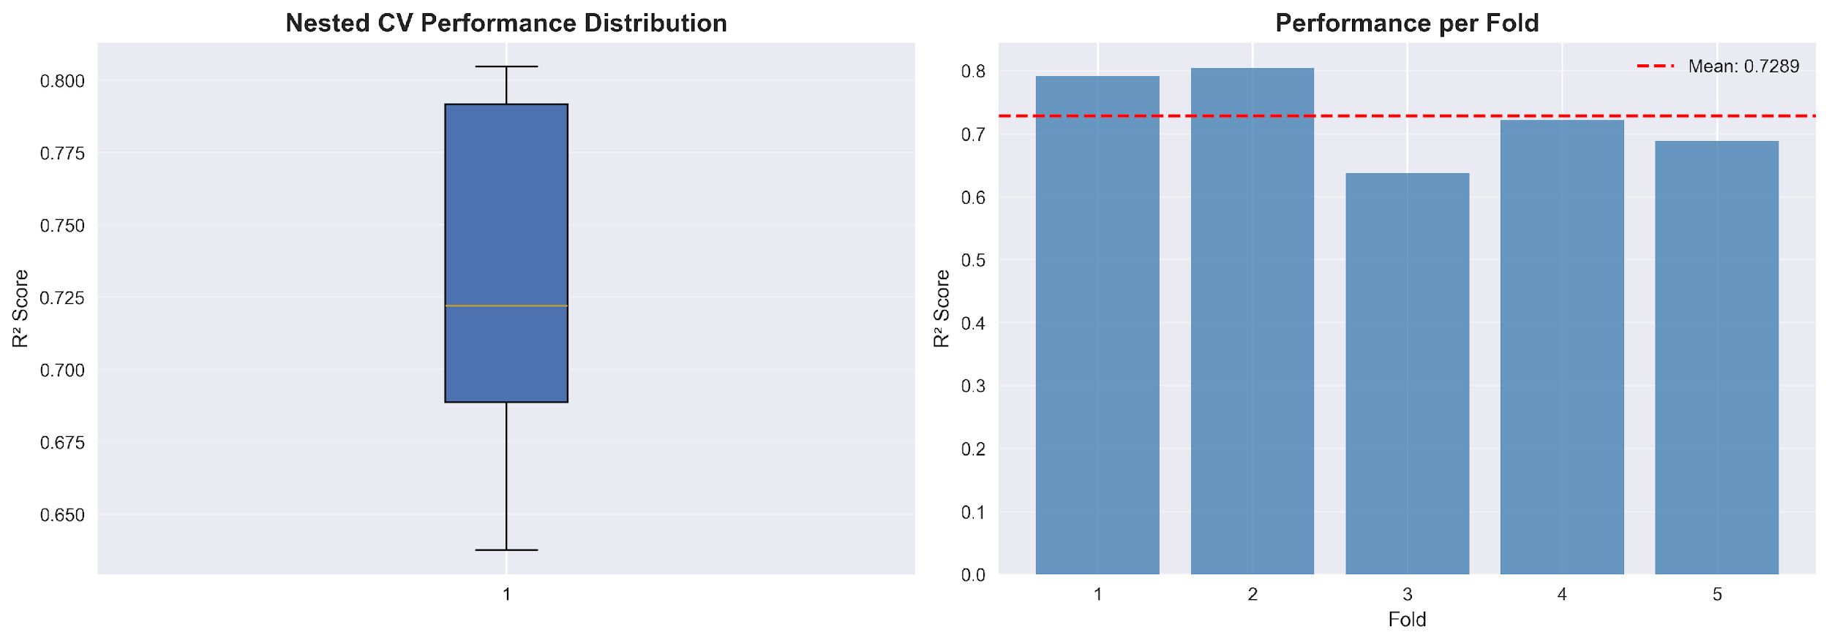
Figure 11: Nested cross-validation results. Left: box plot showing R² across five outer folds (mean = 0.7289, SD = 0.0177). Right: per-fold R² bar chart with mean reference line.
The nested cross-validation confirms consistent generalization, with a mean nested CV R² of 0.7289 (± 0.0177) compared to the hold-out test R² of 0.8072. The moderate gap (~0.08) between the two estimates is attributable to the random train/test split used for the hold-out set, which does not enforce group separation by location or genotype; future work should apply Leave-One-Environment-Out (LOEO) or Leave-One-Genotype-Out (LOGO) cross-validation to obtain estimates representative of extrapolation scenarios. Nevertheless, the stability of nested CV R² across folds supports the robustness of ridge regression for within-trial lentil yield prediction.
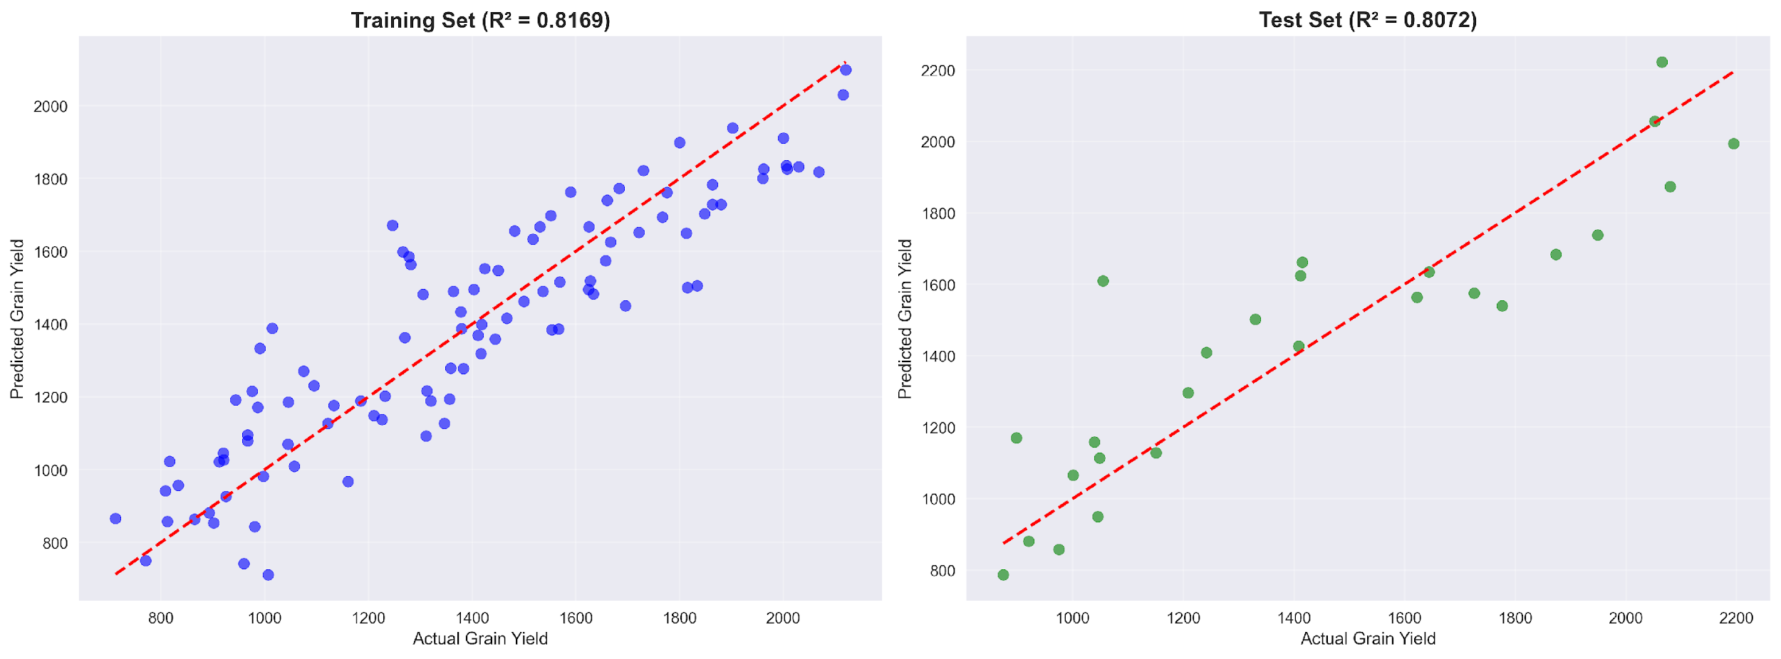
Figure 12: shows actual vs. predicted scatter plots
Ridge Regression did well when looking at the proximity of the predictions to the actual grain yield numbers (Figure 12). In the training group, 100 data points, or dots, were evenly lined up along the ideal match line, from about 770 to 2,100 kg per hectare; R squared was 0.8169 here. When applied to new data, 50 cases, the pattern remained robust across all observed actual yields, with an R-squared close to 0.8072. The error measures were a mean absolute error of 144.84 kg ha⁻¹, an average percentage error just over 11%, and a highest single miss of 554.11 kg ha⁻¹ (see Table 2). A few top-end results, > 2000 kg ha⁻¹, were somewhat below predictions. The model smoothing built in to avoid wild guesses creates that little tug towards average values. Still, overall, dots were on the perfect fit diagonal without tilting too high or low in any segment, which meant estimates were stable at any yield level. This even distribution supports both the shape of the inputs and the choice of a controlled linear approach to forecast these environment-trait interactions.

3.6. SHAP-Based Feature Importance
To better understand the system reaction from the farming perspective, every forecast was analyzed with the SHAP analysis on the ridge regression setup, thus decomposing the forecast into clear positive or negative roles of individual inputs (Figures 13, 14, and 15). Rather than enumerating everything, we provide in Figure 13 an overview in which the characteristics are ordered by average impact size. Table 3, on the other hand, has exact figures for those twenty factors pulling the strongest weight.
Among all the individual growth features, DF_BP_Interaction (days to flowering multiplied by branches per plant) was the most prominent, with a mean absolute SHAP value of 140.60; its contribution was 12.77 percent. That combo matters because a plant’s flowering time in the process of building its bulk affects yield in ways other traits just don’t capture. Thousand seed weight was not far behind with a weight of 102.35 on the scale, which was significant at 9.30 percent. Next is tagged biological yield. A little below that is 100.17, which is 9.10 percent of the whole picture. Pods per plant followed by 89.25, an increase of 8.11 percent. Fifth with 80.34 points was the two-height-by-maturity link, revealing that some life cycle and structure clues boost prediction power when multiplied. Then we have branches on each plant; the count of them appears strong at seventy-eight point one one, taking seven point zero nine percent of the weight. Close behind L_L1, Bashontopur’s marker stands at seventy-three point six zero, adding another six point six eight percent, proving place plays a clear role all by itself. Curvature counts swinging into third PP squared, 67.99617 percent Fifth in the group is the flag of Lalpur, L_L5, landing at sixty-one point nine zero and holding a five point six two percent share.
In Figure 14, the SHAP dots show how each factor pushes the predictions up or down according to its level. In case of high DF_BP_Interaction, TSW or BY, they act far rightward i.e., increase predictions of grain yield via more robust reproduction (DF_BP_Interaction), seed weight (TSW) or total plant output (BY). PP, on the other hand, splits into two clusters, where too many pods or too few lower the estimate, while medium quantities help the most, which is consistent with earlier findings where excessive branching hurts yields when water is scarce. Genotypes tested at Bashontopur show a clear negative signal, pulling the results to the left, as harvests there average just 1,228.84 kg per hectare, well below the general average.
By looking at Figure 15, the SHAP breakdown, we can see how three different yield cases were calculated. Poor early growth and weak branching, both of which dragged results down by over 200 and 150 points respectively, largely contributed to the failure to achieve the expected output of 874 kg/ha (only 787 kg/ha). Those drops were slightly offset by the combined factors working together to produce a little increase. In the middle case, the actual harvest was close to the forecast: 1,408 kg per hectare versus 1,427 kg per hectare. Here influence was more balanced; seed size and sprouting speed added gains along with synergy effects worth about 200 units. The top performance was 2,194 compared to the estimate of 1,994 for a real yield. Several factors pushed values up strongly including plant height traits squared, branch point timing interactions, and pod count patterns. Some of the limitations were due to late flowering and short branches pulling down. The small deficit at the higher levels is due to an inherent dampening of the modeling approach, suggesting that limits prevented extreme reactions.
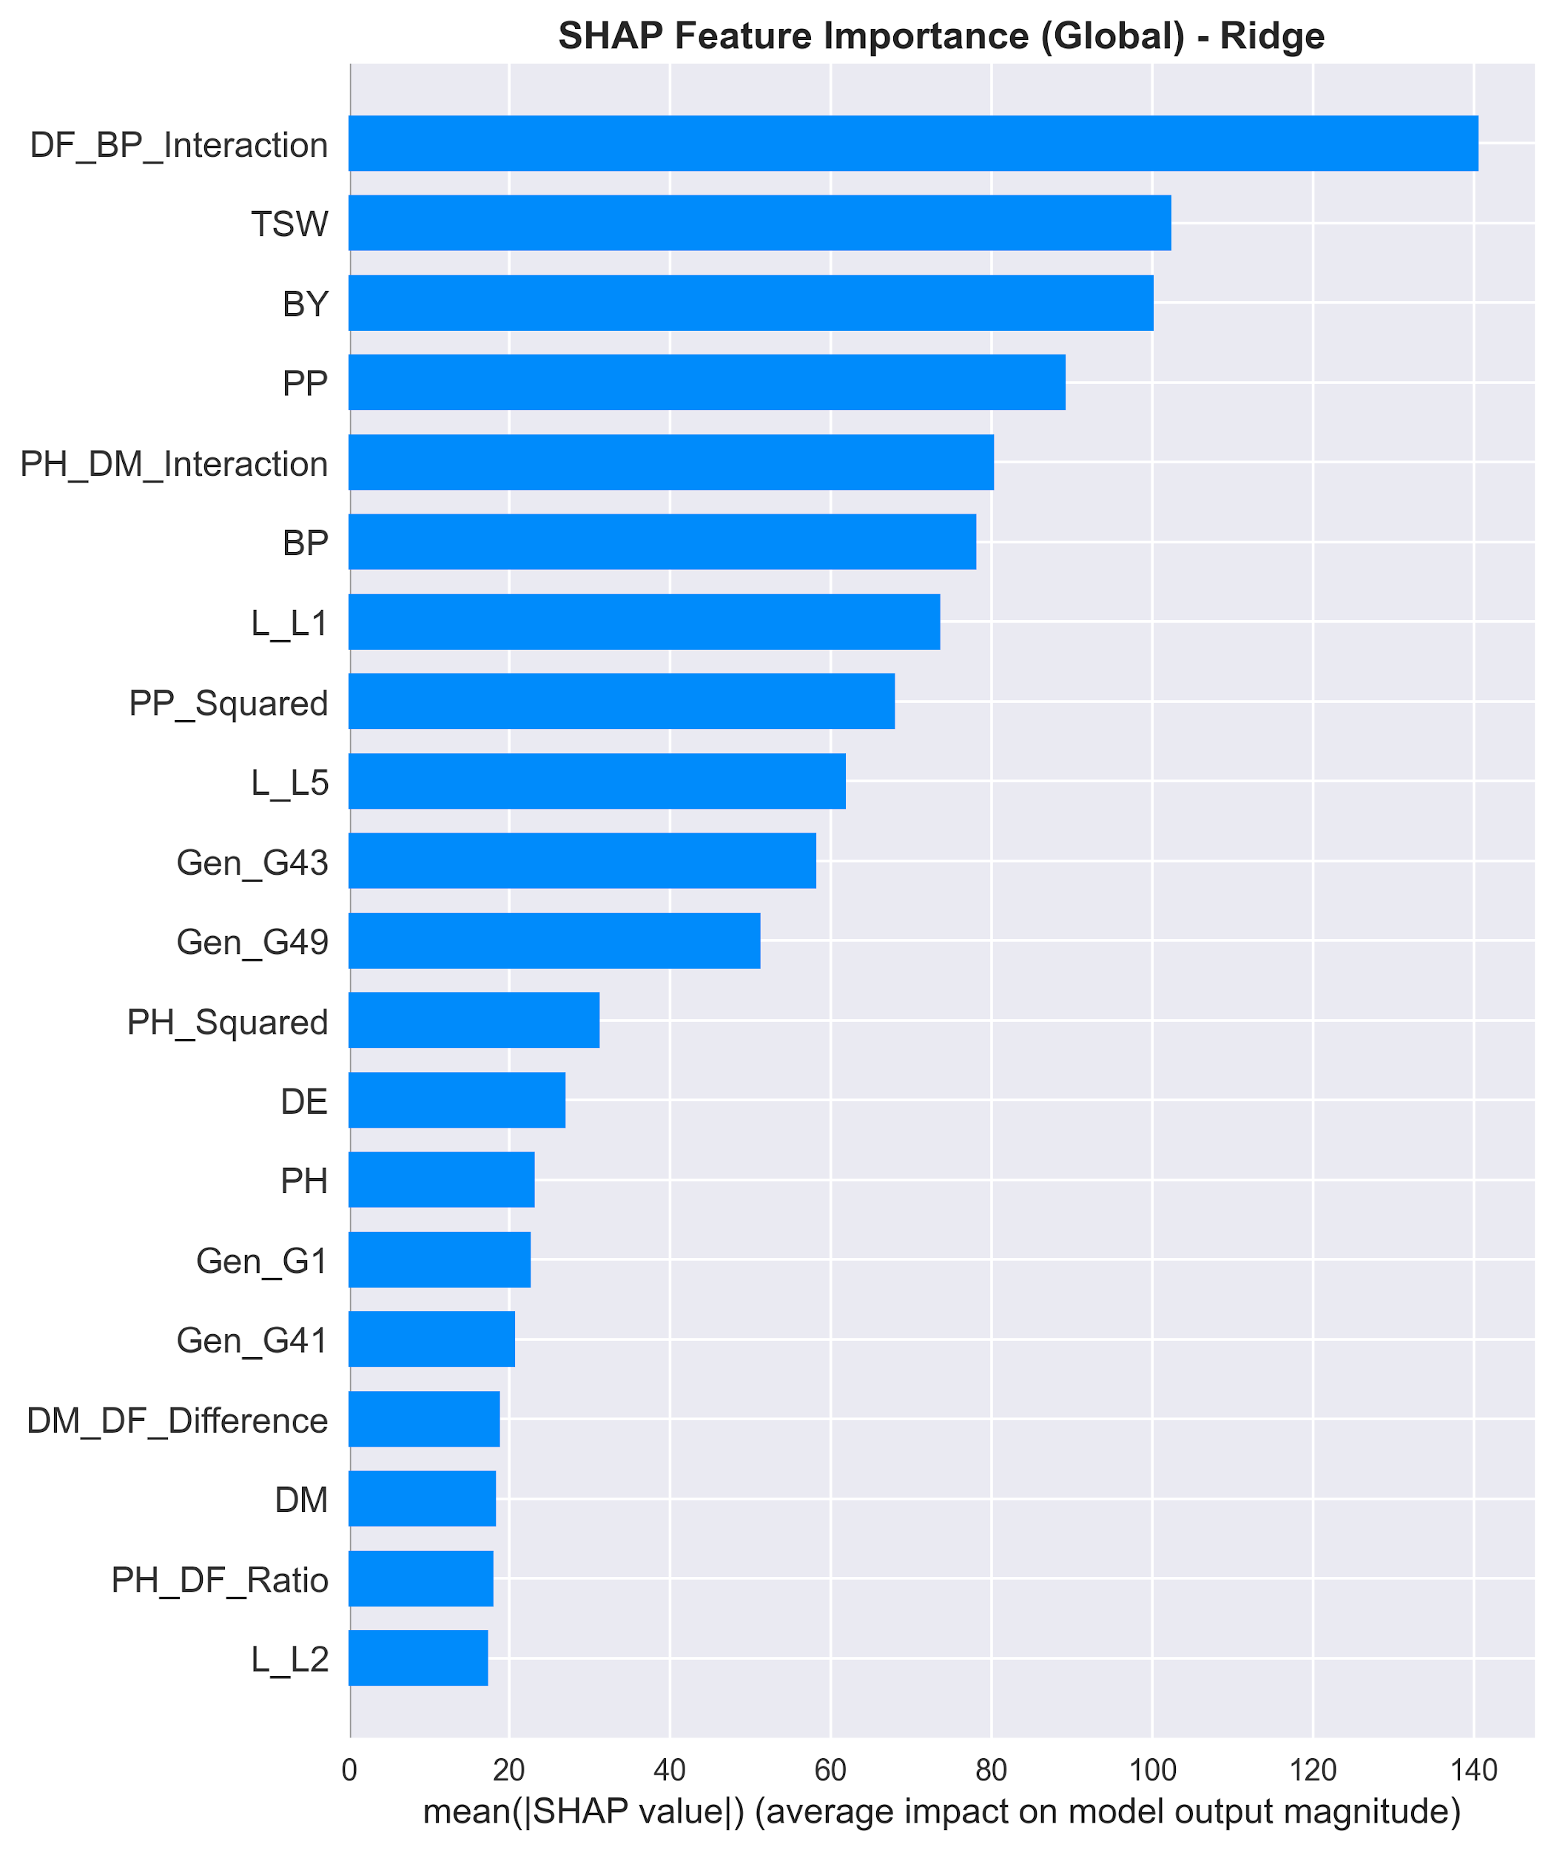
Figure 13: SHAP feature importance bar plot.
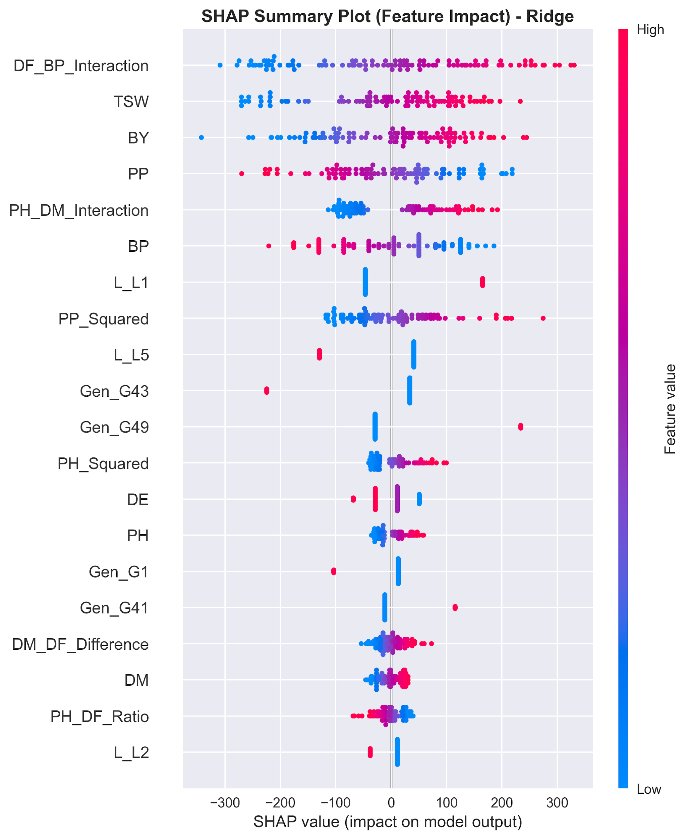
Figure 14: SHAP summary dot plot of feature contributions to model output with color coding.
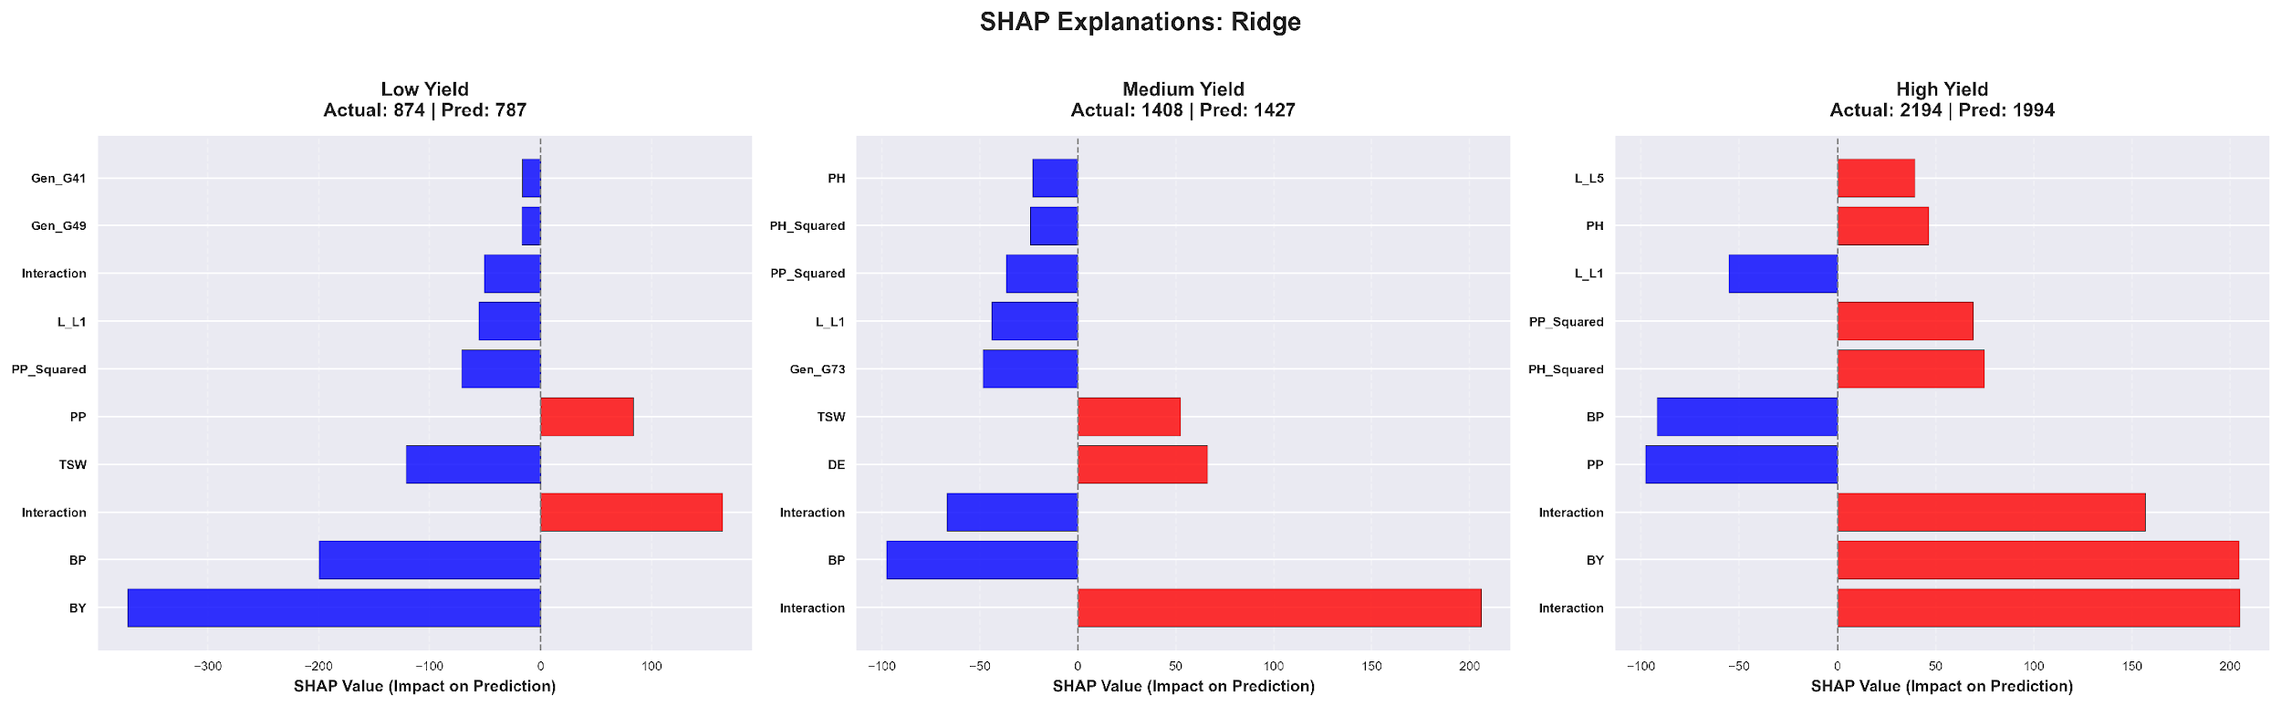
Figure 15: SHAP local explanations for three representative samples.

3.7 Genotype Performance and Stability Analysis
In Figure 16, the left side shows the AMMI biplot separating the overall differences into genetic effects and patterns of interactions represented by IPCA1 and IPCA2 . This arrangement allows you to see the average results and how stable each type is across places . Varieties in the middle of that plot are pretty insensitive to changes in the environment and tend to be more like all-round performers. G63 and G71 are near the average line with small swings in IPCA values and decent yields with little fluctuation, which is consistent with their low stability risk numbers of 187.72 and 171.30 as seen in Table .
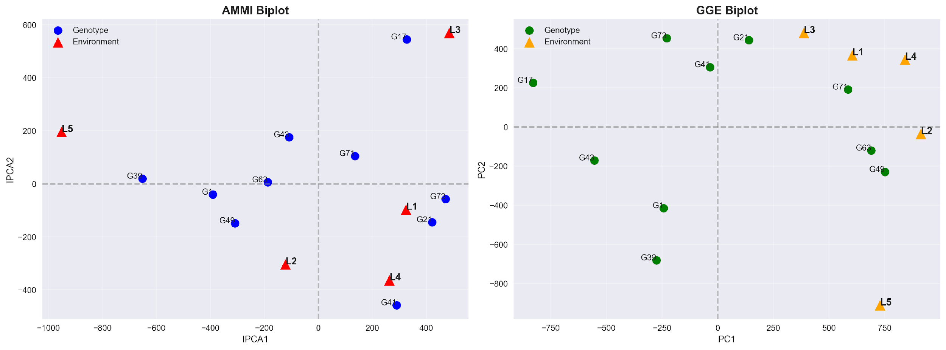
Figure 16: Stability analysis biplots. Left: AMMI biplot (IPCA1 vs. IPCA2) with genotypes (blue circles) and environments (red triangles). Right: GGE biplot (PC1 vs. PC2) showing environment–genotype affinities.
Additionally, G39 and G17 are far along the IPCA1 direction, with the highest stability indices (651.88 and 635.09), indicating that they are active only under specific conditions and not broadly active. G21 is the middle path with an ASV of 445.98 and an average of 1,437.97 kg/hectare and may be more suitable to areas with abundant resources, such as Shyampur.

Table 3: Integrated genotype ranking. Lower ASV = greater cross-environment stability. OverallRank = (YieldRank + StabilityRank) / 2.
Genotype | Mean Yield (kg/ha) | ASV (Stability) | Yield Rank | Stability Rank | Overall Rank | Classification
G63 | 1679.23 | 187.72 | 2.0 | 2.0 | 2.0 | High performing & High stability
G71 | 1652.37 | 171.30 | 3.0 | 1.0 | 2.0 | High performing & High stability
G49 | 1682.28 | 342.73 | 1.0 | 4.0 | 2.5 | High performing & Moderate stability
G21 | 1437.97 | 445.98 | 4.0 | 6.0 | 5.0 | Moderate performing & Moderate stability
G43 | 1128.15 | 206.12 | 9.0 | 3.0 | 6.0 | Low performing & High stability
G1 | 1234.78 | 392.84 | 7.0 | 5.0 | 6.0 | Moderate performing & Moderate stability
G73 | 1278.60 | 475.31 | 6.0 | 7.0 | 6.5 | Moderate performance & Low stability
G41 | 1319.91 | 542.26 | 5.0 | 8.0 | 6.5 | Moderate performance & Low stability
G39 | 1207.26 | 651.88 | 8.0 | 10.0 | 9.0 | Low performing & Low stability
G17 | 1057.15 | 635.09 | 10.0 | 9.0 | 9.5 | Low performing & Low stability
Figure 16, right panel, displays the GGE biplot which illustrated the overall performance of each variety and the changes induced by different test sites. Instead of just listing numbers, it drew a star-shaped pattern showing where certain types won under certain conditions. The six major varieties G73, G21, G71, G49, G39, and G17 were located at the vertices of that shape. G17 and G39 were at the external vertices due to their strong PC1 and PC2 values. Lines radiated from the center to five test locations, L1 through L5, but these merged into two separate wedges, like pie slices separating groups of locations. L1, L3, and part of L4 tended to one cluster on top, preferring G21 and G71 over the others. Meanwhile, L2 and some overlap from L4 settled down near the bottom right, with G49 pulling ahead and G63 showing stronger results. Winners varied by site, and no one type was best across all five areas. This changing result illustrated how much a growing place shapes performance, proving that gene-by-environment interaction wasn’t just random noise; it formed clear patterns worth tracking.

3.8. GGE Biplot: Which-Won-Where Pattern
G71 was the most consistent with an ASV of 171.30 and third for average output at 1,652.37 kg per hectare, which earned it a total score of 2.0, a tie with G63. Rated second best in stability with an ASV of 187.72, G63 came in just above with 1,679.23 kg per hectare on average, also reaching a combined position of 2.0. G49 produced the highest harvest at 1,682.28 kg per hectare across sites, but was less consistent with an ASV of 342.73, resulting in a reliability rank of 4th and a final score of 2.5. So it appears that these three, G49, G63, and G71, were the standout performers when grown under different dry trial conditions here, giving good results without much loss of adjustment ability. On the other end, G17 was at the bottom with an average of 9.5, due to poor averages coupled with erratic responses in locations, putting it at the bottom of the list. Similarly, G39 was at the bottom with an average of 9.0 due to poor yields and erratic responses, ruling it out for wide-scale use around Rajshahi. Visualized in Figure 17.

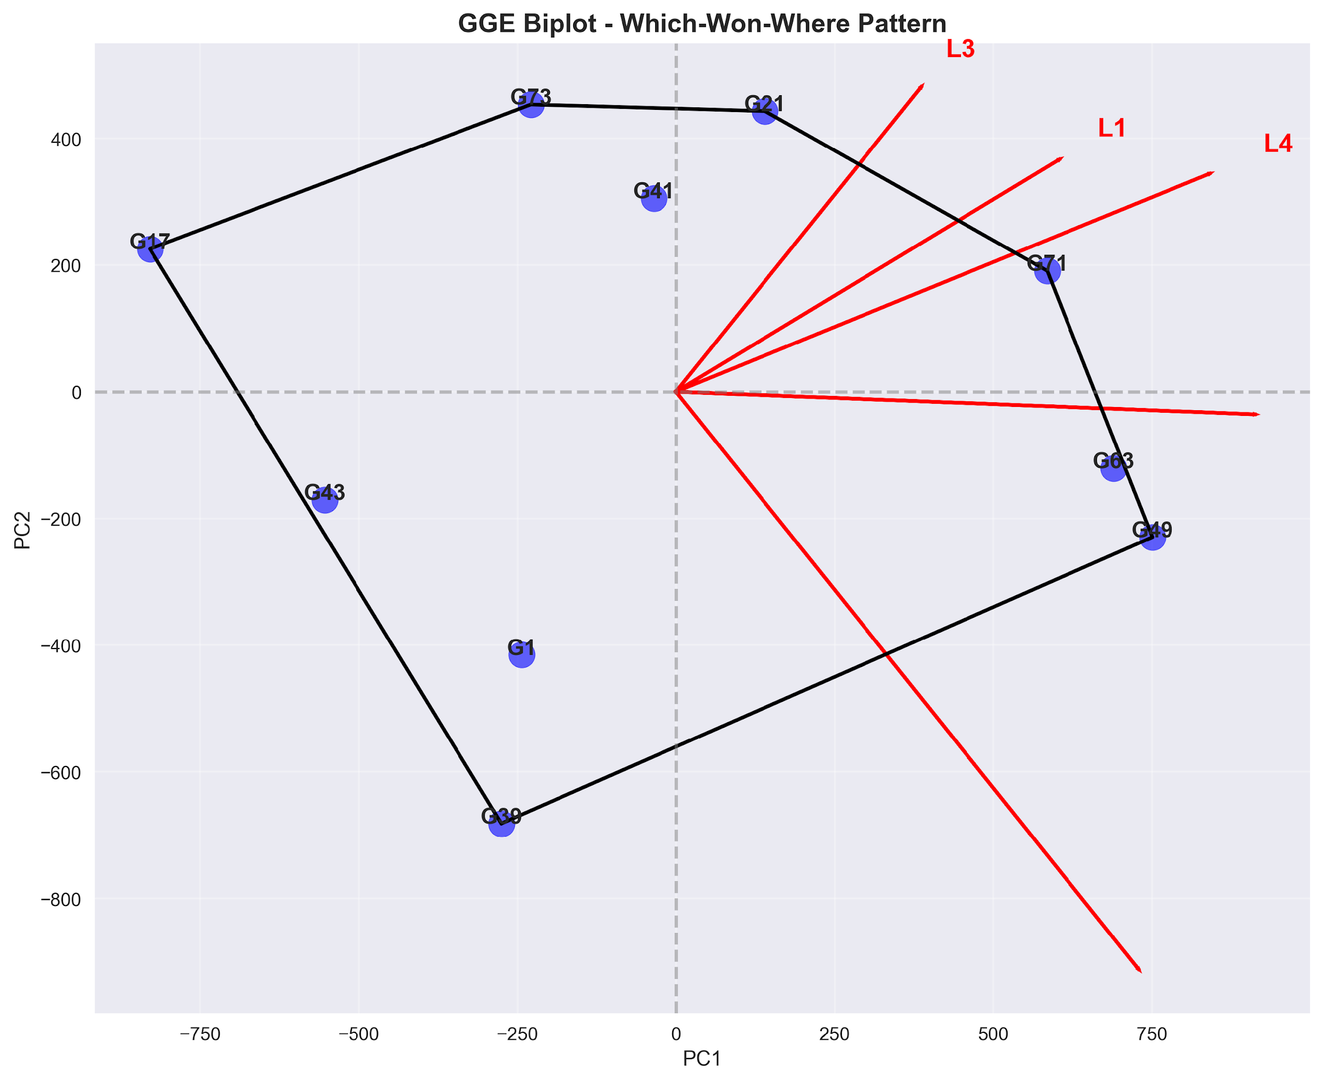
Figure 17. GGE biplot: which-won-where polygon pattern.

3.9. Location Performance Analysis
The growth of ten varieties of lentils is shown in Figure 18 at five locations near Rajshahi, Bangladesh: Bashontopur (L1), Shyampur (L2), Nachole (L3), Sapaher (L4), and Lalpur (L5) based on the color schemes derived from actual harvest figures per hectare. G63 gave the most grain, 2,113 kilograms per hectare at L2, but G39 gave only 770 at L3. Clearly, different crops behave differently depending on where they grow. Shyampur was notable with an average of about 1,709 kg per hectare, its results widely dispersed by ±318 kg, indicating strong variation between individual plots there. Then came Lalpur, which pulled just above 1,370, and Sapaher came close to that at almost 1,362. But under all of them sat Nachole, pulling a division bottom mark near 1,169, perhaps because of stiffer growing challenges such as a stronger lack of water. The top two from the best locations, G49 and G63, had their own stories to tell. At L2, G49 gave 2,025 kg per hectare. Later, at L5, it gave 1,928. Then there’s the G63, even higher with 2,113 at L2, plus strong figures elsewhere: 1,518 at L4 and then 1,816 back at L5. Now look at G17 and G39; they were behind most of the others on average. G17 just grazed the 1057 kg per hectare mark across sites, and G39 just over 1207. The heatmap colors helped to show what words might be missing, the hot zones for output clustered closely around G49, G63 and also G71, especially around Shyampur and Lalpur. On the other hand, bad results piled up where G17 and G43 appeared again and again, at Nachole. Out of these trends came something useful: a basis for more number crunching and forecasting.
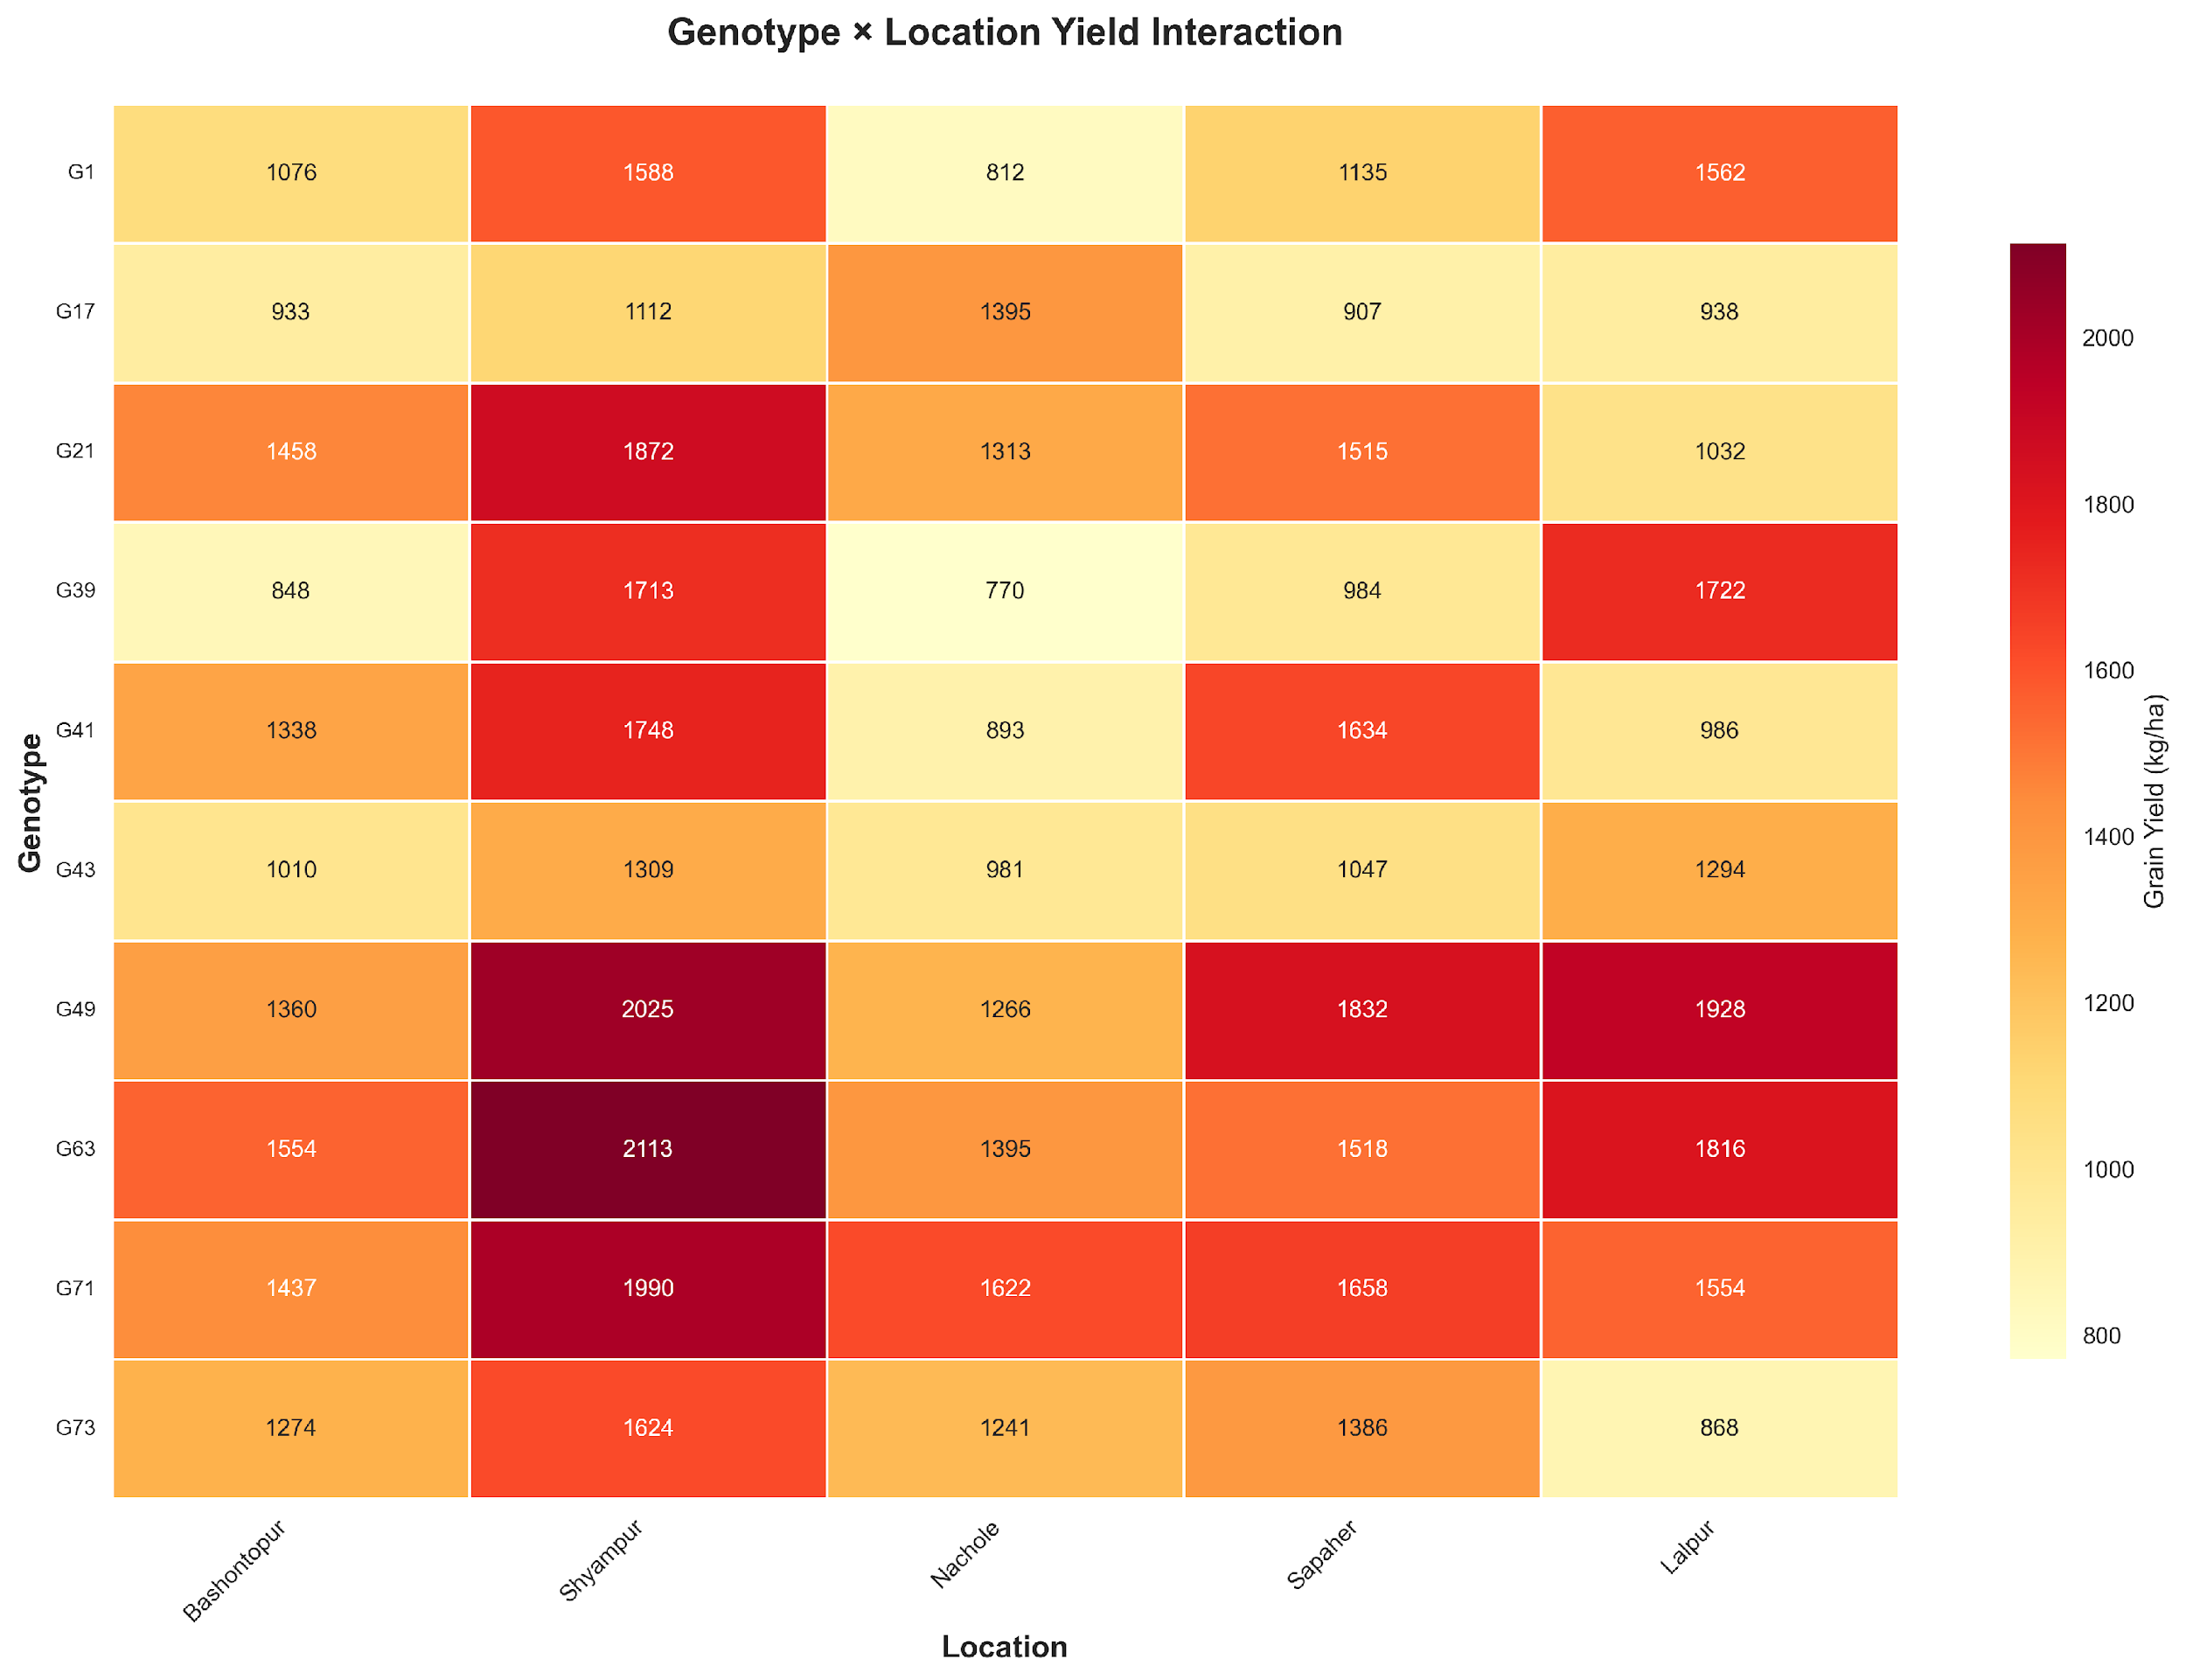
Figure 18: Genotype × Location yield heatmap (kg/ha). Dark red = highest yields; yellow = lowest. G63 at Shyampur (2,113 kg/ha) is the highest yield, and G39 at Nachole (770 kg/ha) represents the lowest yield.

4. Discussion
In the small sample G×E setting, ridge regression outperformed nonlinear methods (XGBoost, RF, etc.) on real farm data while maintaining test R² close to training R² (0.8072, drift 0.0097) thanks to its shrinkage that reduced overfitting when features outnumber observations. Random train/test splits with one-hot encoded location/genotype may boost holdout R²; thus, future leave-one-environment-out and leave-one-genotype-out validation is warranted. Manifold learning (UMAP/t-SNE) revealed hidden G×E topology, although location-based clustering may partly reflect categorical encodings rather than emergent agronomic structure, indicating traits-only embeddings as a sensitivity check. ML and agronomy were linked by SHAP analysis with DF_BP_Interaction (flowering timing × branching) and TSW/BY as the main predictors in accordance with plant physiology in drought conditions. The AMMI/GGE stability analysis revealed the genotypes with consistently high performance (G71 and G63) and the high-yielding but unstable lines (G49) for the breeding program in Bangladesh. Major limitations include single-region, single-year, single-crop scope and unmeasured traits (e.g., canopy temperature). Future work should include mixed-model baselines (e.g., REML with pedigree/genomic relationships) and broaden validation to evaluate generalizability across legumes and environments. The current feature set is biologically informed but does not account for dynamic physiological markers (e.g., root depth, stomatal conductance) that may better capture drought-response mechanisms. Also, the absence of pedigree or genomic relationship matrices limits the model’s ability to exploit genetic relatedness for better inference in small samples. In my opinion, the main value of this workflow is not to outperform complex ML but to make G×E patterns interpretable and actionable for breeders with limited data; I strongly recommend that future applications prioritize group-aware validation and traits-only manifold checks to ensure findings reflect biology, not encoding artifacts, and that teams share engineered feature definitions openly to accelerate community learning.

5. Conclusions
The method uses basic math rules combined with plant-based data adjustments and shows it can predict lentil yields well on different farms in dry areas of Rajshahi, Bangladesh, from a hilltop vantage point. Ridge regression, a more straightforward model, outperformed complex systems in terms of performance on unseen data with an R² value near 0.81 and an error slightly below 184 kilograms per hectare. Forests of decision trees, or combined learners, tried their best but failed when confronted with new plots, mainly because their training was confined to the scope of real-world growing trials. What really shone through was the clearness from using SHAP values and peeling away the layers to see why the predictions landed where they did. Twelve were tried; one silent player led not with flash but with a steady reach into unknown fields. The interesting thing here is how well basic tuned models do; it shows something fundamental about statistics. Bigger models need more data, but Ridge takes smaller sets and just gently pulls coefficients inwards while keeping all the variables in play, so none of the crafted features are lost. When the data were projected by UMAP and t-SNE, curved patterns were observed in the genotype–environment combination, which confirmed the construction of features and offered another view of interactions that linear methods like AMMI or GGE do not capture. Of all factors, DF_BP_Interaction stood tallest, its influence clear at 140.60, making up nearly 13% of what mattered. Close behind came TSW, holding steady at just under 9.3%, then biological yield trailing slightly below it. What shifted understanding was how combining days to flowering with branches per plant revealed something deeper, a pattern regular traits could not show on their own. Stability checks through AMMI and GGE pointed firmly toward G71 and G63, consistent performers no matter where they grew. In contrast, G49 thrived only when conditions leaned richer, favoring stronger soils or better water access. A closer look at performance zones suggested not one uniform area but at least two distinct pockets across Rajshahi’s test sites, one shaping choices in one place, another guiding them elsewhere.
Together, these results form an approach that combines traditional stability checks with current machine learning plus interpretability methods. It gives crop scientists a way to clearly identify promising plant types, prioritize important yield traits, and map where certain varieties thrive under dry conditions. Starting with broader data across several seasons and species could test how well the system scales up. Another point of view is to compare this setup with the regular REML approaches to genetic evaluation. Such comparisons may be required in the future of digital crop improvement.

Author Contributions: For research articles with several authors, a short paragraph specifying their individual contributions must be provided. The following statements should be used “Conceptualization, X.X. and Y.Y.; methodology, X.X.; software, X.X.; validation, X.X., Y.Y. and Z.Z.; formal analysis, X.X.; investigation, X.X.; resources, X.X.; data curation, X.X.; writing—original draft preparation, X.X.; writing—review and editing, X.X.; visualization, X.X.; supervision, X.X.; project administration, X.X.; funding acquisition, Y.Y. All authors have read and agreed to the published version of the manuscript.” Please turn to the CRediT taxonomy for the term explanation. Authorship must be limited to those who have contributed substantially to the work reported.
Funding: This research received no external funding.
Institutional Review Board Statement: Not Applicable.
Informed Consent Statement: Not applicable.
Data Availability Statement: We encourage all authors of articles published in MDPI journals to share their research data. In this section, please provide details regarding where data supporting reported results can be found, including links to publicly archived datasets analyzed or generated during the study. Where no new data were created, or where data is unavailable due to privacy or ethical restrictions, a statement is still required. Suggested Data Availability Statements are available in section “MDPI Research Data Policies” at https://www.mdpi.com/ethics.
Acknowledgments: During the preparation of this manuscript, generative AI tools were used only for language polishing, grammar improvement, and readability refinement. The study design, experiments, analysis, interpretation, figures, tables, and scientific conclusions were developed and verified by the authors. The authors manually reviewed, revised, and approved all text and take full responsibility for the accuracy, originality, interpretation, and integrity of the final manuscript.
Conflicts of Interest: Declare conflicts of interest or state “The authors declare no conflicts of interest.” Authors must identify and declare any personal circumstances or interest that may be perceived as inappropriately influencing the representation or interpretation of reported research results. Any role of the funders in the design of the study; in the collection, analyses or interpretation of data; in the writing of the manuscript; or in the decision to publish the results must be declared in this section. If there is no role, please state “The funders had no role in the design of the study; in the collection, analyses, or interpretation of data; in the writing of the manuscript; or in the decision to publish the results”.

References
1. Laskar, R.A.; Khan, S.; Deb, C.R.; Tomlekova, N.; Wani, M.R.; Raina, A.; Amin, R. Lentil (Lens Culinaris Medik.) Diversity, Cytogenetics and Breeding. In; Springer, 2019; pp. 319–369 ISBN 9783030233990.
2. Dikshit, H.K.; Mishra, G.P.; Aski, M.S.; Singh, A.; Tripathi, K.; Bansal, R.; Pratap, A.; Gupta, S.; Kumar, S. Lentil Breeding. In; Springer Nature Singapore, 2022; pp. 1181–1236 ISBN 9789811692567.
3. Kobir, M.S.; Harun-Or-Rashid, M.; Ahmed, S. Development of Integrated Fertilizer Management Strategies in Lentil for Higher Productivity in the South-Western Region of Bangladesh. as 2020, 2, p275, doi:10.30560/as.v2n1p275.
4. Aktar-Uz-Zaman, M.; Khan, M.M.H.; Islam, M.R.; Sarkar, D.; Iqbal, M.S.; Shahinuzzaman, M.; Hossain, M.S.; Uddin, R.; Nahar, N.; Rohman, M.M.; et al. Assessing Yield Stability of Heat-Tolerant Lentil Genotypes across Multiple Hotspot Regions in Bangladesh. Research Square 2025.
5. Nath, U.K.; Rani, S.; Paul, M.R.; Alam, M.N.; Horneburg, B. Selection of Superior Lentil (Lens Esculenta M.) Genotypes by Assessing Character Association and Genetic Diversity. The Scientific World Journal 2014, 2014, 1–6, doi:10.1155/2014/372405.
6. Hamdi, A.; Erskine, W.; Gates, P. Adaptation of Lentil Seed Yield to Varying Moisture Supply. Crop Science 1992, 32, 987–990, doi:10.2135/cropsci1992.0011183x003200040031x.
7. B R, H.; Singh, R.; Kant, R.; C V, N.; Kumari, A.R.; Prasad, J.; Singh, A.P.; Ramulu, C.; Pal, J.; Dubey, S. Field Evaluation of Lentil (Lens Culinaris Medik) Genotypes: A Step towards Climate-Resilient Pulse Farming in Indo-Gangetic Plains of North Western Bihar, India. AATCCReview 2025, 13, 341–343, doi:10.21276/aatccreview.2025.13.03.341.
8. De Leon, N.; Jannink, J.; Edwards, J.W.; Kaeppler, S.M. Introduction to a Special Issue on Genotype by Environment Interaction. Crop Science 2016, 56, 2081–2089, doi:10.2135/cropsci2016.07.0002in.
9. Hadasch, S.; Forkman, J.; Piepho, H. Cross‐Validation in AMMI and GGE Models: A Comparison of Methods. Crop Science 2017, 57, 264–274, doi:10.2135/cropsci2016.07.0613.
10. Carvalho, T.B. Leveraging Relationship Information for Assessing Genotype Stability and Performance in Multi-Environment Trials, Pro Reitoria De Pesquisa E Pos Graduacai Ufv, 2025.
11. Westcott, B. A Method of Assessing the Yield Stability of Crop Genotypes. J. Agric. Sci. 1987, 108, 267–274, doi:10.1017/s0021859600079259.
12. Shukla, S.; Pant, B.; Bordoloi, D.; Abou-Zahra, S.; Brewer, J.; Cooper, M.; Agrawal, S.; Vieira, D.; Alaba, F.; Othman, M.; et al. PREDICTION OF CROP YIELD IN PRECISION AGRICULTURE USING MACHINE LEARNING METHODS. Webology 2021, doi:10.29121/web/v18i4/122.
13. Ennaji, O.; Baha, S.; Vergutz, L.; El Allali, A. Gradient Boosting for Yield Prediction of Elite Maize Hybrid ZhengDan 958. PLoS ONE 2024, 19, e0315493, doi:10.1371/journal.pone.0315493.
14. Kukal, M.S. Relative and Unified Skill of Environmental, Edaphic, and Management Factors to Explain Crop Yield Variance Using Machine Learning. Journal of the ASABE 2024, 67, 995–1011, doi:10.13031/ja.15755.
15. Danilevicz, M.F.; Upadhyaya, S.R.; Batley, J.; Bennamoun, M.; Bayer, P.E.; Edwards, D. Understanding Plant Phenotypes in Crop Breeding through Explainable AI. Plant Biotechnology Journal 2025, 23, 4200–4213, doi:10.1111/pbi.70208.
16. Zhou, Y.; Tang, C.; Xiao, X.; Zhan, X.; Wang, T.; Xiao, G.; Xu, L. Dimensionality Reduction for Visualizing Spatially Resolved Profiling Data Using SpaSNE. GigaScience 2025, 14, doi:10.1093/gigascience/giaf002.
17. A P, J.; A P, S. A Survey on the Usage of Numerous ML Models for Agriculture.; Institute Of Electrical Electronics Engineers, January 24 2024; Vol. 16, pp. 1–5.
18. He, K.; Yu, T.; Gao, S.; Chen, S.; Li, L.; Zhang, X.; Huang, C.; Xu, Y.; Wang, J.; Prasanna, B.M.; et al. Leveraging Automated Machine Learning for Environmental Data-Driven Genetic Analysis and Genomic Prediction in Maize Hybrids. Advanced Science 2025, 12, e2412423, doi:10.1002/advs.202412423.
19. Robert, P.; Le Gouis, J.; Rincent, R. Combining Crop Growth Modeling With Trait-Assisted Prediction Improved the Prediction of Genotype by Environment Interactions. Front. Plant Sci. 2020, 11, 827, doi:10.3389/fpls.2020.00827.
20. Akter, S.; Jahan, I.; Amir Hossain, M.; Anwar Hossain, M. Laboratory-and Field-Phenotyping for Drought Stress Tolerance and Diversity Study in Lentil (Lens Culinaris Medik.). Phyton 2021, 90, 949–970, doi:10.32604/phyton.2021.014411.
21. Neupane, S.; Stonehouse, R.; Ramsay, L.; Baker, M.; Haile, T.; Konkin, D.J.; Sidebottom, C.; Bett, K.E. Development of a Nested Association Mapping (NAM) Population for Untangling Complex Traits in Lentil (Lens CulinarisMedik.). bioRxiv (Cold Spring Harbor Laboratory) 2025.
22. Sabaghnia, N.; Dehghani, H.; Sabaghpour, S.H. Graphic Analysis of Genotype by Environment Interaction for Lentil Yield in Iran. Agronomy Journal 2008, 100, 760–764, doi:10.2134/agronj2006.0282.
23. Bootkrajang, J. Boosting Ridge Regression for High Dimensional Data Classification. arXiv (Cornell University) 2020.
24. Cattivelli, L.; Rizza, F.; Badeck, F.-W.; Mazzucotelli, E.; Mastrangelo, A.M.; Francia, E.; Marè, C.; Tondelli, A.; Stanca, A.M. Drought Tolerance Improvement in Crop Plants: An Integrated View from Breeding to Genomics. Field Crops Research 2007, 105, 1–14, doi:10.1016/j.fcr.2007.07.004.
25. Messina, C.D.; Cooper, M. Incorporating Genetics into Crop Models to Identify New Phenotypes Adapted to Climate Change. In; Burleigh Dodds Science, 2023; pp. 75–104 ISBN 9781801461740.
26. Parent, B.; Tardieu, F. Can Current Crop Models Be Used in the Phenotyping Era for Predicting the Genetic Variability of Yield of Plants Subjected to Drought or High Temperature? Journal of Experimental Botany 2014, 65, 6179–6189, doi:10.1093/jxb/eru223.

Disclaimer/Publisher’s Note: The statements, opinions and data contained in all publications are solely those of the individual author(s) and contributor(s) and not of MDPI and/or the editor(s). MDPI and/or the editor(s) disclaim responsibility for any injury to people or property resulting from any ideas, methods, instructions or products referred to in the content.

